Chemical Investigations
Determination of Aspirin
Pupil Guide
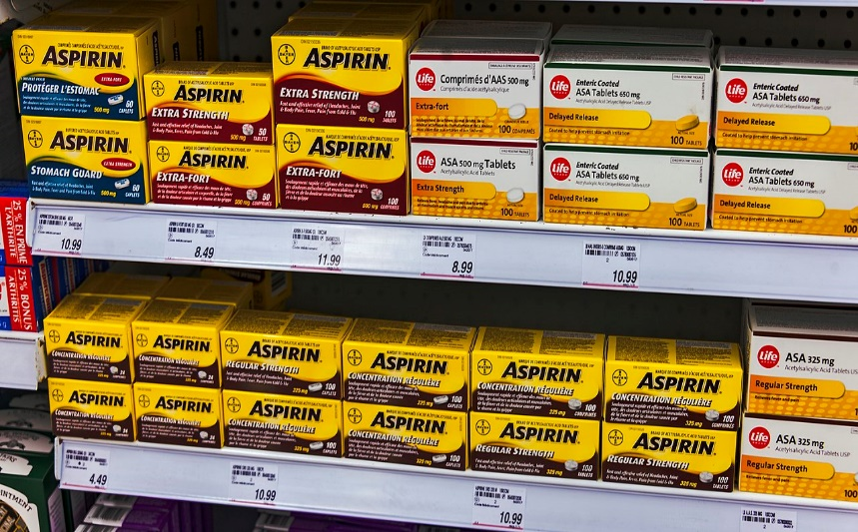
Photo: Daniel Case via Wikimedia Commons under a Creative Commons 3.0 license

Determination of Aspirin

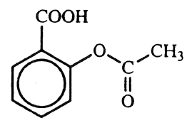
Introduction
Aspirin has the following structural formula:
Since it is insoluble in water, aspirin has to be determined by a ‘back titration’ technique. This involves treating a sample of accurately known mass with a definite amount of sodium hydroxide i.e. the volume and concentration of the alkali must be accurately known. The alkali first catalyses the hydrolysis of the aspirin to ethanoic and salicylic acids and then neutralises these acids. An excess of alkali has to be used and the amount remaining after reaction is determined by titrating it against a standard solution of sulphuric acid.

Health & Safety
Wear eye protection and if any chemical splashes on your skin wash it off immediately.
0.050 mol l⁻¹ sulphuric acid is of no significant hazard.
1.0 mol l⁻¹ sodium hydroxide is corrosive to the eyes and skin. Goggles should be worn and possibly gloves.
Phenolphthalein indicator solution is highly ﬂammable and irritating to the eyes because of its ethanol content.

You will need
aspirin tablets | 0.050 mol l⁻¹ sulphuric acid
1.0 mol l⁻¹ sodium hydroxide | phenolphthalein
250 cm³ standard ﬂasks | conical ﬂasks (100 cm³ and 250 cm³)
25 cm³ pipette | 50 cm³ burette
weighing bottle deionised water | balance (accurate to 0.01 g)
hot plate (or Bunsen burner and tripod) | 50 cm³ measuring cylinder
pipette filler | ﬁlter funnel
white tile | wash bottle
dropper

Procedure
- Carry out the following procedure in duplicate.
- Add a definite number of aspirin tablets (about 1.5 g in mass) to the weighing bottle and weigh the bottle and contents.
- Transfer the tablets to a large conical ﬂask and reweigh the weighing bottle.
- Rinse the 25 cm³ pipette with 1.0 mol l⁻¹ sodium hydroxide and pipette 25 cm³ of this solution into the ﬂask containing the tablets.
- To the mixture in the ﬂask, add approximately 25 cm³ of deionised water.
- Place the ﬂask on the hotplate and simmer the mixture very gently for about 30 minutes.
- Allow the reaction mixture to cool before transferring it to the 250 cm³ standard ﬂask.
- Rinse the conical ﬂask with a little deionised water and add the rinsings to the standard ﬂask
- Repeat this procedure until you are within about a centimetre of the graduation mark on the ﬂask.
- Using a dropper, make up the solution to the graduation mark with deionised water.
- Stopper the ﬂask and invert it several times to ensure the contents are completely mixed.
- Rinse the burette, including the tip, with 0.050 mol l⁻¹ sulphuric acid and fill it with the same solution.
- Rinse the 25 cm’ pipette with the ‘standard ﬂask‘ solution and pipette 25 cm³ of it into a 100 cm³ conical ﬂask.
- Add a few drops of phenolphthalein indicator to the solution in the conical ﬂask and titrate to the end-point.
- Repeat the titrations until two concordant results are obtained.
- Calculate the mass of aspirin per tablet using the accurate concentrations of the sulphuric acid and sodium hydroxide solutions provided by your teacher/lecturer.
- For one of your determinations, calculate the percentage error and hence the absolute error in the mass of aspirin per tablet. Your teacher/lecturer will provide you with the errors in the concentrations of the sulphuric acid and sodium hydroxide solutions.

Note
It is important that plain aspirin tablets are used in this determination. ‘Soluble aspirin‘ and any tablets that contain citric acid, carbonates, hydrogencarbonates, esters (ﬂavourings), paracetamol etc., should be avoided.

