Chemical Investigations
Derivative Formation
Teacher/Technician Guide
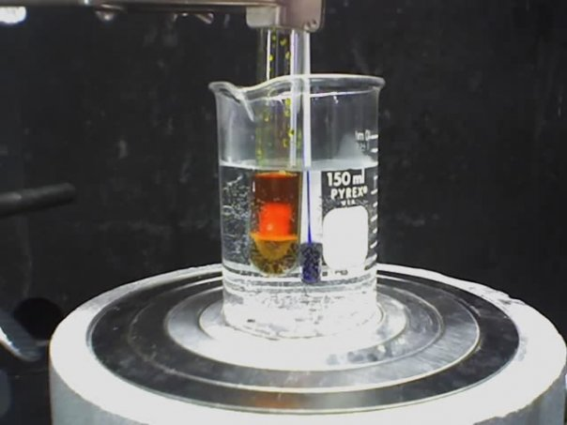
Photo: Ccroberts via Wikimedia Commons under a Creative Commons 2.5 license

Identiﬁcation by Derivative Formation
UNIT 3 PPA 2
Introduction
Even if the homologous series to which an organic liquid belongs has been established, it can still be difficult to identify the liquid from its boiling point To overcome this problem the liquid can be convened into a solid derivative. By comparing the melting point of the derivative with those of known derivatives, it is then possible to identify the organic liquid.
In this experiment, an unknown ketone is converted into a derivative by condensing it with 2,4-dinitrophenylhydrazine:
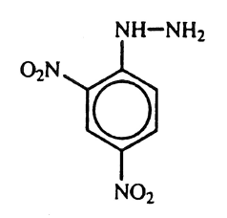
The derivative, known as a 2,4-dinitrophenylhydrazone, is puriﬁed by recrystallisation before its melting point is determined.
Health & Safety
Wear eye protection and if any chemical splashes on your skin wash it off immediately.
The ketone used is likely to be volatile and highly ﬂammable and harmful if swallowed. The vapour irritates the eyes, skin and lungs and is narcotic in high concentrations. Wear gloves.
Brady's reagent contains 2,4-dinitophenylhydrazine which is toxic by ingestion and by skin absorption. Brady‘s reagent also contains methanol which is volatile and highly ﬂammable. It is toxic by ingestion, inhalation and by skin absorption. High concentrations may damage the central nervous system and impair vision. Brady's reagent also contains sulphuric acid which is irritating to the eyes and skin. Wear gloves.
Ethanol is volatile, highly ﬂammable, irritating to the eyes and intoxicating if inhaled or ingested.
No information is available on the toxicity of the ketone-2,4-dinitophenylhydrazone but analogy would suggest that its toxicity is similar to that of 2.4-dinitrophenylhydrazine itself. It should be handled in the same way as Brady's reagent.

Requirements
unknown ketone | Brady's reagent (2,4-dinitrophenylhydrazine solution)
ethanol | anti-bumping granules
test tube and rack | stopper to fit test tube
dropper | Hirsch funnel and ﬂask
50 cm³ conical ﬂasks | glass ﬁlter funnel
hot plate | ﬁlter papers
Access to an oven | capillary tube
thermometer | melting point apparatus
water pump | 10 cm³ measuring cylinder
watch glass

Procedure
- Add about 10 cm³ of 2,4-dinitrophenylhydrazine solution to the test tube followed by approximately 10 drops of the unknown ketone. Stopper the test tube and invert it several times to ensure complete mixing.
- Set up the Hirsch funnel and ﬂask for ﬁltration and connect the side arm of the ﬂask to the water pump. Place a small ﬁlter paper in the funnel and wet it with a few drops of ethanol.
- Tum on the water tap and the suction from the pump will ensure that the ﬁlter paper adheres firmly to the perforated bed of the funnel.
- Filter off the precipitate at the water pump.
- Transfer the precipitate to a conical ﬂask and add a small volume of the solvent, ethanol (about 10 cm³).
- Add a few anti-bumping granules to the mixture and heat it gently on the hot plate until the precipitate dissolves. Do not boil the solution. If noticeable amounts of solid remain, add a little more ethanol.
- Filter the warm solution into a conical ﬂask through a pre-heated ﬂuted filter paper and funnel.
- Set aside the conical ﬂask until the solution has cooled to room temperature and crystallisation has occurred.
- Using the Hirsch funnel and ﬂask, ﬁlter the crystals at the water pump using the filtrate to wash out and remove the remaining crystals from the ﬂask.
- Wash the crystals with a little ethanol and transfer them to a watch glass. Dry the crystals in an oven at a temperature of about 50 - 60°C.
- Using the melting point apparatus, determine the melting point of the crystals. To get an accurate value of the melting point it is important to raise the temperature very slowly – about 2°C per minute.
- Compare the melting point with those in the following table and hence identify the ketone.

Ketone | m.p. of 2,4-dnp derivative / °C | Ketone | m.p. of 2,4-dnp derivative / °C
propanone | 128 | pentan-3-one | 156
butanone | 115 | hexan-2-one | 107
pentan-2-one | 141 | cyclohexanone | 162

Notes
Brady's reagent should be stored in a cool place and preferably in the dark It should be stable for several weeks, but ultimately produces a brown deposit.
To prevent decomposition of the 2,4-dinitrophenylhydrazone, it should not be boiled in the solvent during the recrystallisation process nor should the crystals be left in contact with the mother liquor for a prolonged period prior to filtration.
The crystals of the derivative could equally well be dried in the open air or in a desiccator with silica gel or anhydrous calcium chloride as desiccant.

TECHNICIAN GUIDE
Requirements per student (or group)
Reagents
unknown ketone (~0.5 cm³) (use propanone)
Brady's reagent (10 cm³))
(Dissolve 2.5 g 2,4-dinitrophenylhydrazine in 5 cm³ concentrated sulphuric acid. To this mixture add 50 cm³ methanol carefully and with cooling. Warm the resulting solution to dissolve any remaining solid and add 10 cm³ of water)
ethanol (~15 cm³)
anti~bumping granules
Apparatus
test tube (1) and rack (1) | stopper to ﬁt test tube (1)
access to oven | capillary tube (1)
dropper (1) | Hirsch funnel and ﬂask (1)
0 - 200 °C thermometer (1) | access to melting point apparatus
50 cm³conical ﬂasks (2) | glass ﬁlter funnel (1)
10 cm³ measuring cylinder (1) | water pump (1)
access to hot plate | ﬁlter papers to fit Hirsch funnel (2) and ﬁlter funnel (1)
watch glass (1)

Notes
Brady's reagent should be stored in a cool place and preferably in the dark It should be stable for several weeks, but ultimately produces a brown deposit.
To prevent decomposition of the 2,4-dinitrophenylhydrazone, it should not be boiled in the solvent during the recrystallisation process nor should the crystals be left in contact with the mother liquor for a prolonged period prior to filtration.
The crystals of the derivative could equally well be dried in the open air or in a desiccator with silica gel or anhydrous calcium chloride as desiccant.

