Chemistry
At
Home
Ice and snow

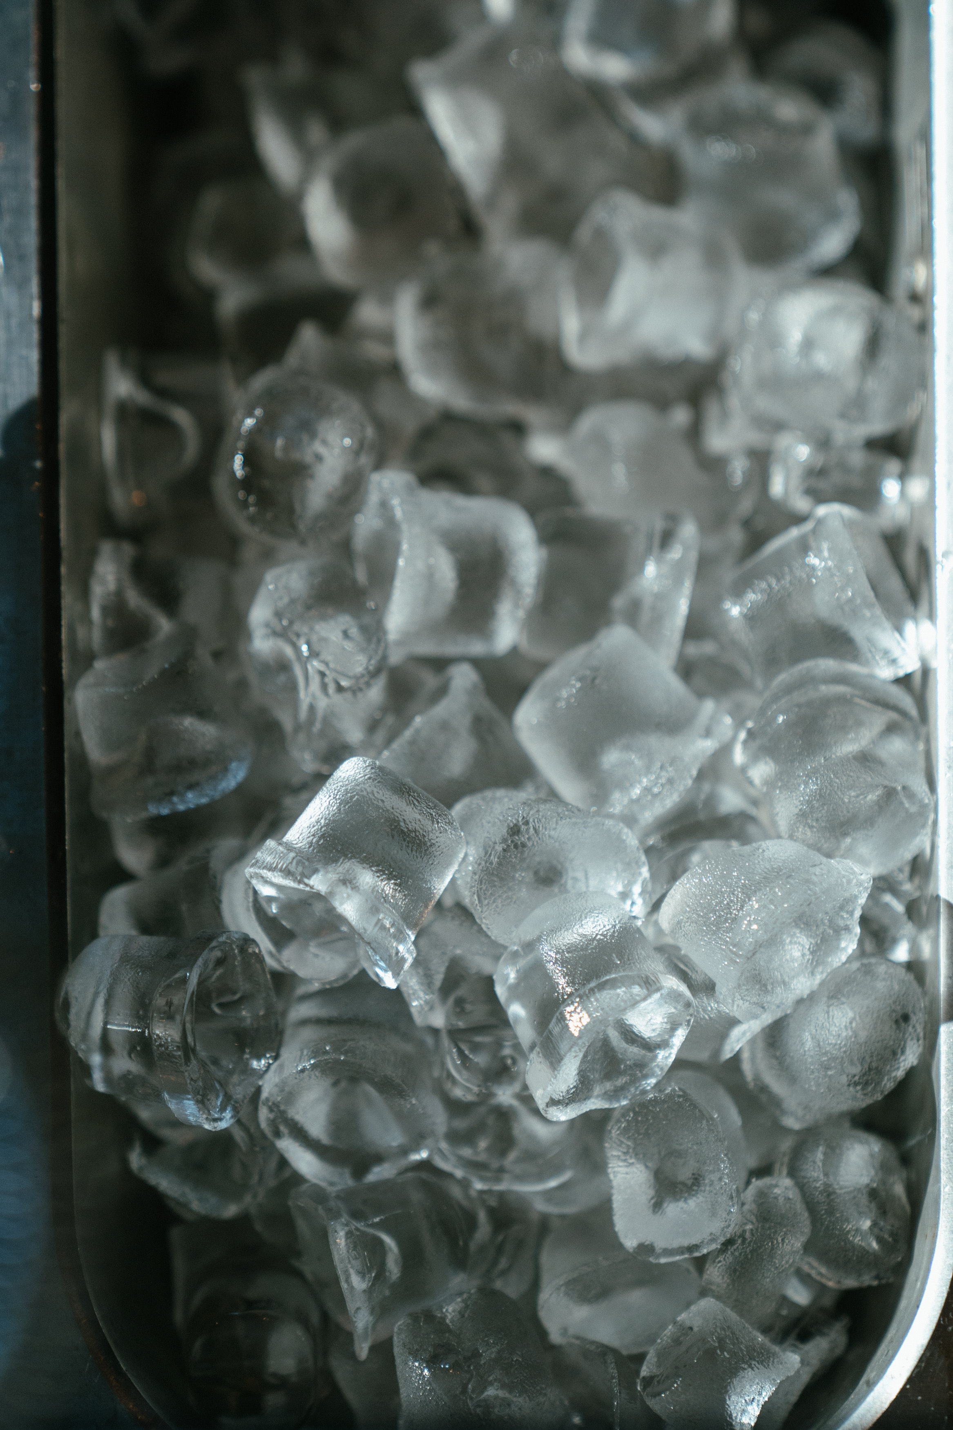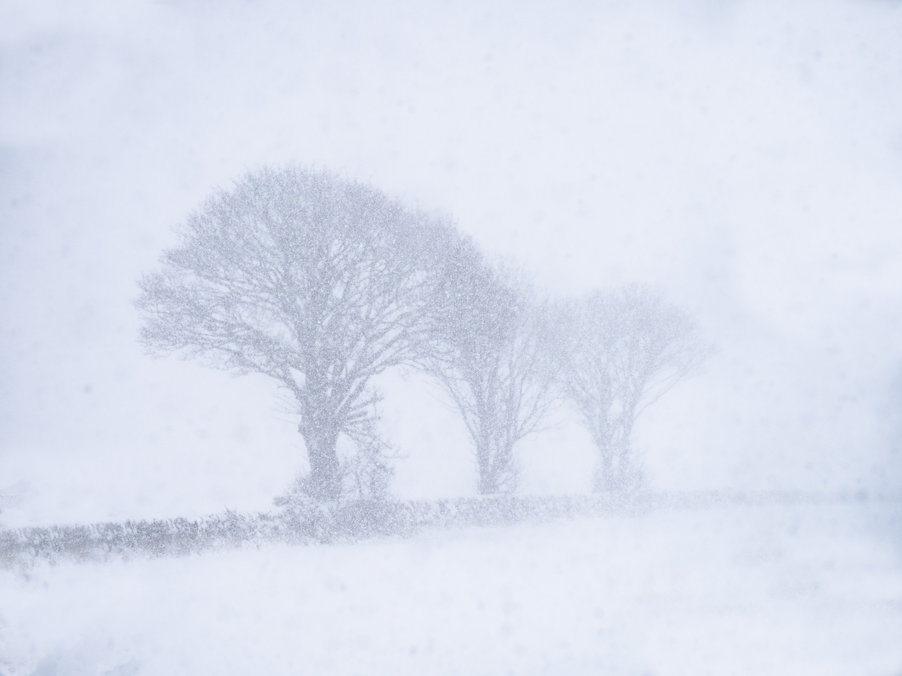
A timely series of experiments – at the time of writing anyway.
Snow and ice are something that, like water, we take very much for granted – at least in winter. But in fact they are fascinating substances in their own rights and well worth investigating..

Experiment 1 – How much air is in snow?
Even though snow is made of ice crystals (frozen water), because of the way it gently settles on the ground, a lot of air gets trapped in the structure, You can easily demonstrate this.
You will need
A jug (or other container) with volume markings on | snow

Procedure
- Fill your jug to a known volume mark with snow – don’t pack it in, just collect it and smooth off the top a little. Make a note of the volume
- Leave it somewhere warm enough to melt.
- Measure the volume now?
You will see that the volume of water is much less than the snow was to start with.
Extensions
You can see if the density of the snow changes with time. As it sits, snow often compresses under its own weight, squeezing out the air. So take samples on successive days from the same place and see if there is a difference
If you have snow on more than one day, see if they are the same. The size and shape of snow crystals varies hugely so snow that falls on one day can pack very differently from that which falls on another. Take samples from each fresh snowfall and see if they are the same.

Experiment 2 - de icing
You will have seen people putting salt on the paths and lorries spreading it over the roads but does it actually make any difference?
You will need
An ice-cream tub (or any container) | snow
A measuring jug/cylinder | Salt, sugar, baking soda etc
A sieve (maybe)

Procedure:
- Put some snow into your container – if you are doing more than one, make sure as far as possible that you have the same amount and you arrange it in the same way – don’t spread it out in one and pile it up in another.
- Leave it for a while (it will depend on the temperature, the amount of snow and many other factors) and watch what happens.
- Pour the snow/slush into a sieve over a measuring jug and see what volume of water you have. (You might be able to do it without a sieve).
- Now repeat the experiment but this time sprinkle a teaspoon of snow over the top (or any size spoon – as long as you keep the same one for all your tests).
- Leave it for the same length of time and measure the water again. Is it the same?
Extension
You can try again with other things: sugar, baking soda, bath salts etc. Do these have any effect? If so are they better or worse than the salt.

Experiment 3 – Looking at ice cubes.
Have you ever wondered why ice cubes are usually ‘cloudy’ even though they come from clear water?
In fact, it’s all down to bubbles.
You will need
An ice-cube tray | Samples of water
A pan and access to a cooker | Access to a kettle
A freezer (or a cold night!)

Procedure
- Put some water in a kettle and bring it to the boil. Some cold water, water from the kettle and some of the boiled water from the pan into compartments in the tray and put in the freezer 9or leave outside).
- Then put some more water in a pan and bring that to the boil – keep this boiling for 10 minutes.
- Now put some of your tap water, your water from the kettle and your water from the pan into a tray and put it in the freezer.
- Leave it overnight and see what has happened – you should find that the water that was boiled for the longest makes much clearer ice – boiling water drives out dissolved gases which will otherwise form bubbles.
Extensions
Try using mineral water (or perhaps de-ionised water from a garage) and see if there is any difference.
Add a small amount of salt to the water – does it still freeze? Try different amounts – how much ice needs to be added to stop it freezing?

Experiment 4 – Ice and the Mpemba effect.
In 1963 a 13 year old schoolboy, Erasto Mpemba, popularised this effect, which had been known since ancient times.
Hot water will freeze faster than cold water – it seems counterintuitive and, to be fair, there is a significant amount of disagreement – see what you can find out.
You will need
An ice-cube tray – or water bottles | Samples of water
Access to a kettle (or a pan and cooker | A freezer (or a cold night!)

Procedure
- Take one sample of water at room temperature and put into a bottle or some of the compartments of the ice tray.
- Boil the kettle and while it is still hot (being careful not to scald yourself) fill another bottle or the rest of the ice cube tray
- Put the tray/bottles in the freezer – or leave outside in the cold – check from time to time and see which freezes first.

Experiment 5 – Supercooling
Strange though it might seem, it is possible to get water below zero degrees celsium and not have it freeze.
This is know as supercooling
You will need
Water bottles | Samples of water
A freezer (or very cold weather).

Procedure
- Fill your bottles with water – do several as not all will work.
- Put them in the freezer - or freezer compartment of the fridge – for at least three hours.
Don’t leave it too long though – a freezer will get down to -18°C and at that temperature the water will certainly have turned to ice. In 3-5 hours (usually) the water temperature should be a few degrees below zero
- Take your bottles out – carefully. If one is still liquid bash it down on the work surface or give it a quick shake.
You should see that the whole of the bottle of water turns solid in only a couple of seconds and the supercooled water turns to ice.

The reverse phenomenon is called superheating. Water can get over 100°C without boiling.
This can happen in a microwave and it can be dangerous as when you take the cup out, the whole of the water can boil at once and splash out over your hand causing a nasty scald.
Don’t be tempted to try this.

Extensions
You can try leaving it for different lengths of time to see what is best. Ideally, use a thermometer to see what the actual temperature is.
A similar phenomenon is how hand warmers work. They are filled with supercooled sodium acetate solution – which is actually at room temperature. There is a clicker in the packet and the shockwave this creates sets off the solidifying – in this case the process is exothermic.

