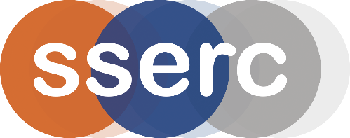
SSERC Risk Assessment (revised version March 2018)
(based on HSE’s INDG 163 ‘Risk assessment - A brief guide to controlling risks in the workplace’)

2 Pitreavie Court, South Pitreavie Business Park, Dunfermline KY11 8UU
tel : 01383 626070 e-mail : enquiries@sserc.org.uk web : www.sserc.org.uk

Activity assessed | Alkali metals in water
Date of assessment | 24th March 2014
Date of review (Step 5)
School
Department

Step 1 | Step 2 | Step 3 | Step 4
List Significant hazards here: | Who might be harmed and how? | What are you already doing?  What further action is needed? | Actions
 |  |  | by whom? | Due date | Done
Sodium and potassium in particular are reactive metals and will react violently with water. | Demonstrator during preparation. Demonstrator or audience during demonstration by explosion of wetted metal (especially sodium) | Wear eye protection.  Handle sodium with forceps or tongs.  Keep well away from water or aqueous solutions.  Replace lid on jar immediately after piece to be used has been extracted.  Do not use too large a piece.  Ensure water is cold – ideally chilled

Description of activity:

Small pieces of alkali metals are added to cold water and the effect observed.

Additional comments:

Do NOT use too large a piece. No more than about 3mm on each side.

At the end, all equipment (tile scalpel etc) can be placed in the water trough to remove any small pieces that might have stuck to them.

