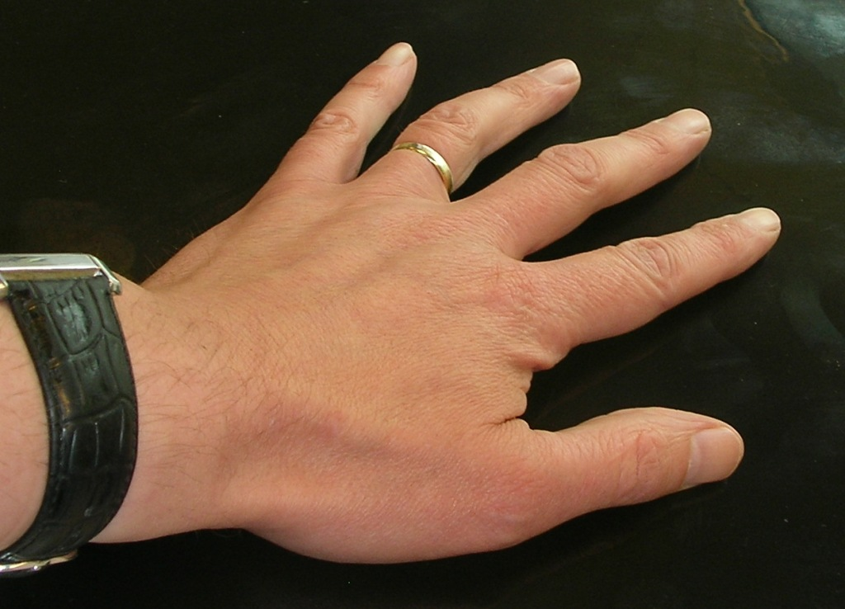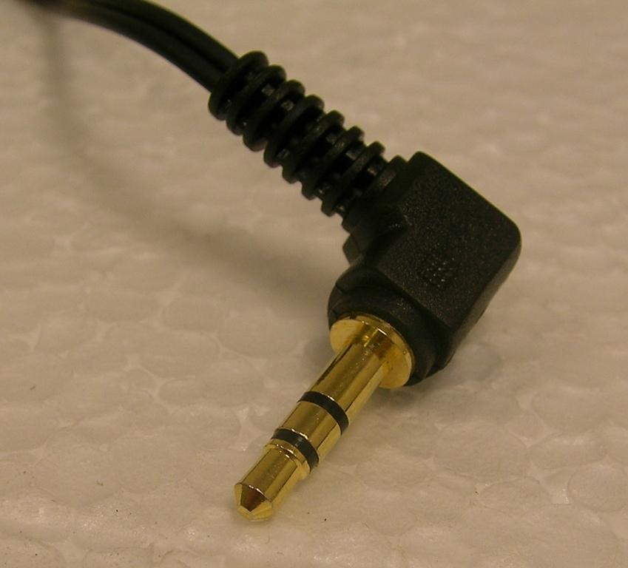

Headphone jack plugs are made of steel because steel is a metal and all metals conduct electricity.

# Properties of Metals

All metals share certain properties. This means that they all have some things in common. For example, they all conduct electricity.

Here we are going to look at a metal with an unusual property.

The metal is called nickel-titanium or NiTi for short. It is sometimes called shape memory alloy.

What is an alloy?

Things to talk about, think about and research.

What could NiTi be used for?

**What to do:**

* Boil the water in the kettle. If you don’t have a kettle, your teacher may ask you to heat up water in the beaker using a Bunsen.
* While the water is heating up, bend the copper and NiTi into shapes.
* Make sure everyone in the group is wearing safety glasses.
* Fill the beaker about two thirds full of recently boiled water.
* Use the tongs to drop the bent wire into the hot water.
* Watch carefully what happens.
* If you would like to try again, fish the wire out of the beaker with the tongs. It should be cool enough to touch in 30 seconds.
* In your group, decide how you could describe the property of NiTi you have observed.

Why is NiTi sometimes called ‘Muscle Wire’?

Why does it behave this way?

# Safety!

* Wear safety glasses when pouring hot water.
* Use tongs for lifting wire in and out of the beaker.
* The outside of the beaker will get hot.

NiTi and copper wire

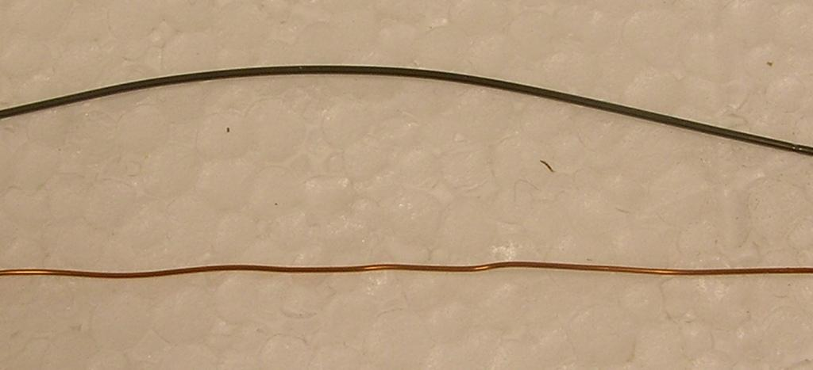

**What you need:**

10 cm length of copper wire, 10 cm NiTi wire, medium-sized beaker, kettle of water, tongs, safety glasses

**What to do:**

* The hot water should not be much above 60°.
* Pour the granules into the hot water.
* Leave the granules in the water until they have turned clear.
* Fish the granules out with the tongs.
* Carefully begin moulding the polymer. It may contain pockets of hot water. Let it drip for a bit.
* Polymorph turns white when set. It can be remoulded as often as you wish.

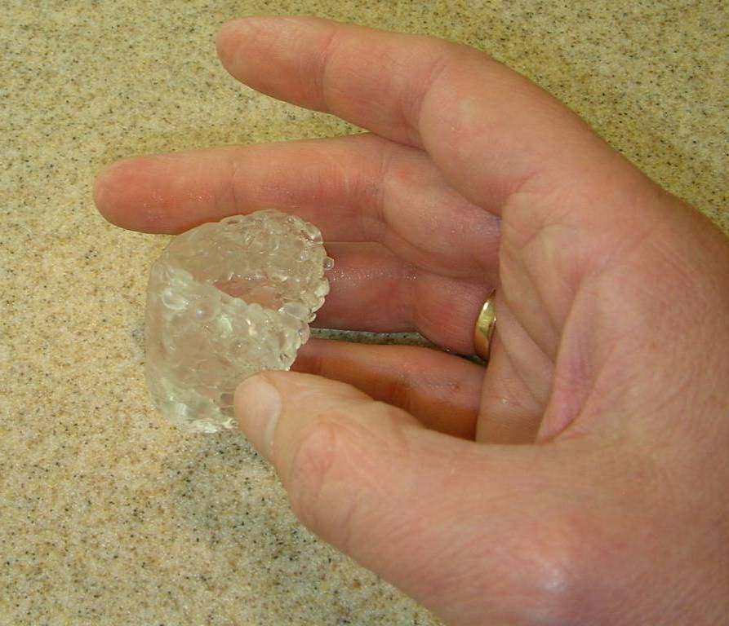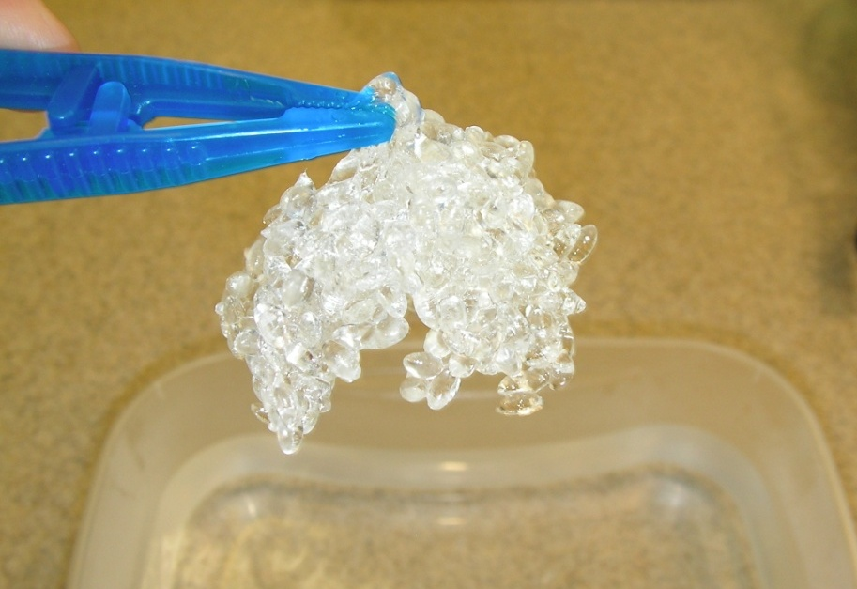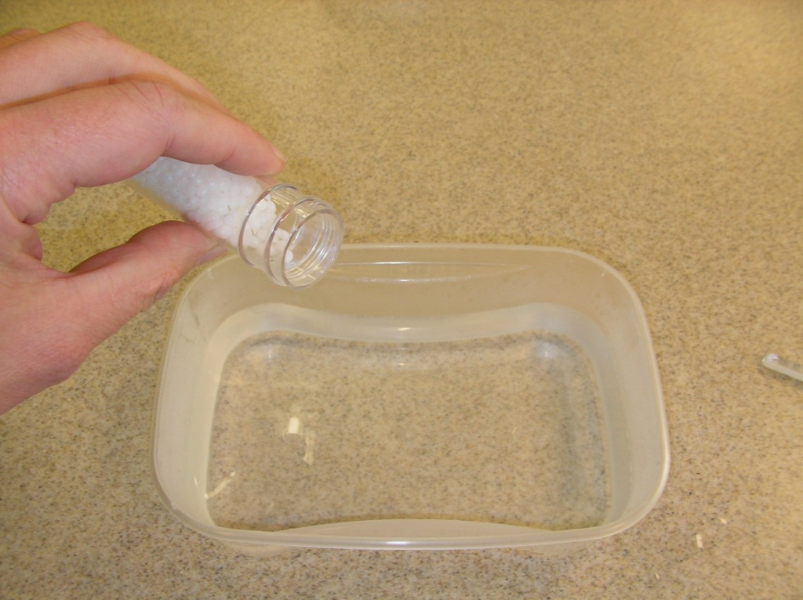

**What you need:**

Polymorph granules, tweezers, tub of hot water, thermometer to check temperature (optional)

# Polymorph

Polymorph is a plastic than can be moulded at low temperatures.

# Safety:

* Do not use boiling water.
* **Be careful when beginning to mould the polymer. It tends to be a bit sponge-like when fished out the tub and may contain pockets of hot water.**
* Do not mould the polymer around body parts.

NiTi and copper wire



**What you need:**

Strip of shape memory polymer, tub of very hot water, tweezers.

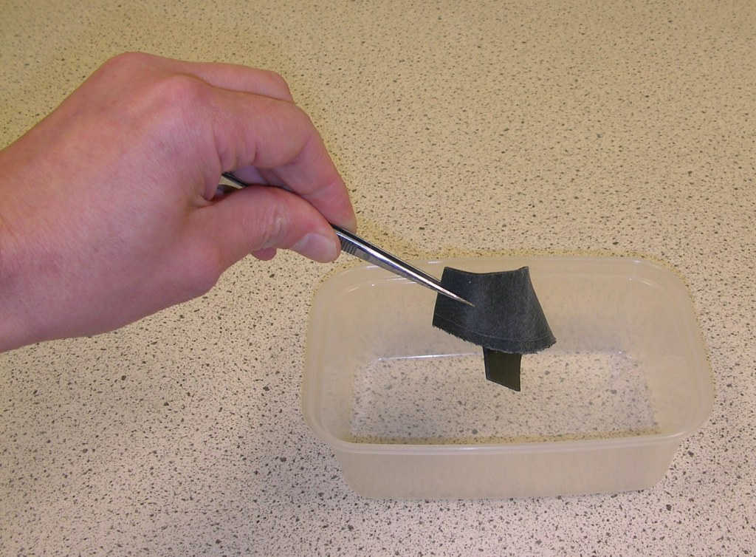

# Safety

* Take care to avoid splashes or spills when using boiling water.

**What to do:**

* The water in the tub should be freshly boiled.
* Place the strip of polymer into the tub and leave it for several seconds.
* Remove the polymer using tongs.
* Reshape the polymer.
* It is probably best to replace the water with freshly boiled water again. Place the reshaped polymer into the very hot water and observe the results.

# Shape memory polymer

This plastic can be easily shaped when warmed. When placed in very hot water, it returns to its original shape.

# Safety:

* The resistance wire will become hot.

**What to do (1):**

* Place your hand on the thermochromic film for a short time.
* Remove your hand and look at the film.

**What to do (2):**

* Connect the resistance wire (it is attached behind the thermochromic film) to the power supply.
* Place the thermochromic panel in its stand.
* Turn the power supply down.
* Switch on the power supply.
* Gradually increase the output of the power supply.
* Observe the thermochromic panel.

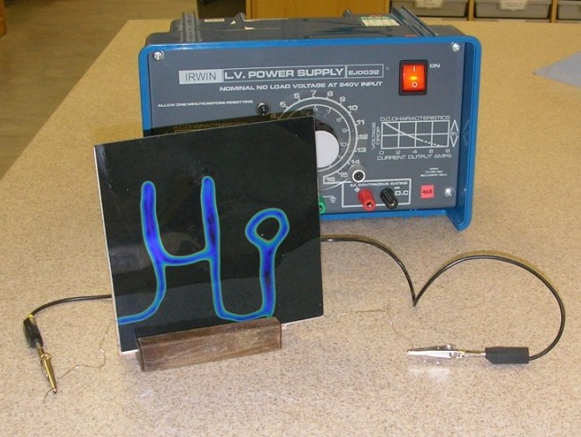

**What you need:**

Sheet of thermochromic film, power supply, sheet with film and resistance wire.



# Thermochromic film

This film changes colour according to temperature.

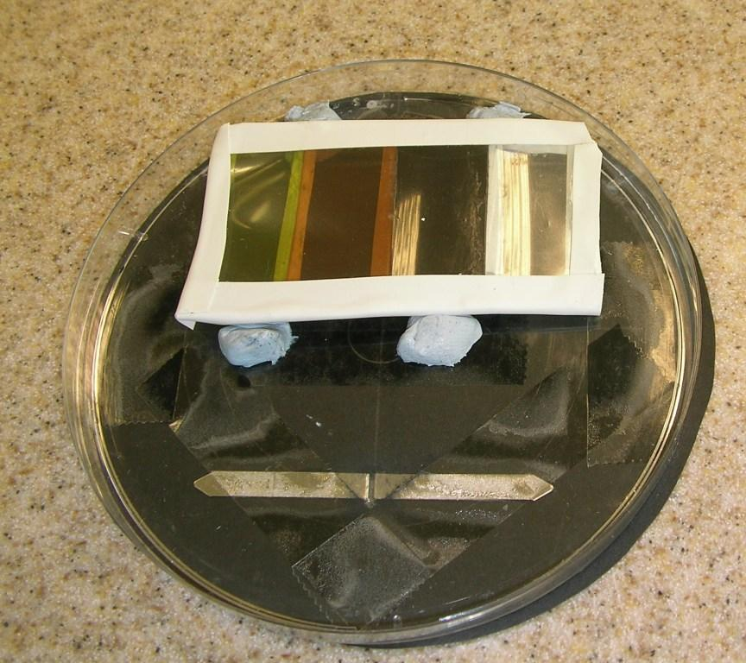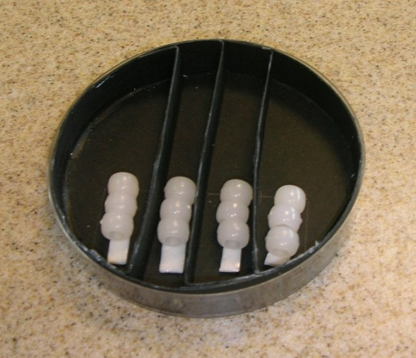

# Safety:

* Avoid looking directly at the UV light.
* Avoid unnecessarily irradiating your skin with UV.

# Ultraviolet (UV) sensitive beads.

These beads are sensitive to ultraviolet light and turn vivid colours when exposed to sunlight or artificial sources of ultraviolet radiation. When removed from UV, they revert to white. Here, we use them to test which colour of plastic would be most suitable for a bottle containing medicine that was unstable in UV light.

**What to do:**

* Stick the strip of coloured plastic to the inside of the UV kit lid, over the “window” cut into the card.
* Put the lid on the kit.
* Open the card window to check that there is a row of beads under each strip of coloured plastic.
* Close the window. Wait a couple of minutes if the beads had any remaining colour.
* If using sunlight, go outside. Open the card window and expose the beads to sunlight through the different plastics.
* If using a lamp, clamp the lamp above the open card window. Switch the light on. Note the safety advice. Expose the beads to UV through the coloured plastics.
* After a couple of minutes, have a look at the beads. Which plastic blocked the UV most effectively?

You may have to experiment with the exposure time to be able to compare the plastics effectively.

**What you need:**

UV bead kit, strip of different-coloured plastics, UV lamp, clamp stand.

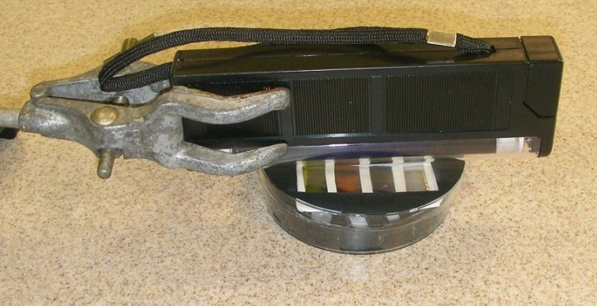

# Note:

A commercial product, D3O®, has similar properties. It is built into some brands of motorcycle and ski clothing to give impact protection whilst till remaining flexible.

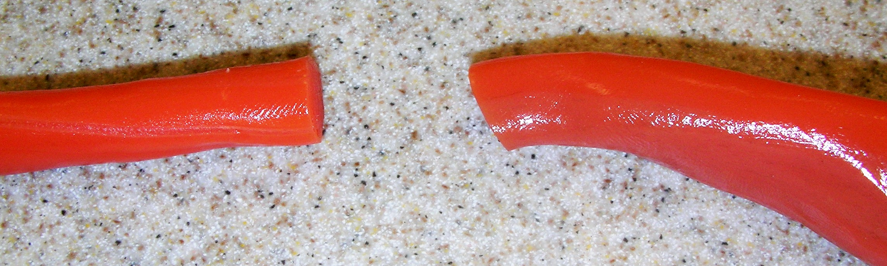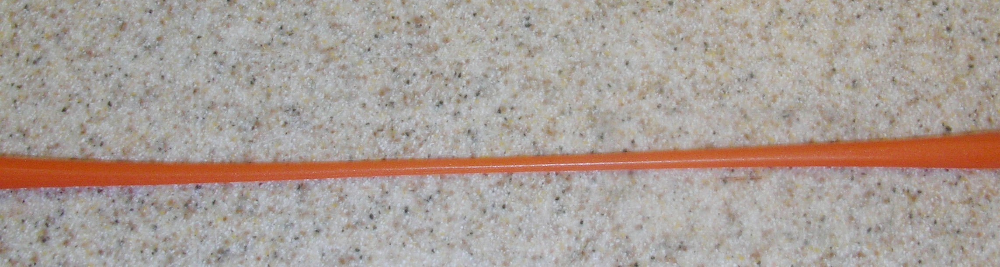

**What to do:**

* Roll out the smart putty into a snake shape.
* Hold an end in each hand.
* Slowly pull the ends of the smart putty.
* Repeat, but give the ends a sharp tug.
* Now roll the smart putty into a ball.
* With due consideration to those around, throw the ball at the floor or wall.

**What you need:**

Piece of smart putty

# Smart putty

Smart putty is thermochromic and shear thickening.