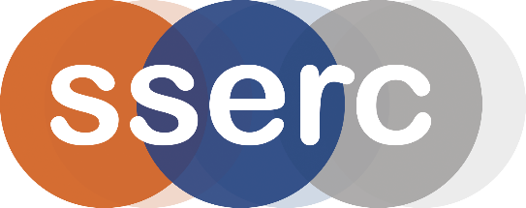
SSERC Risk Assessment (revised version March 2018)
(based on HSE’s INDG 163 ‘Risk assessment - A brief guide to controlling risks in the workplace’)

2 Pitreavie Court, South Pitreavie Business Park, Dunfermline KY11 8UU
tel : 01383 626070 e-mail : enquiries@sserc.org.uk web : www.sserc.org.uk

Activity assessed | Shape Memory Alloy
Date of assessment | 30th June 2020
Date of review (Step 5)
School
Department

Step 1 | Step 2 | Step 3 | Step 4
List Significant hazards here: | Who might be harmed and how? | What are you already doing?  What further action is needed? | Actions
 |  |  | by whom? |  | Due date |  | Done
Nickel is a sensitizer  Risk no greater than handling nickel-alloy coin, therefore users need only be made aware of the fact that nickel is a sensitiser | Teachers, technicians, pupils. | Gloves can be made available to those affected.
Scald from hot water. (slight) | Teachers, technicians, pupils. | Tongs provided to remove wire from very hot water.
Burn from electrically-heated wire when ‘training’ the metal. | Teachers, technicians, possibly pupils. | Warn users not to touch wire when current is present and for a minute afterwards (0.006 mm wire) or 2 minutes (0.8 mm wire). Jig for thicker wire labelled with warnings.
Facial / eye injury from ejecting smart wire  Occurs occasionally when wire is shaped then placed in a small beaker of very hot water- as it straightens, it can fly out of the beaker. | Teachers, technicians, pupils. | Wear eye protection.

Description of activity:

The wire described here is an alloy of nickel and titanium.

- A 10 cm piece of 0.8 mm smart metal is shaped by hand the dropped into very hot water. It straightens out.

- A 20 cm piece of 0.8 mm smart wire or a 30 cm length of 0.006 mm smart wire is trained to remember a shape by being heated electrically to a high temperature for a few minutes whilst constrained in a jig. The wire is allowed to cool then is reshaped by hand. It is then placed in a trough of very hot water.
Additional comments:

