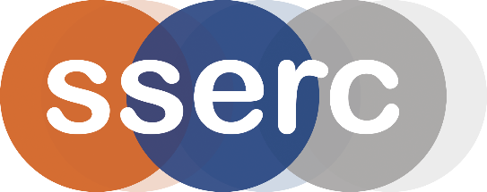
SSERC Risk Assessment (revised version March 2018)
(based on HSE’s INDG 163 ‘Risk assessment - A brief guide to controlling risks in the workplace’)

2 Pitreavie Court, South Pitreavie Business Park, Dunfermline KY11 8UU
tel : 01383 626070 e-mail : enquiries@sserc.org.uk web : www.sserc.org.uk

Activity assessed | Salts of strong and weak acids
Date of assessment | 30th June 2020
Date of review (Step 5)
School
Department

Step 1 | Step 2 | Step 3 | Step 4
List Significant hazards here: | Who might be harmed and how? | What are you already doing?  What further action is needed? | Actions
 |  |  | by whom? |  | Due date |  | Done
Universal indicator is flammable. | Demonstrator/audience by ignition. | Keep away from sources of ignition.

Description of activity:

Samples of sea water (either genuine or made to a recipe) and tap water have universal indicator added. The demonstrator blows into both flasks simultaneously, using a T-piece.
The tap water goes yellow much faster than the sea water due to the buffering action of the carbonate/hydrogen carbonate system in sea water.
Additional comments:

Sea water is slightly alkaline (about pH 8-8.5) so it will be a darker green. For a more convincing demonstration, adjust the colour of the tap water by adding 1 or 2 drops of very dilute NaOH or Na₂CO₃.

