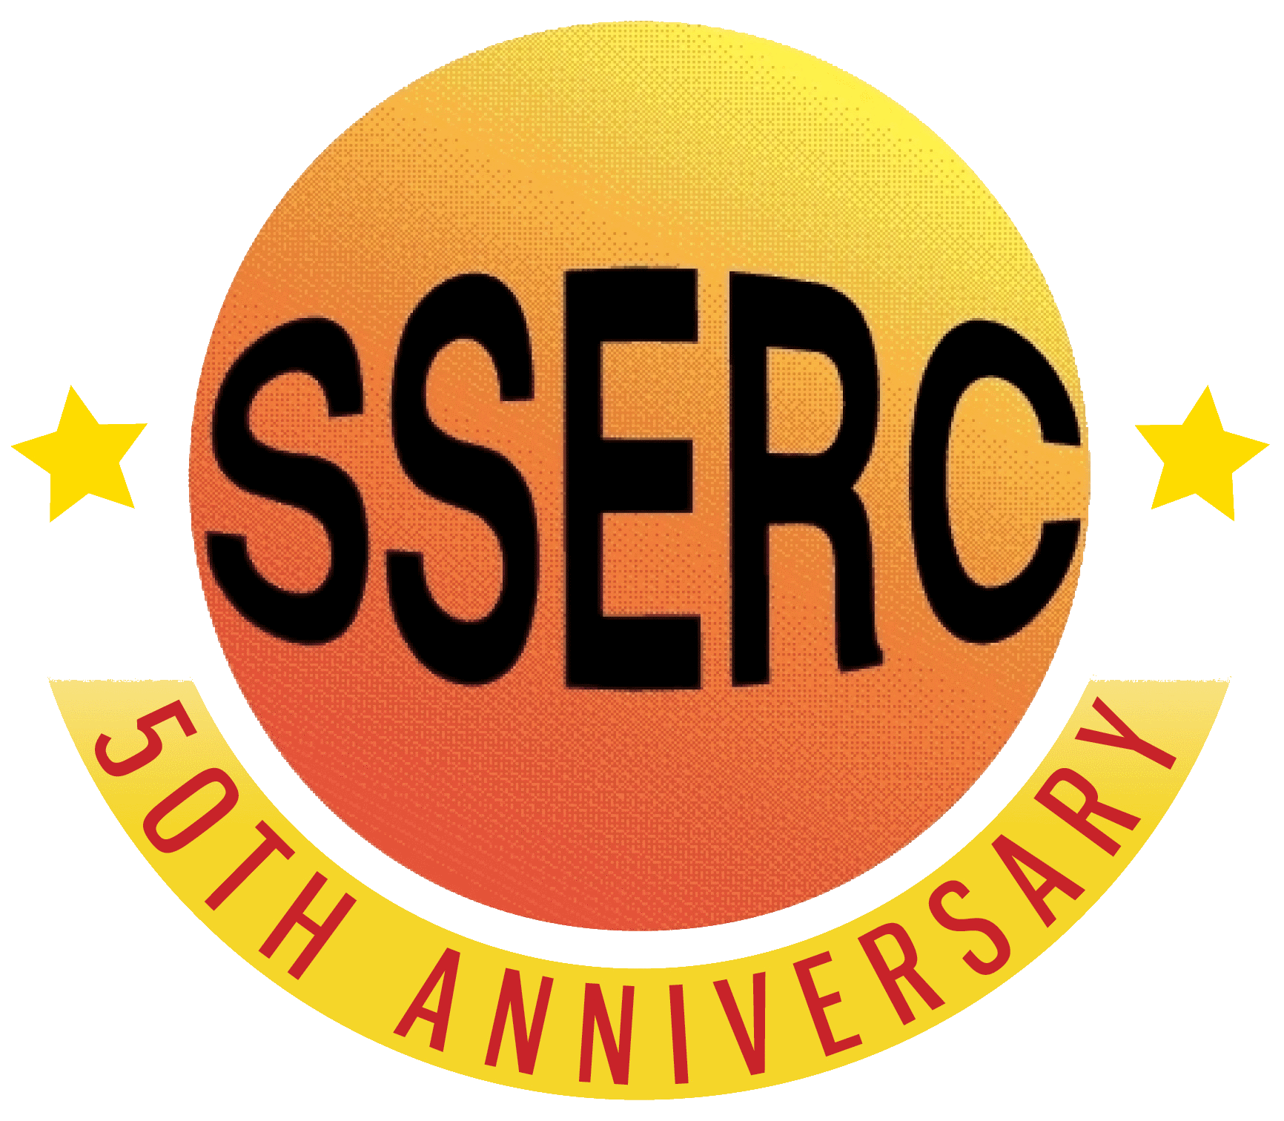

Food Chemistry
Maillard reaction

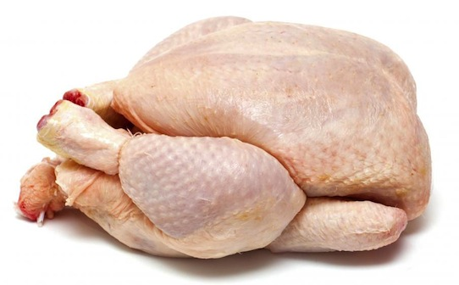
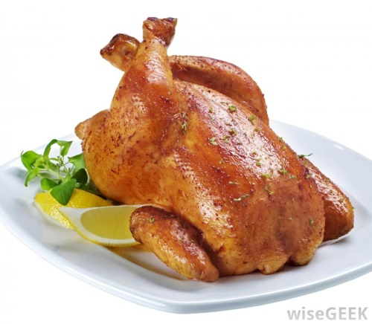

CfE Level 3
Through experimentation, I can identify indicators of chemical reactions having occurred. I can describe ways of controlling the rate of reactions and can relate my findings to the world around me.
SCN 3-19a
CfE Higher – Nature’s Chemistry
The Chemistry of cooking
Introduction
Under certain conditions, reducing sugars may react with compounds bearing a free amino group and undergo a sequence of reactions known collectively as the Maillard reaction.
As a part of this, alpha-dicarbonyl compounds produced in the Maillard reaction can react with amino acids and produce aromatic pryazines. At the same time brown melanoidins are produced so the Maillard reactions has an effect on both colour and aroma of foods.
The series of reactions is extremely complex. A simplified (believe it or not) schematic is shown below.
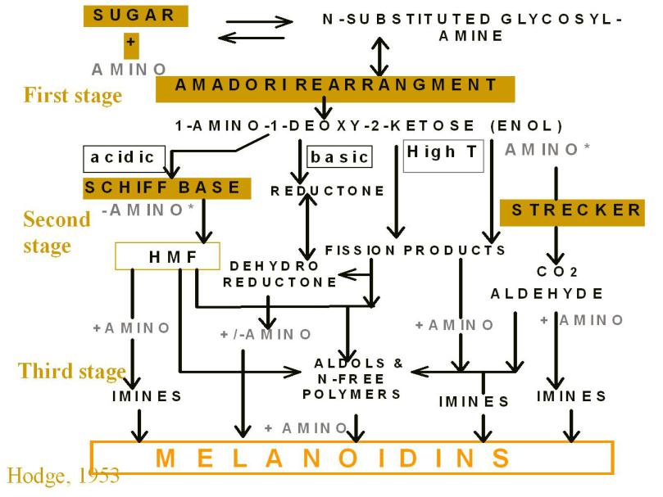
According to This model, the Maillard reaction has three stages.
- the carbonyl group of a sugar reacts with an amino group on a protein or amino acid to produce water and an unstable glycosylamine.
- the glycosylamine undergoes Amadori rearrangements to produce a series of aminoketose compounds.
- a multitude of molecules, including some with flavour, aroma, and colour, are created when the aminoketose compounds undergo a host of further rearrangements, conversions, additions, and polymerizations.

History of the Maillard reaction
Even though the reactants are fairly simple, Maillard chemistry was so complicated and produced so many products—hundreds of them—that the research world largely ignored it until around the time of World War II.
At this time, the military became interested in producing on an industrial scale food that both was palatable and had a long shelf life. Because the Maillard reaction is responsible for the appealing aromas of freshly cooked food as well as some of the unwelcome ingredients in processed or long-stored food, scientists began to seriously study the reaction.
Then in 1953, an African American chemist named John E. Hodge, who worked at the U.S. Department of Agriculture in Peoria, Illinois, published a paper that established a mechanism for the Maillard reaction. Maillard discovered the reaction, but Hodge understood it. In fact, because citations of Hodge’s paper far outnumber those of Maillard’s, there has been some discussion of renaming it the Maillard-Hodge reaction.

Note:
Browning due to the Maillard reaction should not be confused with other types of browning.
Caramelisation – This occurs when polyhydroxycarbonyl compounds (sugars, polyhydroxycarboxylic acids) are heated to relatively high temperatures in the absence of amino compounds.This type of browning characteristically requires more energy to get started than the carbonyl-amino reactions, other conditions being equal.
Enzymic browning– This is the group of oxidative reactions which, for example, convert ascorbic acid and polyphenols into di- or polycarbonyl compounds. These oxidations may or may not be enzyme-catalyzed (See enzymic browning factsheet).
(Not all of these oxidative reactions are in fact enzyme catalysed but they are all grouped together here for simplicity)

Some examples of Maillard reactions
Raw food | Cooked food
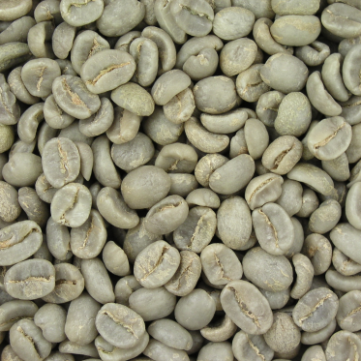 | 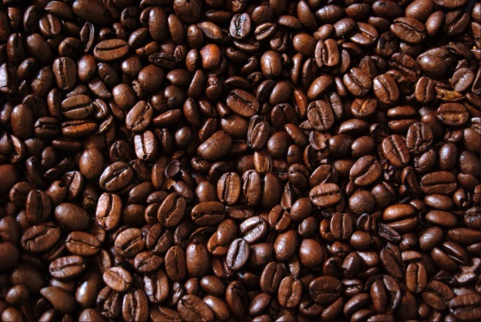
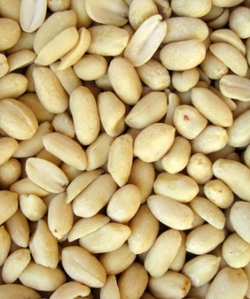 | 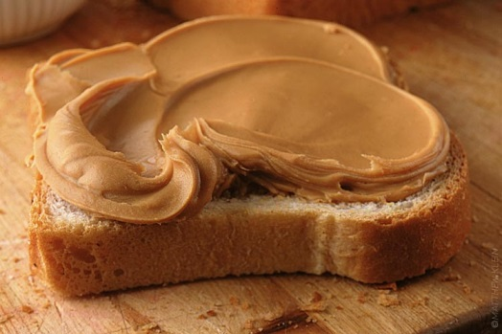
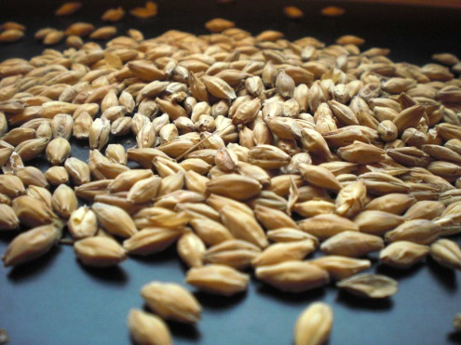 | 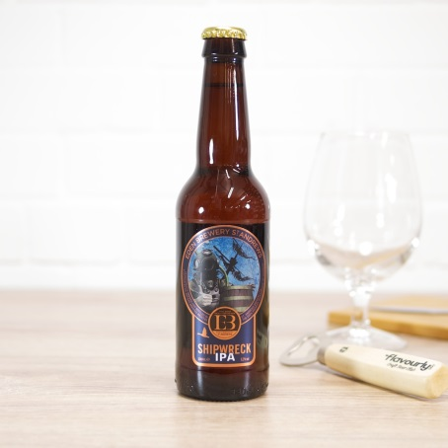
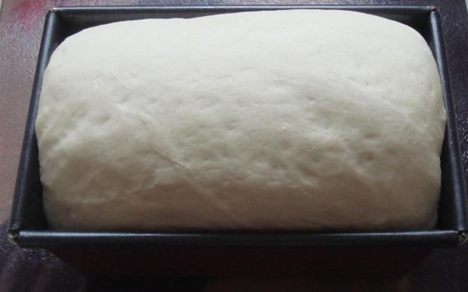 | 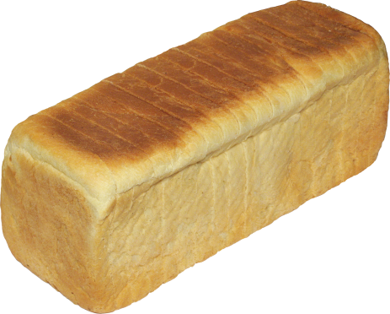
The experiment
The objective of this exercise is to evaluate the aroma and colour of heated amino acid-glucose solutions.
You will need
D-glucose | L-Amino acids (6 or so different ones)
Test tubes | Boiling water bath
Sodium carbonate* | Aluminium foil
Access to a 2dp balance | spatula

* the Maillard reaction occurs more rapidly in alkaline conditions so the sodium carbonate is added to speed things up.
Procedure
- To 0.05 g of d-glucose in a test tube add 0.05 g of an amino acid
- Add 1.0 ml of distilled water. Mix thoroughly. Cover the top with aluminium foil.
- Repeat for all your other amino acids
- Smell each mixture and record any sensations.
- Place a piece of heavy aluminium foil over each test tube top and heat the solutions in a water bath at 100°C. You will rapidly start to see some of the tubes develpping a yellow-brown colour. L
- Leave the tubes in the water bath for 10 – 15 minutes. Remove them and allow to cool a little. Then examine them.

Your results
Qualitative
- Record the odour sensations for each solution (e.g. chocolate-like, potato-like, popcorn-like).
- Record the colour as 0 = none, 1 = light yellow, 2 = deep yellow, 3 = brown.

Quantitative
- Dilute your solutions to 5 cm³ with distilled water.*
- Transfer 3 cm³ of each sample to a cuvette and use a colorimeter to determine their absorbance at 400 nm. (Blue LED on the mystrica colorimeter)
* some of them, such as arginine and lysine may need to be diluted more, possibly quite a lot more.

Health & Safety
All the reagents are of low hazard.

Technicians’ Guide
Each group will need
D-glucose | L-Amino acids (6 or so different ones)
6 - Test tubes (or so – one for each amino acid) | Boiling water bath – very hot rather than actually boiling will do.
Sodium carbonate* | Aluminium foil
Access to a 2dp balance | spatula

J. Agric. Food Chem.1953, 1, 928.

