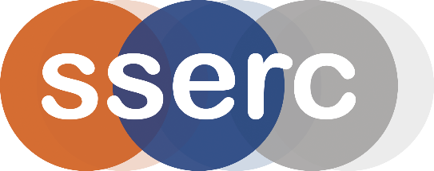
SSERC Risk Assessment (revised version March 2018)
(based on HSE’s INDG 163 ‘Risk assessment - A brief guide to controlling risks in the workplace’)

2 Pitreavie Court, South Pitreavie Business Park, Dunfermline KY11 8UU
tel : 01383 626070 e-mail : enquiries@sserc.org.uk web : www.sserc.org.uk

Activity assessed | Light Sticks
Date of assessment | 30th June 2020
Date of review (Step 5)
School
Department

Step 1 | Step 2 | Step 3 | Step 4
List Significant hazards here: | Who might be harmed and how? | What are you already doing?  What further action is needed? | Actions
 |  |  | by whom? |  | Due date |  | Done
Unless the light sticks are broken, this activity is of negligible hazard

Description of activity:

Light sticks are activated and then placed in hot and cold water to show the different brightness.
Additional comments:

