How to run Tracker in a browser
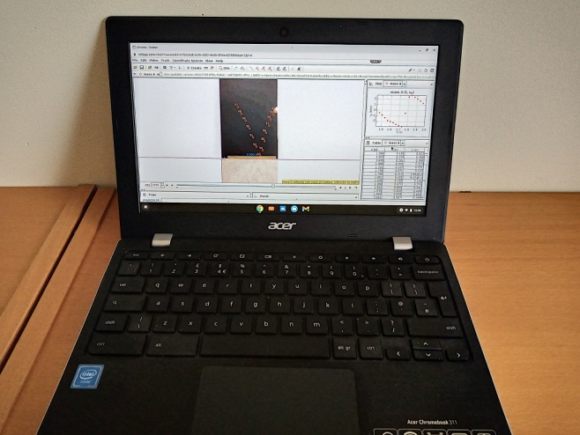
Figure 1 – tracker on a Chromebook
There are versions of Tracker for Windows, OSX (Mac) and Linux [3]. At this point, we can almost feel the frustration emanating from some of you. We know that getting software installed on school computers can be difficult. We are aware of one department that took pendrives home and installed Tracker directly on to them. Tracker could then be run from the pendrives when they were inserted into school machines. This does not work for every school. Furthermore, many schools have now moved to Chromebooks.
The following solution may work for schools where either Chromebooks are in use or installing software on laptops and desktops is not possible. It has its limitations but we have had some success with it.
Visit the Rollapp website [4]. Rollapp allows certain applications to run in a browser, including Tracker and another physics education favourite, Audacity. If you opt for the free Rollapp service you will encounter the following limitations:
- You cannot save your work (surprisingly not such a big deal as far as Tracker is concerned, in our experience).
- Uploading files to analyse is a bit of a pain.
When go to the Rollapp Tracker page you will see a button marked Launch Online (Figure 2).
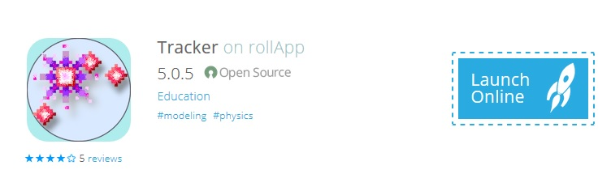
Figure 2 – Launch Online
You will now be taken to a screen that gives you the option of signing up or logging in. If you haven’t signed up beforehand, you’ll have to do that now.
Once you have signed up and logged in you may be met with a screen that entices you to upgrade to a less limited version of Tracker. Ignore this and click on Launch Tracker with limited capabilities.
Normally, to analyse a video or image in Tracker you would go to the menu Video and select Import (Figure 3)
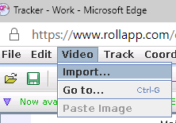
Figure 3
You would then navigate to that file on your computer. With Rollapp, you need to upload the file first.
When you select Import... you should see a pop-up (Figure 4).
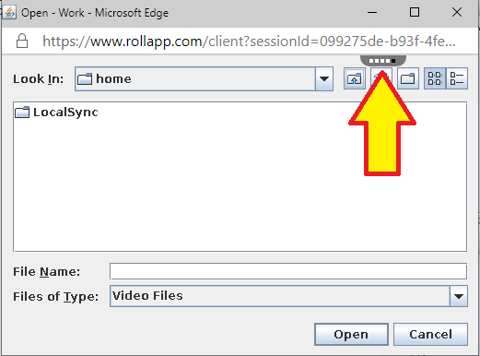
Figure 4
Look for the wee dots (see the arrow in figure 4) and hover your mouse pointer over them (Figure 5).
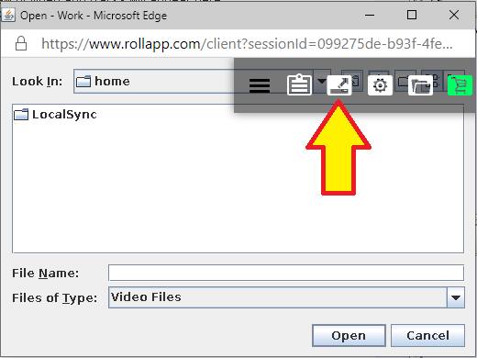
Figure 5
Select the icon indicated by the arrow in Figure 5.
You will then be able to navigate to the file on your computer that you would like to upload. Once uploaded, it is placed in the LocalSync folder, available any time you use Rollapp. You can also link cloud storage such as Onedrive or Googledrive to your Rollapp account. We did so with Googledrive, but set up a bespoke account solely for use with Rollapp as the permissions the platform was asking for made us emit an abrupt squeak.
At the end of this article we will tell you how to find out more about using Tracker.
Alternatives to Tracker
If you have an Android tablet or phone, or can run Android apps on your Chromebook, you might like to check out a motion analysis app called Vidanalysis. It is not as sophisticated as Tracker but is still useful, especially if you can use a mouse or trackpad rather than a touch screen with your device. For iPad users, there is Vernier Video Physics. This is a paid-for app that is reasonably slick. You can find out more in our apps guide [5] or by signing up to our Mobile Devices self-study course [6].
Learning more about Tracker
You can find out how to carry out many different activities by working through the documents on out Tracker section of the SSERC website: [7] or you can sign up for a self-study course [8]. Feel free to share the materials with your students. Both the webpage and the course include sample videos and images.
[3] https://physlets.org/tracker/ (accessed November 2020)
[4] https://www.rollapp.com/app/tracker (accessed November 2020)
[5] https://www.sserc.org.uk/wp-content/uploads/2013/07/All_apps_iOS_Droid.doc (accessed November 2020) Some of the apps, including the SSERC speed camera app, mentioned in this document are no longer on the Play Store. We may be able to help you obtain them. Please get in touch.
[6] https://www.sserc.org.uk/professional-learning/secondary-clpl/physics-clpl/mobile-devices-self-study/ (accessed November 2020)
[7] https://www.sserc.org.uk/subject-areas/physics/physics-higher/tracker-easy-motion-analysis-and-more/
[8] https://www.sserc.org.uk/professional-learning/secondary-clpl/physics-clpl/tracker-self-study

