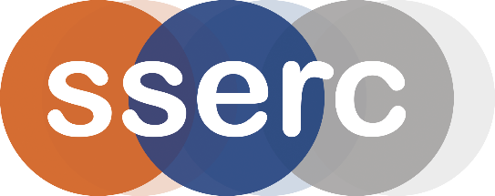
SSERC Risk Assessment (revised version March 2018)
(based on HSE’s INDG 163 ‘Risk assessment - A brief guide to controlling risks in the workplace’)

2 Pitreavie Court, South Pitreavie Business Park, Dunfermline KY11 8UU
tel : 01383 626070 e-mail : enquiries@sserc.org.uk web : www.sserc.org.uk

Activity assessed | Gloopy and Gooey
Date of assessment | 3rd February 2020
Date of review (Step 5)
School
Department

Step 1 | Step 2 | Step 3 | Step 4
List Significant hazards here: | Who might be harmed and how? | What are you already doing?  What further action is needed? | Actions
 |  |  | by whom? |  | Due date |  | Done
Copper sulphate is harmful if swallowed and corrosive to eyes | Technician preparing solutions. | Avoid raising dust. Wear goggles (EN 166 3)
Sodium tetraborate is a reproductive toxin. | Technician preparing solutions. | Avoid raising dust. Wear gloves and eye protection.
Reaction mixtures can cause irritation | Demonstrator / audience | Avoid handling too much (wear gloves if appropriate) and If spilled on skin, wash off with copious amounts of water.

Description of activity:

- Gaviscon is squirted from a syringe into copper sulphate solution. The alginates in GavisconTM are cross-linked by the Cu⁺⁺ ions to form a polymer.
- Borax solution is mixed with PVA to make a slime.
Additional comments:

