Science investigation

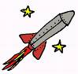

Fizz Pop Rockets – Teacher Guide

Investigating a chemical reaction using fizz-pops
It is a good idea to laminate all cards to make them less consumable!
Background:
The chemicals in effervescent vitamin C tablets from Boots react together in the presence of water to produce a gas. If the chemical reaction is done in a capped film container, the pressure of the gas becomes great enough to blow off the lid of the container.

Setting the scene:
Explain that these vitamin C tablets react in water to produce a gas.
Demonstrate the reaction as follows, ensuring the ‘rocket’ is not underneath any light fittings:
Using either the measuring cylinder or the syringe, measure out 20 cm³ of water from a beaker into one of the cans. Add a vitamin C tablet and quickly place the cap on the container. Quickly invert it and place it in the large plastic container (saves a lot of mess!) After a short time the ‘fizz-pop’ rocket will launch. It has been known to reach the ceiling.
Now discuss timing the reaction. How could inaccuracies between mixing the reactants (when timer should be started) and getting the lid on be reduced? Try by Q & A to steer them towards keeping the ingredients apart until the can is inverted. This may even help to identify pupils who are working at a higher level. Hopefully (or maybe you have eventually prompted them) they will come round to the idea of the tissue paper.
Now repeat the experiment but place a sheet of toilet tissue over the mouth of the can and make a small well in it after you have added the water. Now add the tablet to the paper, place the lid on the can and invert as before. The water will soak through the tissue paper allowing the ingredients to react.

Possible variables to investigate:

- Surface area
- Temperature
- Concentration

Four dependent variable readings should be recorded for each investigation to enable data to be plotted.
Divide the class into groups of 8 - 10 students and issue Investigation Cards and set task.
Now issue each student with a Planning Sheet. Stress each member must record the decisions made by the Group and that the work of each Group must be checked after Part 1 (this is so you, the teacher, can ensure they are on the right track to carry out an investigation of a functioning variable).
Discussion with pupils is vital, not only to ascertain their level of understanding, but to possibly direct them to ways of changing the variables.
It also gives you an opportunity to discuss the work with groups and to direct them as needed, and to ensure all conditions are being tested. Encourage group discussion to involve all students.

It is a good idea to open discussion of results to the whole class and introduce the idea of reliability from repetition of experiments.
After discussion to confirm pupils have grasped what is required, the teacher should divide each of the groups into three, with one group going on to investigate the temperature variable another investigates the effect of surface area while the third investigates the effect of concentration i.e. the lesson could develop as follows:
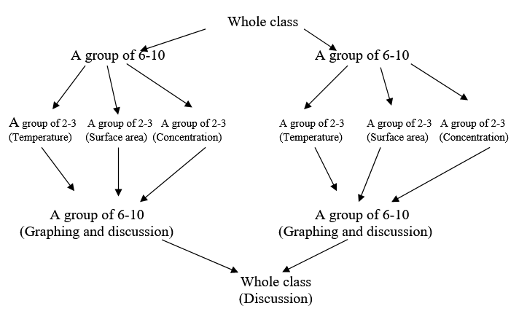

Depending on the time available and the class, the whole group could investigate all the values of their variable. Alternatively, each student in a group could experiment with 1 value only of the variable and results pooled. This would still give a total of four results to enable a graph to be plotted.

Pupil Apparatus needed

Vitamin C tablets (effervescent type) | A selection of plastic 35mm film cans with lids
Small measuring cylinders or some 5 cm³ and 20 cm³ syringes | Eye protection
Stop clocks or other suitable timers | Some large basins or plastic containers
A polybag with some sheets of toilet paper | A container of distilled water
A selection of 100 cm³ beakers | Water (cold and hot)
Spatulas | Mortars and pestles
Lemon juice | Blutack
thermometer | Pupil Investigation Cards

Surface area pupil instructions

What you do:
- Measure out 5 cm3 of water and place it in the film can.
- Stick some ‘blue tack’ to the lid of the can.
- Press the tablet into the blue tack until it sticks.
- Place the lid on the can, quickly invert it and place it in the basin.
- Start the stop clock at the same time.
- Time how long it takes for the ‘rocket’ to be launched.
- Repeat the experiment three more times with fresh water but with a tablet cut in half, then into three and finally into quarters -making sure to stick the whole tablet to the blutack so the amount is the same.

Surface area hints:
The surface area can be increased by first using a whole tablet, then one cut in half then one cut into quarters and finally by using one powdered up in a mortar and pestle.
The labels ‘whole’, ‘halves’, ‘quarters’, ’powder’ can be used as an indication of increasing surface area when plotting the data as a Bar Graph.

Temperature pupil instructions
What you do:
- Stick some ‘blue tack’ to the lid of the can.
- Press the tablet into the blue tack until it sticks.
- Measure out 5 cm3 of water and place it in the film can. Measure and record its temperature.
- Place the lid on the can, quickly invert it and place it in the basin.
- Start the stop clock at the same time.
- Time how long it takes for the ‘rocket’ to be launched.
- Repeat the experiment three more times with fresh water with fresh water but at three different temperatures. (e.g. 40°C, 30°C and 20°C)

Temperature hints:
Heat enough of water to use in all four experiments
Do not heat to more than 50 ⁰C
Use the syringes to transfer the hot water to the film can and allow to cool down to the desired temperature before adding the tablet.
(Purists may wish to take the average of the starting and finishing temperatures as being the reaction temperature but this is not really necessary. Good results can be obtained using only the starting temperatures).

Concentration pupil instructions

What you do:
- Measure out 5 cm3 of water and place it in the film can.
- Stick some ‘blue tack’ to the lid of the can.
- Press the tablet into the blue tack until it sticks.
- Place the lid on the can, quickly invert it and place it in the basin.
- Start the stop clock at the same time.
- Time how long it takes for the ‘rocket’ to be launched.
- Repeat the experiment three more times with fresh water but with half a tablet, then a third and finally a quarter.
Concentration hints: Can be varied by using a whole tablet, then a half, then a quarter etc.
Some of these variables produce difficulties in measuring. This is a good opportunity for discussion of the shortcomings of the experiment

