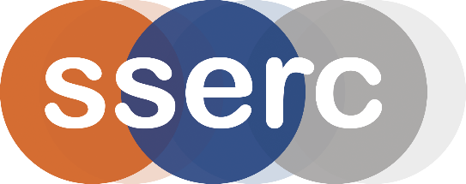
SSERC Risk Assessment (revised version March 2018)
(based on HSE’s INDG 163 ‘Risk assessment - A brief guide to controlling risks in the workplace’)

2 Pitreavie Court, South Pitreavie Business Park, Dunfermline KY11 8UU
tel : 01383 626070 e-mail : enquiries@sserc.org.uk web : www.sserc.org.uk

Activity assessed | Turning Copper coins to Silver and Gold
Date of assessment | 30th June 2020
Date of review (Step 5)
School
Department

Step 1 | Step 2 | Step 3 | Step 4
List Significant hazards here: | Who might be harmed and how? | What are you already doing?  What further action is needed? | Actions
 |  |  | by whom? |  | Due date |  | Done
Sodium hydroxide and the 6M solution are both corrosive | Technicians, demonstrator and audience by splashes. | Wear goggles (EN166 3) and nitrile gloves.  If spilled on skin, wash off immediately with copious amounts of water.
Zinc powder is highly flammable | Technicians, demonstrator and audience. | Keep containers tightly closed and dry.  Remove sources of ignition.

Description of activity:

Sodium zincate is prepared by dissolving zinc in sodium hydroxide and then a copper coin is held in the hot solution, zinc-plating it (silver)]
The coin is then heated causing copper and zinc to combine into brass (gold)
Additional comments:

There is a much safer version of this that doesn not use concentrated sodium hydroxide – see microscale zinc plating

