Sanitising of equipment in Science & Technology
As a result of the latest (Oct 30th) Scottish Government guidance, there is no specific requirement to quarantine jotters or other equipment between uses and so this guidance (which was included in previous iterations of SSERC’s guidance document) is currently less relevant but it could still be useful.
Books
Any unnecessary resource sharing including textbooks should be avoided, especially where this does not contribute to education and development. This is another example of where use of electronic media may preferable. Where possible:
- Let learners have their own copy of any textbooks or other physical resources. If this is not possible then, like library books, they should be quarantined for 72h on their return before being issued to anyone else.
- Distribute scans of instruction sheets and/or display on boards rather than hand out individual copies.
- Where possible get learners to submit work electronically rather than on paper / in jotters etc.
This will include any equipment or machinery with keyboards, touchscreens or control panels that are likely to be used by more than one person.
If equipment has not been used for 72h or more, there should be no problem with virus on the keys. So, if users wash their hands properly before using them, there should be no contamination issues.
However . . .
It would be sensible to make sure that the keyboards are properly cleaned before term starts, just to be certain you have a good baseline standard of cleanliness. Harmful microbes (and not just coronavirus) cling to dirt, so if your device looks dirty, it really is.
Use a damp, soft, lint-free cloth to wipe away as much visible dirt as possible before any sterilisation. You may need to do this more than once. Keep going until you are satisfied it is properly clean. Use a toothpick on any areas where grime can build up.
To disinfect computers, just like anything else, you need an alcohol-based disinfectant with at least 60 percent ethanol (or 70 percent isopropanol.) You can use aerosols, pump sprays, or wipes, whichever you prefer, just make sure they contain the necessary amount of alcohol.
Because alcohol evaporates quickly, you can spray your gadgets just leave them to dry. This is easy to do regularly. If you need to rub with a cloth, where possible, use wipes or paper towels you can dispose of when you are finished.
N.B. Alcohols are highly flammable and so should never be sprayed where there is a source of ignition – such as an item of electrical equipment that is plugged in.
Remember that if you are using compressed air cans to clear dust out, they can damage laptops and other all-in-one devices.
If there are any difficult to reach cracks etc., you can use a sharp (but not too sharp) object, like a wooden toothpick, to dislodge any dirt without causing damage to the device.
Computers
You need to be more careful with laptops than desktop models because the computer’s main components are underneath the keyboard and thus more susceptible to damage.
Before you clean it, make sure your laptop is completely powered off and unplugged to avoid any serious damage. For a desktop you can simply unplug the keyboard and mouse to clean rather than power down completely.
For a laptop, let it dry for a few minutes so the alcohol has time to evaporate before you turn it on again.
Keyboard
As described above, use a damp, soft, lint-free cloth to get the whole of the keyboard as clean as you can. Once all dirt has been removed, wipe all the keys and the rest of the keyboard with alcohol wipes and leave to dry.
The gaps between the keys on most laptops are small to prevent dirt and dust from getting in there. However, these small gaps still collect dirt from your fingers, so pay attention to them while you are cleaning.
Mice
Again, use a damp, lint-free cloth to clean your mouse the best you can and dislodge any obvious dirt. Inspect your mouse if you did not get it all the first time, disinfect any dirty areas again.
Now disinfect with an alcohol spray or wipe. If you are using a spray, leave for a few minutes, and then wipe off any remaining grime with a clean paper towel or cloth.
If your mouse is wired, you can also clean the length of the cord and USB connector with a bit of alcohol.
Touchpads
As for the other devices, wipe down thoroughly with a damp (not wet) soft, lint-free cloth to remove as much dirt as possible. Do this more than once if you need.
Use a toothpick to clean any grooves or gaps. Then, using alcohol spray or wipes, thoroughly disinfect the whole of the trackpad and the area to the left and right of the trackpad, where your hands normally rest.
Touchscreens
As for trackpads, wipe the screen with a lint-free cloth (microfibre ones are good for screens). Then disinfect using alcohol spray or wipes as before.
Prevention of contamination
In some cases, it is possible to prevent contamination by:
Using a device such a pencil to press a button rather than a finger – though if the pencil has been in someone’s mouth, this is not a good idea.
Placing a protective covering over the surface. Some surfaces, especially things like touchscreens can easily be covered by e.g. clingfilm. A dispenser can be placed close by a section torn off before each use and disposed of immediately afterwards. The pictures below show examples for a laboratory balance and an iPad.

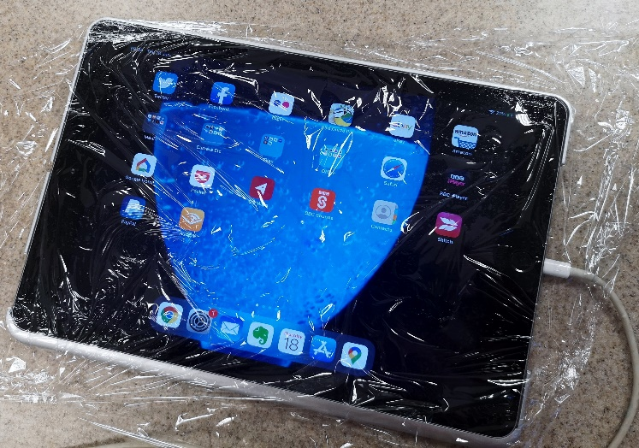
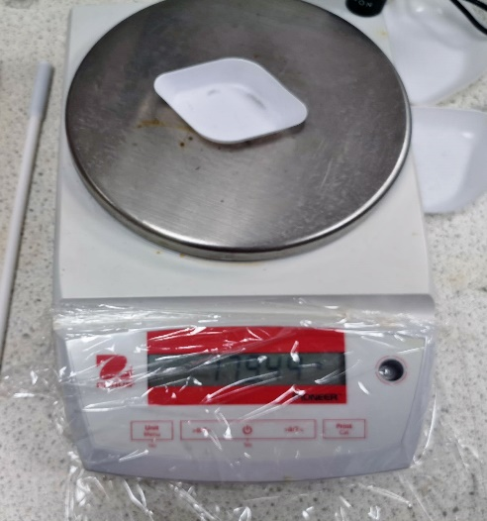

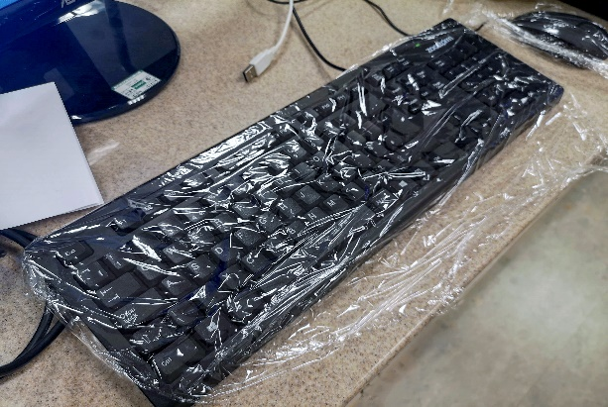
It is trickier, but still works, to do the same for a computer keyboard – as shown in the picture to the right.
A computer mouse work even less well so is probably not worth trying. If there is a scroll wheel, this will snag the clingfilm.

