Disinfection and Eye Protection
Eye protection is not a particular problem per se but an issue arises when items are used by more than one individual – as is nearly always the case.
There are two main approaches to be taken here: reduce sharing and instigate disinfection.
Reducing sharing
There are a few approaches, some or all (or none) of which might be worthwhile trying.
- Remodel as many practicals as possible so that they either do not need eye protection at all or they can be done with safety specs rather than goggles (as these are easier to disinfect – see below).
Eg 2 mol l⁻¹ sulphuric acid is corrosive but 4mol l⁻¹ hydrochloric acid is only irritant.
- Try to adjust the programme so that classes that do need eye protection, or need specific eye protection, do not require it all at the same time, or immediately before/after others.
- If possible try to assign a pair of goggles/spectacles to an individual learner – at least for a particular unit/spell of work. That way there will be no need for disinfection between them
Sanitise between uses
Safety spectacles are quite straightforward as they can be wiped (or dipped) in their entirety and will dry quickly but they are not suitable for all experiments.
Goggles are generally more difficult. The plastic facepiece can easily be wiped with alcohol (>60%), Hydrogen peroxide (3%/10vol) or Milton’s* and will dry quite quickly. Be careful with any that have metal parts as bleach (and particularly Milton’s as it contains sodium chloride as well) can cause them to corrode.
* Instead of Milton’s, a dilute solution of bleach can be used: normal ‘thin’ bleach diluted 1:100.
The main problem with disinfecting goggles between uses though is the fact that the straps take a long time to dry.
There is, however, a possible solution – for some designs at least. You can have individual straps for each student and then the plastic facepieces can be wiped/washed like safety spectacles and they will easily dry.

For each student you will need:
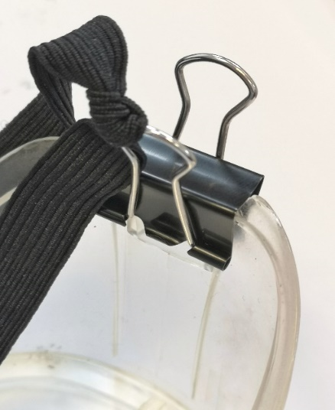
- A length of elastic. This can be purchased quite inexpensively in bulk from Amazon or haberdashery stores and cut to length – about 12mm wide is a common width but check the straps on your current goggles.
- 2 bulldog clips – check the size on your particular goggles before you order them.
- A small plastic bag (ziplock type)
On first use, each pupils works out the length and ties each end to a bulldog clip (as shown right). Thy can adjust the length to get it firm enough before getting properly tight.
Once done, they simply use their goggles as normal.
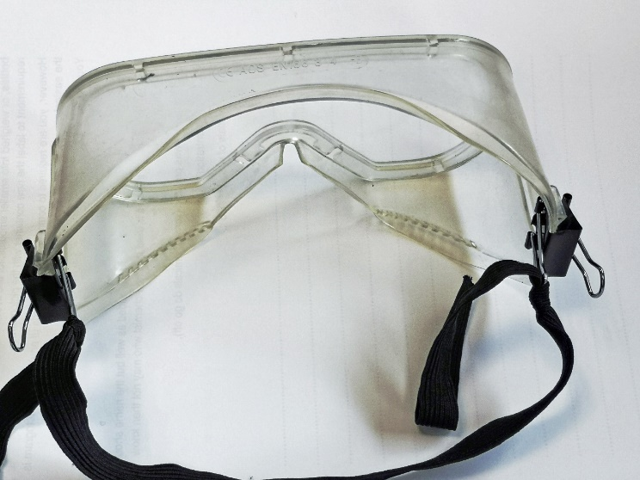
At the end of the lesson:
Each student unclips their strap from the goggles.
The strap goes into a ziplock bag with their name on and this stays in the lab.
The plastic facepiece is handed in and can be wiped down with eg alcohol which will dry quickly – or soaked in Milton’s to be left overnight.
When the next group need goggles, they are handed the bag with their strap in it, they fix it to the frame and get on with their experiment

