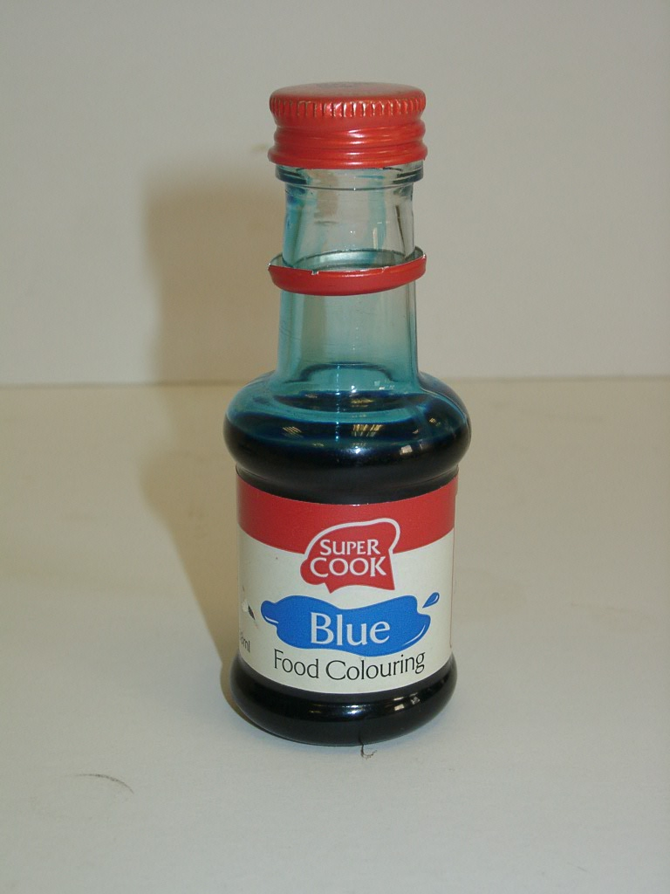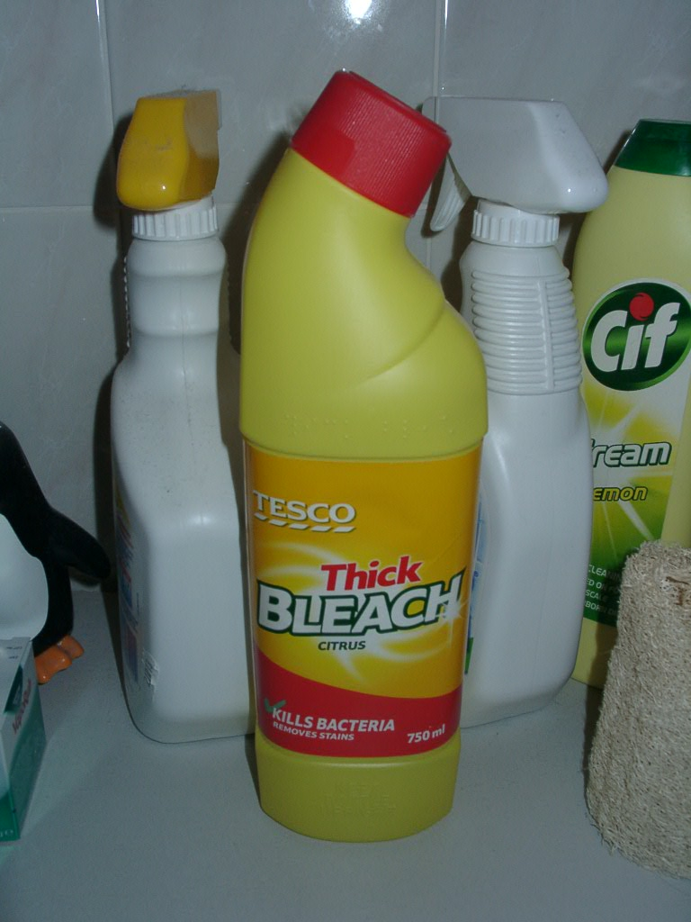

Technician’s Guide

Technician Guide

You need:

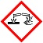Bleach, household (corrosive) | Blue food colourant (Dr Oetker extra strong food colour gel)
Sodium chloride | Colorimeter
Cuvettes | Timer
Graduated pipettes (1ml)

Preparation of bleach solution
Dilute the bleach to 25% of its original concentration.

Preparation of the blue dye solution
Add 4 drops of the blue food colourant to 100ml of distilled water (if the food colouring is not extra strong, more drops may be required).
(This should give a %T colorimeter reading of roughly 7% with the red filter).

Preparation of the sodium chloride solution (equimolar to the bleach)
Dissolve 4.124g sodium chloride in approximately 30ml of distilled water and make up to 100ml using a standard flask.

Hazards and control measures

Chemicals and Procedures | Main Hazard | Control Measures
Bleach 5.25% (m/v)  i.e. 0.705M NaOCl | Corrosive | Wear plastic gloves and indirect vent goggles.
Colorimeter | Electrical | Check that colorimeter has been PAT tested before use, plus visual check of cables.

