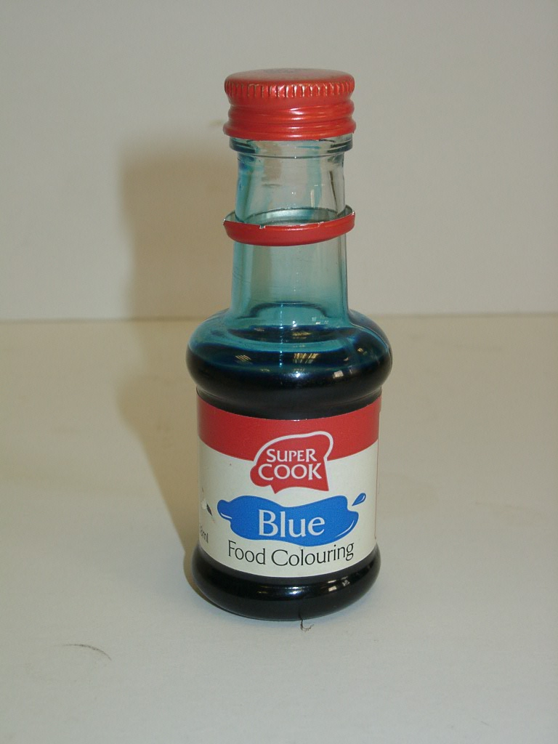

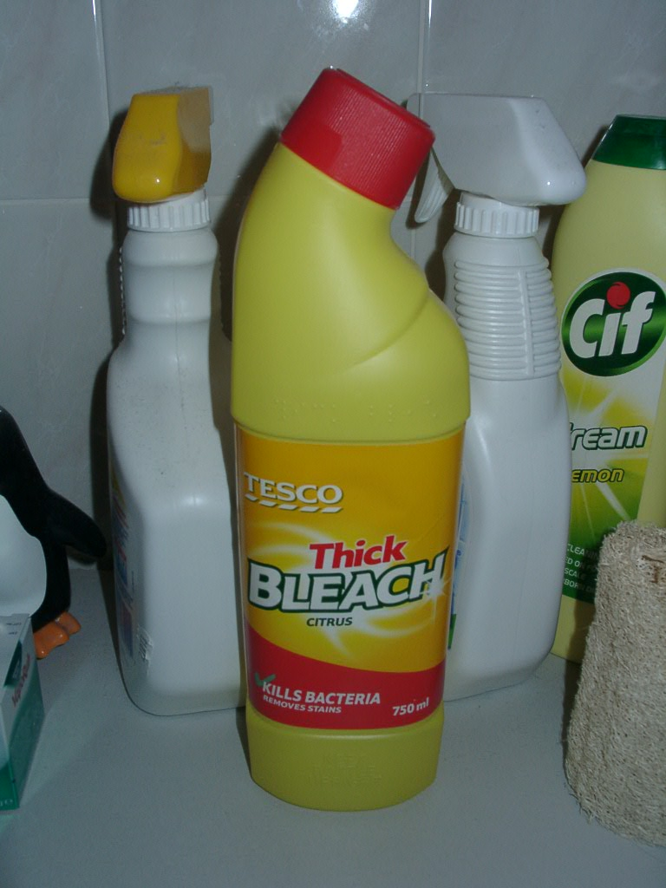

Experimental Guide

Bleach is well known to decolourise the blue dye in jeans and shirts.
The aim of this experiment is to calculate the rate constant for the reaction between a household bleach and a blue food colourant, using:

Rate = k [blue dye]ª [bleach]^{b}
and determine the order of reaction with respect to the dye (a) and the bleach (b).
Most blue food colourants used in cookery contain the dye E133 (brilliant blue) which decolourises when oxidised.
Household bleach is an aqueous solution of sodium hypochlorite, 5.25% NaOCl (m/v).

Hazards and control measures

Chemicals and Procedures | Main Hazard | Control Measures
Bleach 5.25% (m/v)  i.e. 0.705M NaOCl | Corrosive | Wear plastic gloves and indirect vent goggles.
Colorimeter | Electrical | Check that colorimeter has been PAT tested before use, plus visual check of cables.

Introduction
In these experiments household bleach decolourises a solution of blue food dye within about ten minutes. The overall rate equation is:
Rate = k [blue dye]ª [bleach]^{b}
The rate of dye decolouration can be followed using a colorimeter, and by applying the Beer-Lambert Law the concentrations of dye can be calculated.
From these results, the rate constant for the reaction (k), and the orders of reaction (a and b) can be determined.
Instructions

These instructions are for the Mystrica colorimeter. The principles hold for any other make though. (If being carried out manually, leave out steps 2 – 6)

- Switch on the colorimeter. It may need to warm up before use.
Set it to the nearest value to 630nm and check for zero absorbance using a blank cuvette containing only distilled water. (If using a Mystrica Colorimeter, select the red filter – which is 630nm)
- Set up your colorimeter to take continuous readings (if possible)
- Measure 2 cm³ of blue dye solution into a cuvette using a 3 cm³ pasteur pipette.
- Add 1.0 cm³ of bleach to the cuvette. Quickly put the lid on, invert to mix the solutions, and put the cuvette into the colorimeter.
- As soon as the cuvette is in the colorimeter, press start on the logging program Follow the reaction for ten minutes by recording the absorbance of the solution at one minute intervals.
- Repeat the procedure but this time add 0.5 cm³ of distilled water and then 0.5 cm³ of bleach*

* For exactness, in the second experiment 0.5 cm³ of equimolar sodium chloride solution should be used instead. This will maintain a constant ionic strength as well as constant volume and for the two experiments. In reality, the difference is negligible.
The absorbance values are used to calculate the concentrations of the dye. The calculation uses the molar absoptivity value of the blue dye which is quoted as being
1.38 x 10⁵ cm⁻¹ mol⁻¹ litre at 630 nm.
If following the reaction automatically, as described above, in this manner, the data should be exported to allow the concentration to be calculated from the absorbence.

If the reaction is first order with respect to the blue dye, then
rate = k_{obs} [blue dye]
where k_{obs} is the observed rate constant.

The integrated form of this equation is
log_{n} [blue dye] = - k_{obs}t + log_{n} [blue dye]_{o}
where t = time, and [blue dye]_{o} is the initial concentration of blue dye.
So plotting log_{n} [blue dye] versus time gives a straight line with a slope of - k_{obs}

If the reaction is second order with respect to the blue dye, then
rate = k_{obs} [blue dye]²
where k_{obs} is the observed rate constant.

The integrated form of this equation is
1/[blue dye] = k_{obs}t + 1/[blue dye]_{o}
where t = time, and [blue dye]_{o} is the initial concentration of blue dye.
So plotting 1/[blue dye] versus time gives a straight line with a slope of + k_{obs}

- Calculation of the Activation Energy

This experiment can be extended to investigate the activation energy of the reaction using the Arrhenius equation. This equation provides a relationship between the rate constant of a chemical reaction (k), its activation energy (Ea) and the temperature (T) measured in Kelvin.
k = Ae ^{–Ea/RT}
where: A is the frequency factor (or pre-exponential factor). This term includes factors such as the frequency of collision and whether particles have the correct orientation.
e is a mathematical number (2.71828) which is rather like pi (π). On your calculator it’s the ex button (on the same key as ln)
R is the Gas Constant (8.31 J K-1 mol-1).
As the kinetic experiments are carried out within a small temperature range the activation energy can be considered as being independent of the temperature.
To make the equation easier to work with, it can be re-written as:
logn k = logn A – Ea/RT
where: logn is the natural logarithm

If the bleach-dye reaction is carried out at four different temperatures, the four values of logn (kobs) can be plotted versus 1/T. Using a line of best fit the slope can be used to calculate the activation energy (from –Ea/R) and the y-axis intercept can be used to determine the frequency factor (A).

- The Effects of Temperature and Catalyst

A further use of the Arrhenius equation would be to show the effect of a 10ºC temperature rise on the rate constant (and hence the rate of reaction).
The frequency factor (A) is fairly constant within a small temperature range, but the fraction of molecules which have energies equal to, or in excess of, the activation energy (Ea) does change, and is given by:
e ^{–Ea/RT}
For example if the activation energy is + 50kJ mol-1,
then at 20ºC e ^{–Ea/RT} = e ^{-(50,000 / 8.31 x 293)} = 1.21 x 10-9
and at 30ºC e ^{–Ea/RT} = e ^{-(50,000 / 8.31 x 393)} = 2.38 x 10-9
So the fraction of particles with sufficient energy to react has virtually doubled with a 10ºC rise in temperature.*
In a similar manner, the effect of a catalyst can be shown using this function.
For example if a catalyst lowers the activation energy to 25kJ mol-1,
then at 20ºC e ^{–Ea/RT} = e ^{-(25,000 / 8.31 x 293)} = 3.47 x 10-5
So there are approximately 30,000 times more particles which are able to react in the presence of the catalyst, when compared to the uncatalysed reaction.

* Please note that the assumption of the rate of a chemical reaction doubling for every 10ºC rise in temperature only applies to reactions which have an activation energy of roughly 50 kJ mol-1 at about room temperature.

At higher temperatures, for instance from 1000ºC to 1010ºC, the rate constant continues to increase as the temperature rises, but the actual rate of increase drops off quite dramatically at these higher temperatures.

Microsoft Office Excel 2007

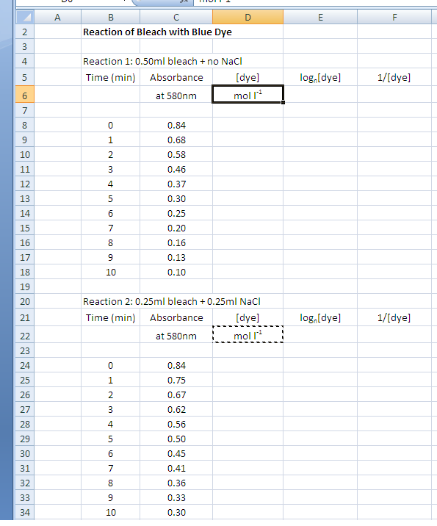

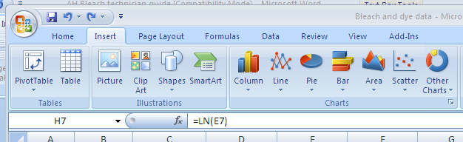
=SUM(C8/138000)
Highlight column E and select Insert and select Line Chart (2D)
Highlight column and
Fill Down (Ctrl D)
=1/D8
=LN(D8)
Fill Down columns E and F

