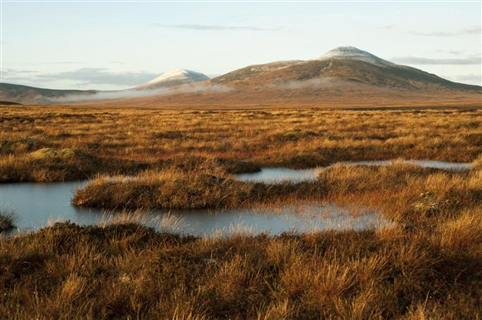

Forsinard Flows. Photo: Eleanor Bentall – taken from RSPB website

Curriculum Links

Environmental Science
There are, not surprisingly, plenty of links that can be made here. If your school is near a peat wetland then it can be used for fieldwork.
There is also scope for examination of the role of peat wetlands relating to water flow and carbon dioxide sequestration.

Biology
Likewise peat wetlands can be used as examples of habitats and biomes in many areas of the biology syllabus

Chemistry
Within the chemistry syllabus, analysis of the pH of water from peat wetlands can be carried out.

Fact File
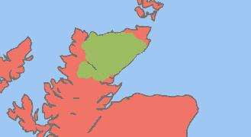
Where is it?
The Flow Country is in Caithness and Sutherland (the North of Scotland).
What is it?
It is large area of peat bog, (4000km²), but Scotland has lots of other peat bog areas too
What is peat?
Peat is a type of soil made up mostly of dead plants. The dead plants do not decompose well and just pile up on top of each other. It can become several metres thick and is often surrounded by bog and water.
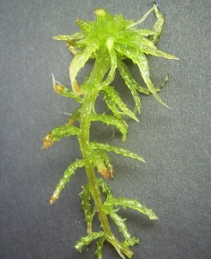
What kind of plants?
Mostly mosses (like sphagnum moss).
Why do the dead plants not decompose like in other soils?
The climate is very wet and cold, which slows down decomposers

Why is peat important?
- Peat bogs store carbon. If damaged they can release carbon dioxide (so they affect climate change).
- A lot of Scottish people drink tap water that has flowed through peat soil and then through lead pipes, which is a poisonous combination unless it is treated.

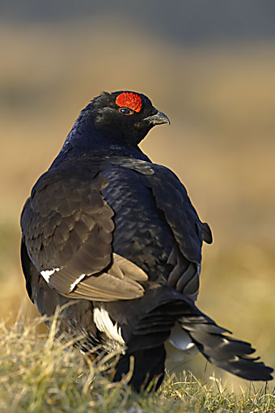
Who cares?
Peat is really useful. It can be dug up and used:
- as fuel (for heating and also making electricity)
- in gardens to help plant growth.
- they are home to rare wildlife.
What is there to discuss then?
Peat bogs like those in Scotland and the Flow Country are on land that could be used for other things (like farming and forestry). This means we really need to think about what we should do with them.
Activity 1 and 2 The pH of Peat Water Teacher Notes

Context
The context for this experiment is that water from peat bogs is acidic, and much of this water contributes to Scotland’s water supply. Acidic water has been known to react with old lead pipes, causing serious hazards to human health. Water companies therefore monitor the acidity in water supplies and modify it when appropriate.

Aim
The aim of this experiment is to enable pupils to investigate the pH of peat rich soils, which are naturally acidic. Pupils are asked to:

- Investigate the pH of 3 samples - two soil/water samples and a tap water sample. Pupils will discover peat rich soils are more acidic than other soils (activity 1).
- Neutralise the acid in the peat-rich soil water, as water companies do (activity 2).

For further background information please see the accompanying Teacher Background Notes.

Activity 3 Drinking Water and Peat Bogs Teacher Notes

Context
Much of Scotland’s water supply comes through peat areas like the Flow Country. Acidic water has been known to react with old lead pipes, causing serious hazards to human health.
Here pupils examine the effect of organic acids on aluminium foil, using different foods. The metal used here is aluminium but pupils should be able to make the connections with the issue of lead pipes and Scotland’s water supply.
Aim
The aim of this experiment is to enable pupils to investigate the relationship between acids and metals and enable them to draw comparisons between acidic water and lead water supply pipes. Pupils are asked to:
- Place 4 different food samples on a tray lined with aluminium foil
- Cover the samples with cling film and set aside for 1 week
- Assess the effect of the acidic food samples on the foil
Extension Work
Pupils could further their understanding by:
- Investigating effects such as the moisture or contact area. Repeating the experiment with and without the cling film, liquidising the samples etc.
- Devising ways of assessing the damage to the foil. They could draw grids onto the foil and look at the percentage of holes or devise a scale of effects that match text descriptions.
- Testing the pH of each of the foods and discuss any unexpected relationship between pH and foil damage.
For further background information please see the accompanying Teacher Background Notes.
Activity 4 Peat Bogs and Water Level Teacher Notes

Context
Many peat bogs have a water table well above the surrounding area. This is because the moss plants are specially adapted to soak up the water. Their leaves make up a sponge-like lattice network of surfaces that exerts a significant capillary action. High water levels are one of the factors that enable peat soils to build up. In a wider context, the dehydration of peat would release significant quantities of carbon dioxide into the atmosphere.

Aim
The aim of this experiment is to enable pupils to explore peat bog water levels using a model. Pupils will be asked to:

- Set up the model using two sponges and a plastic box
- Investigate water level in the sponges using coloured water (fruit squash)
- Relate water level in sponges to water level in peat bogs

Activity 5 Carbon Dioxide and Peat Moisture Teacher Notes

Context
The build up of organic matter in peat bogs makes them globally significant carbon stores. Draining (dehydrating) large areas of peat significantly contributes to greenhouse gas emissions through increased decomposition. Pressure to drain peat comes from any interests that want to use the land for other kinds of agriculture, including forestry as well as for environmentally sustainable projects such as bio-fuels and building wind farms. There is, therefore a complicated global warming argument over Scottish peat bogs.

Aim
This experiment explores the relationship between moisture levels in peat and carbon dioxide release by decomposers. Pupils will be asked to:

- Investigate the relationship between waterlogged soil and carbon dioxide release
- Investigate the relationship between moist soil and carbon dioxide release
- Draw conclusions about the relationship between soil/ water saturation and carbon dioxide release
- Make the connection between dehydration of peat bogs and the effects on carbon dioxide and global warming

see the Scottish Water website and their ‘your water’ leaflet http://www.scottishwater.co.uk/portal/page/portal/SWE_PGP_HOUSEHOLD/SWE_PGE_HOUSEHOLD/SWE_HH_WTR/your%20water%20leaflet.pdf).

