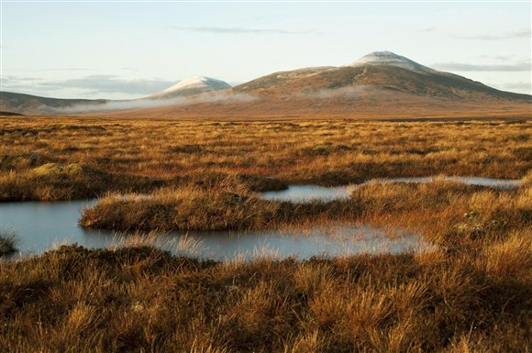
Forsinard Flows. Photo: Eleanor Bentall – taken from RSPB website

Fact File
Where is it?
The Flow Country is in Caithness and Sutherland (the North of Scotland).
What is it?
It is large area of peat bog, (4000km²), but Scotland has lots of other peat bog areas too
What is peat?
Peat is a type of soil made up mostly of dead plants. The dead plants do not decompose well and just pile up on top of each other. It can become several metres thick and is often surrounded by bog and water.
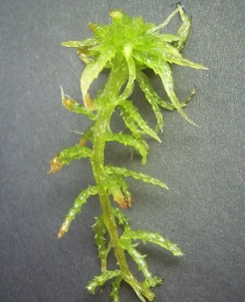
What kind of plants?
Mostly mosses (like sphagnum moss).
Why do the dead plants not decompose like in other soils?
The climate is very wet and cold, which slows down decomposers

Why is peat important?
- Peat bogs store carbon. If damaged they can release carbon dioxide (so they affect climate change).
- A lot of Scottish people drink tap water that has flowed through peat soil and then through lead pipes, which is a poisonous combination unless it is treated.

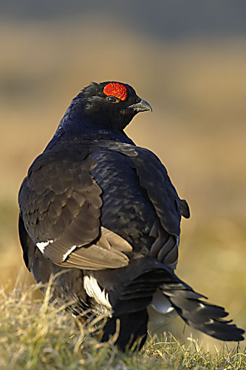
Who cares?
Peat is really useful. It can be dug up and used:
- as fuel (for heating and also making electricity)
- in gardens to help plant growth.
- they are home to rare wildlife.
What is there to discuss then?
Peat bogs like those in Scotland and the Flow Country are on land that could be used for other things (like farming and forestry). This means we really need to think about what we should do with them.
Activity 1
The pH of Peat Water Pupil Guide
The water that we drink has passed through the rocks and soil. This changes the properties of the water. One of the properties it can change is whether the water is acidic, alkaline or neutral. Acidic solutions contain lots of hydrogen (H+) ions and can damage materials (they are corrosive). Alkaline solutions contain lots of hydroxide ions (OH-) and are also corrosive. A neutral solution is neither acid nor alkaline and is not corrosive.

Experiment
Today we are going to investigate the pH of water from peat soils. This is carried out by water companies in Scotland because a lot of our drinking water comes from areas with peat soils and it’s their job to make sure that the water is safe to drink (i.e. not too acidic or too alkaline).

We can find out the pH of a solution using a special dye (universal indicator). The universal indicator changes colour depending on how acidic or alkaline a solution is. The colour can be matched to a chart, which gives us a pH number.

0
1
2
3
4
5
6
7
8
9
10
11
12
13
14
ACIDIC
ALKALINE
NEUTRAL

A pH of less than 7 is acidic (strong acids are red). A pH over 7 means it is alkaline (strong alkalis are blue). A pH of 7 is neutral (green). pH can also be measured using a pH meter.

Aim
In this experiment you are going to investigate the pH of tap water, water from a peat soil water and water from a non-peat soil.

Part 1: Testing the pH of water samples

Equipment list
5 boiling tubes and a rack | 2 rubber bungs, to fit the boiling tubes
100ml measuring cylinder | A dimple tile
A dropping bottle of universal indicator | Universal indicator chart
2 soil samples, A and B | Tap water
Distilled water | 3 teat pipettes
2 funnels | 2 circles of filter paper
A spatula | Pen for labelling boiling tubes
A balance (for weighing the samples)

Procedure
Preparing the samples
- Using the balance and the spatula weigh 3g of sample A into one of the boiling tubes, and stand it in the rack
- Add 30cm³ of distilled water to sample A in the boiling tube
- Put a rubber bung in the top of the tube and give it a good shake until the soil and water is well mixed
- Put a funnel into one of the clean boiling tubes, place filter paper inside the funnel
- Now pour the sample A mix through the filter paper into the funnel. Label the tube
- Repeat steps 1-5 with sample B. Use clean tubes, funnel and filter paper to avoid contamination across the samples.
- Wash the measuring cylinder out with tap water and then measure 30cm³ of TAP WATER and put it into a boiling tube, label it sample C

Testing the samples
- Using a pipette place three drops of the water from sample A, into a hollow dimple tile
- Add three drops of the universal indicator dye to the tile and watch for any change in colour
- Match the colour to the chart and write the number from the universal indicator chart against sample A on your worksheet
- Repeat steps 9 & 10 for sample B and sample C, using a new pipette each time
- Complete part 1 of your worksheet.

Activity 1 Measuring the pH of Peat Water Pupil Worksheet

1. Fill in the pH values in the table.

Sample A | Sample B | Sample C

2. Your experiment should have shown that sample A was water from a peat soil and sample B was water from a non-peat soil. Now answer the following questions:

Is peat water acidic, neutral or alkaline? ____________

Is the non-peat soil sample (B) acidic, neutral or alkaline? _______

What about the tap water (C)? ____________

Is tap water more or less acidic than peat water? _______

The Flow Country is an area of peat bog in Scotland – will the water that flows from it be acid, alkaline or neutral?

_______________________________________________________

Activity 2 Changing the pH of water Pupil Guide

Water Companies have to continually check the pH of the water they pipe into our homes. If the water is acidic, the lead that old water pipes are made from can dissolve into the water. A picture of an old lead pipe is shown below.

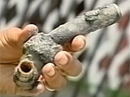
Lead is poisonous and can have the effect of

- Reduced IQ
- Slowed body growth
- Hearing problems
- Behavior or attention problems
- Kidney damage

Aim
Water from peaty areas is acidic. The Water Company will change the pH of the water by adding chemicals to it. They try to make the water neutral so it is less harmful. The aim of this experiment is to neutralise the acidic peat water by adding alkali.

Equipment list
The water from sample A (the peat water sample) | A 250ml beaker
Teat pipette | Milk of magnesia (10ml)
A glass rod | A pH meter

Procedure
- Pour the water from sample A into the small beaker.
- You teacher will have shown you how to use the pH meter. Check the pH of the water by switching on the meter and placing it in the water.
- Write the pH number of the water on your results sheet and then remove the pH meter from the beaker.
- Now add ONE drop of milk of magnesia to the water and stir with the glass rod. Check the pH again.
- Write the number on your results sheet.
- Repeat steps 3-5 until the sample has a pH just above 7 – this means that you have neutralised the solution
Changing the pH of Water Pupil Worksheet

- Record the pH of your water sample in the table below

Peat Water
Number of drops of  magnesium hydroxide | pH of the water
1
2
3
4
5
6
7
8

2. Magnesium hydroxide is a type of chemical called an alkali. What has the magnesium hydroxide done to the acidic water?

3. Why do you think people can take milk of magnesia for acid indigestion?

4. Water Companies would not add magnesium hydroxide to the water but they do use a different alkali, why do you think this is?

5. Imagine you are the scientific advisor to a water company. The water company intends to build a new water supply reservoir. The water that fills this reservoir will mostly come from upland peat bog areas. What technical advice will you give to the water company about their new water supply?

Activity 3 Drinking Water and Peat Bogs Pupil Guide
Aim
Water that has flowed through peat bogs is much more acidic than water from other areas such as farmland. In the past water used to reach homes by flowing through lead pipes. However, lead is no longer used in water pipes in the UK. Why do you think this is? The aim of this experiment is to investigate the effect that acid can have on metals.

Equipment list
a tray | aluminium foil (a bit bigger than the tray)
cling film (a bit bigger than the tray) | a waterproof pen
Sample A: a slice of pickled gherkin | Sample B: a slice of lemon
Sample C: one tea spoon of tomato ketchup | Sample D: one tea spoon of yoghurt
Ruler

Procedure
- Cover the tray with the foil
- Draw four same-sized circles on different parts of the foil, making sure there is space between them (see diagram 1).
- Put the samples in each circle and label them as follows:
A - Gherkin
B - Lemon
C - Ketchup
D - Yoghurt.
- Cover the tray in cling film (this is so the samples don’t dry out).
- Leave the tray for about a week.

* *
- After one week remove the cling film and take off the samples (DO NOT eat any of them)
- Wash the foil under the tap (leave it on the tray to do this)
- Now fill in your worksheet.

Diagram 1: Food and Foil Experiment
Food samples

Tray lined with aluminium foil
Sample A
Sample D
Sample C
Sample B

Activity 3 Drinking Water and Peat Bogs Pupil Worksheet
You have prepared an experiment with some aluminium foil and some food samples. Carefully remove the washed foil from the tray. Now look very carefully at the circles you drew around each of the foods. You could try holding the foil up to the light or maybe use a magnifying glass.

1. Describe what you see:

2. Which foods seemed to remove more foil?

Aluminium is a metal. The samples that you used are all acidic. The aluminium was corroded by the acidic liquid from the food. Other metals can also be corroded by acid.

Lead is a metal often found in old water pipes. If the water is too acidic, the lead in the pipes will corrode and dissolve into the water. This is dangerous because lead is poisonous. To stop this, water companies check the acidity of their water so that our drinking water will not dissolve lead.

Imagine you were a scientific adviser to the large water company. The water the company supplies is collected on upland peat bogs.

3. What considerations might the water company have to make?

The person who owns the land the water flows through has just received permission to change a large area of the peat bog into farmland.

4. What might you need to advise the company to do? Give reasons for your answer.

Activity 4 Peat Bogs and Water Level Pupil Guide
Aim
Peat bogs are very damp and waterlogged. The water level in peat bogs is important for the health of the peat bog. If a peat bog dries out a lot of carbon dioxide is released into the atmosphere.

Mosses live on peat bogs and like very damp conditions. Moss leaves are small and packed together, making a network of leaves, with spaces between them. Mosses can help keep the peat bog damp by sucking up water through these tiny spaces – just like a sponge. This is called capillary action. Today you will investigate how mosses affect water level in peat bogs.

Equipment list
A small plastic box with straight sides | One piece of sponge A
Two smaller pieces of sponge B (stored in water) | A long piece of masking tape
A 500ml beaker | Tap water
50ml blackcurrant squash | A waterproof pen
Ruler

Procedure
- First wet Sponge A under the tap. Then squeeze as much water out of it as you can.
- Put sponge A at one end of the plastic box. Push it up to the end of the box and hold it in with a piece of tape.
- Take the pieces of sponge B out of the tub and squeeze the water out.
- Put the two pieces of sponge B at the other end of the plastic box, one on top of the other. Push them up against the side of the box.
- Using the ruler and pen, mark a line on the outside of the box 3.5cm from the bottom. Draw the line in the gap between the two types of sponge.
- Add blackcurrant squash to 500ml of water in the beaker until the water is a dark purple colour (DO NOT drink it).
- Pour some squash into the gap BETWEEN the sponges and fill up box up to the line you have marked then stop.
- Watch the water levels in the box.
- After five minutes look closely at the two types of sponge.
- Mark on the side of the plastic box how high you think the water has reached in each of the sponges.
- Also mark the new water level in the gap between the sponges.
- Now fill in your worksheet.
Activity 4 Peat Bogs and Water Level Pupil Worksheet

Task 1: Draw a picture of the experiment below. Making sure that you include and label the following things.

- The box
- The two different types of sponge
- The tape
- The water line between the sponges that you used at the start
- The water line between the sponges that you marked at the end
- The water line in the Sponge A at the end of the experiment
- The water line in the sponge B at the end of the experiment

Task 2: Answer the following questions on the worksheet

1. What happened to the water level between the sponges?

2. Why do you think this happened?

3. Which sponge had the higher water level?

4. What are the differences between the two types of sponge?

Sponges can change the surrounding water level - so can mosses in a peat bog! They can suck up water by creating a network of leaves so that there are many tiny holes between them, like a sponge. The tighter the network, the better the mosses are at sucking up the water.

Keeping all this water around reduces the action of decomposers, so when the mosses die they pile on top of other dead mosses. This builds up to make peat. It also helps to keep the water level high in the peat bog.

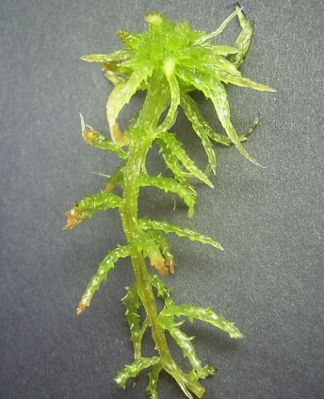
Moses like Sphagnum moss suck up water through capillary action, keeping the water level of peat bogs high
Task 3: Sphagnum moss is used and sold in large quantities in garden centres. Imagine you are a scientist. Someone who owns land with a peat bog on it calls you to ask your opinion. The landowner is thinking of digging up the sphagnum moss and selling it. He wants to know what changes will happen to the peat bog. What are you now able to tell the landowner?

Activity 5 Carbon Dioxide and Peat Moisture Pupil Guide
Aim
Decomposers break down (decompose) dead organic matter in peat (and other soils). This releases carbon dioxide. Carbon dioxide is an important greenhouse gas. So decomposers affect climate change.

High water levels are important for the health of the peat bog. We need to know what happens if we reduce the amount of water in peat because some people want to drain the peat (remove the water) to use the land for other things. Some people believe that if you have less water in the peat, the decomposers will produce more carbon dioxide and add to the greenhouse effect.

You are going to conduct an experiment to find out whether the amount of water in peat makes any difference to the amount of carbon dioxide it releases.

Equipment list
2 x 5L plastic bottles with wide necks and their lids | Peat rich compost (about 8 litres)
A wide funnel | A scoop or spoon
Carbon dioxide sensor and datalogger | 100ml measuring cylinder
Tap water | A4 sheet of card (to use as a fan)
Labels | Pen

Procedure
Your breath contains carbon dioxide so be careful not to breathe into or near the bottles.

- Using the scoop and funnel start putting soil into one of the 5L bottles, until it is about two thirds full.
- Fill the other 5L bottle to the SAME level.
- Label one bottle ‘waterlogged peat’. Label the other one ‘moist peat’.
- Start with the ‘waterlogged peat’ bottle. Count how many 100ml cylinders of water you need to pour into it until the water level is 1cm above the top of the soil. Fill in Box A on your worksheet. Follow the instructions in the worksheet to complete Boxes B & C.
- Now fill the bottle labelled ‘moist peat’ with HALF the amount of water (the amount that you have written in Box C on your worksheet).
- Put the lid on the ‘moist peat’ bottle and shake it until the water is well mixed in. You can tell because you should not be able to see any pockets of water caught in the soil.
- Now take the lid off the ‘moist’ bottle and wipe the inside of the neck of the bottle, so that it is not damp or muddy.
- Use the sheet of card to fan the air above the bottles one at a time. It might be easier if you fold it in 4. Do not breathe into the bottles.
- Now put both bottles to one side and leave them (with their lids OFF) for at least 30 minutes.
- After this screw the lids on BOTH of the bottles at the SAME TIME. You are now ready to take some measurements.
- Take the lid off of the ‘waterlogged’ bottle and seal the carbon dioxide sensor into it. Make sure that no air can get into or out of the bottle at this point.
- Start the stopwatch. Make sure the sensor stays in place. Write down the value from the sensor at 2,4,6,8 and 10 minutes. Do not worry if the number is changing a lot while you are reading it, just write down the first number you see. Put these figures into Table A in your worksheet.
- When you have finished taking measurements, remove the sensor and screw the lid back on the bottle.
- Repeat the last three steps with the ‘moist’ bottle.
- Now fill in the rest of your worksheet.

Activity 5 Carbon Dioxide and Peat moisture Pupil Worksheet
Task 1: Fill in the boxes below
Box A:
ml
1. How much water did you put in the ‘waterlogged’ container?

Box B:
ml
2. Halve the number in Box A and put the result in Box B

3. Round the number in Box B to the nearest 10ml & put the result in Box C. (This is how much water you will put into the ‘moist’ sample)
Box C:
ml

4. As you take the measurements, put them in Table A.

Table A
Time  (mins)  Soil | 2 | 4 | 6 | 8 | 10
Waterlogged Peat (ppm)
Moist Peat (ppm)

5. Now rounding each number to the nearest 10 and put it into the same place in table B. (So 2352 would become 2350 and 2357 would become 2360).

Table B
Time  (mins)  Soil | 2 | 4 | 6 | 8 | 10 | Difference between start and finish  (2 minus 10)
Waterlogged Peat (ppm)
Moist Peat (ppm)
The numbers you have are the concentration of carbon dioxide which was in the air in the bottle. This is measured in ‘parts per million’ (ppm). A reading of 1,000ppm means that for every million ‘parts’ of air, 1,000 of those parts are carbon dioxide and 999,000 are other things (such as nitrogen and oxygen).

Inside the bottle, carbon dioxide from the soil is being released into the air in the bottle as the soil decomposes. The bottles are sealed so no extra air can get to them from outside. So the added carbon dioxide is increasing the concentration or carbon dioxide. For every million parts, more of them are carbon dioxide than before.

This means that over time in the bottles the numbers you have written in Table B should increase. If the numbers are rising over time, the soil is decomposing in both bottles. But is there any difference between the two bottles?

Use the final column in table B to calculate the difference between the start (2 minute) and end (10 minute) carbon dioxide concentration in each bottle. In other words, subtract the 2 minute reading from the 10 minute reading and put the answer in the last column.

Task 2: Answer the following questions on the worksheet

Is the change the same in both bottles? _______

Which soil produced more carbon dioxide (which changed the air more)?

________________________________________________

What was the only variable we tested (the only thing we changed between the two bottles)?

_______________________________________________________

If we wanted to make a peat bog give off MORE carbon dioxide into the atmosphere what would we try to do?

____________________________________________________

Task 3: Imagine you are a scientist interested in global warming. You hear that someone who owns land in the Flow Country of Scotland is going to drain a large area of peat. They are going to do this in order to build wind farms. Wind farms produce electricity without giving off lots of carbon dioxide. The landowner thinks this will help reduce global warming. You are not so sure. Write a letter to the landowner that explains why.

