

|  |
| --- |
| Chemistry  At  Home |
| Food Chemistry |

**Introduction**

Food is something we can all relate to: everybody eats.

What is less well understood, though, is just how much chemistry is involved in its preparation, cooking – and even eating. For any budding chemists out there, it is worth knowing that the food and drink industry is one of the biggest employers of chemistry graduates.

This document contains several activities you can safely carry out at home to investigate aspects of food chemistry

* Changing Chocolate
* Maillard Reactions
* Structural Subtlety
* Taste and Aroma
* Toothpaste and Orange Juice
* Emulsions
* Enzymic Browning
* Meringue – an aerogel

**Health and Safety**

Except where indicated, there is no risk involved in the experiments below, other than those normally found in a kitchen such as shark knives and hot items.

Changing Chocolate

**You will need:**

* Three small bars of chocolate (milk chocolate is best)
* a source of warmth: oven (at a low temperature) or even a radiator
* A fridge

**What to do:**

1. Keeping one bar of chocolate as a control, put the other two in a cool oven or on a radiator so it melts (still in the wrapper or there will be an awful mess!)
2. Remove the bars from the heat source and place one in the fridge to cool rapidly and let the other cool slowly.
3. Cut the chocolate bars up and taste them to see if they can tell any difference

**What is happening?**

The taste of chocolate is dependent on its microscale structure. Chocolate is made up of tiny particles and crystals which range in diameter from 0.01 mm to 0.1 mm. These particles govern how the chocolate is perceived by the consumer. In order for you to taste the flavour compounds in chocolate, they have to reach your mouth and nose. However, the texture of the chocolate is important too. The way you perceive the texture is a result of how the chocolate melts and breaks up in the mouth.

A key ingredient of chocolate is cocoa butter. Cocoa butter is a fat and it has at least six different crystal forms. This means that the atoms are the same but they are arranged differently. The different arrangements can lead to different properties in the chocolate, including melting point, how easily it snaps, strength, glossiness and texture.

The ability of the structure to take on many different crystalline forms is called polymorphism. (‘poly’ means many; ‘morph’ means shape). The details of the polymorphism of chocolate are very complex and this is still an area of active research. One of the six polymorphs – form V – has a far superior taste and texture than the others. It is also the glossiest and snaps well.

The table below shows some of the characteristics of different cocoa butter polymorphic forms

|  |  |  |
| --- | --- | --- |
| **Cocoa  butter polymorph** | **Conditions to make it** | **Melting point (°C)** |
| Form I | Rapidly cooling molten chocolate | 17.3 |
| Form II | Cooling the molten chocolate at 2°C | 23.3 |
| Form III | Solidifying the molten chocolate at 5-10°C  (or storing ‘Form II’ at 5-10°C) | 25.5 |
| Form IV | Solidifying the molten chocolate at 16-21°C  (or storing ‘Form III at 16-21°C) | 27.3 |
| Form V | Solidifying the molten chocolate whilst stirring.  Needs a special process called ‘tempering’ | 33.8 |
| Form VI | Storing ‘Form V’ at room temperature for four months | 36.3 |

**Extensions**

Why not see if you can make some more of the forms of chocolate described in the table above?

Maillard reactions

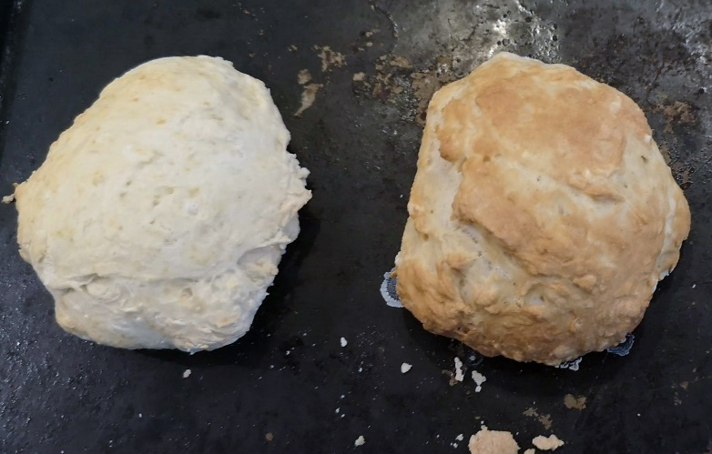Maillard reactions are possibly the most important in the whole area of food chemistry. They are, simply put, reactions between sugars and amino acids from proteins.

In reality, it is far more complicated and the reaction can lead to literally thousands of molecules which are key components in the colour, taste and aroma of foods. The colour of beer and chocolate, the flavour and colour of roast meats and toast, to name but three.

**You will need:**

* bread dough (can be made in situ) – You don’t need to worry about yeast, or leaving it to prove unless you’re planning on eating it as well. Just make a flour/water mix.
* sodium hydrogen carbonate (bicarbonate) solution (make a saturated solution)
* Baking tray
* Access to an oven

**Procedure:**

1. Prepare the bread dough if it is not already done.
2. Take a small piece and form into a ball for a roll (or try to roll it out and twist into a pretzel if you are feeling ambitious.
3. Do the same with another small piece as a control
4. Paint one of the rolls/pretzels with the sodium hydrogen carbonate solution, or dip it on.
5. Do the same with the other only using water.
6. Place both rolls on the baking tray and put in the oven at around 220°C for 10 minutes or so.
7. On removal, the roll/pretzels coated with sodium hydrogencarbonate will be a significantly darker colour

**What is happening?**

The Maillard reaction is, to put it simply, a reaction between an amino acid and a sugar.

It is an extremely complex series of reactions but the key points can be summaries as follows.

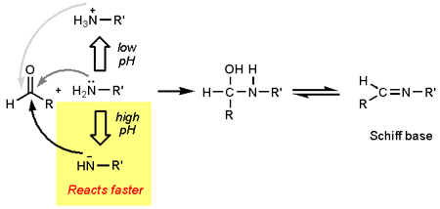The first step involves a reaction between a reducing sugar (depicted as R(C=O)H and an amino acid (depicted as R’NH2) followed by loss of water to yield a Schiff base.

The reactivity of the amino acid is influenced by the pH. A **simplified** reasoning goes like this: At low pH the amino group is protonated, yielding it less nucleophilic. At higher pH, the nitrogen becomes more nucleophilic and at very high pH the amino group can even be deprotonated.

So the brown colour on the surface of the roll/pretzel is due to reactions between sugars and amino acids. (This produces a class of compounds called melanoidins that give the colour and add various flavours too)

Structural Subtlety

This is less of an experiment and more of an observation.

Most biochemical molecules have different optical isomers – though in nature only one form usually dominates. In this case, we investigate the differences between the two optical isomers of the terpene molecule carvone using that delicate piece of equipment, the human nose.

**You will need:**

* 2 small bottles/jars, ideally with lids
* pestle and mortar
* Caraway seeds
* Spearmint (or spearmint sweets such as tic-tacs)

**Procedure:**

1. Crush a teaspoon of caraway seeds in a pestle and mortar and place in one of the jars.
2. Do the same with the mint (or mint sweets) and place in the other jar.
3. Allow the two jars and try to identify the odours – then try it on others.

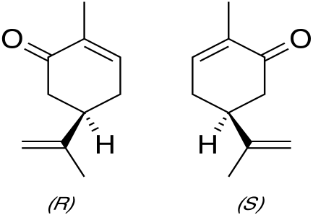**What is happening?**

The main odour molecules in spearmint and caraway are different optical isomers of a terpene called carvone.

Caraway contains the S – Isomer

Spearmint contains the R isomer

It is a simple demonstration of how the human senses can detect substances that are structurally very similar.

It is possible to isolate essential oils from spearmint and caraway which contain around 50 – 80% carvone.

Taste and Aroma

Most of what we consider as taste is actually aroma, detected by the nose. That is why, when you get a bad cold, you will often lose a significant amount of your sense of taste. This is easy to investigate

**You will need:**

* Strawberry jam (or similar)
* teaspoon

**Procedure:**

1. Either hold your own nose or get someone to do it for you.
2. Place some jam in your mouth, swirl it round with your tongue and describe the taste.
3. Let go of your nose.
4. Now describe the taste.

Now try it on someone else.

**What is happening?**

The tongue can detect only 5 tastes: sweet, sour, salt, bitter and umami. When the nose is held, the jam only really registers as sweet.

The vast majority of what makes up the taste of a food is in fact the aroma molecules detected by the nose. When you let go of your nose, the molecules can make their way there and the unmistakable ‘strawberry-ness’ comes through.

This explains why food tastes bland when you have a bad cold.

**Extensions**

See if other foods will do it too – cheese and onion crisps are a good place to start.

Toothpaste and Orange Juice

Many of you will have had the experience of going in to breakfast after cleaning your teeth, taking a sip of orange juice – and realising that it tastes horrible. Many people thing this is something to do with the mint in the toothpaste – we’re going to investigate that.

**You will need:**

* Toothpaste
* mint (sweets)
* orange juice

**Procedure:**

1. First of all, try sucking on a mint and then take a sip of orange juice.
2. The orange will taste quite normal.
3. Now put a dab of toothpaste in your mouth and swirl it round for a minute or two.
4. Then repeat the orange juice tasting and it will taste horrible

It’s even more fun if you repeat this with other people.

**What is happening?**

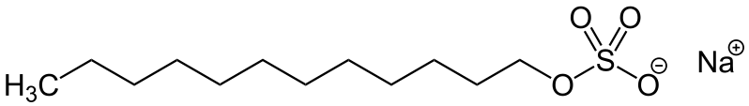

Contrary to popular opinion, the guilty party in the toothpaste is not the mint flavouring, it is a surfactant called sodium dodecyl sulphate (sodium lauryl sulphate - SLS) that is used to make the toothpaste foam when you brush your teeth.

In the mouth, the SLS suppresses the working of the taste buds that detect sweetness.

In addition, SLS destroys phospholipids. These fatty compounds act as inhibitors on your bitterness receptors.

So by inhibiting sweet receptors and destroying phospholipids, SLS dulls the sweetness and promotes the bitter taste in orange juice.

**Extensions**

See what effect there is on other foods and drinks – remember you need to have both sweetness and bitterness. A sweet substance will just taste less sweet and a bitter one, more bitter.

If you have the time and inclination (and a bit of money) see about getting hold of some ‘miracle berries’ (miracle fruit). These berries interfere with your taste buds and cause sour things to taste sweet. So after sucking on one of these, you can eat a lemon!

Emulsions

**Introduction**

An emulsion is a mixture of two fluids such as oil and water that is achieved by breaking up the molecules in both substances into very fine, small droplets in order to keep the combination from separating.

There are several common foods that are considered emulsions: milk, margarine, ice cream, mayonnaise, salad dressings, and sauces like béarnaise and hollandaise. When packaged and manufactured on a larger scale, most of these foods need emulsifiers to stabilise the mixture and keep the different ingredients from becoming separated.

In this investigation you will look at emulsion formation and at the effectiveness of various substances as emulsifying agents.

**You will need**

* Small screw cap bottles or jars with lids. Ideally, quite a small, or at least narrow one – that way you need less oil. If you can only find one, that’s OK, just do the experiments one at a time.
* Oil (ordinary cooking oil is best)
* Water (with a few drops off food colour or ink in – this isn’t essential, it can just make the layers easier to see.
* Egg yolk – roughly 2 cm3 (A level teaspoon is about 5 cm3)
* Mustard – roughly 2 g
* Detergent (washing-up liquid) roughly 2 cm3
* timer

**What to do**

1. In a jar, add water and oil with about 1 part oil to 9 parts water
2. Put the lid on (tightly) and shake vigorously for 1 minute. (You will see it seems to blend together to make a single cloudy/milky mixture.
3. Put it down and start the timer. How long does it take the two layers to settle out?
4. Now take another jar (or wash out the first) put the same amount of water/oil in and this time add the potential emulsifier (egg yolk, mustard or washing up liquid).
5. Shake again for the same length of time and again time how long it takes for the layers to separate this time.
6. Repeat with the other emulsifiers.

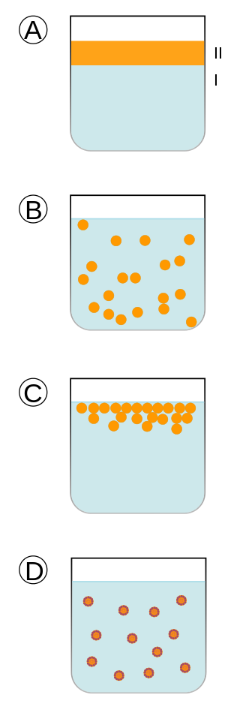

**What is happening?**

The diagrams to the right help to explain

1. Two immiscible liquids, not yet emulsified.
2. An emulsion of Phase II dispersed in Phase I
3. The unstable emulsion progressively separates
4. The emulsifier ( shown by the outline around the particles) positions itself on the interfaces between Phase II and Phase I, stabilizing the emulsion

By Fvasconcellos 14:24, 17 April 2007 (UTC) - Own work, after Image: Emulsions.png by Ike9898, Public Domain, <https://commons.wikimedia.org/w/index.php?curid=1961781>

Enzymic Browing

**Introduction**

You will know that if you take a bite out of an apple and then cut it, where you have bitten into it will soon go brown. This is because of enzyme catalysed reactions that turn polyphenols into coloured melanins. Browning of fruit and vegetables makes them look less appetising so the food industry tries to reduce this as far as possible.

The objective of this investigation is to assess the effect of various treatments on enzymatic discolouration of apples.

**You will need**

* 1 bramley apple (cooking apple)*
* Lemon juice
* Sharp knife and chopping board
* 3 glasses, jars, bowls

* Other apples or pears could be investigated but Bramley apples (sold as cooking apples) go brown quicker than any others we tried. Don’t use Granny Smiths as they go brown a lot slower.

**What to do**

Preparation

* Get your three containers ready.
* If you are using fresh lemon juice, squeeze it out first

It is important to work quickly as the browning starts very quickly.

1. Using a sharp knife take a thin slice of apple. (Trim it down so it will fit in your container flat.)
2. Place it in one container and set to one side.
3. Take a second slice and cover with water
4. Take a third slice and cover with lemon juice
5. Now leave all three containers in the same place and see what happens

**What is happening?**

Plant tissues often contain phenolics compounds associated with their cell walls. Some of these also contain polyphenoloxidase (PPO), an enzyme that will convert the phenolic to a quinone, which will eventually be transformed into a brown melanin pigment.

One of the main oxidative reactions is enzymatic browning. This involves two oxidoreductase enzymes: polyphenoloxidase (PPO) and peroxydase (POD).

PPO catalyzes two reactions;

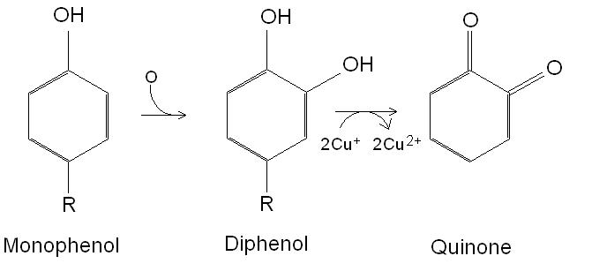

The first, a hydroxylation of monophenols to diphenols, is relatively slow and results in colourless products.

The second, the oxidation of diphenols to quinones, is rapid and gives coloured products.

Because the substrates involved in these reactions are located in the vacuoles while enzymes are in the cytoplasm; the reactions can take place only if they are mixed and in the presence of oxygen (i.e. when you cut a piece of fruit or vegetable).

One factor that affects this browning is pH. PPO is largely inactive below pH 3 so the lemon juice should pretty much stop the browning.

**Extensions**

1. You can try using other foods and see if they go brown too.
2. Temperature
   1. Repeat the experiment but put the samples in the fridge – or even the freezer. You can check on them every 5 minutes or so to see what is happening.
   2. Blanching – Drop your apple slice into boiling water for a very short period of time – less than a minute so your apple doesn’t fall apart – and repeat the experiment. The heat should have deactivated the enzyme

Meringue – an aerogel

We are all familiar with meringues. Structurally, they are interesting in that once cooked they are mainly air – and so are very light. This is something called an aerogel and the aerospace industry is very interested in them as a concept as they can theoretically be used to make very strong and very light materials.

Making a meringue basically involves whipping up an egg white to get air into it and then cooking it – very slowly.

You will need

* 3 eggs
* 175g white caster sugar
* Baking tray and parchment (optional but it’s easier to get the meringue off)
* Access to an oven

**What to do**

Preparation

Warm the oven up but only on a very low setting 60 - 70°C is ideal

Separate out the egg whites. Be careful not to get any yolk in as it will interfere with the process. You can keep the yolks for all sorts of things – including making mayonnaise – an emulsion.

Beat the eggs, either by hand or in a mixer until the mixture resembles a fluffy cloud and stands up in ‘soft peaks’ when the whisk is lifted. If there is someone in the house who is a cook, ask them when you do it the first time.

While continuously whisking, slowly add the caster sugar – 1 tbsp at a time – until you have a stiff, glossy meringue mixture.

Form the meringue mixture into 6-8 ‘blobs’ on the baking parchment and put in the oven.

Leave for several hours, ideally overnight. (As an alternative, you can have the oven at about 130°C and cook for 1 ½ hours). You are just as much simply drying the meringue out rather than actually cooking it.

Then leave to cool in the oven.

Cut open and look at the structure of your meringue.

**What is happening?**

As well as incorporating air, beating also exposes some amino acids that repel water – i.e. are “hydrophobic”.

When egg whites get beaten, these water-wary amino acids come into close contact with other water-loving (i.e. hydrophilic) amino acids. Next, water molecules from egg whites, the air and amino acids all jockey to get into the best possible position to be near components they like, and to get as far away as possible from the ones they do not like.

They incorporate air into the structure to help them do this. Some of the amino acid strands also make “bridges” between them to try to stabilise the meringue.

When the whipped-up egg white is cooked, ovalbumin – the main protein in egg white – becomes completely denatured, meaning it cannot return to its former shape. This is what makes meringue solid.

However, bubbles and proteins divided against themselves will not stand, and the foam will collapse without a little stabilizer. One way of doing this is to introduce an acid such as vinegar, lemon juice or cream of tartar, which encourages the proteins in the egg white to bond together. Another ingredient that adds structural integrity, in addition to providing flavour, is sugar, which works like a glue that holds the foam together.

But why don’t we want to use the yolk? This part of the egg contains fat, which interferes with how the proteins line up and coat all those bubbles that are supposed to bulk up your meringue. If the bubbles aren’t properly protected, your meringue will never have much body. This is also why chefs are discouraged from using plastic bowls for this purpose as they have a tendency to retain oils.

**Extensions**

1. You can have a look at the effects of acid as a stabiliser
   1. Make another batch but this time, before whisking, rub the whisk and the inside of the bowl with a slice of lemon. The idea is to very slightly acidify it but not make them taste of lemon.
   2. Use ‘cream of tartar’. About ⅛ of a teaspoon for each egg white. Added again before whisking.