Chemistry
At
Home
Testing for acids and bases

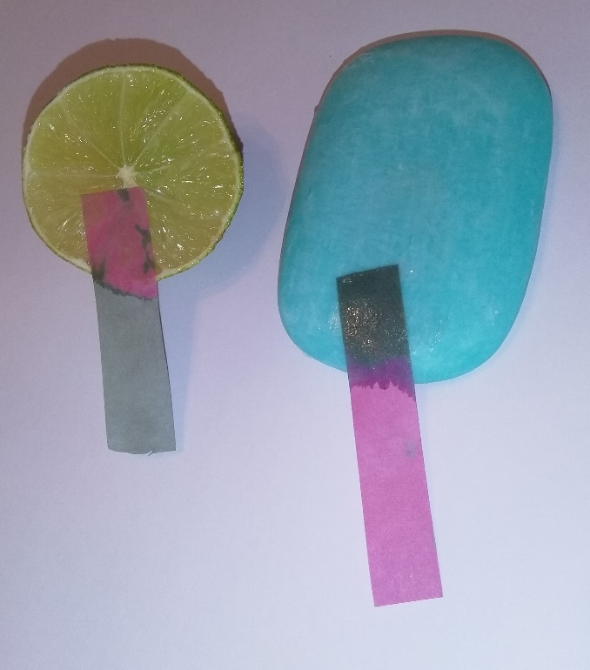
Introduction
In chemistry we can use indicators to determine whether compounds are acids or bases. These indicators can undergo many colour changes depending on the substance. For example, Universal Indicator changes from red (with acids) to green (with neutral solutions) to blue (with bases) and all the colours in between.
Other indicators only have one colour change. One such example is litmus paper. This comes in two forms - red litmus paper and blue litmus paper. Red litmus turns blue with basic substances. Blue litmus will turn red with acidic substances. We can therefore use both litmus papers to determine whether something is an acid, base or is neutral. The table below summarises the colour changes.

 | RED LITMUS PAPER | BLUE LITMUS PAPER
Acidic Substance | Red  (no change) | Red
Basic Substance | Blue | Blue  (no change)
Neutral Substance | Red  (no change) | Blue  (no change)

This activity involves preparing homemade blue and red indicator paper, and testing a variety of household substances to see if they are acidic, basic or neutral. Of course, being made from cranberries it isn’t actually litmus but it is very similar

You will need
- Cranberry Juice
- Sodium bicarbonate (bicarbonate of soda)
- Container to make the indicator paper.
- Paper
- Kitchen Roll (if available)

Health and Safety
Sodium bicarbonate is of no hazard. All foodstuffs and toiletries that can be tested are also of no hazard.
Bleach should not be tested, as not only is it hazardous, it will turn both papers white. Liquid detergent pods should not be used either as they are not designed to be opened up,
Laundry detergent and other cleaning products can cause severe eye irritation and therefore should only be used in the presence of a responsible adult. Hands should be washed immediately after touching these products.
It is the responsibility of the teacher to ensure an adequate risk assessment is carried out.

What to do
RED INDICATOR PAPER
- Pour the cranberry juice into the container to a depth of about 1cm.
- Cut the paper to size so it can lie flat in the bottom of the container and place it in the cranberry juice, ensuring the paper is completely covered. **
- Leave to soak for 3 hours (can leave overnight).
- Remove the pink paper and allow to dry (on a kitchen roll is fine).
- Once dry, cut up into strips (~1cm by 5cm).

BLUE INDICATOR PAPER
- Pour the cranberry juice into the container to a depth of about 1cm.
- Cut the paper to size so it can lie flat in the bottom of the container and place it in the cranberry juice, ensuring the paper is completely covered. **
- Leave to soak for 3 hours (can leave overnight).
- Remove the pink paper from the cranberry juice and put to one side on some kitchen roll.
- Pour the cranberry juice down the sink and wash out the container.
- Take 1 teaspoon of sodium bicarbonate and dissolve it in a glass of water.
- Pour the bicarbonate solution into the container.
- Add the pink paper (doesn’t have to have dried out) to the bicarbonate solution and leave for about 15 seconds (or when the colour has changed).
- Remove the now blue/green paper and allow to dry (on a kitchen roll is fine).
- Once dry cut up into strips (~1cm by 5cm).

**Only place one piece of paper in the container at one time. If more than one piece of paper is used, ensure that they are not overlapping with each other, as this prevents the cranberry juice reaching all the paper.

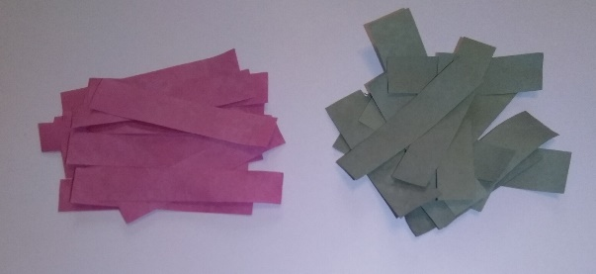

TESTING HOUSEHOLD SUBTANCES
Once the indicator papers are ready you can begin to test various substances around the house. For best results, dampen the litmus paper first with water and hold the paper in the substance for 30 – 60 seconds.
On the next page there is a table with some suggestions:

Substance | Red indicator paper (dampened) | Blue indicator paper  (dampened) | Conclusion acid/base/neutral
Water
Bicarbonate of soda dissolved in water
Vinegar
Bar of soap (dampened with water)
Hand sanitiser
Liquid soap
Lemon juice
Washing up liquid
Fruit
Salt dissolved in water
Honey
Lemonade
Window cleaner
Shower gel
Shampoo
Sugar dissolved in water
Perfume

Extension
Try making indicator paper from some other fruits or vegetables. How do they compare?

What is happening?
Cranberries, like most other fruits, are coloured due to the presence of molecules called anthocyanins (and derivatives called anthocyanidins)
The specific chemistry is complicated but in general, anthocyanins behave as follows:
red or pink in acidic solutions (pH < 7),
purple in neutral solutions (pH ≈ 7),
greenish-yellow in alkaline solutions (pH > 7), and
colorless* in very alkaline solutions, where the pigment is completely reduced.
* in fact the final colour will vary as there are some other compounds that are not rendered colourless, So, for instance, red cabbage is yellow in strong alkali.
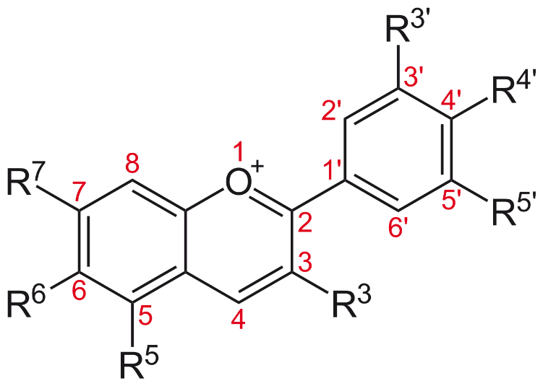
More detail
The general structure is shown in the diagram and different anthocyanins.cyanidins have different groups at each R site.

Image by NEUROtiker (talk) - Own work, Public Domain, https://commons.wikimedia.org/w/index.php?curid=4507478

