Chemistry
At
Home
Spectrometry

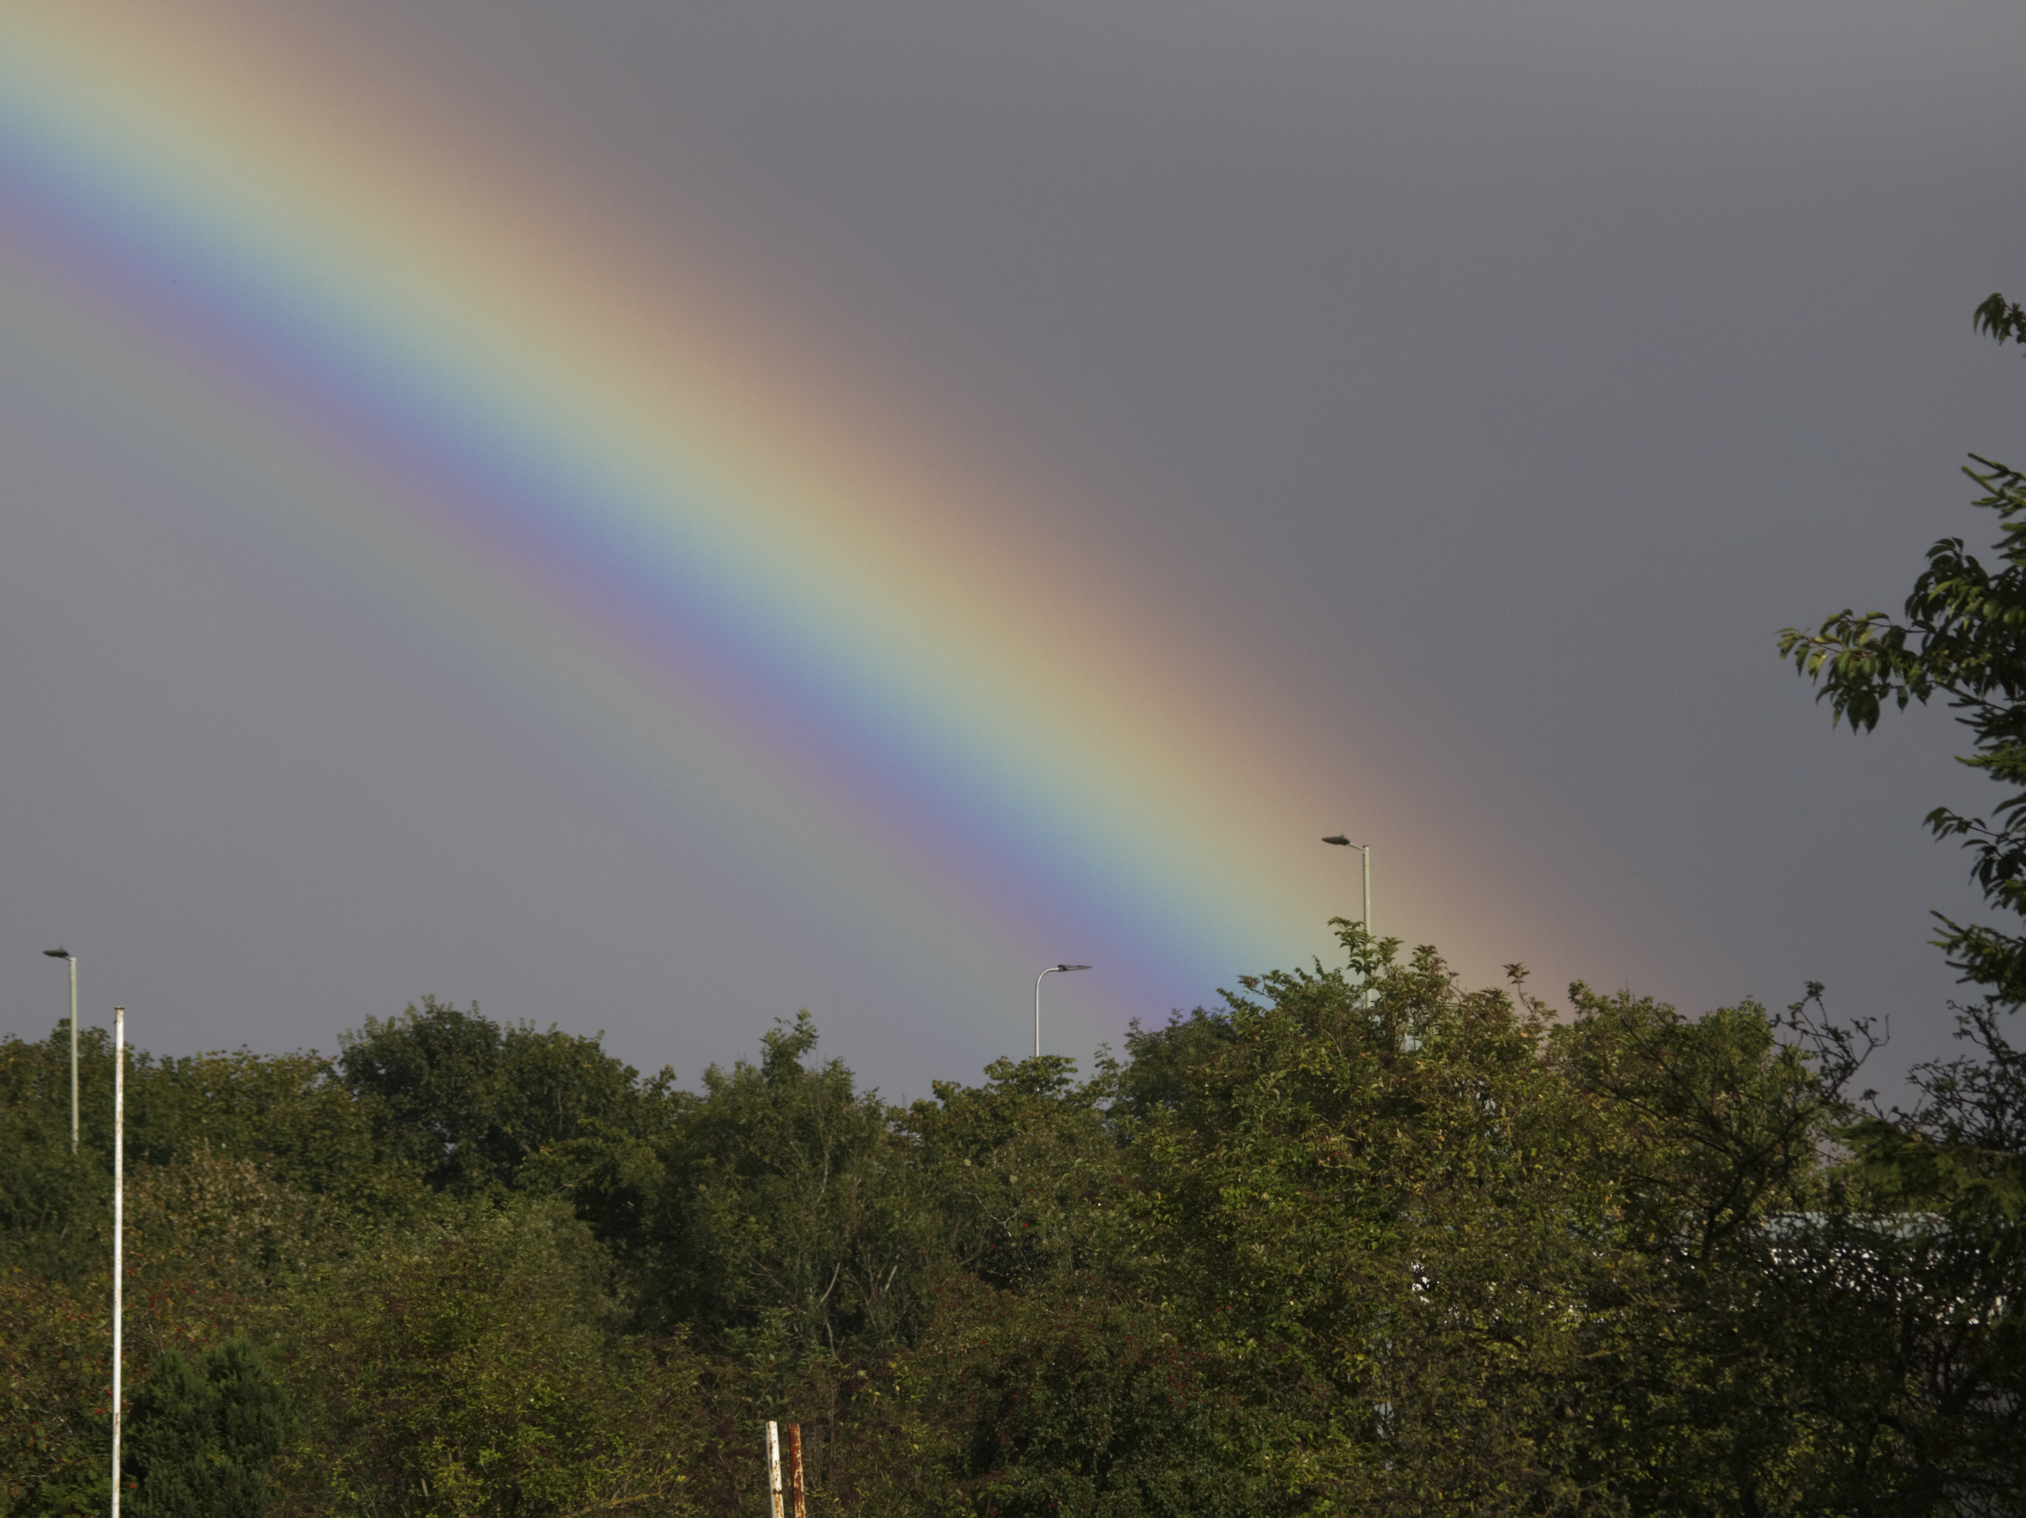
Spectrometry is the science of splitting light up into its component colours. If you do this, it can be possible to identify what a substance is.
Spectrometers are generally expensive pieces of equipment but tt is possible to make a simple spectrometer at home that you can fix to your phone and use it to see the spectra of various light sources.
This version was devised by the Spectral Workbench group of PublicLab.org.
For details and the template see https://www.sserc.org.uk/subject-areas/chemistry/chemistry-resources/dvd-spectroscope/

You will need
- an old DVD you can get rid of
- a copy of the template – printed out on card – ideally black but you can paint it.
- (If you don’t have access to a printer, you can trace the template from your screen instead.)
- A pair of scissors
- Black electrical tape if possible or selotape
- A ruler
- A scalpel or craft knife.

1) Preparing the diffraction grating.
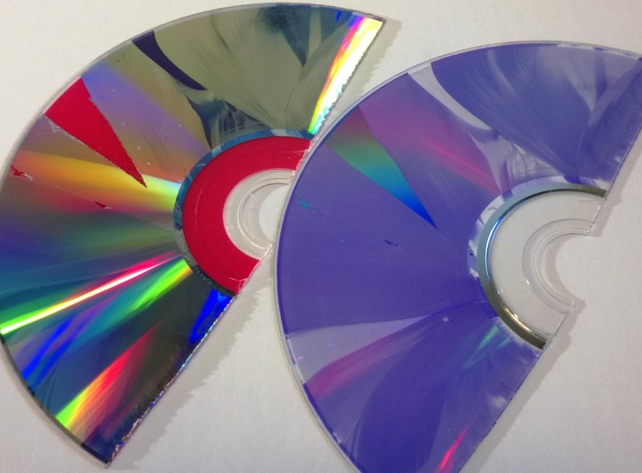You will need a recordable DVD (DVD-R).
DVD layers
Cut the DVD-R into halves or quarters with a pair of scissors and then you should be able to get a fingernail in and separate it into two layers: the metallic layer with the label on and a clear plastic layer with a purple sheen. (Figure 1)
You need the clear layer. Try to handle the surface as little as possible to avoid marking it.

Cut a piece from the edge of the now clear plastic, approximately 1cm x 1cm. This is your diffraction grating.

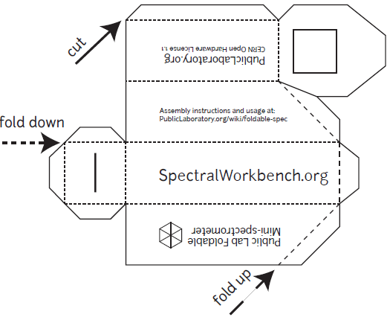2) Getting and preparing the template
You can find the template on the publiclab website (but a copy is on the back page of this document) It refers to printing on 11” x 8” paper but A4 seems to work fine. (http://publiclab.org/sites/default/files/8.5x11mini-spec3.8.pdf)
If possible print this out onto black card: card so it is stiff enough and black to reduce internal reflection. You might think printing black lines onto black card is a daft thing to do but it is still possible to see the design clearly enough to cut it out. If you don’t have black card, print on white and then colour or paint the template as dark as you can
Cut round the outside, scissors are probably easiest.
Use a scalpel or sharp craft knife to cut out the square (top right of the diagram) where the grating goes. Then use the scalpel/knife to cut a narrow slit (lower left of the diagram) - the narrower the better.
3) Assembling the spectrometer
Use tape or glue to fix your 1 cm x 1 cm piece of diffraction grating on the inside of the ‘door’, over the square hole you cut out for it. The lines need to be horizontal so make sure that the edge of the DVD-R is at the top or bottom rather than to one side. Then fold the device as shown in the diagram and tape or glue it shut (tape is probably easier and black electrical tape is best).
You will now have a rectangular box, approximately 10 cm long with a slit at one end (Figure 4) and a slope at the other end with a window containing the diffraction grating (Figure 5)
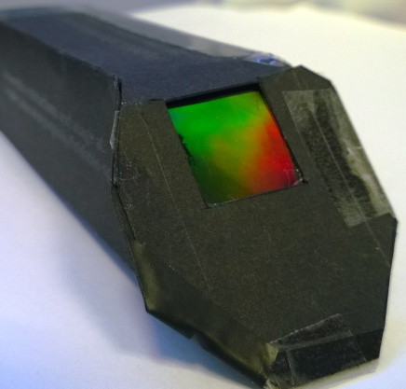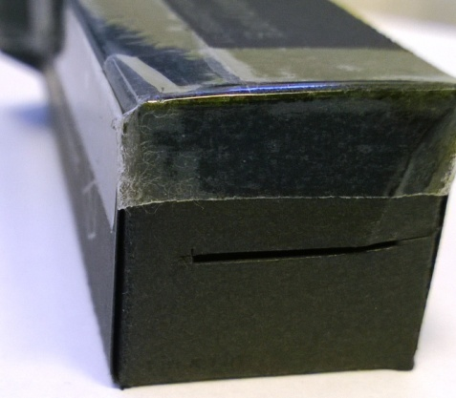
The diffraction grating
The slit

4) Attaching the spectrometer to your phone
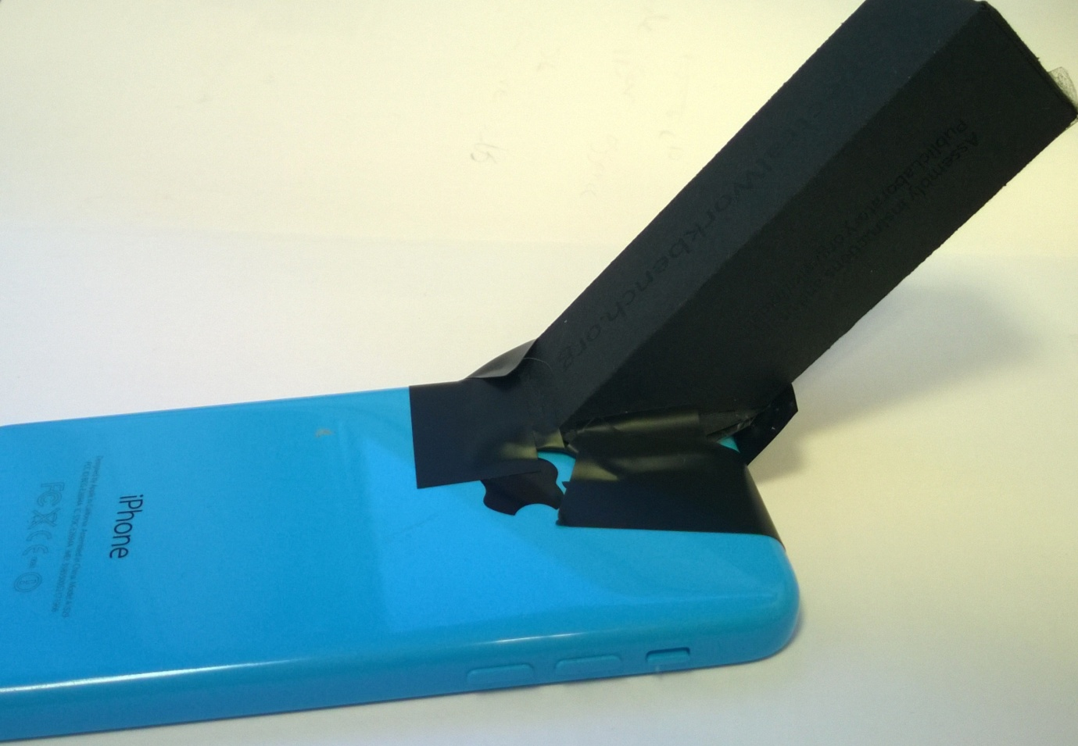You can simply do this using tape (again, black electrical tape is best). Launch the camera app. Place the ‘window’ with the diffraction grating against the lens, check that you are getting a pattern and then tape it in place. This is a bit tricky with some phones that have the camera lens is stuck away in a corner. It is possible, however, to get it in place with a bit of care.
Spectrometer attached to an iPhone 5c

Once in place, launch the camera app and then you can point it at various light sources and get photographs of their spectra.

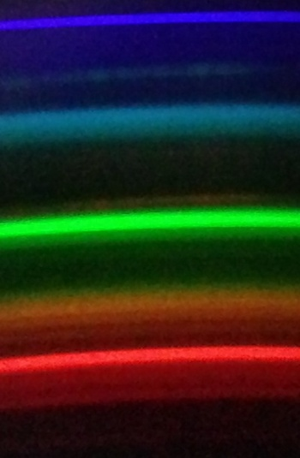
Spectrum of a compact fluorescent lamp

Warning
Do not look directly at the sun – you can cause permanent damage to your eyes.
Do not point your spectrometer directly at the sun either – you will get too much glare to get a good result and you could cause damage to your phone’s camera.

