Chemistry
At
Home
Rusting
(and other reactions
of iron)

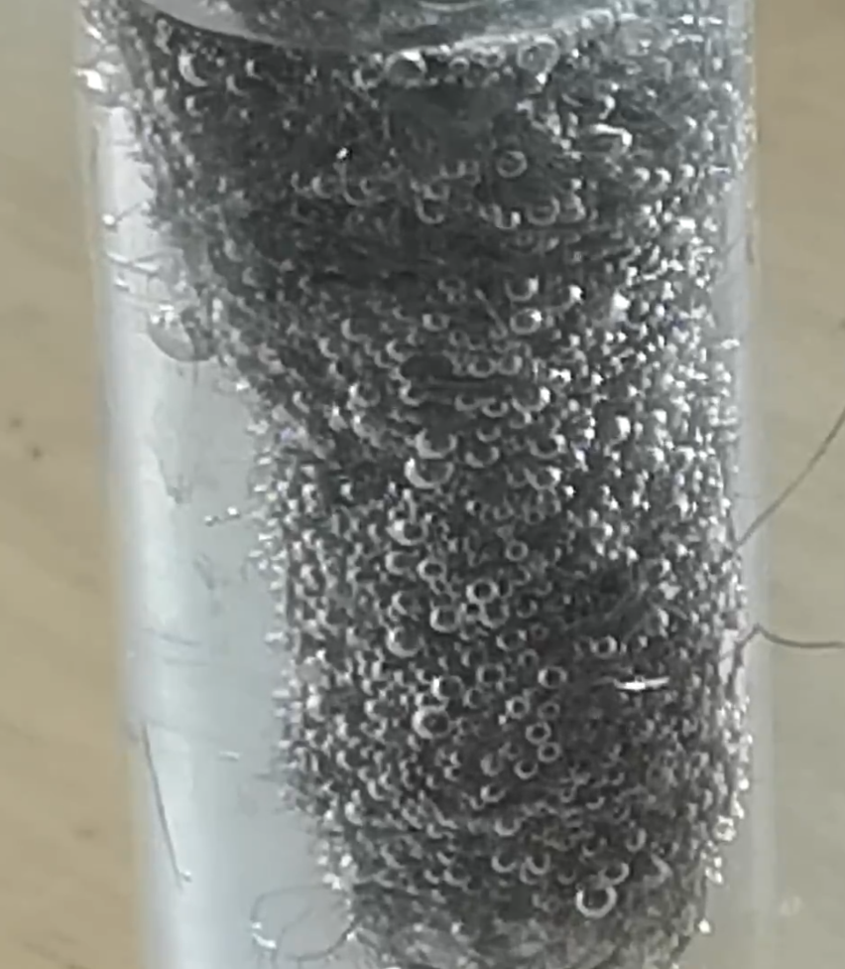
Introduction
Iron is one of the commonest elements in the Earth’s crust. More than that, it is by far the most commonly used metal in most households.
You will be able to get hold of iron in a usable form easily (and may well have it in the house already). The most useful forms are wire (easily available in the form of small nails) and steel wool (available from DIY shops as an alternative to sandpaper.

You will need
Iron nails (small ones are fine, and you get more for your money! | Galvanised iron nails (these are just the same but are coated with zinc)
Steel wool | Water
Salt | Vinegar
Small containers (ideally with lids)*

* If you are struggling for these, the small plastic shot glasses from the supermarket can work and you can cover the tops with clingfilm instead of using lids – not quite as good but OK.
Health and Safety
There are no significant hazards with any of the reagents here
It is the responsibility of the teacher to ensure an adequate risk assessment is carried out.

Investigation 1 - Rusting

What to do
We are going to look at the effect of air, water and salt on rusting.
- Set up the following glasses/jars and place one nail in each.
  - Just dry air (If you have a small bag of silica gel to absorb moisture, that’s even better)
  - Air and water - place a shallow later of water in the bottom of the jar.
  - Water. (To remove the air, boil the water and, carefully, while it is as hot as you can manage, pour some into the jar – enough to completely cover the nail. Then put a layer of oil (cooking oil is fine) on top of the water – this will stop any fresh air getting in.
  - Salt – just put a layer of dry salt in the bottom of the jar and put the nail in (Again, a silica gel bag is ideal but not essential)
  - Salt water and air – repeat jar b but this time add some salt to the water.
  - Repeat b but using a galvanised nail
  - Repeat e but using a galvanised nail
- Now cover the jars (or put lids on) and leave them to see what happens.

Extension
You can investigate the effect of temperature but setting up duplicates of jar b and putting them in (Freezer, fridge, room, on a radiator)
What is happening?
You might have thought that the reaction is a simple oxidation due to a reaction with oxygen but in fact it is a very complicated process.
When iron comes into contact with oxygen, it can be oxidised:
Fe → Fe²⁺ + 2e–
The oxidation state of iron is further increased by oxygen when water is present to catalyse the reaction.
4Fe²⁺ + O₂ → 4Fe³⁺ + 2O²⁻
Next, as water is present, the following reactions occur between the iron cations and the water molecules.
Fe²⁺ + 2H₂O ⇌ Fe(OH)₂ + 2H⁺
Fe³⁺ + 3H₂O ⇌ Fe(OH)₃ + 3H⁺
These iron hydroxides are also formed from the direct reaction between the iron cations and hydroxide ions.
O₂ + H₂O + 4e– → 4OH–
Fe²⁺ + 2OH– → Fe(OH)₂
Fe³⁺ + 3OH– → Fe(OH)₃
The resulting hydroxides of iron now undergo dehydration to yield the iron oxides that go to make up rust. This process involves many different chemical reactions, some of which are listed below.
- Fe(OH)₂ ⇌ FeO + H₂O
- 4Fe(OH)₂ + O₂ + xH₂O → 2Fe₂O₃.(x+4)H₂O
- Fe(OH)₃ ⇌ FeO(OH) + H₂O
- FeO(OH) ⇌ Fe₂O₃ + H₂O

Investigation 2 – an exothermic reaction
You will need
a thermometer* | Steel wool
Vinegar | A jar
Some cotton wool or paper towel as an insulator
* You can pick up a simple but adequate thermometer from a supermarket for about £1.
Steel wool has a microscopic layer of oil on it from the manufacturing process which helps reduce the amount of corrosion while it is being stored.

What to do
- Soak some steel wool in vinegar for about 1 minute. This should remove the protective layer.
- Dry the steel wool as much as you can – squeezing it in kitchen towel works well.
- 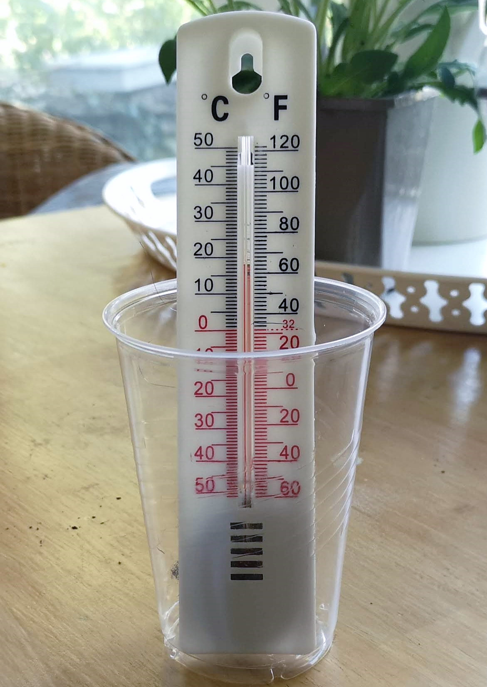Wrap the steel wool round the bulb of the thermometer.
- Place the thermometer in a jar and pad the space round the thermometer bulb with cotton wool or paper towel.
- Record the temperature and observe that happens over the next 10 – 15 minutes.

What is happening?
Rusting is in fact an exothermic reaction. However as it happens so slowly this is rarely noticeable. However, the removal of the protective layer allows rusting to happen much faster (and the high surface area of the steel wool increases this too).
You should see a noticeable (though not spectacular increase in temperature.

Investigation 3 – galvanic corrosion
This is not an entirely different sot of reaction in that galvanic reactions are involved in the effect that sodium ions have on corrosion.
You will need
Iron wool | Vinegar
Salt water | Aluminium foil

What to do
- Soak some steel wool in vinegar for about 1 minute. This should remove the protective layer.
- Dry the steel wool as much as you can – squeezing it in kitchen towel works well.
- Take some aluminium foil and fold/roll it into a ‘stick’ shape
- Wrap the steel wool around the aluminium foil. Try to get it as closely in contact as possible.
- Place the steel wool wrapped aluminium into some salt water.
- Observe what happens.
- Soak some steel wool in vinegar for about 1 minute. This should remove the protective layer.

What is happening?
After a short time, you should start to see bubbles appearing. These are bubbles of hydrogen as the aluminium reacts with the water, acting as a ‘sacrificial anode’.
When placed in an electrolyte, each bit of aluminium and iron becomes a tiny battery. But because the aluminium and iron particles are in contact, they become lots of tiny short-circuited batteries, which quickly burn out.

Investigation 4 – Composition of the air
It is possible to use the rusting of iron as a way to determine the percentage of oxygen in the air.
You will need
Iron wool | A tall-ish, narrow container*
A shallow bowl off water | Marker pen
Vinegar (optional) | Ruler

What to do
- Wedge some steel wool in the bottom of the narrow container
(To speed up the process, soak the steel wool in vinegar for a minute first and then squeeze out the liquid and dry as much as possible using kitchen towel)
- Place the container upside down in the water and leave.
- Watch what happens to the height of the water inside the container.
- When the experiment has finished, before removing it, use a marker pen to mark the position of the water level now and the level it was when the experiment started,

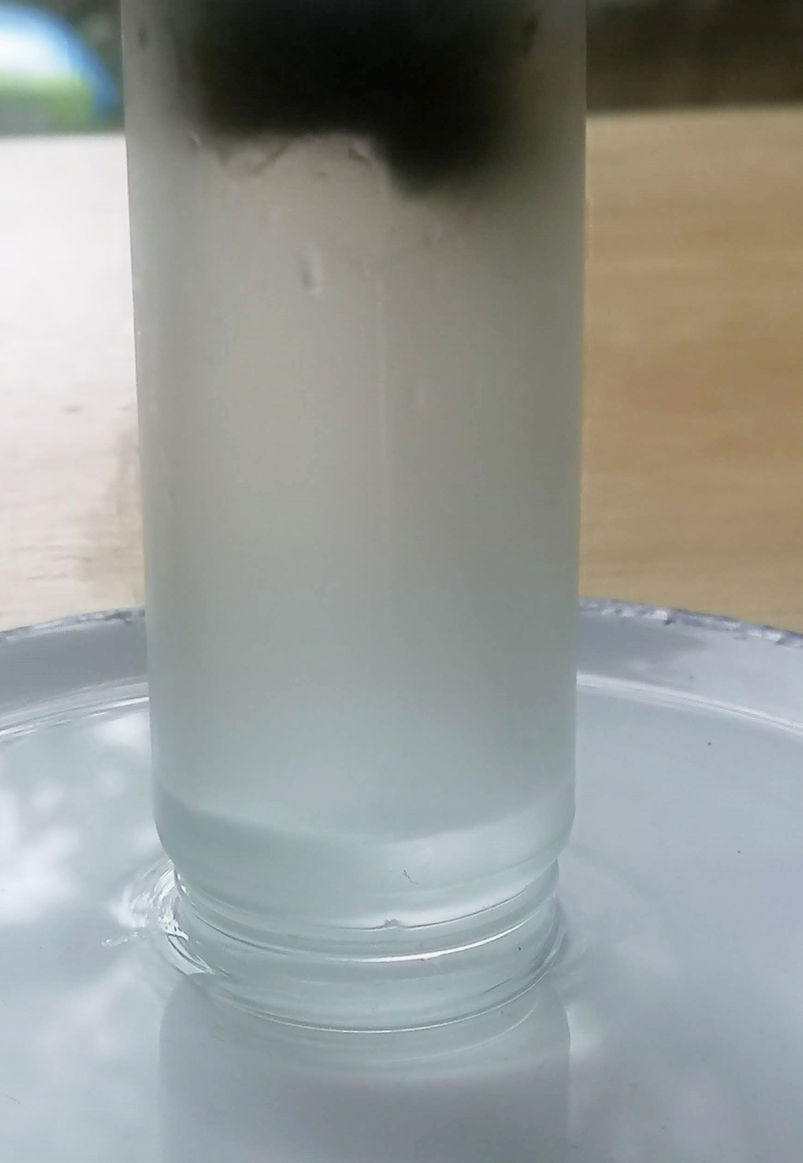What is happening?
As iron rusts, it reacts with oxygen in the air.
As the container is sealed at the bottom by the presence of water, the removal of oxygen means that it is at a lower pressure than that on the outside. As a result, the exterior air pressure forces the water up inside the container until the pressures are equal.
If you measure the distance from the original water level to the top (bottom) of the container, and the distance to the final water level. You should find out that the second value is roughly 20% of the first – representing the roughly 20% of the atmosphere that is made of oxygen.
* For this attempt, I used the glass jar from a salt/pepper grinder from a supermarket (handily empty). The initial figure I obtained was 25% oxygen.
However, the total volume was partially made up of the iron wool. Can you work out a way of finding out the volume of the iron wool to get a more accurate figurre?

