

|  |
| --- |
| Chemistry  At  Home |
| Molecular models |

**Introduction**

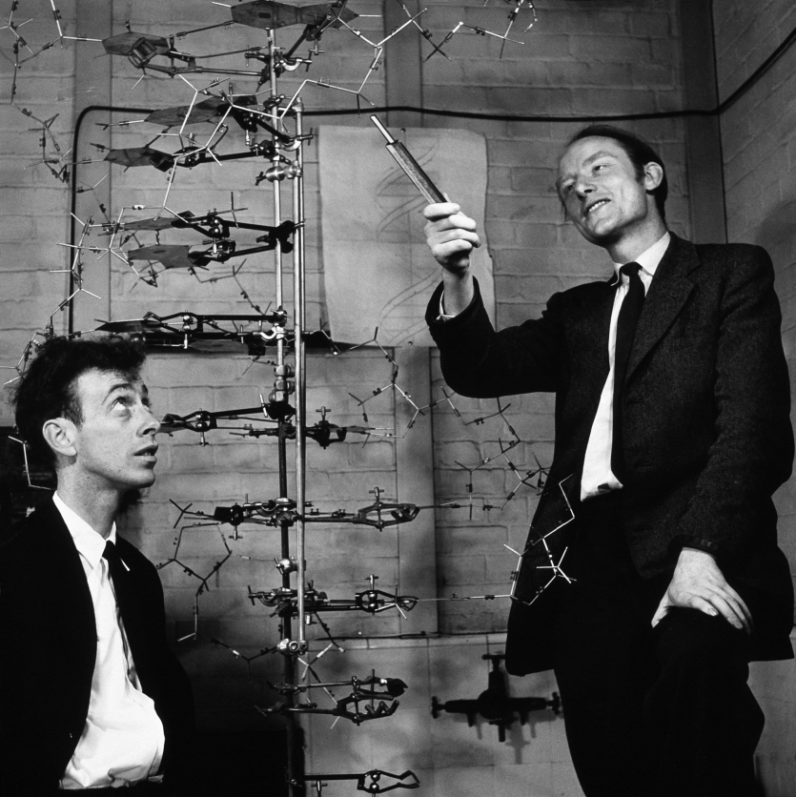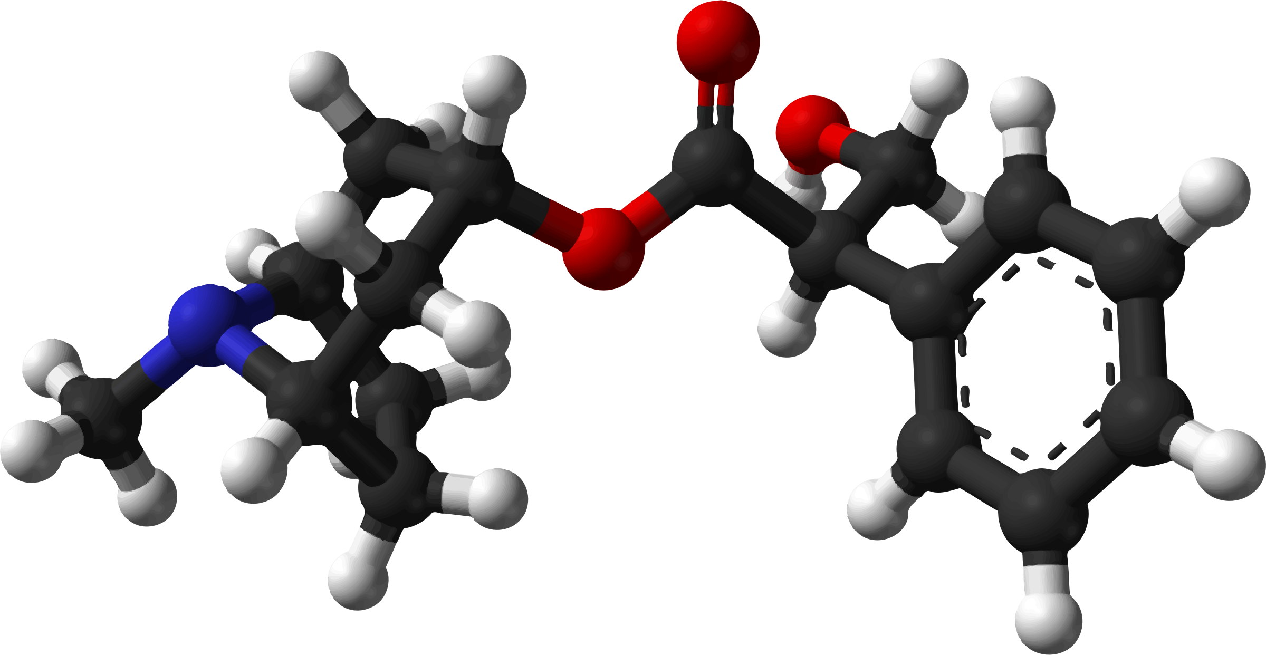

You will all of you have seen the sorts of molecular models on the front – drawn with the aid of computer software.

However, before the invention of computers, molecular models were still important – but they were all made by hand as physical, 3D structures.

It can still be a useful (and entertaining) activity to do.

# **You will need**

* Cocktail sticks (or possibly straws)
* ‘atoms’

The best stuff to use for these is probably plasticine, play doh or modelling clay but you can also produce a decent molecular model using sweets – and have more fun in the process.

Marshmallows are good (though they only have two colours). If you don’t want your model to be too large, use the mini ones. Alternatively, any small sweets that are soft enough to push cocktail sticks into will do. Midget gems, for instance, though they do need to be fairly warm as they get hard in the cold

# **What to do**

Decide on the molecule you are going to make and pick which sweets are going to represent which atom.

You might find it easier, particularly with small sweets, to cut the cocktail sticks in half (or even less) and then sharpen the ends.

Start assembling your molecule and see what you get.

How big/complicated a molecule can you make?

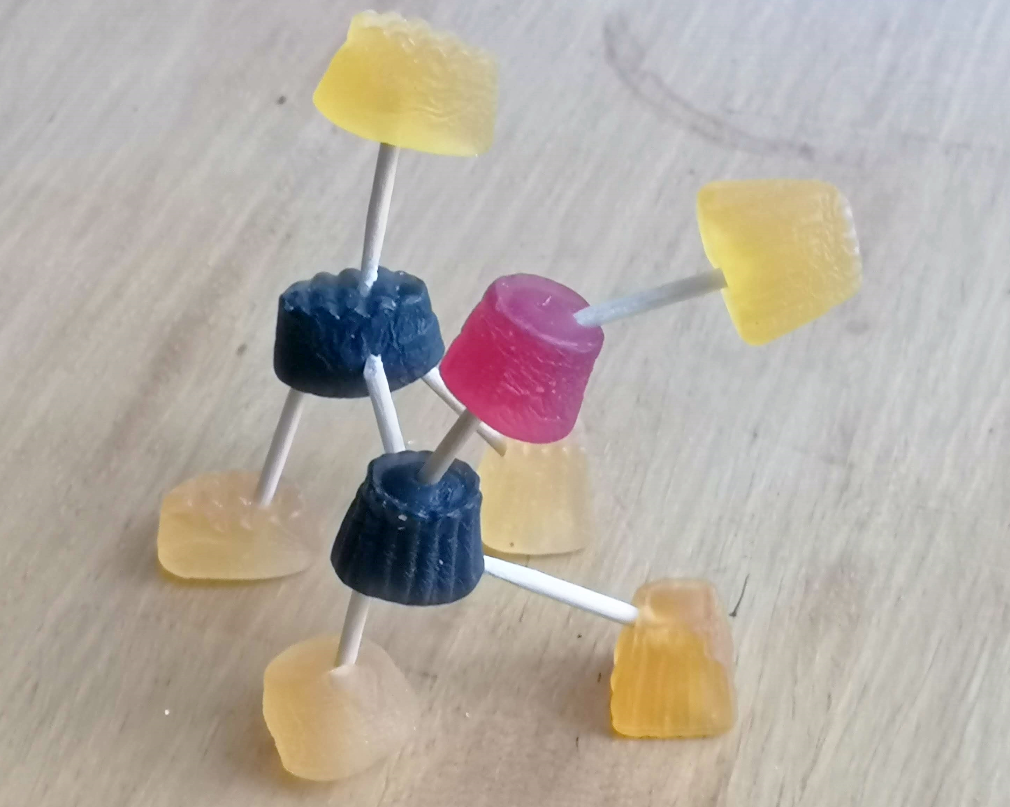

Here is a model of ethanol made from midget gems

Carbon = black

Hydrogen = yellow

Oxygen = red

**Extensions**

If you want to see about molecular modelling on computer, there is an excellent piece of free software called Chemsketch that you can download and use.

It is not the simplest piece of software to use but it is very powerful.