Chemistry
At
Home
Making
magnesium carbonate

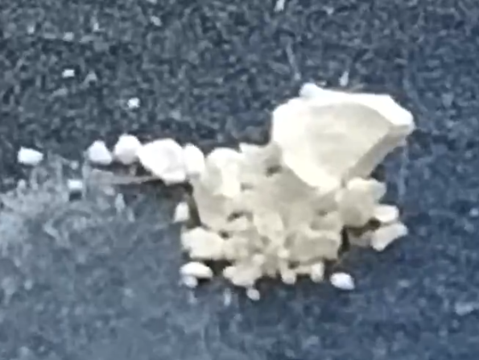
Introduction
While much chemistry is out of reach when at home, it is possible to synthesise some simple compounds at your kitchen table.
In this experiment, we will make some magnesium carbonate out of sodium carbonate (washing soda) and magnesium sulphate (Epsom salts). This will precipitate out when the solutions are mixed and can be filtered off.

You will need
- Magnesium sulphate (epsom salts*)
- Sodium carbonate (washing soda**)
- Plastic (or other cups) to make up solutions in.
- Measuring jug or some way of measuring liquid volume.
- Filter paper (coffee filter or kitchen towel)
- Funnel (if not available a tea-strainer will do.
- water
* Epsom salts can be found with bath salts in most supermarkets.
** Washing soda will be near the laundry detergents in most supermarkets.
Health and Safety
Sodium carbonate is an eye irritant. We recommend that eye protection of some sort is worn when using it. If this is not available, a responsible adult can make the saturate solution up and then dilute it 50:50 with water. This will be of no hazard.
Magnesium sulphate is of no hazard – but if the sodium carbonate is being diluted then diluting the magnesium sulphate 50:50 with water as well means you can stick with the measurements given here – the yield will be lower, that’s all.
It is the responsibility of the teacher to ensure an adequate risk assessment is carried out.

What to do
- Make saturated solutions of your two compounds. (If need be, dilute the two solutions 1:1 with water, see above)
A saturated solution of sodium carbonate at room temperature is about 20 g per 100 cm³ (which comes to 0.07 moles per 100 cm³.)
A saturated solution of magnesium sulphate at room temperature has 113 g per 100 cm³ (which comes to about 0.46 moles per 100 cm³.)
The equation for the reaction is:
Na₂CO₃ + MgSO₄ --> MgCO₃ + Na₂SO₄
So you need an equal number of moles of each reagent to react fully.
Given the difference in solubility, this means that you need to have about 6.5 times as much sodium carbonate as magnesium sulphate.
- Measure out the volumes of liquid you are going to mix and pour them both into a cup.
- 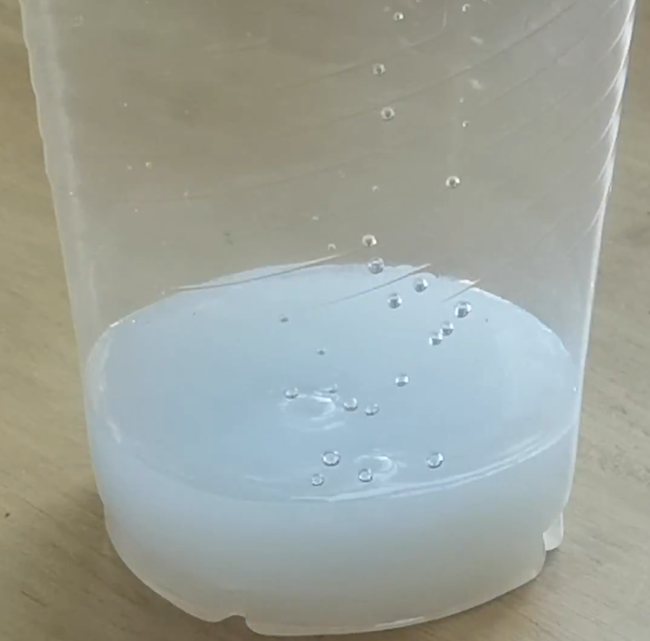You will see that the solution goes a cloudy white as insoluble magnesium carbonate is formed.

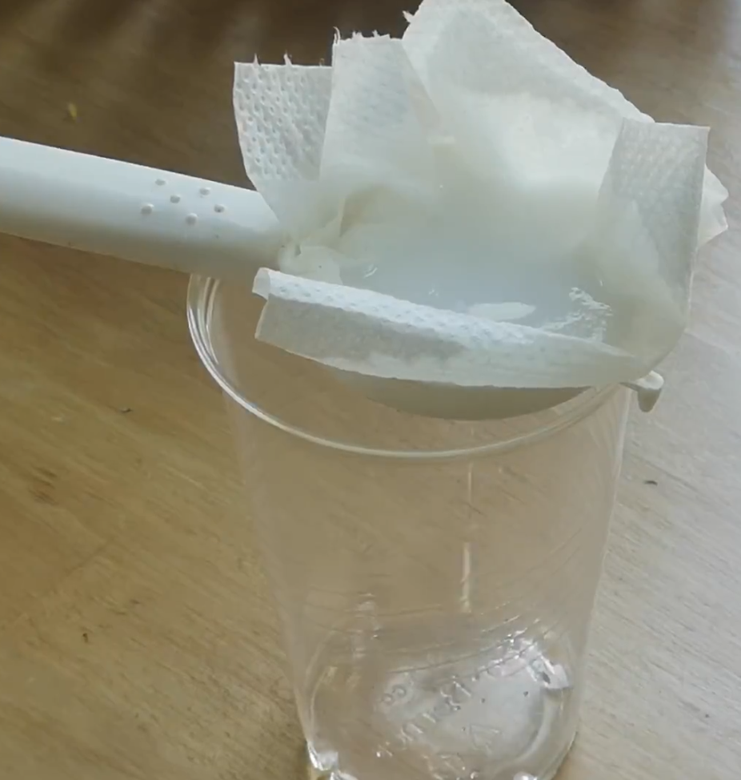
- Set up your filtration apparatus. It can be as simple as this one – a piece of kitchen towel (I folded it in two to make sure it filtered all the particles) in a tea strainer.
- Give your solution a stir and pour it into the filter. You will probably need to do this in several batches and it may be quite slow.
- Once all the filtrate has dripped through, sprinkle some fresh water on top of the filter to wash the filtrate. Let that drip through as well.

- Once it is not dripping any more, you can remove the filter paper and put it somewhere warm to dry. On a sunny windowsill, a radiator or even in an oven at a low temperature.
- When it is dry, you will have a white powder. This is magnesium carbonate.
- 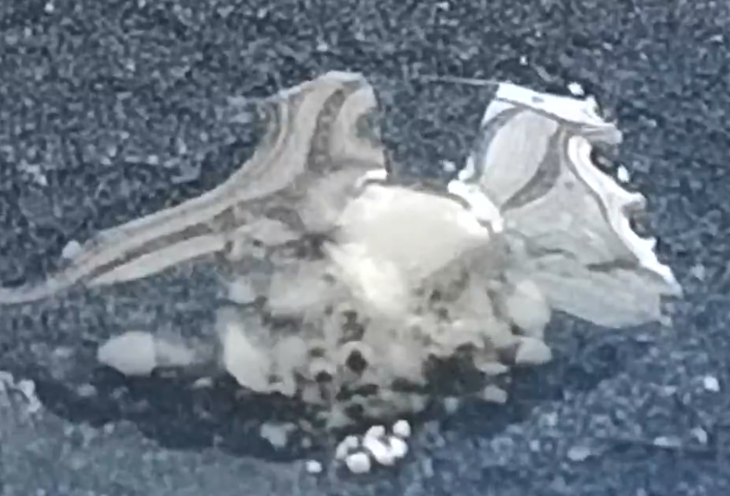Take a small amount of it and add a few drops of vinegar. You should see it fizzing, which proves it is a carbonate.

Extensions

Yield
If you have a pocket balance, (and you can get one for less than £10 on Amazon or Ebay) you should be able to work out your yield.
Given the solubilities of your starting materials and the amount you added, you should be able to work out how many moles you mixed. And from the equation you should be ably to work out how many moles of magnesium carbonate you expect to get.
If you weigh your magnesium carbonate, you should be able to work out how many moles you actually did get and see how it compares with what you expected.
Making magnesium ethanoate (magnesium acetate)
If you react your magnesium carbonate with ethanoic acid, it will react to give you a solution of magnesium ethanoate.
MgCO₃ + 2 CH₃COOH --> Mg(CH₃COO)₂ + CO₂ + H₂O
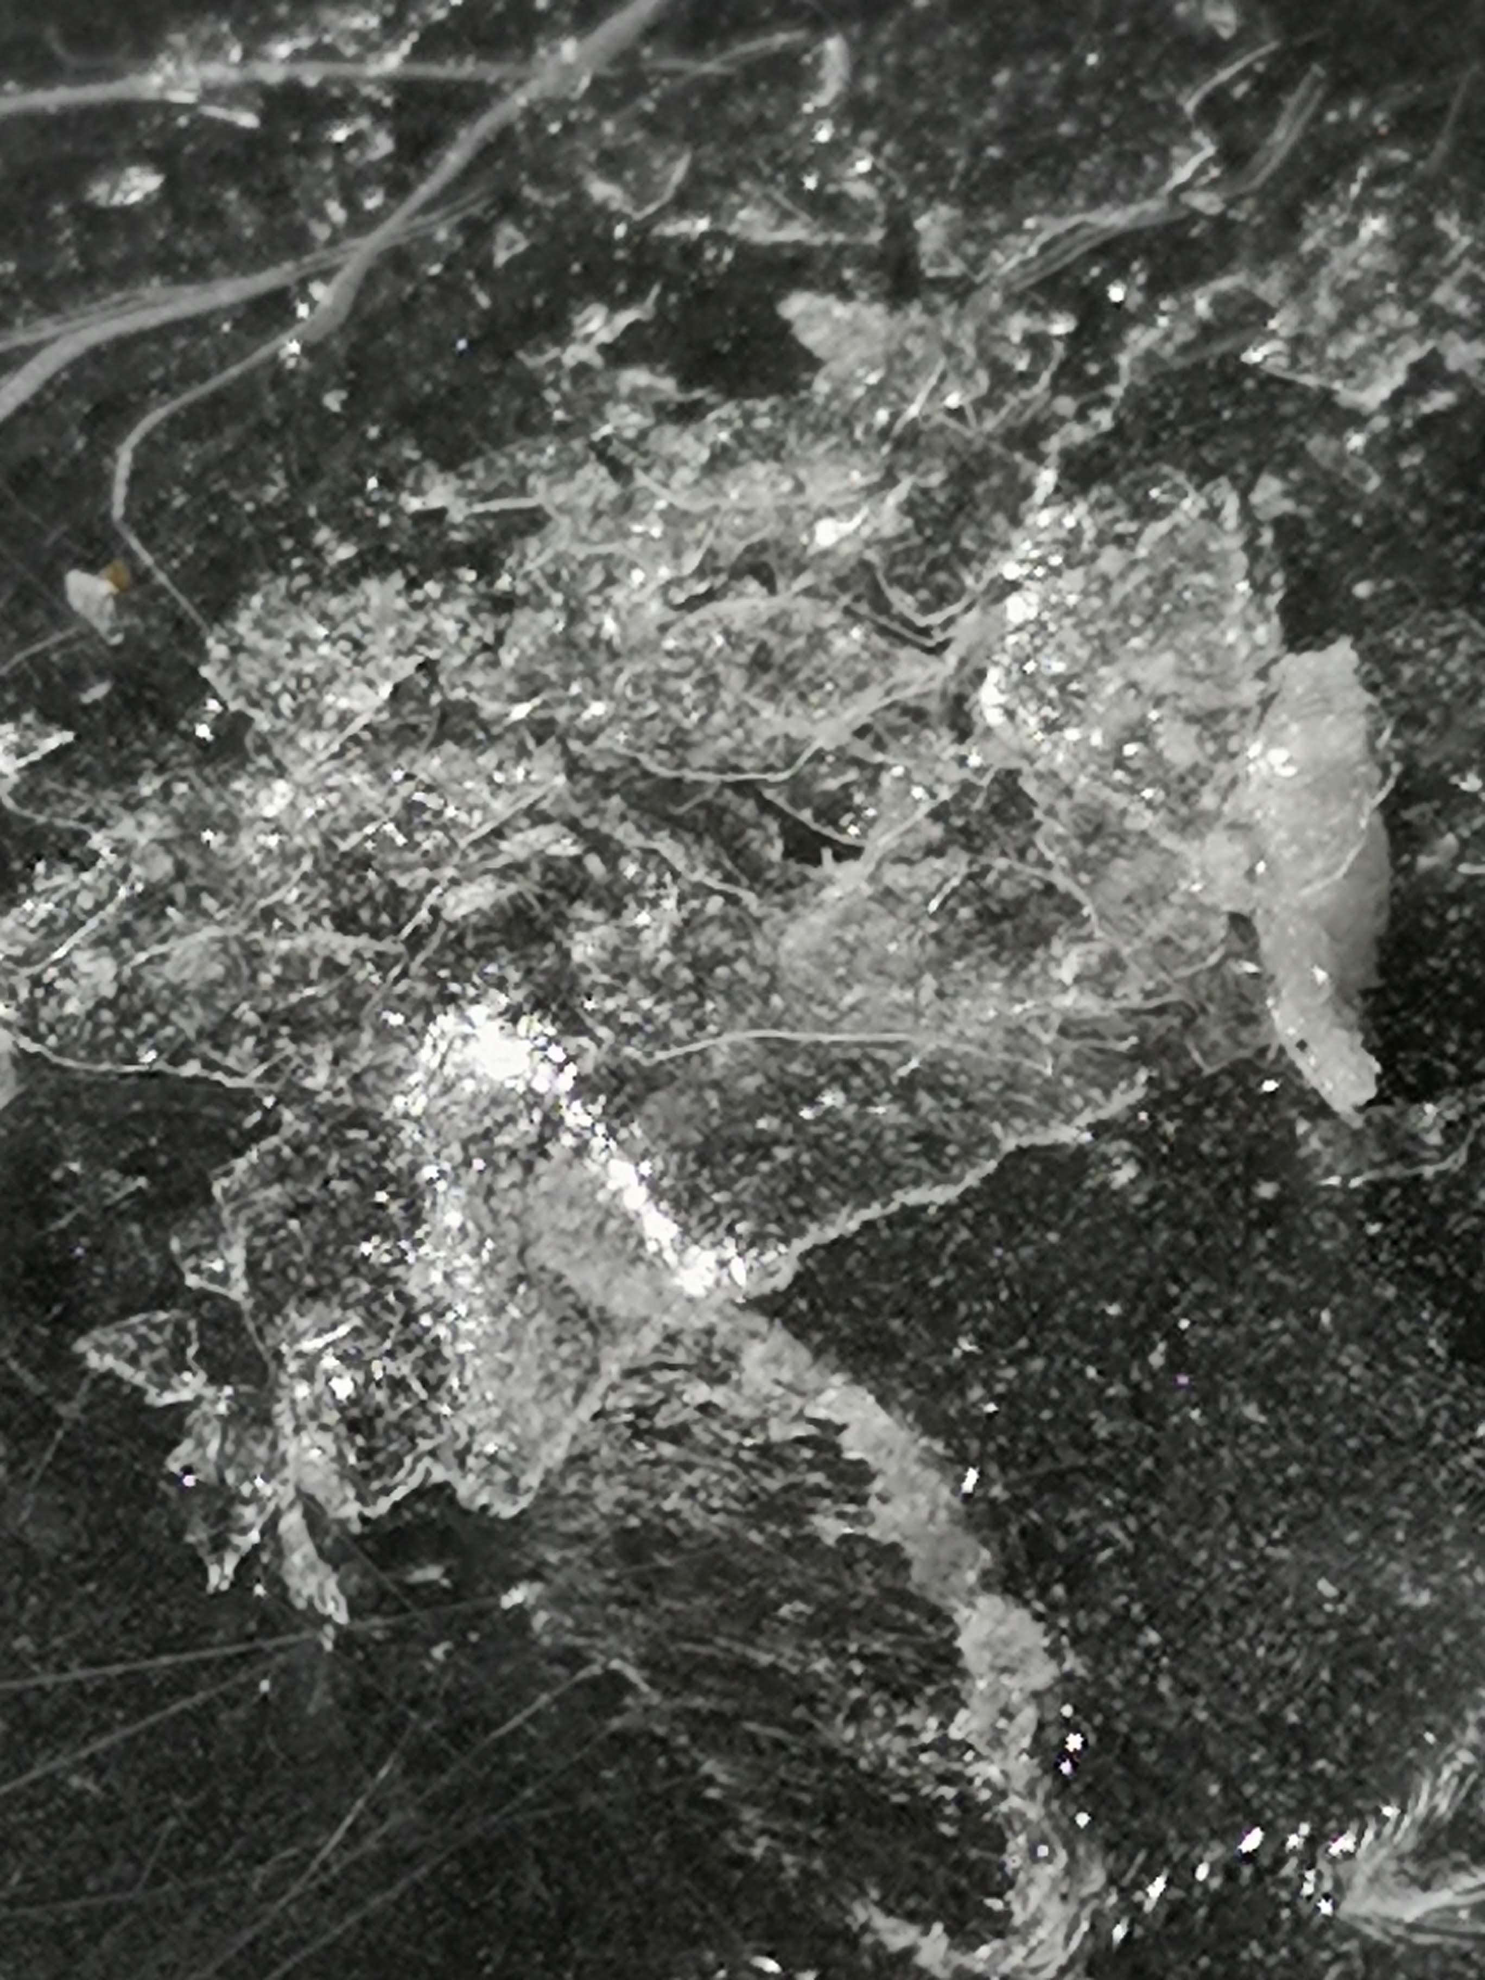Adding excess carbonate (so that there is some left unreacted at the bottom) means that the liquid will only contain magnesium ethanoate, CO₂ and water. So if you evaporate it, you will get magnesium ethanoate.
It is, however, very hygroscopic (it will absorb water greatly from the air) so you are unlikely to get nice looking crystals but you should see a white solid

