Chemistry
At
Home
Hydrogels

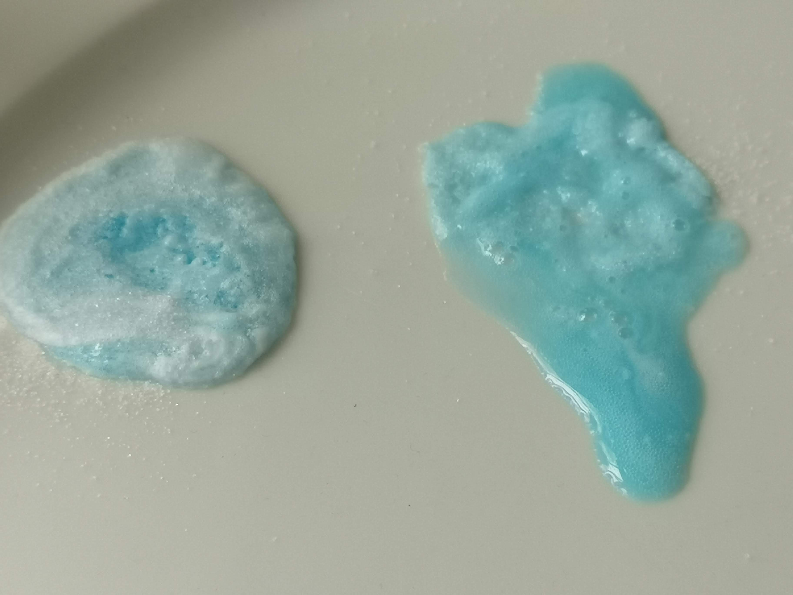
Introduction
A hydrogel is a solid, jelly-like material that can vary from soft and weak to hard and tough. By weight, gels are mostly liquid, yet they behave like solids.
Gels consist of a solid three-dimensional network that spans the volume of a liquid medium and ensnares it through surface tension effects. Virtually any fluid can be the basis of a gel including water (hydrogels), oil, and air (aerogel).
Both by weight and volume, gels are mostly fluid in composition and thus exhibit densities similar to those of their constituent liquids.
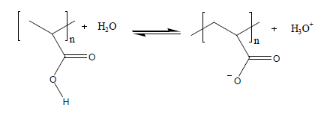Edible jelly is a common example of a hydrogel and has approximately the density of water.
Many hydrogels are polymers of carboxylic acids. The acid groups stick off the main chain of the polymer . When these polymers are put into water, the hydrogen atoms react and come off as positive ions.
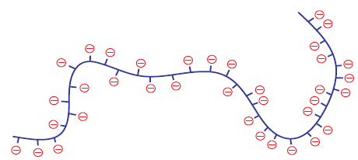
This leaves negative ions along the length of the polymer chain.
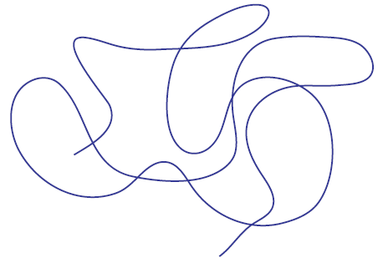

When polymer chains are in solution, they tend to coil up.
However, the hydrogel now has lots of negative charges down its length.
These negative charges do two things:
• They repel each other. This forces the polymer chain to unwind and open up.
• They attract water molecules. The water molecules stick to the hydrogel polymer and force it to open up even further.
The combination of the polymer opening up and the water molecules sticking to it make a solution of the hydrogel get thicker and more viscous.

Health & Safety
The materials involved are all of low hazard.
The only thing to watch out for is pupils being too vigorous in extracting the hydrogel particles from the nappies and raising too much dust that can be inhaled.
If this is a concern, a responsible adult can extract the hydrogel beforehand.
Experiment 1 – properties of Hydrogels
You will need
1 x dish/plate | 1 x sample of hair gel
salt | sugar
Spatula/teaspoon

Instructions
- Use the spatula/spoon to put two blobs of the hair gel on opposite sides of a dish
- Sprinkle some sugar on one blob.
- Sprinkle some salt on the other blob
- Leave for a few minutes.
- Observe any changes.

What is happening?
The polymer is in equilibrium with the water around it, but that equilibrium can be disturbed in a number of ways. If the the ionic concentration of the solution is increased – e.g., by adding salt – the positive ions attach themselves to the negative sites on the polymer, effectively neutralising the charges. This causes the polymer to collapse in on itself again.
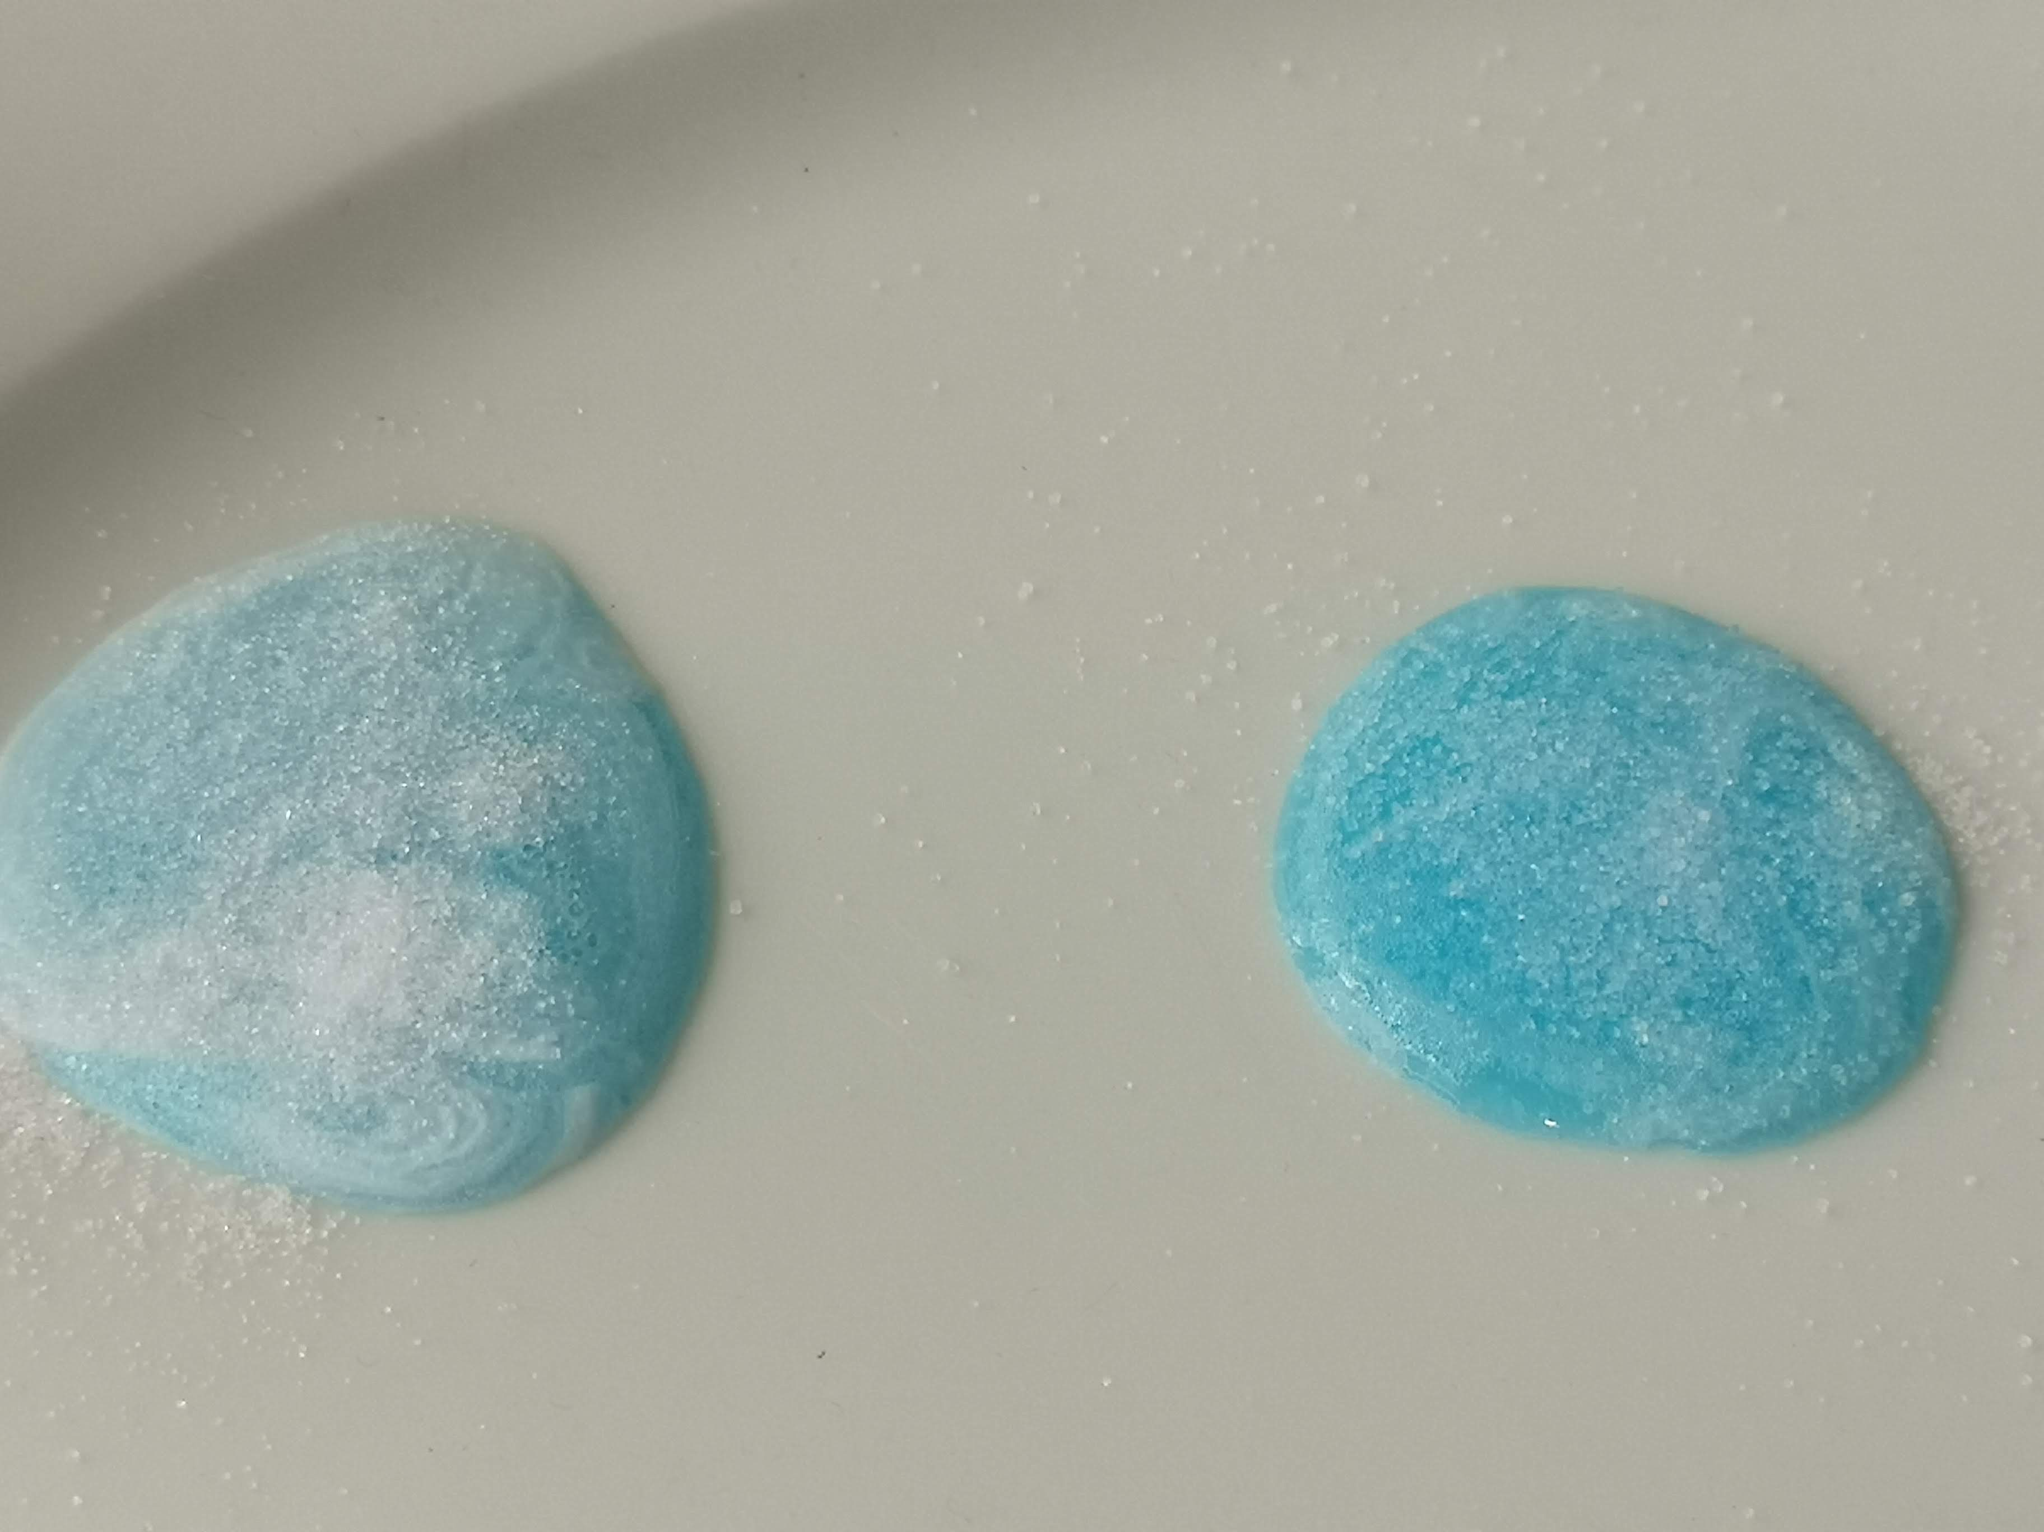
Sugar Salt Sugar Salt
Before After

Experiment 2 – hydrogels in action – disposable nappies

You will need
A disposable nappy | Scissors
A large plastic bag (ideally transparent) | Distilled water
Salt | Dessert spoon or similar measure
A stirring rod or spoon | A large beaker/jug (600 cm³)
Measuring cylinder or jug to measure 100 cm³

What to do
- Cut the middle section out of the nappy. You want the thicker piece which is designed to absorb urine. Discard the other piece.
- Make sure your ice cream container is completely dry – wipe it with a paper towel if necessary. If there is any moisture in the tub the experiment will not work properly.
- Be careful with this step.
Put the centre piece of the nappy into plastic bag and gently take it apart. Try to tease it apart as much as you can. You should start to see small white grains coming away from the nappy and this is what you are trying to collect. Keep gently pulling the nappy apart until you have collected as many of the grains as you can. Do not do this roughly or you will lose your product and put a lot of dust and fluff into the air. Avoid breathing in any dust you do create.
- The grains are heavier than the other materials and fall to the bottom of the heap, which makes it easier to separate them out. The easiest way to get them is to cut to corner off the bag and pour the grains out, then you can get rid of the rest of it in the bin.
- Estimate the volume of the grains.
- Pour the grains into the large beaker and add about 100 cm³ distilled water). Stir the mixture and keep adding distilled water until no more can be absorbed. Stir between each addition of water. Estimate the final volume of the hydrogel.
- Take a spoonful of your hydrogel and put it in a small beaker for later
- Add a dessert spoonful of salt to the large beaker and stir.
What is happening?
As was said in the introduction; in solution the hydrogel has lots of negative charges down its length and these negative charges do two things:
• They repel each other. This forces the polymer chain to unwind and open up.
• They attract water molecules. The water molecules stick to the hydrogel polymer and force it to open up even further.
The combination of the polymer opening up and the water molecules sticking to it make a solution of the hydrogel get thicker and more viscous.
When salt is added, the positively charged sodium ions adhere to the polymer more strongly that the weakly polarised water molecules and so displace them. The water and the polymer separate.
Experiment 3 – Hydrogel Beads
You will need
Water | Salt
Plant water beads* | Some small cups/glasses
Distilled/deionised wate (optional)

* These are available online (Amazon, Ebay) for around £1.50 per pack)
** Not essential but bottles can be bought from garages quite cheaply (or you can try to make your own)
What to do
- Set up about 4 small glasses containing
  - Deionised water
  - Tap water
  - Slightly salty water. (Seawater contains around ½ a level teaspoon of salt per 100 cm³)
  - Very salty water (Make it saturated or close to)
- Put 3 or 4 beads into each glass and then leave.
- Watch what happens.
What is happening?
You will find that the purer the water the bigger the bead swells up.
This polymerr is more rrigid but still absorbs a significant amount of water.
As before, though, if there is salt present, it will prevent the water binding to the polymer and as a result the bead does not swell up as much.
Extension
See if there is a relationship between the concentration of the salt and the diamete of the beads. You can set up a few glasses with different amounts of salt and plot a graph.

Investigation 4 – Gelatin gels and enzymes
One of the most common gels use in food is gelatin – responsible for jellies and for most jelly-type sweeeties.
In this case, the gel network is composed of a protein, collagen.
Some fruits contain enzymes called proteases that break down proteins and as a result they will beak down the structure. The easiest to get hold of are Kiwi fruit (which contains actinidain) and pineapple (which contains bromelain)
You will need
Water | Gelatin / jelly*
Kiwi fruit and/or pineapple | Some small glasses or sauces

* You can find gelatin easily enough in supermarkets – make a 2% solution following the manufacturer’s instructions. Alternaitively, just get a packet of jelly and make it up accorning to the instuctions
What to do
- Before it sets, pour a layer of your gelatin/jelly into a few containers (cups/saucers etc)
  - One is left alone as a control
  - On one put some pieces of kiwi fruit
  - On another put some pieces of pineapple
- Leave overnight, or at least fo seveal hours, and see what happens

What is happening?
The enzymes digest the protein network that contains the water so you should find that there is much more liquid in the sample that has been exposed to eithe of the fruits.
Extensions
- Blend a kiwi fruit or two. Keep half to one side and boil the other for a few minutes in a pan. Once cool, put a teaspoon or two of each of the kiwi extracts onto anotehr sample of gelatin/jelly and leave to see what happens.
Enzymes, like mose biological molecules, are quite fragile. Boiling destroys their structure and prevents them from working – so the boiled one should have little effect on the jelly.
- Tinning
Try using tinned fruit to see if it works as well

