Chemistry
At
Home
Growing Crystals

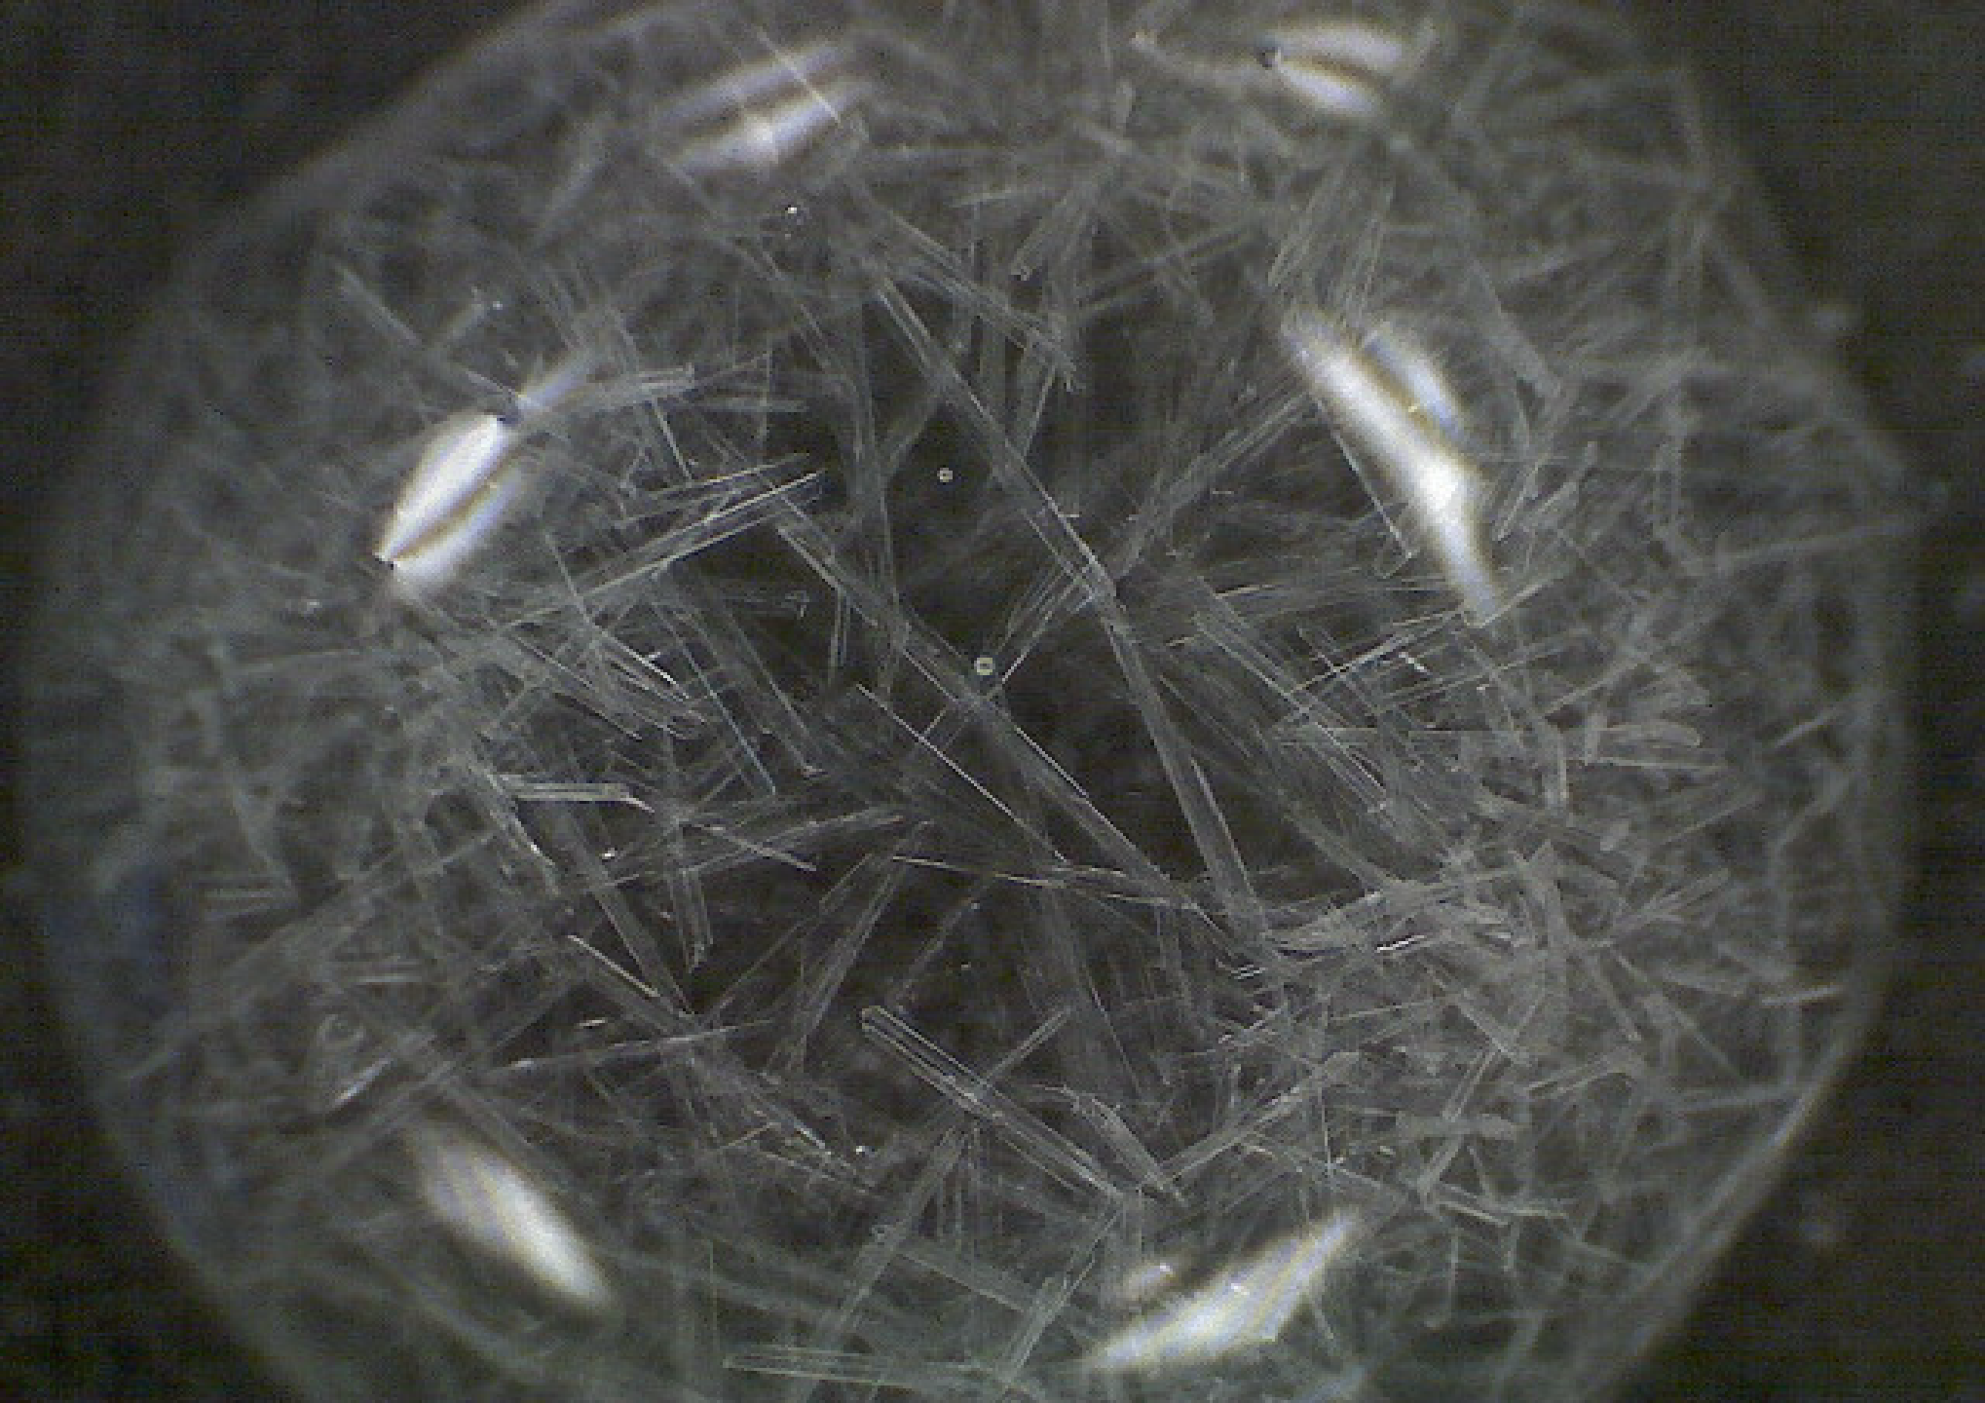
Growing crystals is always an interesting activity

You will need

- Warm water
- Magnesium sulphate (Epsom salts)
- Paper (Black or dark coloured paper if possible).
- Scissors
- small dish

What to do

- Cut the black paper so it will fit in the bottom of your pie pan.
- Add 15g of magnesium sulphate* (1 tablespoon) to 50 cm³ of warm water. Stir until it is dissolved.
- Pour the salty water onto the (black) paper in the dish
- Put the dish in a warm place: a sunny windowsill or on a radiator**.
- When the water evaporates, you'll see lots of crystal spikes on the black paper!
If you are using white paper the crystals will still be there but might be a bit harder to see.
* These can be found as Epsom salts in most supermarkets – they are used as bath salts.
** The warmer the place the quicker the crystals will form but the smaller they will be.

Other crystals
You can try growing and examining all sorts of other crystals. Salt (sodium chloride) is a good place to start. You won’t get the needle-shaped crystals you get from epsom salts but they might still be interesting. Sugar is another one to try.
Go ahead and try other substances* – if you can only find bath salts that don’t claim to be Epsom salts, try them and see what you get. Research which ones make crystals and see what you can get.

* Safety.
It is very unlikely that you will find anything dangerous in the home to grow crystals from but care is needed.
Salt, sugar, Epsom salts, other bath salts, baking soda (sodium bicarbonate) and cream of tartar are fine. If you find something else, make sure you check before growing the crystals with someone who knows – your chemistry teacher would be the best option.

Different ideas
You can also grow crystals on a string. Look on the internet, there are plenty of simple methods given.

Photographs
These crystals look great under a microscope . . . but you are unlikely to have a microscope at home.
However, it is possible to buy cheap clip-on lenses for your phone that magnify quite well enough to get some great pictures of crystals. (See over the page).
