Chemistry
At
Home
Chromatography

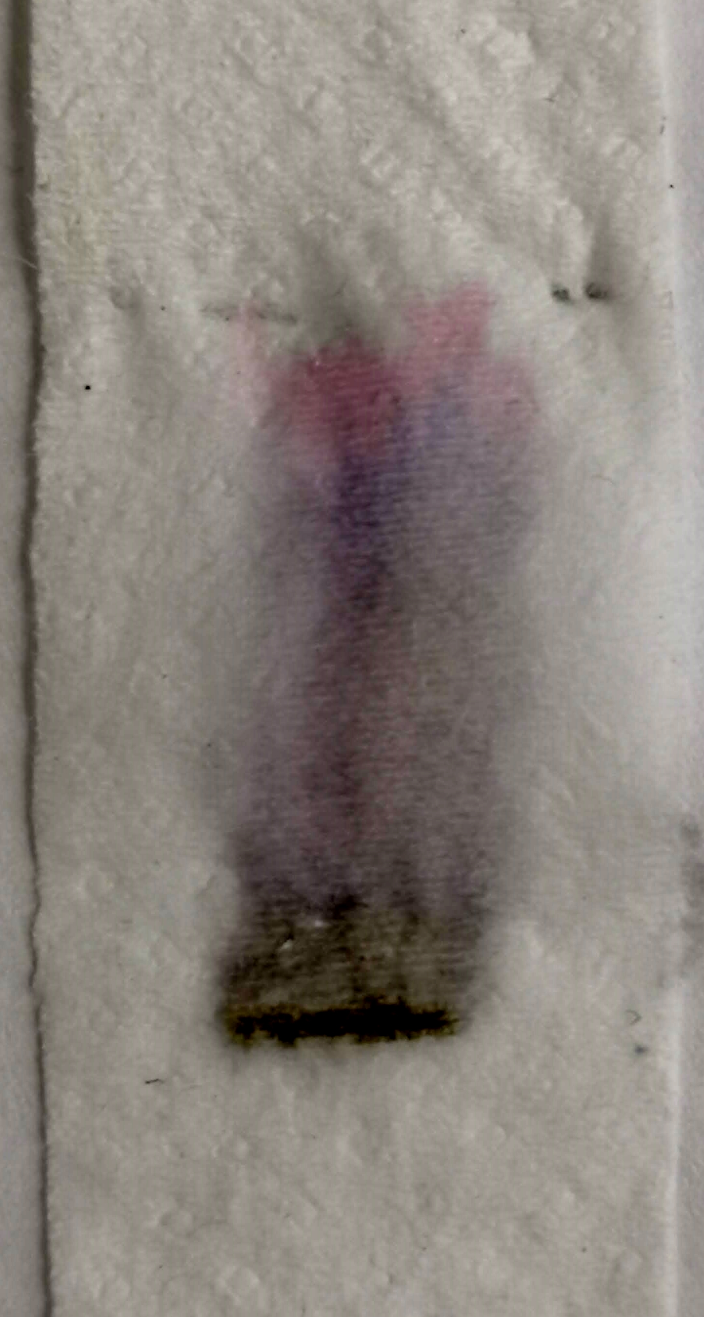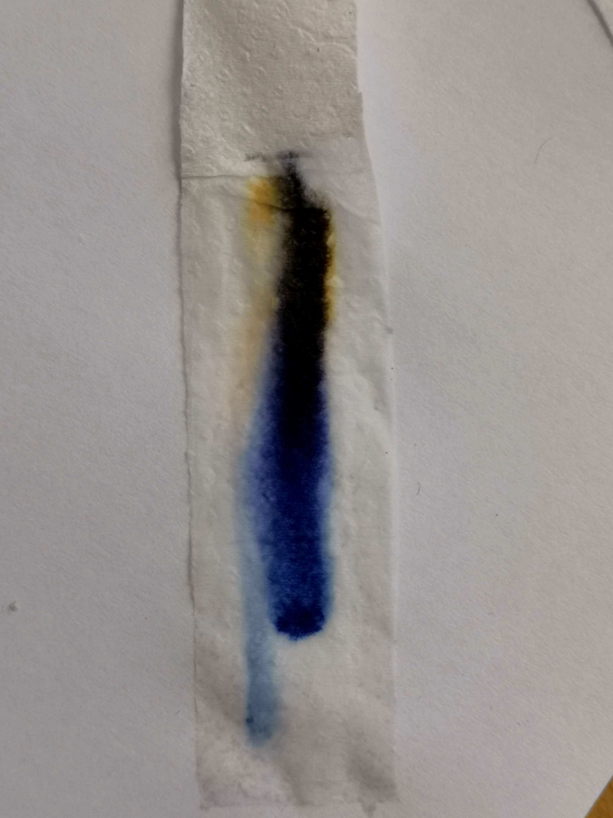
Introduction
This experiment uses a technique called chromatography.
In this simple paper chromatography, when you dip the paper in water, the dried pigments in the ink dissolve. As the water travels up the paper, it carries the pigments along with it. Different-coloured pigments are carried along at different rates; some travel farther and faster than others. How fast each pigment travels depends on the size of the molecule and on how strongly it is attracted to the paper. Since the water carries the different pigments at different rates, if the ink is made up of a mixture of separate inks, they separate to reveal the colours that were mixed to make it.

You will need
- scissors
- white paper coffee filter (This is the best but it is possible to use strips of kitchen roll – at a pinch, you can use strips of newspaper – it actually works reasonably well but is very slow – it will take about an hour)
- Marker pens (not permanent). Darker colours are best, especially black.
- Pen/pencil
- water
- coffee cup or mug or a glass

What to do
- Take your pen, pencil and use selotape to fix the end of a strip of paper to the middle of it so that when you place the pencil across the top of the mug/glass, the paper dangles down into it.
- See how far your paper goes and cut the length so it is just short of the bottom.
- Make a pencil mark on your paper about 1-2 cm from the bottom (so you can see where the ink started from afterwards)
- Apply a small blob of ink to the paper level with the line and let it dry for a few minutes.
- Put a small amount of water into your mug/glass. It must be below the level of your ink blob.
- 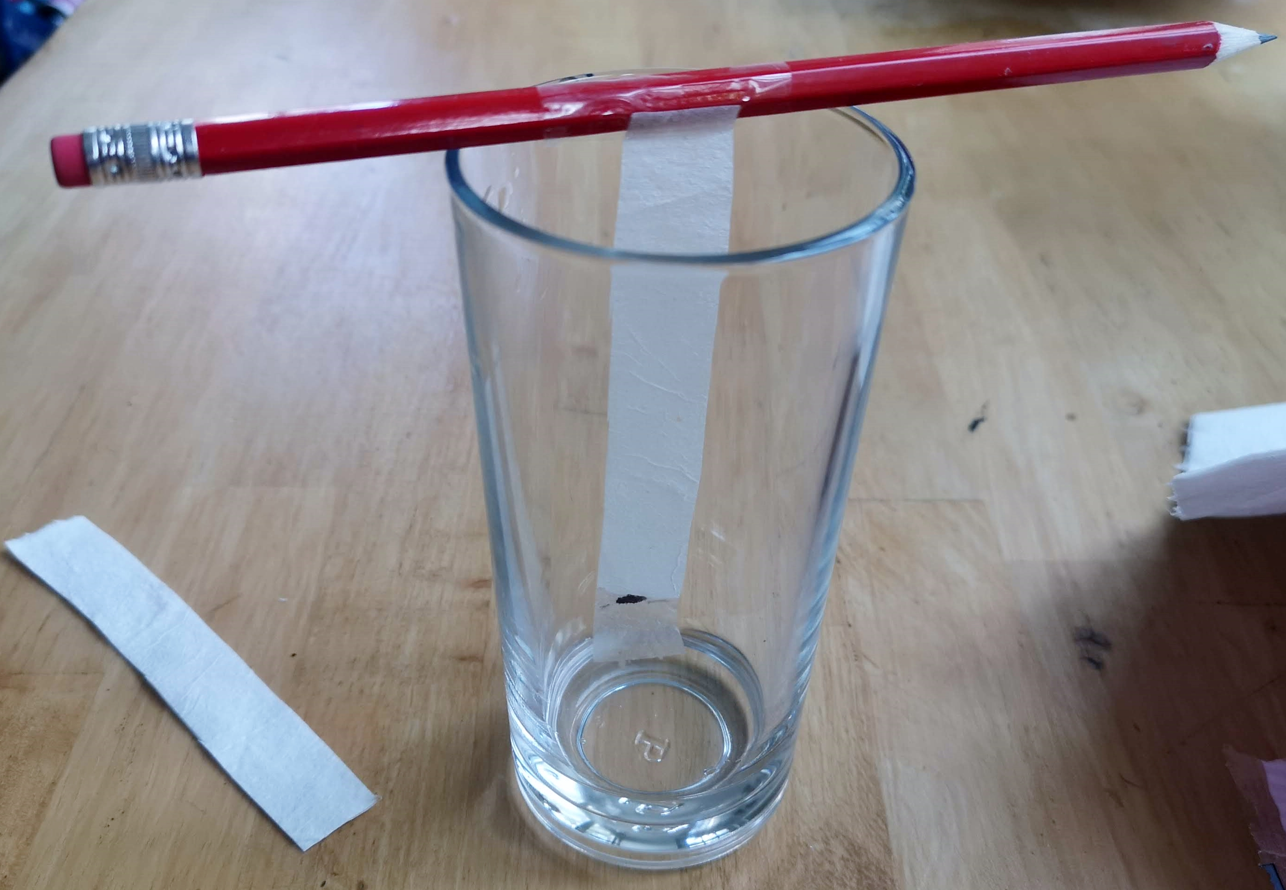Dip your paper into the water and lower the pen/pencil/stick onto the rim of the glass to support it.
- Wait and watch what happens.
- Once you have had enough, take the paper out and make another pencil mark on the dry part of the paper, just above where the water reached (as close to it as you can)
Now try with some more pens.
Do all the black pens give you the same set of colours?

Extensions

Sweets
You can try to investigate the colours of some sweets. Skittle and M&Ms seem to work best but feel free to try any.
- Put a few sweets of the same colour in the bottom of a glass or cup.
- Add a few drops of water. Use the smallest amount you can as that gives the most concentrated colour.
- Swirl the sweets around in the water to get the colour into the water.
- Now try to put a small drop of the colour onto the paper strip – in the same way you did with the pen.
Use a very small paint brush – at a pinch you can get a small stick like a cocktail stick. If you squash one end of it with a pair of pliers, you can make it fibrous and use this instead.
- The dye will be quite faint so leave it to dry and then put another drop on top of the first,
- Leave that to dry as well (put it on a radiator or somewhere warm – if you are careful, you can use a hairdryer). Then add another few drops, drying each time.
Now dip the paper strip in the water as you did before and see what happens

Rf values
To help you see if the colours are actually the same, you can look at how far they travelled up the paper. To do this we use figures called Rf values.
Take your first paper strip.
Measure how far from the bottom the first colour travelled. It can be difficult if it is smeared or not in a straight line but do your best.
You can pick both the furthest and the nearest distance to give you a range.
Now measure the distance travelled by the water. This is where your second pencil mark comes in handy.
If you divide the distance travelled by the ink by the distance travelled by the water, you get a number (between 0 and 1) – this is the Rf value and it will always be the same for the same ink using the same paper and solvent.
Bow have a look at your other papers – see if any of them contain the same dyes.

