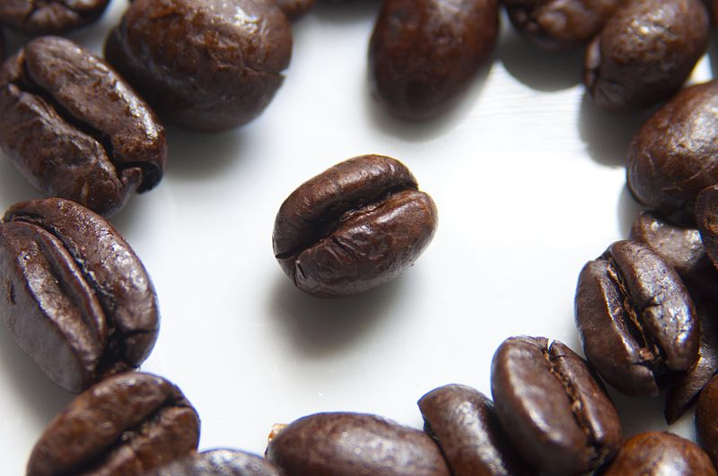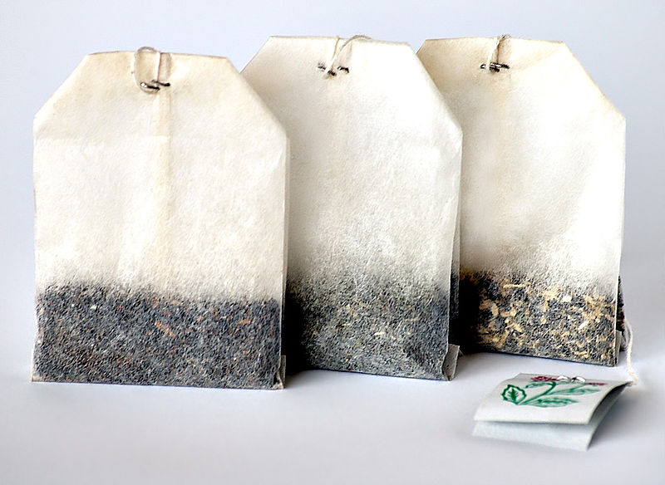Introduction - Colorimetry and Beer’s Law

Analysis of

Iron and Manganese

in Tea and Coffee

A colorimeter consists of a light source, a filter to provide an approximation of monochromatic light, a cell for the test solution and a measuring deviceto determine the response of a photo-electric cell to the transmitted light. This can be represented diagrammatically as below:

Light Source Filter Sample Cell Photocell Sensitive meter

Beer’s Law (1852) states that absorbance (optical density) is proportional to the concentration of the absorbing species when the light path in the solution is of constant length.

Absorbance = log Io/I

Where Io is the intensity of the incident light;

And I is the intensity of the transmitted light.

Therefore, the concentration of the absorbing species is proportional to (log Io/I)

Solutions are tested against a “blank” - a cell containing only the solvent used in the preparation of the test solution. The colorimeter is set to give 100% transmittance with the blank - 100 is then taken as the value for Io .

The wavelength of the filter used is determined by placing a cell containing the sample solution in the colorimeter and fitting different filters to the light source. With solutions of low concentration, the filter which gives the lowest transmittance should be used as this transmits more of the wavelengths absorbed by the sample. This means that small changes in concentration have a large effect on the readings obtained.

## Quantitative Analysis of Iron in Tea

This experiment aims to quantify the level of iron in a sample of tea. This can be achieved by bringing the iron into solution as Fe3+ ions and reacting with excess thiocyanate ions (CNS-). The concentration of the blood-red complex formed by this reaction can then be determined using colorimetry and hence the mass of iron in the original sample determined.

The predominant complex formed will probably be [Fe(CNS)]2+ although small quantities of the [Fe(CNS)2]+ and [Fe(CNS)6]3- complexes may be formed. All three species are red and all contain 1 mole of iron. Therefore, the presence of these other complexes will have no bearing on the results obtained.

In order to calibrate the colorimeter, AR iron(III) nitrate was used to prepare a solution of 0.001 M Fe3+. Accurate dilutions were performed upon this solution to give a range of Fe3+ concentrations.

50 cm3 of each solution was treated with 5cm3 of 0.1M ammonium thocyananate and the concentration of the resulting complex tested using the colorimeter.

|  |  |  |
| --- | --- | --- |
| Concentration (mol l-1) | Transmittance, I(%) | logIo/I |
| 0.0001  0.0002  0.0004  0.0006  0.0008  0.001 | 94  90  78  67  58  52 | 0.027  0.051  0.108  0.187  0.236  0.284 |

A filter of wavelength 580 nm was used as this gave the lowest transmittance with the most concentrated sample tested.

# Quantitative Analysis of Iron in Tea - Method

**Preparation**

* *Approximately 2g of the tea is weighed accurately into a crucible and roasted in a fume cupboard for several minutes until all the tea has turned to ash.*
* *The ash is allowed to cool and washed into a beaker using up to 20 cm3 2mol l-1 nitric acid.* [corrosive]
* *A further 20cm3 of 2mol l-1 nitric acid* [corrosive] *is added and the mixture is boiled for 5 minutes.*
* *The mixture is again allowed to cool and then filtered (to make sure any unburned carbon, that could possibly remain in the mixture and affect the result, is removed).*
* *The filtrate is then placed in a 50cm3 standard flask and made up to the mark using distilled water.*

**Method**

* Put 10 cm3 of the tea extract in a test tube
* Add 1 cm3 of 0.1*mol l-1* ammonium thiocyanate solution.

*This constitutes an excess. Excess thiocyanate is added to ensure that all the Fe3+ions present react and to provide a stronger, more stable colour.*

* Put 3 cm3 of the resulting coloured solution into a cuvette and read the absorption / transmittance in a colorimeter at (roughly) 580nm.
* In the mystrica colorimeters we are using, select the red filter.
* Repeat the process 3 times for each tea tested.
* Compare your colorimeter reading with a standard graph to determine the concentration of the iron complex in your solution.

# Results

|  |  |  |  |
| --- | --- | --- | --- |
| Tea | Transmittance 1(%) | logIo/I | Concentration (mol l-1.) |
| Tesco  Somerfield  Earl Grey  Darjeeling | 92  90  91  95  94  96  79  77  78  84  85  86 | 0.036  0.046  0.041  0.022  0.027  0.018  0.102  0.114  0.108  0.076  0.071  0.066 | 0.000130  0.000160  0.000140  0.000080  0.000095  0.000065  0.000340  0.000390  0.000370  0.000270  0.000250  0.000235 |

# Tesco:

Mass of sample = 2.014g

Average concentration of iron(III) complex = 0.000143 mol l -1

No. moles iron in sample = cv = 0.000143 x 0.05 = 7.15 x 10-6 moles

Mass of iron in sample = 7.15 x 10-6 x 56 = 4.0 x 10-4g = 0.40mg

Mass of iron in 100g of tea = (0.40/2.014) x 100 = 20.0mg

# Somerfield

Mass of sample = 2.805g

Average concentration of iron(III) complex = 0.00008 mol l-1

No. moles iron in sample = cv = 0.00008 x 0.05 = 4 x 10-6 moles

Mass of iron in sample = 4 x 10-6 x 56 = 2.24 x 10-4g = 0.22mg

Mass of iron in 100g of tea = (0.22/2.805) x 100 = 11.0mg

# Earl Grey:

Mass of sample = 2.168g

Average concentration of iron(III) complex = 0.000367 mol l-1

No. moles iron in sample = cv = 0.000367 x 0.05 = 1.835 x 10-5 moles

Mass of iron in sample = 1.835 x 10-5 x 56 = 1.03 x 10-3g = 1.03mg

Mass of iron in 100g of tea = (1.03/2.168) x 100 = 47.5mg

# Darjeeling

Mass of sample = 2.072g

Average concentration of iron(III) complex = 0.0002517 mol l-1

No. moles iron in sample = cv = 0.0002517 x 0.05 = 1.258 x 10-5 x 56 moles

Mass of iron in sample = 1.258 x 10-5 x 56 = 7.04 x 10-4g = 0.70mg

Mass of iron in 100g of tea = (0.70/2.072) x 100 = 34.0mg

# Quantitative Analysis of Manganese in Tea

This experiment aims to quantify the level of manganese in a sample of tea. This is achieved by bringing the manganese into solution as Mn 2+ ion then oxidizing to the purple MnO4- (permanganate) ion using potassium periodate:



The concentration of the permanganate ion can then be determined using colorimetry and hence the mass of manganese in the original sample calculated.

A solution of 0.001mol l-1 potassium permanganate was made up and accurate dilutions performed to give a range of permanganate concentrations.

Each solution was tested against a blank in the colorimeter.

|  |  |  |
| --- | --- | --- |
| Concentration (mol l-1) | Transmittance, I (%) | Log Io/I |
| 0.0001  0.0002  0.0004  0.0006  0.0008  0.001 | 91  84  63  51  42  34 | 0.041  0.076  0.202  0.292  0.377  0.469 |

A filter of wavelength 430nm was used as this gave the lowest transmittance with the most concentrated sample tested.

## Quantitative Analysis of Manganese in Tea - Method

* *Weigh approximately 2g of the tea accurately into a crucible and roast it in a fume cupboard for several minutes until all the tea has turned to ash.*
* *Allow the ash to cool and then wash it into a beaker using concentrated hydrochloric acid.*
* *Add further hydrochloric acid to just cover the ash. Then evaporate the mixture to dryness in a fume cupboard.*
* *Dissolve the residue in 4mol l-1 sulphuric acid and filter it as a precaution to ensure that no unburned carbon which could affect the results remains in the solution.*
* *Heat the solution until it begins to fume in order to drive off any chlorides present which could react with the periodate and give false results.*
* *Allow the solution to cool and then add 2 cm3 of concentrated phosphoric acid in order to prevent the precipitation of ferric periodate or iodate and decolourise any ferric ion which might be present.*
* *Add 0.5g of potassium periodate and boil the mixture for 1 minute and then keep it hot for a further 5 minutes.*
* *Allow the resulting permanganate solution to cool*
* *Place the filtrate in a 50cm3 standard flask and make up to the mark using distilled water.*
* *Then test it using the colorimeter.*

**Method**

* Put 3 cm3 of the resulting coloured solution into a cuvette and read the absorption / transmittance in a colorimeter at (roughly) 430nm.
* In the mystrica colorimeters we are using, select the blue filter.*
* Repeat the process 3 times for each tea tested.
* Compare your colorimeter reading with a standard graph to determine the concentration of the iron complex in your solution.

*\* The reference graph here was obtained at 430nm, not using the mystrica colorimeter. The blue LED for this is 465 nm.*

# Results:

|  |  |  |  |
| --- | --- | --- | --- |
| Tea | Transmittance, I (%) | Log Io/I | Concentration (mol l-1) |
| Tesco | 92  93  91 | 0.036  0.032  0.041 | 0.000130  0.000160  0.000140 |
| Somerfield | 95  96  96 | 0.022  0.018  0.018 | 0.000050  0.000035  0.000035 |
| Earl Grey | 75  74  75 | 0.125  0.131  0.125 | 0.000260  0.000275  0.000260 |
| Darjeeling | 84  82  80 | 0.076  0.086  0.097 | 0.000160  0.000180  0.000200 |

## Tesco:

Mass of sample = 3.162g

Average concentration of permanganate = 0.00013 mol l-1

No. of moles manganese in sample = cv = 0.00013 x 0.05 = 6.5 x 10-6 moles

Mass of manganese in sample = 6.5 x 10-6 x 55 = 3.60 x 10-4g = 0.36mg

Mass of manganese in 100g of tea = (0.36/3.162) x 100 = 11.4mg

## Somerfield

Mass of sample = 2.031g

Average concentration of permanganate = 0.00004 mol l-1

No. of moles manganese in sample = cv = 0.00004 x 0.05 = 2 x 10-6 moles

Mass of manganese in sample = 2 x 10-6 x 55 = 1.1 x 10-4g = 0.11mg

Mass of manganese in 100g of tea = (0.11/2.031) x 100 = 5.4mg

## Earl Grey:

Mass of sample = 2.580g

Average concentration of permanganate = 0.000265 mol l-1

No. of moles manganese in sample = cv = 0.000265 x 0.05 = 1.325 x 10-5 moles

Mass of manganese in sample = 1.325 x 10-5 x 55 = 7.288 x 10-4g = 0.73mg

Mass of manganese in 100g of tea = (0.73/2.580) x 100 = 28.3mg

## Darjeeling

Mass of sample = 2.421g

Average concentration of permanganate = 0.00018 mol l-1

No. of moles manganese in sample = cv = 0.00018 x 0.05 = 9 x 10-6 moles

Mass of manganese in sample = 9 x 10-6 x 55 = 5.0 x 10-4g = 0.50mg

Mass of manganese in 100g of tea = (0.50/2.421) x 100 = 20.7mg

# Conclusion

This project calculated the levels of iron and manganese in various teas from around the world. The results of these experiments can be displayed using a bar chart:

It is clear from this that Earl Grey, a Chinese tea, contains a higher level of both iron and manganese than the other teas tested. Darjeeling, an Indian tea, in turn contains more of these metals than the supermarket blends.

This may be because the cheaper blended teas are of lower quality than the other teas and so contain more of the stems of the plants, as opposed to the leaves, and therefore smaller quantities of metals are present. It may also be that blended teas are predominantly made up of tea from Ceylon and tea from this region contains less iron and manganese than tea from elsewhere – just as the Indian tea contains lower levels than the Chinese tea.

# Errors

The errors in these experiments come from the measurement of weights and volumes, and from the preparation of solutions using standard flasks.

All weights were measured using an electronic balance (correct to 3 decimal places, ± 0.001g) and all volumes were measured using pipettes (± 0.6ml). the errors associated with these pieces of equipment and those associated with the standard flasks are very small.

There may also have been errors in reading the scale on the colorimeter (± 1%) and in drawing the calibration curves. These errors should also have been very small.

# Suggestions for Future Work

The experiments could be extended to include teas from other parts of the world, particularly Ceylon. The same analysis could also be carried out on various types of coffee or vegetables and cereals.

# Bibliography

P.R Scott – School Science Review, March 1992, 73 (264)

A Jackson – School Science Review, September 1990, 72 (258)

Arthur J. Vogel – Quantitative Inorganic Analysis

J Smart & AJ Watson – Practical Work in CSYS Chemistry

Equipment/Chemical list

General:

Indirect Vent goggles

Gloves

Colorimeter (580 nm and 420 nm filters)

Buchner funnel and Filter paper

Side arm flask

Water pump

Standard flasks

Wash bottles of distilled water

Bunsen burner, heat mat and tripod stand

Crucibles

Samples of tea

Fume cupboard

Balance (preferably 3 d.p.)

Spatulas

Stirring rods

Beakers

Iron in Tea:

AR iron(III) nitrate to prepare a solution of 0.001 M Fe3+

2M nitric acid

0.1M ammonium thiocyanate

Manganese in Tea:

Potassium permanganate to prepare 0.001M potassium permanganate

concentrated hydrochloric acid

4M sulphuric acid

concentrated phosphoric acid

potassium periodate