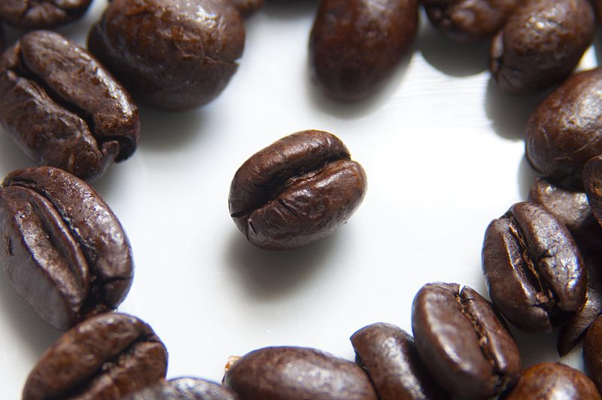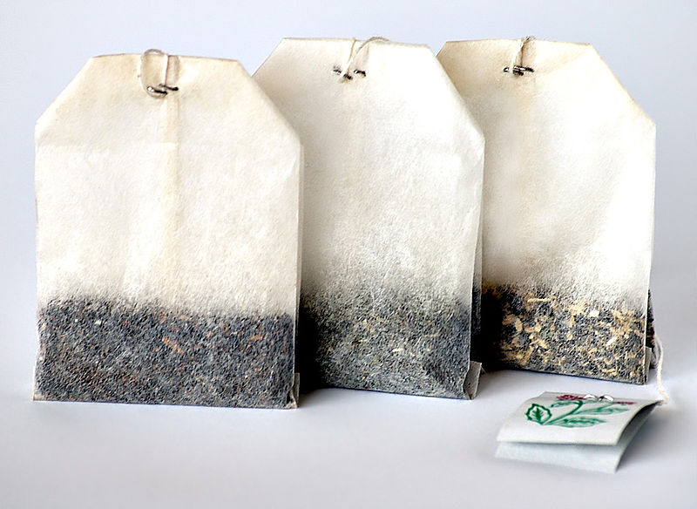Quantitative Analysis of Iron in Tea

Analysis of

Iron and Manganese

in Tea and Coffee

This experiment aims to quantify the level of iron in a sample of tea. This can be achieved by bringing the iron into solution as Fe3+ ions and reacting with excess thiocyanate ions (CNS-). The concentration of the blood-red complex formed by this reaction can then be determined using colorimetry and hence the mass of iron in the original sample determined.

The predominant complex formed will probably be [Fe(CNS)]2+ although small quantities of the [Fe(CNS)2]+ and [Fe(CNS)6]3- complexes may be formed. All three species are red and all contain 1 mole of iron. Therefore, the presence of these other complexes will have no bearing on the results obtained.

**Reference curve**

In order to calibrate the colorimeter, AR iron(III) nitrate is used to prepare a solution of 0.001 M Fe3+.

Accurate dilutions should be performed upon this solution to give a range of Fe3+ concentrations.

50 cm3 of each solution is treated with 5cm3 of 0.1M ammonium thocyananate and the concentration of the resulting complex tested using the colorimeter.

A filter of wavelength 580 nm was used as this gave the lowest transmittance with the most concentrated sample tested.

## Quantitative Analysis of Iron in Tea - Method

**Preparation**

* *Approximately 2g of the tea is weighed accurately into a crucible and roasted in a fume cupboard for several minutes until all the tea has turned to ash.*
* *The ash is allowed to cool and washed into a beaker using up to 20 cm3 2mol l-1 nitric acid.* [corrosive]
* *A further 20cm3 of 2 mol l-1 nitric acid* [corrosive] *is added and the mixture is boiled for 5 minutes.*
* *The mixture is again allowed to cool and then filtered (to make sure any unburned carbon, that could possibly remain in the mixture and affect the result, is removed).*
* *The filtrate is then placed in a 50cm3 standard flask and made up to the mark using distilled water.*

**Method**

* Put 10 cm3 of the tea extract in a test tube
* Add 1 cm3 of 0.1 *mol l-1* ammonium thiocyanate solution.

*This constitutes an excess. Excess thiocyanate is added to ensure that all the Fe3+ions present react and to provide a stronger, more stable colour.*

* Put 3 cm3 of the resulting coloured solution into a cuvette and read the absorption / transmittance in a colorimeter at (roughly) 580nm.
* In the mystrica colorimeters we are using, select the red filter.
* Repeat the process 3 times for each tea tested.
* Compare your colorimeter reading with a standard graph to determine the concentration of the iron complex in your solution.

**Results**

By comparing your colorimeter reading with the reference graph, you can find the concentration of the Iron thiocyanate complex in the solution.

From there it is possible to work out the amount of iron in the original sample.

Sample – Name ……………………………….……

1. To find the number of moles of iron extracted from the tea sample (and hence in the original 50cm3 sample)

*Moles of Iron = Concentration (from graph) x volume (in l)*

*= …………………. x 0.05 = …..........................*

1. To find the mass of **iron** extracted from the tea sample

*Mass of Iron = Moles Fe (from above) x RAM of iron*

*= …………………. x 56 = …..........................*

1. To convert this value to mg, multiply by 1000

*= …………………. x 1000 = …..........................*

1. To find the mass of **iron** per 100g of tea

Mass of Iron per 100g = Mass Fe (from above) x (mass tea or coffee/100)

= …………………. x ...................... = …..........................

100

Sample – Name ……………………………….……

1. To find the number of moles of iron extracted from the tea sample (and hence in the original 50cm3 sample)

*Moles of Iron = Concentration (from graph) x volume (in l)*

*= …………………. x 0.05 = …..........................*

1. To find the mass of **iron** extracted from the tea sample

*Mass of Iron = Moles Fe (from above) x RAM of iron*

*= …………………. x 56 = …..........................*

1. To convert this value to mg, multiply by 1000

*= …………………. x 1000 = …..........................*

1. To find the mass of **iron** per 100g of tea

Mass of Iron per 100g = Mass Fe (from above) x (mass tea or coffee/100)

= …………………. x ...................... = …..........................

100

Quantitative Analysis of Manganese in Tea

This experiment aims to quantify the level of manganese in a sample of tea. This is achieved by bringing the manganese into solution as Mn 2+ ion then oxidizing to the purple MnO4- (permanganate) ion using potassium periodate:



The concentration of the permanganate ion can then be determined using colorimetry and hence the mass of manganese in the original sample calculated.

**Reference curve**

A solution of 0.001M potassium permanganate should be made up and accurate dilutions performed to give a range of permanganate concentrations.

Each solution should be tested against a blank in the colorimeter.

A filter of wavelength 430nm was used as this gave the lowest transmittance with the most concentrated sample tested.

# Quantitative Analysis of Manganese in Tea - Method

* *Weigh approximately 2g of the tea accurately into a crucible and roast it in a fume cupboard for several minutes until all the tea has turned to ash.*
* *Allow the ash to cool and then wash it into a beaker using concentrated hydrochloric acid.*
* *Add further hydrochloric acid to just cover the ash. Then evaporate the mixture to dryness in a fume cupboard.*
* *Dissolve the residue in 4 mol l-1 sulphuric acid and filter it as a precaution to ensure that no unburned carbon which could affect the results remains in the solution.*
* *Heat the solution until it begins to fume in order to drive off any chlorides present which could react with the periodate and give false results.*
* *Allow the solution to cool and then add 2 cm3 of concentrated phosphoric acid in order to prevent the precipitation of ferric periodate or iodate and decolourise any ferric ion which might be present.*
* *Add 0.5g of potassium periodate and boil the mixture for 1 minute and then keep it hot for a further 5 minutes.*
* *Allow the resulting permanganate solution to cool*
* *Place the filtrate in a 50cm3 standard flask and make up to the mark using distilled water.*
* *Then test it using the colorimeter.*

**Method**

* Put 3 cm3 of the resulting coloured solution into a cuvette and read the absorption / transmittance in a colorimeter at (roughly) 430nm.
* In the mystrica colorimeters we are using, select the blue filter.*
* Repeat the process 3 times for each tea tested.
* Compare your colorimeter reading with a standard graph to determine the concentration of the iron complex in your solution.

*\* The reference graph here was obtained at 430nm, not using the mystrica colorimeter. The blue LED for this is 465 nm.*

**Results**

By comparing your colorimeter reading with the reference graph, you can find the concentration of the permanganate in the solution.

From there it is possible to work out the amount of manganese in the original sample.

Sample – Name ……………………………….……

1. To find the number of moles of manganese extracted from the tea sample (and hence in the original 50cm3 sample)

*Moles of Manganese = Concentration (from graph) x volume (in l)*

*= …………………. x 0.05 = …..........................*

1. To find the mass of **manganese** extracted from the tea sample

*Mass of Manganese = Moles Mn (from above) x RAM of iron*

*= …………………. x 54.9 = …..........................*

1. To convert this value to mg, multiply by 1000

*= …………………. x 1000 = …..........................*

1. To find the mass of **manganese** per 100g of tea

Mass of manganese per 100g = Mass Mn (from above) x (mass tea or coffee/100)

= …………………. x ...................... = …..........................

100

Sample – Name ……………………………….……

1. To find the number of moles of manganese extracted from the tea sample (and hence in the original 50cm3 sample)

*Moles of Manganese = Concentration (from graph) x volume (in l)*

*= …………………. x 0.05 = …..........................*

1. To find the mass of **manganese** extracted from the tea sample

*Mass of Manganese = Moles Mn (from above) x RAM of iron*

*= …………………. x 54.9 = …..........................*

1. To convert this value to mg, multiply by 1000

*= …………………. x 1000 = …..........................*

1. To find the mass of **manganese** per 100g of tea

Mass of manganese per 100g = Mass Mn (from above) x (mass tea or coffee/100)

= …………………. x ...................... = …..........................

100