Resistance – it’s (all) in the bag.
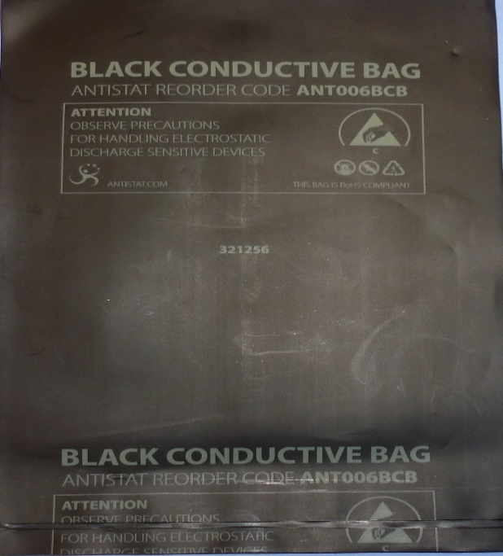
Velostat™ or (Linqstat™) is a carbon-loaded polyethylene manufactured by 3m™. This material is often used in the form of a small bag 0.1 mm thick to protect static sensitive semiconductor components (fig1). The resistance across the long axis of a strip 0.1 mm x 30 mm x 130 mm is of the order of 50 kΩ.

Fig 1 Black conductive bag made from Velostat.
Possible Investigations using Velostat
- Factors affecting Resistance (length and width)
A strip of Velostat of a fixed width can be cut. One end of the Velostat is attached over a piece of laminated graph paper (to make measurements of length simpler) using binder clips as shown in fig 2. One lead of a multimeter set to a suitable resistance range is connected to this binder clip. The other end of the multimeter is connected to a similar binder clip which is used to push down on the Velostat at various distances (use the graph paper scale) from the first clip. Readings of distance between binder clips and resistance can then be noted. A typical graph is shown in fig 3.
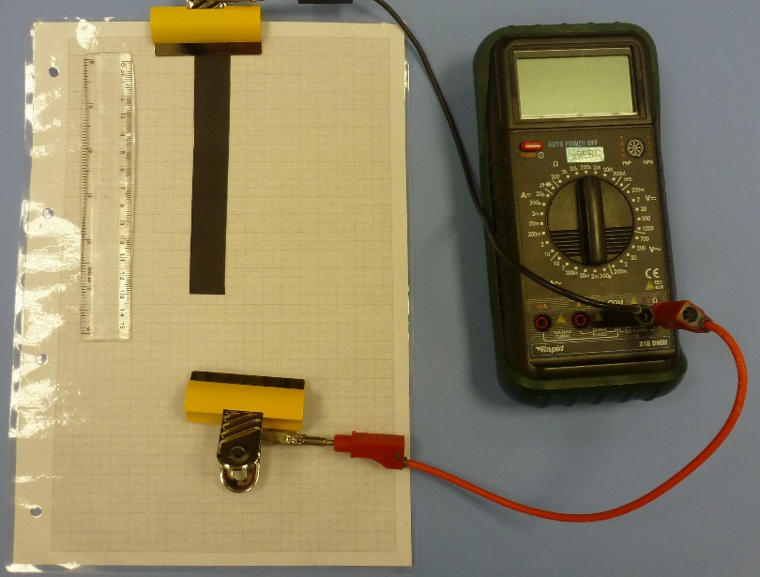
Fig 2 Investigating Length vs Resistance Fig 3 Results of Length vs Resistance
Strips of the same length but of different width can be used to investigate how the width (really the cross-sectional area as material has a uniform thickness of 0.1 mm) affects resistance. Plotting R against 1/w for five values of width results in a typical graph as shown in fig 4. For a slightly more detailed analysis (fig 5) using the same data, plotting Ln(R) vs Ln(w) gives a gradient equal to the power to which the width is raised.

Fig 4 Graph of Resistance vs 1/width Fig 5 Graph of Ln(R) vs Ln (w)

- Factor affecting Resistance (Temperature)
Noting the resistance of a strip of Velostat at different temperatures shows that the resistance increases as temperature increases. The resistance of a fixed length of Velostat was measured using a multimeter and the temperature measured using a non-contact infra-red thermometer. Readings were taken indoors, outdoors and in a fridge. This is awkward as an investigation and results were ‘messy’.

- Factor affecting Capacitance (Area of overlap)
A similar test set up to fig 2 can be used to investigate capacitance vs area of overlap. Two strips of Velostat (narrower strip uppermost if dissimilar) are separated by a piece of polythene cut from a small bag. Leads from a capacitance meter are attached as shown in fig 6. The upper strip is moved to alter the area of overlap which can be calculated from the width of the upper strip and the length of overlap (again the ruler or graph paper can help). Typical results are shown in fig 7. The capacitance measured is small and for small areas of overlap there may be other factors to consider.
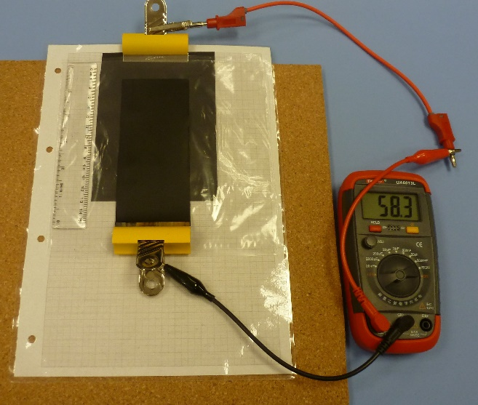
Fig 6 Capacitance vs Area of overlap Fig 7 Results of Area of overlap vs Capacitance
- Factor affecting Capacitance (Thickness of dielectric)
The experiment above can be repeated using several thicknesses of polythene as the dielectric. It was found difficult to exclude air from between the layers of dielectric (and from between the velostat and the dielectric) which had a noticeable effect on the measured capacitance.

- Factor affecting resistance (Piezoresistance)
A small ‘test rig’ was constructed using two pieces of copper foil each approximately 50 mm x 30 mm and a piece of Velostat approximately 40 mm x 40 mm (fig 8). Leads were soldered to the edge of the copper foil pieces and connected to a multimeter measuring resistance. The mass placed on top and the corresponding resistance were recorded. Typical results are shown fig 9.

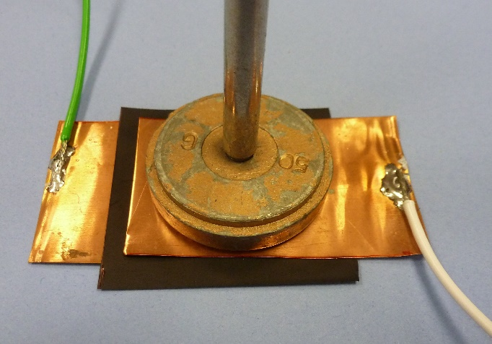

Fig 8 Piezoresistance test set up Fig 9 Graph of Resistance vs Force

The data from fig 9 plotted as R vs 1/F is shown in fig 10. Plotting Ln(R) vs Ln(F) yields a gradient of -0.9415.

Fig 10 Graph of Resistance vs 1/Force
Summary
Velostat is available widely and cheaply and this article has described six potential physics investigations ranging from N3 to AH. Only the investigations involving capacitance require a specialist capacitance meter. The resistance investigations are straightforward and use equipment readily available in the physics classroom.
[1] http://www.farnell.com/datasheets/2149000.pdf?_ga=2.15722230.1544946094.1579697240-734347397.1579697240
Sources of Velostat bags (Jan 2020)
https://uk.farnell.com/multicomp/006-0003f/conductive-bag-101-6mm-x-152-4mm/dp/1687804?scope=partnumberlookahead&ost=006-0003F&searchref=searchlookahead&exaMfpn=true&ddkey=https%3Aen-GB%2FElement14_United_Kingdom%2Fw%2Fsearch
£3.95 + VAT + delivery for 100 bags (approx. 100 mm x 150 mm)
Order code 1687804

https://coolcomponents.co.uk/products/pressure-sensitive-conductive-sheet-velostat-linqstat
10 x 280 mm x 280 mm £3.97 inc VAT + delivery. Product code Sku 1455

