SSERC Annual Science & Technology Conference:
Carnegie Conference Centre, Dunfermline

Friday 6th December 2019

Keynote Speakers

We are delighted to have two keynote speakers at the 2019 SSERC Annual Scince & Technology Conference.

Graeme McAlister is the Chief Executive at the Scottish Childminding Association. Graeme has over 17 years’ senior experience in the voluntary and health sectors in Scotland, specialising in communications, public affairs, stakeholder engagement and membership. During this time, he has influenced legislation, policy, practice and thinking in a number of areas and contributed to the strategic repositioning of organisations for which he has worked. | 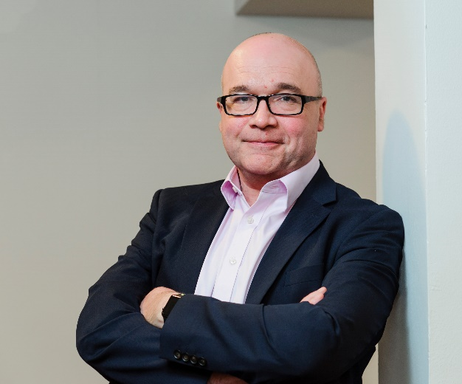

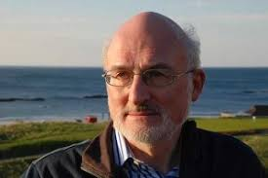 | Howie Firth is a scientist, writer and broadcaster who was director of the first Edinburgh Science Festival in 1989, providing the city's concept of a science festival with a format that has subsequently spread to many other countries. Howie continues to advise and assist with the organisation of science festivals across the UK and internationally.

