Super Science and Terrific Technology
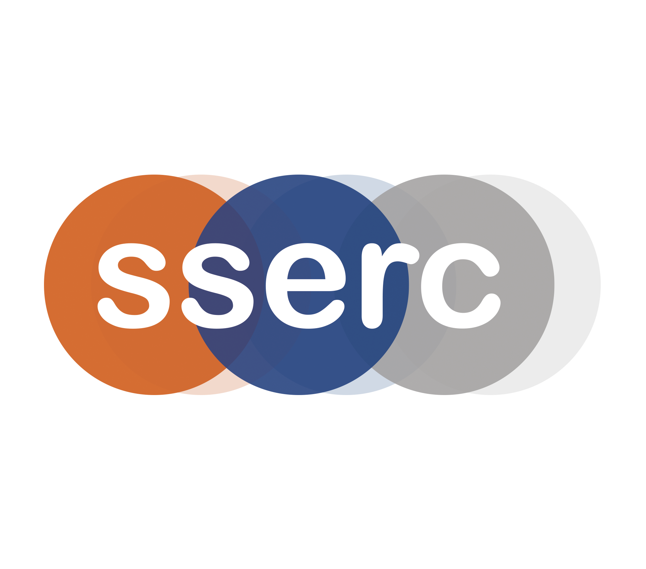
Programme - Part 1
Friday 15th – Saturday 16th November 2019

This programme of professional learning provides equipment and resources to support delegates in the implementation of Curriculum for Excellence.

 | 15th November 2019 | 16th November 2019
MORNING | 09:00 – 09.15 Registration at SSERC  09.15– 10:00 Introduction and Welcome: SSERC Primary Team  10:00- 12:45 Light Entertainment – part 1: Hayley Sherrard, Lynn Daley and Euan Mitchell (includes a coffee break) | Check out of Hotel  Own transport to SSERC  08.50-09.00 Registration at SSERC  09:00-11:00 Getting Smart with Materials: Hayley, Lynn and Euan  11:00–11:15 Tea/Coffee  11:15-12:30 Making Sense of Science and Technology: Hayley, Lynn and Euan
AFTERNOON | 12:45-13:15 LUNCH  13:15-14:30 Light Entertainment - part 2: Hayley, Lynn and Euan  14:30-14:45 Tea/coffee  14:45-16:15 I can see clearly now…: Hayley, Lynn and Euan  16:15 Transfer to Hotel and check in | 12:30-13:30 Animated Science and Technology  13:30-14:15 Action Planning , Closing Remarks, Evaluation and Lunch  14:15 Depart
EVENING | 17:00-17:15 Action Planning  17:15-19:00 Now you see it…: Hayley, Lynn and Euan  19:00 DINNER  20:00 Mirror Maze Challenge

Draft Programme Part 2

 | 20th March 2020 | 21st March 2020
MORNING | 09:00 – 09.15 Registration at SSERC  09:15 – 09:30 Welcome and Introduction  09.30 – 11:30 Garden Chemistry: SSERC Primary Team  11:30 – 11:45 Tea/Coffee  11:30 – 13:30 Marvellous Magnets:  SSERC Primary Team | Check out of Hotel  Own transport to SSERC  08:50 – 09:00 Registration at SSERC  09:00 – 10:30 A Bundle of Bubbles: SSERC Primary Team  10:30 – 11:45 Construction Challenge  11:45 – 12:00 Tea/Coffee  12:00 – 14.00 Titanic Science & Technology:  SSERC Primary Team
AFTERNOON | 13:30 – 14:30 LUNCH Showcase Set-up  14:30 – 16:30 Showcase (tea and coffee available)  16:30 Transfer to Hotel and check in | 14:00 – 14:30 LUNCH  14:30 – 14:45 Evaluation & Depart
EVENING | 17:00 – 17:15 Action Planning  17:15 – 19:30 Moving things with charges – Paul Chambers  19:30 DINNER

SSERC is a national science and technology advisory body which supports Scottish Local Authorities, teachers and technicians and co-ordinates the development and provision of Continuing Lifelong Professional Learning for school science educators. This programme of professional learning has been supported by the National Science Learning Centre (York).

