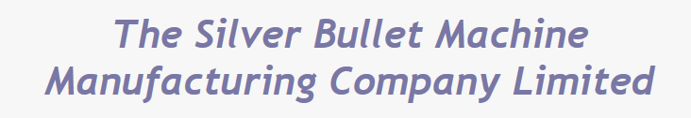
 | Monday 28th October 2019 | Tuesday 29th October 2019
MORNING | 09:00 Coffee and registration at SSERC, Dunfermline  09:30 Welcome and introduction  09:45 How creative are we?  10:30 Tea / coffee  10:45 Is ‘creativity’ the same as ‘innovation’?  11:30 The insights of Arthur Koestler  Koestler’s Law of Creativity  12:45 Lunch | 09:00 Coffee and registration at SSERC, Dunfermline  09:30 Recap on Day 1  09:45 Creativity in action (2)  10:30 Tea / coffee  10:45 Group feedback  11:15 How to evaluate ideas wisely  12:45 Lunch
AFETRNOON | 13:30 The Learning Trap  14:15 How to have ideas ‘on demand’ – the InnovAction! process  15:15 Tea / coffee  15:30 Creativity in action  16:30 Group feedback  17:00 Transfer to hotel | 13:30 Evaluation in action  14:15 Group feedback  15:15 Tea / coffee  15:30 How can we take this learning ‘back home’?  16:15 Group feedback & evaluation  17:00 Programme close

Creativity

A 2-day workshop -– draft programme

