The effect of competitive and non-competitive inhibitors on β-galactosidase

Context

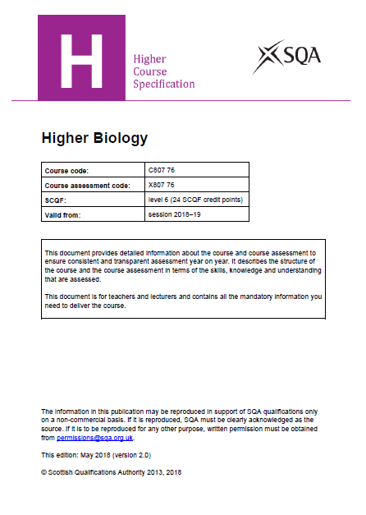 | 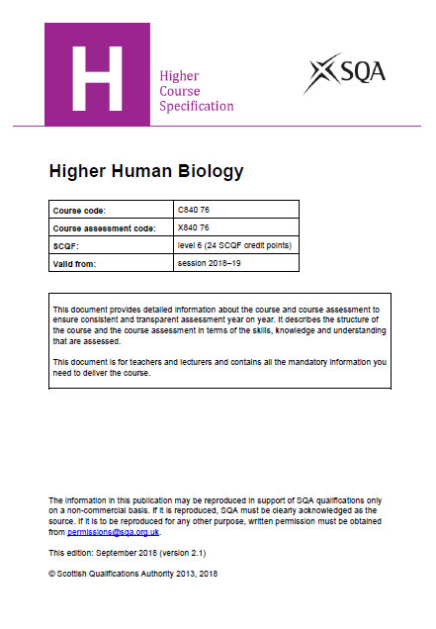

The Course Specifications for Higher in both Biology and Human Biology have the following suggested learning activity:

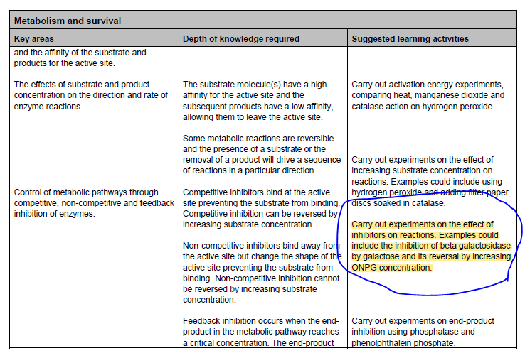

Background

The enzyme β-galactosidase catalyses the following reaction (more detailed chemical structures are given in Appendix 1):

The chemical ONPG (o-nitrophenyl β-D-galactopyranoside) also acts as substrate for the enzyme:

The ONP (o-nitrophenol) that is produced is yellow in colour, allowing the rate of this reaction to be followed using a colorimeter.

Galactose acts as a competitive inhibitor of the enzyme, competing with ONPG for the active site. At high concentrations galactose will inhibit the reaction by preventing ONPG making contact with the active site. This inhibition can be overcome if the ONPG concentration is sufficiently increased. Iodine acts as a non-competitive inhibitor and combines irreversibly with the enzyme, changing its shape permanently in the process; increasing ONPG concentration has no effect on this denatured enzyme.

Experimental Design

In common with many enzyme-based practicals, the inhibition of β-galactosidase offers huge scope to engage students in the process of experimental design. What follows is a fairly prescriptive protocol for the experiment but it would be a useful exercise for students to be shown the basic technique (i.e. the mixing of colourless solutions of β-galactosidase and ONPG leads to the formation of o-nitrophenol which is coloured and so its presence can be followed colorimetrically) and invite them to set out a plan for how they might show that the reaction is competitively inhibited by galactose. At one level one might just add galactose and show that the rate of colour formation is slowed or stopped; the formulation of a detailed, robust protocol which allows for the generation of quantitative results is, by contrast, a demanding exercise.

Classroom management

Students can work individually or in pairs for this experiment. Estimated time: 50-60 minutes should be sufficient to collect all the data.

Extension work

- Investigate the rate of o-nitrophenol production by measuring absorbance changes at regular time intervals over a period of some 5-6 minutes.

- Investigate the effect of enzyme concentration on the rate of o-nitrophenol production in the absence of added galactose.

- Substitute glucose for galactose (the other product of the reaction) to see if it has a similar effect on enzyme activity.

- Investigate the effect of increasing concentration of galactose whilst keeping [ONPG] constant.

References

- Reece, J.B., Urry, L.A., Cain, M.L., Wasserman, S.A., Minosky, P.V. and Jackson, R.B. (2011), Campbell Biology, Pearson, ISBN 10: 0321739752.

- Russo, S.E. and Moothart, L. (1986) Kinetic study of the enzyme lactase. Journal of Chemical Education, 63(3), 242-243.

Investigating the effect of competitive and non-competitive inhibitors on the enzyme
β-galactosidase

Student Activity Guide

Introduction

Inhibitors are substances that reduce the activity of enzymes. They may do this by binding either reversibly or irreversibly with the enzyme.

When the inhibitor binds reversibly to the active side of the enzyme it is known as a COMPETITIVE INHIBITOR. Often a competitive inhibitor is a similar shape to the substrate. Its association with the active site of the enzyme reduces the rate of binding between the substrate and the enzyme, thus lowering the rate of reaction. However, this type of inhibition can be overcome by increasing the substrate concentration as this will decrease the chances of enzyme and inhibitor binding.

NON-COMPETITIVE INHIBITORS bind permanently to the enzyme, changing its shape so that it can no longer react with the substrate. Increasing substrate concentration has no effect as the change to the enzyme is irreversible.

In this experiment you will use the enzyme β-galactosidase. Its normal substrate is lactose but you will use a synthetic substrate, ONPG. When the enzyme is active, it breaks down the ONPG to ONP which is yellow. Thus, the rate of reaction is proportional to the intensity of the yellow colour formed.

The reaction will firstly be carried out without an inhibitor, using a low concentration of substrate. An inhibitor will then be used at a concentration that prevents this enzyme/substrate mixture from reacting. While keeping the inhibitor concentration constant, the substrate concentration will be gradually increased. If the inhibition is overcome by this action, the inhibitor is competitive. If the inhibition is unaffected, the inhibitor is non-competitive.

Equipment and materials

Materials required by each student/group:

- 10 cuvettes  - 10 test tubes + rack  - 2 boiling tubes  - beaker of crushed ice  - 6 x 1 cm³ dropping pipettes  - 10 cm³ syringe  - 6 cm³ ONPG stock solution  (2.8 x 10⁻² mol dm⁻³ in buffer)  - automatic pipette (1 cm³) + tips | - 25 cm³ buffer (0.1 mol dm⁻³ potassium phosphate, pH 8)  - 15 cm³ 20% galactose in buffer  - 5 cm³ I₂/KI solution in buffer  - 25 cm³ distilled water  - eye protection  - gloves  - measuring cylinder (25 cm³)

Materials to be shared:

- colorimeter (420-440 nm filter) or blue diode | - β-galactosidase stock solution

Instructions

CARE! Wear eye protection and gloves throughout this experiment to avoid direct skin and eye contact with some of the chemicals used.

The experimental protocol is split into 3 sections.

Section 1 – Preparing a diluted enzyme solution of suitable activity

You are going to use a sample of enzyme which has been purchased from an external source. Steps 1-5 of this protocol are designed to ensure (i) that the enzyme sample works efficiently, and (ii) to adjust the concentration of the enzyme to give you a sample which will allow you to gather sufficient data over the course of a practical session.

1. Put 20 cm³ (use the measuring cylinder) of distilled water in a boiling tube. Put the tube in the beaker of crushed ice and add about 10 drops of the stock solution of β-galactosidase.

This is your diluted enzyme solution that you will use throughout the experiments which follow. DO NOT allow this diluted enzyme solution to reach room temperature as this will reduce the enzyme's activity considerably. Ensure the stock β-galactosidase is returned to the refrigerator as soon as possible.

CARE: Enzyme powder can cause allergies. Do not allow spillages to dry up. Wipe up spillages immediately and rinse cloth thoroughly with water.

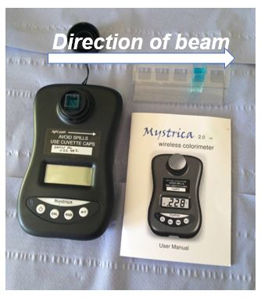 | 2. Using a dropping pipette put 0.5 cm³ of the stock ONPG solution into a separate boiling tube and add 9.5 cm³ (use the syringe) of 0.1 mol dm⁻³ buffer (pH 8). Label x 20 dilution.  3. Put 2 cm³ (syringe) of buffer and 1 cm³ (fresh dropping pipette) of this x 20 diluted ONPG solution into a test-tube. Mix the solution. Zero the colorimeter (blue diode) with this solution. Return the solution to the test-tube.  4. Add 0.5 cm³ (fresh dropping pipette) of the diluted enzyme to the test-tube. Start the stop-clock and mix the contents of the test-tube.
5. Read the absorbance two minutes after adding the enzyme - the value should be between 0.3 and 0.5.

If the absorbance is above 0.5, dilute the enzyme solution with distilled water and repeat steps 3-5 until an appropriate absorbance (in the range 0.3 – 0.5) is obtained after 2 minutes. If the absorbance is below 0.3, add 1-2 drops of the stock β-galactosidase to your diluted enzyme and repeat steps 2-4.
Section 2 – Measuring the effect of galactose and ONPG on enzyme activity

You are now going to investigate:

(i) the effect of galactose (an inhibitor) on the activity of the enzyme
(ii) the effect of increasing the ONPG concentration (the substrate) in the presence of a fixed concentration of galactose

6. Mix the solutions, as shown in the following table, in different test-tubes. Use the automatic pipette to measure the volumes shown. Complete the column marked ‘absorbance reading’ after you have carried out step 7 (a typical data is shown here for illustrative purposes).

Test-tube Number | 20% galactose in buffer (cm³) | ONPG stock solution (cm³) | buffer (cm³) | Absorbance reading
1 | 2 | 0.1 | 0.9 | 0.05
2 | 2 | 0.25 | 0.75 | 0.11
3 | 2 | 0.5 | 0.5 | 0.15
4 | 2 | 0.75 | 0.25 | 0.23
5 | 2 | 1.0 | 0 | 0.27

- Treat each test-tube in turn as follows:

  - Mix the solution, place in the colorimeter and zero the instrument. Return the solution to the test-tube.
  - Add 0.5 cm³ of the diluted enzyme solution. Start the stop-clock and mix the contents of the test-tube.
  - Using a clean cuvette take an absorbance reading 2 minutes after adding the enzyme.

Section 3 – Measuring the effect of iodine on enzyme activity

You are now going to investigate:

(i) the effect of iodine solution (another inhibitor) on the activity of the enzyme
(ii) the effect of increasing the ONPG concentration in the presence of the iodine solution
CARE: iodine is HARMFUL. Wear gloves and eye protection.

8. Again, using the following table as a guide, mix the solutions in different test tubes. Complete the column marked ‘absorbance reading’ after you have carried out step 9.

Test-tube number | I₂/KI solution (cm³) | ONPG stock solution (cm³) | buffer (cm³) | Absorbance reading
1 | 0.2 | 0.20 | 2.6
2 | 0.2 | 1.00 | 1.8

9. Treat each test-tube in turn as follows:

- Mix the solution, place in the colorimeter and zero the instrument. Return the solution to the test-tube
- Add 0.5 cm³ of the diluted enzyme. Start the stop-clock and mix the contents of the test-tube.
- Take an absorbance/transmission reading 2 minutes after adding the enzyme.

Enzyme Control

10. To ensure that enzyme activity has remained constant, repeat steps 3 - 5. These results should be similar to the ones obtained initially.

The effect of competitive and non-competitive inhibitors on β-galactosidase

Technical Guide

Materials required by each student/group:

- 10 cuvettes  - 10 test tubes  - 2 boiling tubes  - beaker of crushed ice  - 6 x 1 cm³ droppers  - 10 cm³ syringe  - 6 cm³ ONPG stock solution  (2.8 x 10⁻² mol dm⁻³ in buffer) | - 25 cm³ buffer (0.1 mol dm⁻³ potassium phosphate, pH 8)  - 15 cm³ 20% galactose in buffer  - 5 cm³ I₂/KI solution in buffer  - 25 cm³ distilled water  - eye protection  - gloves  - measuring cylinder (25 cm³)

Materials to be shared:

- colorimeter (420-440 nm filter) | - β-galactosidase stock solution

Preparation of materials

The buffer: 0.1 mol dm⁻³ K₂HPO₄ adjusted to pH 8 with 0.5 mol dm⁻³ HCl. Each student/group will require 80-100 cm³. About half the volume made up will remain as plain buffer. The rest will be used to make up other solutions. CARE: Avoid direct skin and eye contact, wear eye protection and gloves.

ONPG stock solution: 2.8 x 10⁻² mol dm⁻³ in buffer. Each student/group will require 6-8 cm³. To prepare a stock solution of ONPG weigh out 0.84 g of ONPG and dissolve in 100 cm³ buffer (smaller volumes may be needed depending on the number of groups in your class). Shaking for 5 - 10 minutes will be required for the powder to be completely dissolved. The ONPG stock solution should be stored in the refrigerator and should remain active for at least one week.

ONPG is available from Sigma-Aldrich, Fancy Road, Poole, Dorset BH12 4QH. Catalogue number: N1127, 1g for £33.00 (February 2019 prices).

Galactose solution: 20% in buffer. Each student/group will require 10-15 cm³. To prepare 50 cm³ dissolve 10 g galactose in 50 cm³ buffer. It dissolves readily.

I₂/KI solution: Each student/group will require about 5 cm³. Dissolve 0.1 g iodine and 0.2 g potassium iodide in 100 cm³ buffer. Take 1.0 cm³ of this stock solution and make to 100 cm³ with buffer. This 100 x diluted I₂/KI solution is the solution to be used by the students in the experiment. These solutions should be stored in a dark cupboard.

CARE: Iodine is classified as HARMFUL. Wear gloves when preparing the solution.

β-galactosidase is available as Lactase (Lactozym); from National Centre for Biotechnology Education (NCBE), University of Reading, 2 Earley Gate, Whiteknights Road, READING RG6 6AU, tel no: 01189 873743. Cost £19.00 (February 2019 prices) for 100 cm³. CARE: Avoid direct skin and eye contact, wear eye protection and gloves. Do not allow any spillages to dry up. Wipe up spillages immediately and rinse cloth thoroughly with water.

Appendix 1 Chemical structures of substrates and products

