Drying gases
Many, if not most, methods for the preparation of gases involve reactions that take place in aqueous solution.
It is inevitable then that the gases produced will contain at least some water vapour.
In most instances this is not a problem but if a dry gas is needed, the water vapour can be removed by passing the gases through a substance called a drying agent into a second collection vessel.
Drying agents are chemicals that will absorb the water from the vapour. It is, however, important to choose the right one to ensure that it does not react with the gas you are trying to dry.
The table on the next page lists some common drying agents and their uses.
There are two main techniques.
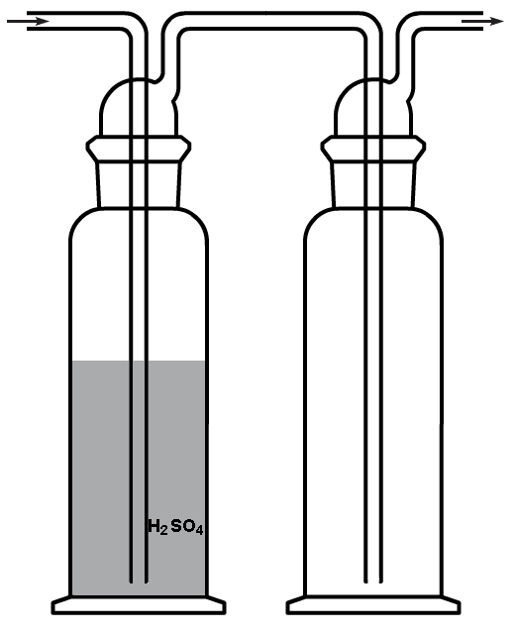
- Using a liquid absorbent. The most common of these is concentrated sulphuric acid. The moist gas is bubbled through the sulphuric acid, usually in a Dreschel bottle.
The longer tube of the drying bottle (on the left in the diagram) is connected the source of the gas to be dried.
The gas bubbles through the tube and through the drying agent into the space above the liquid before passing out into the receiving vessel.
Warning - The pressure of the incoming gas must kept high enough so that the sulfuric acid does not suck back through the gas inlet into the reaction vessel. In most cases this will be unlikely but be careful if you are using this apparatus to fill a gas syringe – if the syringe gets stuck, the pressure will indeed be high enough to do this.
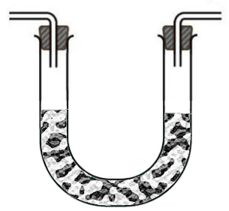
- Using a solid absorbent. This is most often carried out using a U-tube containing the dessicant. This avoids the potential problem with suck-back mentioned above.

Drying agent | Drying power – water content remaining in air (mg.l⁻¹) | Water uptake (%) | Unsuitable for these compounds :-
aluminium oxide | 0.005 | 25 | those with sulphur or carbonyl groups
calcium chloride | 0.14 – 0.25 | 30 | ammonia, amines, alkanols & phenols
calcium oxide | 0.65 | 30 | HCl and other acid gases such as CO₂, chlorine,alkanols & alkanones
calcium sulphate, anhydrous | 0.07 | 11 | none
molecular sieves | 0.004 | 20 | none
phosphorus(V) oxide | 0.00003 | 30 | alkanones, amines, acids, alkanols & ethers
potassium hydroxide | 0.9 | 40 | acids, phenols, esters & amides (in the presence of water) and with several chlorinated hydrocarbons.
silica gel | 0.07 | 21 | hydrogen fluoride
sulphuric acid, concentrated | 0.003 – 0.3 | 30 | organic compounds and alkaline gases such as ammonia

