Catalase Activity in Immobilised Yeast

Student Guide

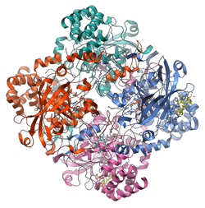
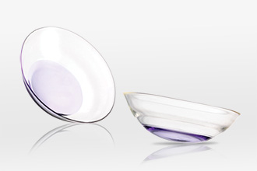
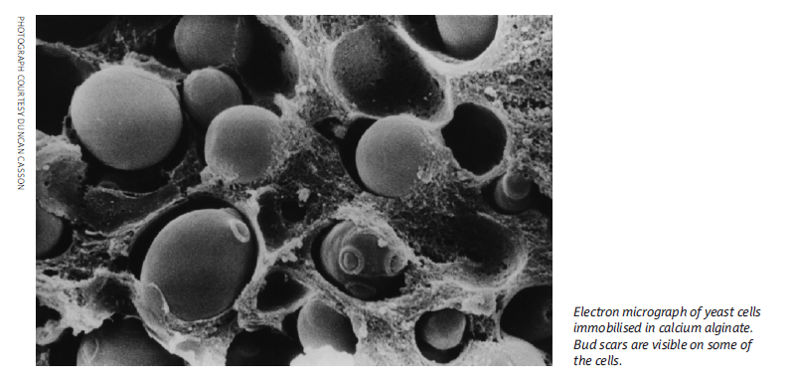

National 5
Biology

Photo: Wikipedia, GDFL

Higher Physics Topical Investigation Skin Cancer—Prevention and Cure

2

Investigation Brief
Suntan creams stop harmful UV radiation reaching the skin. Manufacturers’ products are rated with a Sun Protection Factor (SPF). Suntan creams can have SPF values from 6 to over 50.
UV radiation monitors normally measure irradiance in output intensity per unit area. Thus, a typical low intensity UV lamp may emit approximately 10 mWcm^{-2.}
The aim of this investigation is to determine the effect of various suntan creams on the transmission of UV radiation. In particular, the relationship between SPF and absorption should be found.

Investigation Notes
UV lamps can be harmful. Make sure that you read the safety leaflet which is supplied with the UV lamp. Some cheap UV monitors do not measure the irradiance of UV radiation. Rather, they give an indication of UV index. It is possible to undertake this investigation with such a monitor, but results will be less reliable and accurate. UV radiation does not pass through many transparent materials (including glass). However, UV transparent acrylics are readily available.
3

National 5 Biology

Catalase activity in immobilised yeast

Student Guide

Background information

Why are enzymes important?

Let’s think about sugar. The conversion of sucrose to CO₂ and H₂O is, from an energy viewpoint, a favourable process. There is a significant quantity of energy within sucrose (sugar) and provided this energy can be released in a controlled way it can be used to drive many reactions which take place in living systems.

Of course, you can store a bag of sugar for a long time and there will be little or no change in its composition. So, how do we, as functioning organisms, convert sucrose to CO₂ and H₂O and release the energy in that process? The answer to that question is through the action of enzymes. Through the intervention of enzymes, sucrose is converted into CO₂ and H₂O with the controlled release of energy within the body in a matter of seconds.

The enzymes that catalyse the breakdown of sucrose represent only a few of the many thousands that are required for the human body to function. Enzymes are large molecules that act as catalysts. In general, enzymes are proteins and studies of their properties are important aspects of the school biology curriculum.

Several factors are known to affect the rate of enzyme-controlled reactions including:

- temperature
- pH
- substrate concentration.

Each of the above factors can be easily investigated using the methods described below.

Measuring catalase activity

Catalase is a common enzyme found in nearly all living organisms exposed to oxygen. Catalase is involved in the breakdown of hydrogen peroxide into water and oxygen:

Catalase

2H₂O₂ 2H₂O + O₂
Hydrogen peroxide

In the absence of catalase, hydrogen peroxide, which is a damaging molecule, would become involved in harm to cells and so catalase has an important role in protecting cells.

You may have seen or carried out an experiment where small samples of liver are added to a solution of hydrogen peroxide. You might see foam rise above the solution. You could measure the height of the foam at certain times after mixing and use that data to make an estimate of enzyme activity.

Recently, a new method for measuring catalase activity has been developed into a practical activity suitable for investigation work in schools. The method involves using yeast as a source of catalase. Your teacher will be able to explore with you the advantages of this yeast-based system and where you can find out further information.

Experimental protocol  - Prepare a 10% stock solution of yeast by adding 2.5 g of yeast to a bottle which contains 25 cm³ of distilled water.  - Put 2 cm³ of this stock yeast solution into a clean bottle.  - Shake the yeast and add it to another bottle which contains 2 cm³ of sodium alginate solution (2%). Give this mixture a good shake.  - Place about 30 cm³ of 2% CaCl₂ solution into a plastic cup or beaker.  - Clamp the barrel of your syringe about 20 cm above the top of your plastic cup containing CaCl₂ solution (see Figure 1).  - Making sure that you have thoroughly mixed the solution prepared in 3 above, pour the yeast/alginate mixture into the syringe.  - Once all the liquid has flowed from the syringe leave the newly formed beads for about 5 min. Transfer them to a tea strainer and wash them (gently!) with cold tap water for about 1 min. Give them a final rinse with distilled water. The beads can be stored in distilled water until you use them later. | 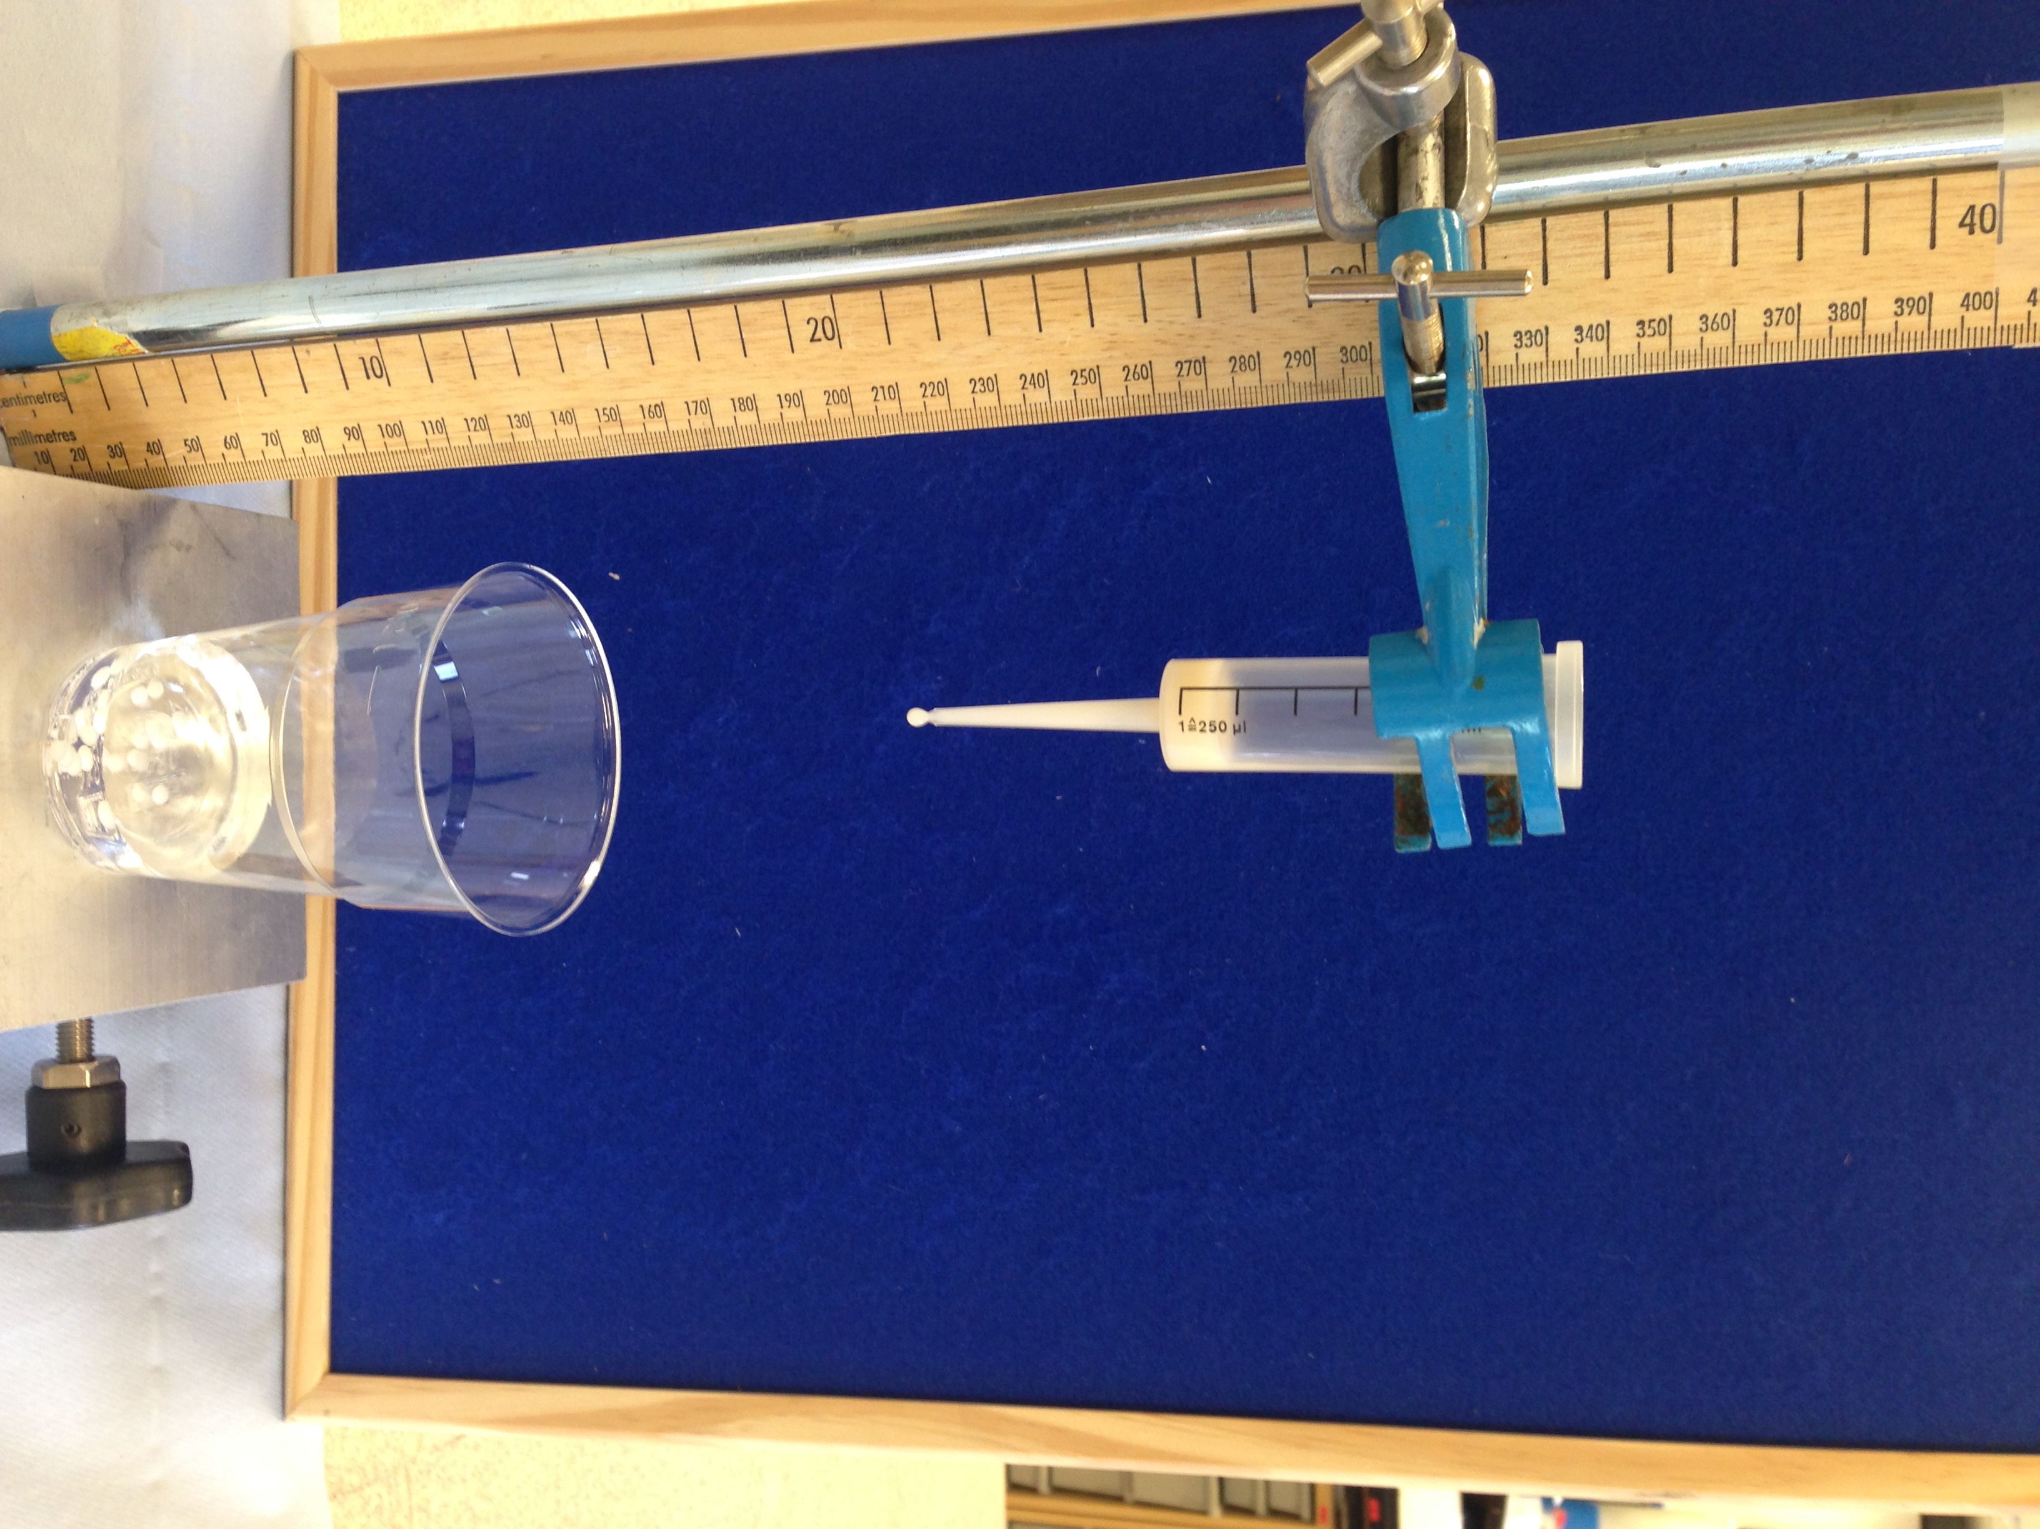  Figure 1. Experimental set-up for producing immobilised yeast.

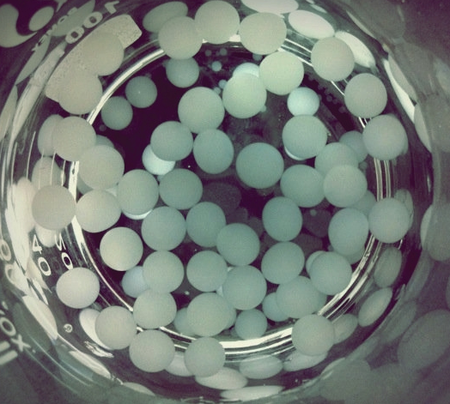  Figure 2. Immobilised yeast beads in distilled water | At this stage you should have a number of beads of yeast which have undergone the process of immobilisation.  - Put 2.5 cm³ of a stock solution of hydrogen peroxide into a measuring cylinder (25 cm³) and add distilled water until the final volume is 25 cm³.  - Add 1 bead of the immobilised yeast, immediately start a timer and measure how long it takes before it rises to the surface (the bead will probably sink to the bottom of the cylinder before rising to the surface). You may want to repeat the measurement.

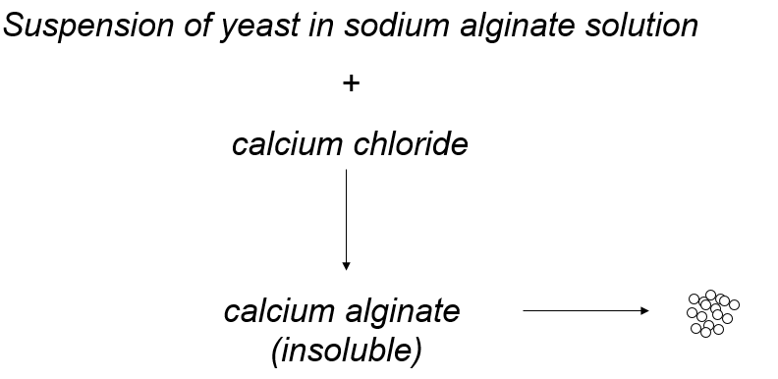  Figure 3. Preparation of immobilised yeast | At this point you will have produced immobilised yeast (see Figure 3) and you are now able to consider using your beads in a series of investigations.

You will need to come up with an experimental plan but perhaps you could:

- Vary the concentration of hydrogen peroxide.
- Vary the temperature at which the experiments are carried out.
- Vary the number of yeast cells in your beads.
- Vary the pH at which your experiments are carried out.
- Make extracts of fruits and vegetables, immobilise them and see what level of catalase activity they have.

Health and Safety

Make sure you discuss any health and safety implications of your experiments with your teacher and technician. When using solutions of hydrogen peroxide it may be necessary to wear goggles depending on the concentrations of the solutions being used.

