Velocity down a slope
Most teachers are familiar with the experiment where a trolley with a mask of known width is released from rest, travelling a displacement s and passing through a light gate connected to a timer. The velocity v at the light gate can be found from the width of the mask divided by the time on the timer. If a timer such as a DJB TSA or Unilab QED is used, it is possible to enter the mask length and then get a direct readout of velocity after each run.
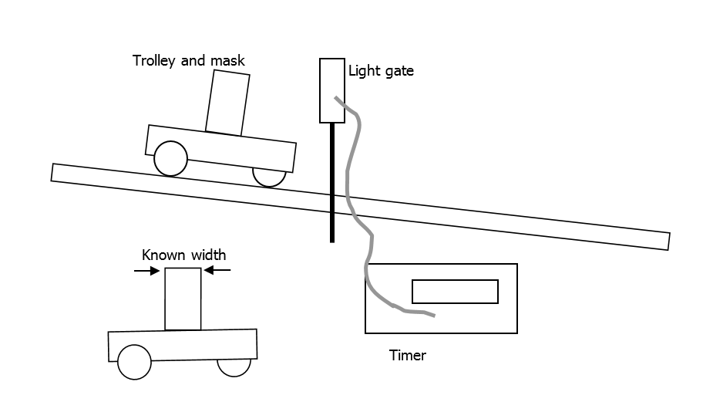
A 5° slope, long enough to let the trolley run up to about a metre, will give a good range of results, going from s = 10 cm to 100 cm in 10 cm steps. Such a slope can be made by raising the end of a 1.5 metre board by about 13 cm. s should be measured from the detector in the light gate to the centre of the mask. Two examples are illustrated by the double-headed arrows in the diagram below.
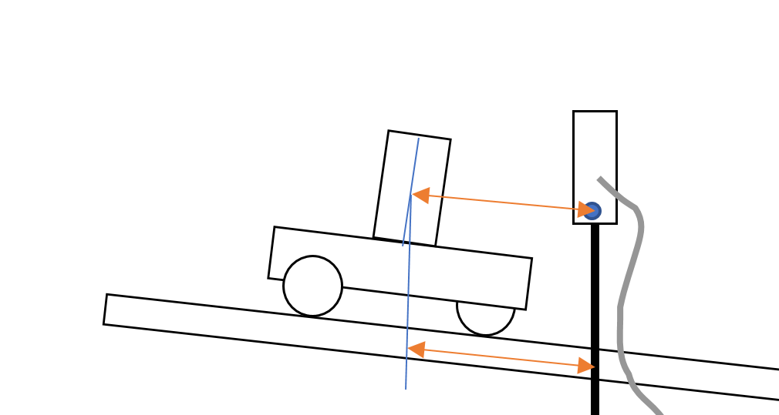
Since v² – u² = 2as,
If the trolley is released from rest, u² = 0, so v² = 2as
A graph of v² versus s should therefore be a straight line through the origin, with gradient 2a. a, the acceleration, should be equal to gsinθ where θ is the angle between the slope and the horizontal and g is the gravitational field strength.
As it can be expensive to invest in a class set of light gates and timers, we decided to investigate alternative methods.
The picture below shows a “Hot Wheels” car on a track that is straddled by a BeeSpiV. This device combines two light gates and a velocity/time computer. When the first light gate is broken, the timer starts, stopping when the second one is broken. The device “knows” the separation of the light gates and is thus able to calculate and directly display the velocity. This can also be placed on a 5° slope.
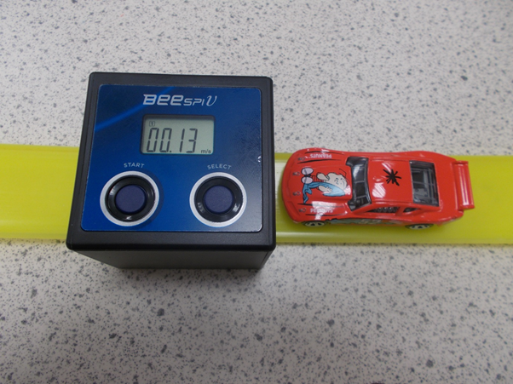
Care is needed when measuring the displacement travelled from rest to the point where v is measured. We aligned the zero end of a metre stick with the mid-point between the light gates and measured the displacement s from the front of the car. However, with certain model cars, this produced an offset in the graph. The figure below offers an explanation:

The second car is lower at the front. Compared with the first one, it travels further before cutting the first light beam. There would therefore be a systematic uncertainty in s, resulting in the graph of v² versus s missing the origin. “SUV” models had less of a problem than sports cars.
Sample graph
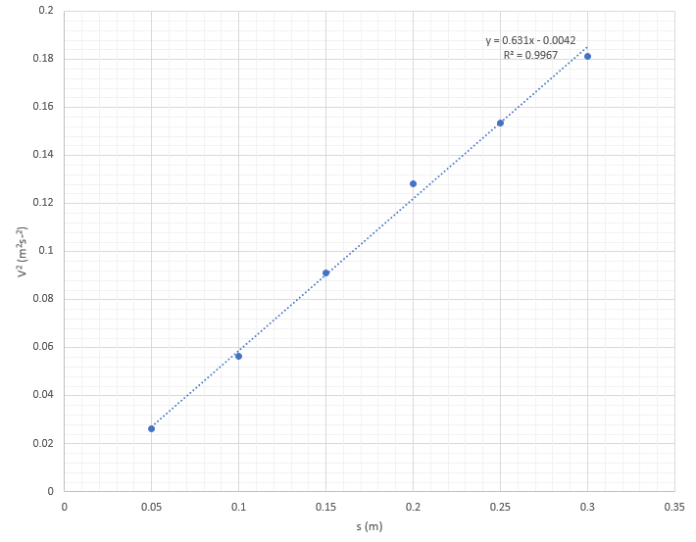
Looking closely at the equation of the line, we can see that the intercept is not zero. However, when we analysed our results using the LINEST function on Excel, the uncertainty in the intercept was almost as large as the intercept itself.
The gradient is significantly less than the theoretical value of 2gsinθ . This is not unexpected, as there will be frictional forces on the model car. Some models occasionally exhibited wheel lock, where a wheel momentarily stopped rotating even though the car was still moving. We chose the range 5 cm to 30 cm because on longer runs, the cars often ended up rubbing along the sides of the track. At the upper end of this distance, the car had to pass over a joint in the track. We were concerned that this might slow the car down, but would have expected this to show up as a change in the slope of the graph.
We tried a ball bearing instead of a model car, reasoning that there would be significantly less friction. This may have been so, but the ball bearing gains rotational as well as translational kinetic energy. An analysis of the relationship between v and s involving rotational motion is beyond Higher Physics.

Charging a capacitor
With many schools electing to do what we might call “core” experiments for their Higher Assignments, we thought it would be worth revisiting some of these to give advice on equipment and component values. We are aiming to help teachers and technicians here – beware of passing this article unedited to students. You could be giving them too much information.
Charge versus potential difference
The first experiment investigates the relationship between the charge on a capacitor and the potential difference across it. Measuring charge on a capacitor can be difficult to do. There are charge-measuring instruments called coulombmeters but they can only measure very small charges. We do have a protocol for such an experiment. Please get in touch if you are interested.
In this version of the experiment, we use a variable resistor to keep the charging current constant. We make a note of this current, and find charge Q after a time t using the relationship:
Q = It
Equipment required:
- 1000 μF capacitor
- 100 kΩ variable resistor
- Smooth dc power supply set to around 5 V, or 3 x 1.5 V batteries wired in series
- Voltmeter
- Ammeter (must be able to read to 0.001 mA or better)
- Stop clock / phone timer
Connect the components as shown in Figure 1 below. If your capacitor is polarity-sensitive (i.e. it matters which leg is connected to the positive side of the circuit), make sure you connect it correctly. It helps to have more than one person working on this experiment.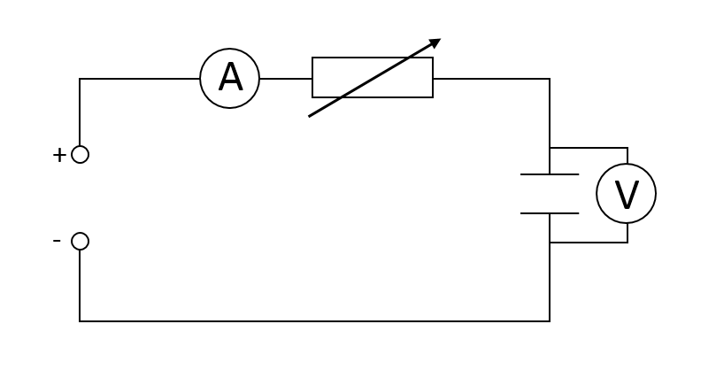
Figure 1 – capacitor charging circuit

Make sure the variable resistor is set to around its mid point before switching on. What we don’t want is a very low resistance when the capacitor is uncharged. “Short” the capacitor, i.e. connect one side directly to the other. The voltmeter should show a potential difference of 0 V across the capacitor.
Record the potential difference across the capacitor as 0 V at time 0 seconds.
Adjust the variable resistor until the current on the ammeter is 0.050 mA. This current is suggested because, for the component values shown, the capacitor should take about 100 seconds to charge. 10 readings can be taken, each separated by 10 seconds.
Remove the short and start the timer.
Throughout this experiment, the variable resistor must be adjusted to keep the current at a fixed value. A small variation will not cause problems.
Record the potential difference across the capacitor every 10 seconds.
You should now have a table of potential difference versus time. In order to study the relationship between potential difference and charge, charge must be found from Q = It, where I is the constant current.
Figure 2 shows a sample graph. These results were obtained with a charging current of 0.05 mA. The capacitor had a capacitance of 1000 μF. Although V was the dependent variable, it has been plotted on the horizontal axis because the gradient of the graph should then be the capacitance.

Figure 2 – Charge versus V
Note that we have chosen fairly large markers on the graph for clarity in this publication. Your students should follow SQA guidance on graph drawing with regard to marker size and type and also gridline spacing.

Potential difference versus time
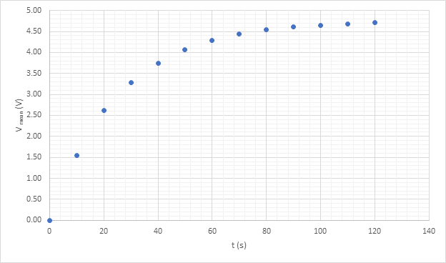
Figure 3 – potential difference versus time
The graph in Figure 3 was obtained by setting the circuit current, with the capacitor shorted, to 0.200 mA. With the short removed, V was recorded every 10 seconds. In this experiment, the current was left to its own devices – no attempt was made to keep it constant. An alternative investigation would be to look at circuit current versus time.
Though beyond Higher, it is interesting to study the graph of ln(V₀ – V) versus time, where V₀ is the supply voltage. Such a graph is shown in Figure 4.
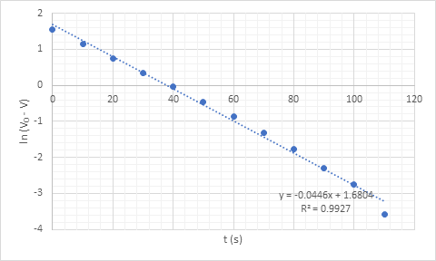
Figure 4 – logarithmic graph

Internal resistance – cells and solar cells
The internal resistance of a cell can be found using adaptations of the circuit below. The cell is shown with its internal resistance r represented by a series resistance.
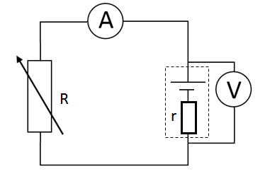
Note that when investigating the internal resistance of a cell, use one that has zinc chemistry, i.e. zinc carbon or zinc chloride. These have higher internal resistances than alkaline or lithium cells. Do not use rechargeable batteries as they have lower still internal resistances. Not only is this detrimental to the investigation, there is a safety risk should the cell be shorted. This can cause overheating and, rarely, can lead to the battery bursting and venting its contents.
Theory:
For a cell of EMF ℰ and internal resistance r connected to an external resistance R (sometimes called the load resistor).
ℰ = IR +Ir where I is the current in the circuit. This rearranges to:
ℰ = I(R +r)
R+r = ℰ
I
R = ℰ -r …………………….. equation 1
I
In the above circuit, provided that the resistance of the ammeter is small compared with that of R, the terminal potential difference V = IR.
So ℰ = V +Ir This rearranges to:
V = -rI + ℰ …………………… equation 2

It can be shown, though the maths is a little beyond Higher, that maximum power is transferred to the load resistor R when R = r, i.e. the internal and external resistances are equal.
Tip - how to get a rough estimate of r
Using the circuit above, measure the EMF by connecting a voltmeter across the cell terminals with no load connected. Now connect either a resistance box or a variable resistor across the battery terminals, with the voltmeter still in place. Adjust the variable resistance until the reading on the voltmeter, i.e. the tpd, drops to half of the EMF.
The external resistance should now equal the internal resistance of the cell. If the external resistance does not have a scale marked on it, it can be removed from the circuit and its resistance measured.
This is worth doing to help guide you towards the range of external resistances that should be used.
We used D cells that were nominally 1.5 V. the internal resistances ranged from just below 1 ohm to around 5 ohms.
Method 1
In this set-up, the circuit current I is varied by adjusting R. It is not necessary to know the value of R. For each value of I, the terminal potential difference V is recorded.
V versus I is graphed. Comparing equation 2, V = -rI + ℰ with y= mx = c, we expect a straight line with gradient -r that intercepts the vertical axis at V = ℰ.
Sample graph
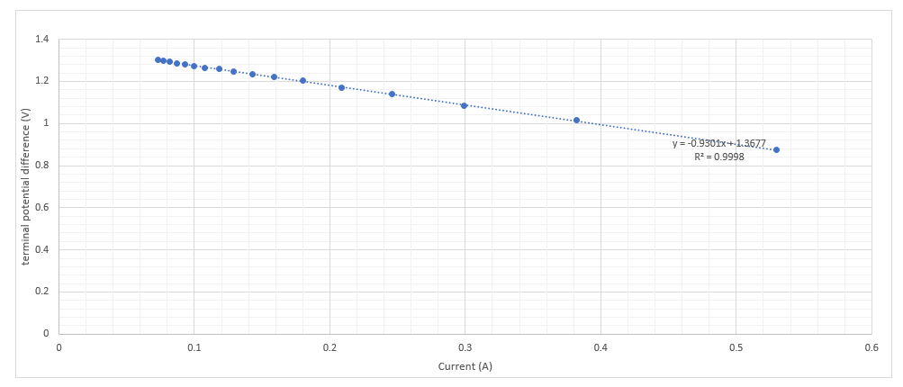
Points to note
This method works best if the external resistances used are of a similar order of magnitude to the internal resistance, which can be estimated using the technique in the Tips section above. For example, if r is around 1 ohm for a cell of EMF 1.50 V, using a range of external resistances from 1 to 10 ohms will give currents from 0.75 to 0.14 A. The corresponding values of V range from 0.750 V to 1.364 V. However, if R ranged from 100 to 1000 ohms, V would only range from 1.485 to 1.499 V.

Method 2
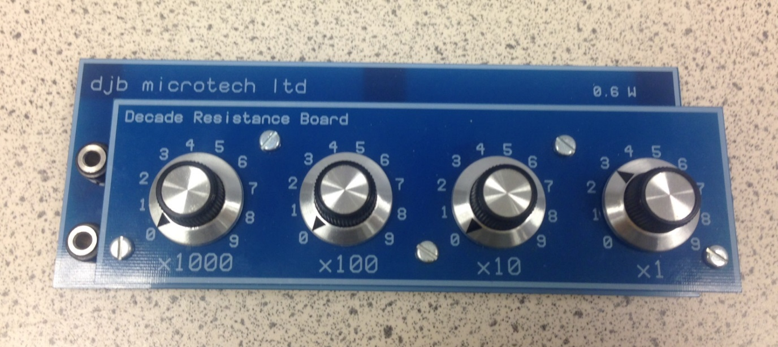
This method requires the external resistance to be varied and the corresponding current measured and recorded each time. A variable resistor with no scale could be used if it was removed from the circuit and set to the appropriate value with the aid of an ohmmeter. A resistance box like the one shown above will make life much simpler. This is a “Decade Resistance Board” from DJB. Timstar and Scientific and Chemical sell decade resistance boxes that are also suitable. R is read from the scale. It is claimed that this is accurate to ± 1%. However, please see the discussion in the Points to note section.
V does not have to be measured in this experiment.
R versus I⁻¹ is graphed. Comparing equation 1 to y = mx +c,
R = ℰ -r
I
The graph should be a straight line of gradient ℰ which cuts the vertical axis at R = - r.

Sample graph

Points to note
Method 1 required that the values of R were of the same order of magnitude as r. With this approach, provided a milliammeter is used, values of R can range from 10 x r to 100 x r, or even up to 1000 x r if the meter has a suitable range.
We found that, for a cell of internal resistance ~ 1 ohm and using a range for R of 2 to 15 ohms, our value for r did not match that found using method 1. We discovered that the leads used to connect the resistance box to the cell had a combined resistance of around 0.7 ohms. Using spreadsheet modelling, we found that the contribution to R of the leads' resistances could explain the anomaly. In other words, the measurement of R is subject to a systematic uncertainty if it is taken from the dial setting on the resistance board.
This method requires slightly more complex analysis as it is the inverse of current that is plotted. Also the independent variable is plotted on the vertical axis in order that the EMF can be found easily from the gradient. This could cause confusion amongst some students.
Solar Cells
Our investigations into solar cells led us to conclude that the model of a cell in series with an internal resistance r does not hold, at least at higher currents.
The graph below was obtained when method 1 was used to investigate the internal resistance of a solar cell that was under constant illumination.

The graph below was obtained when method 2 was used.

Method 3
Using the same circuit as for method 1 but with a calibrated resistance board as used in method 2, load resistance was varied. The circuit current and the potential difference across R were measured and recorded for each value of load resistance. The power transfer to R was then calculated using P=IV, though other power formulae could be used.
Maximum power transfer to the load resistance should occur when R = r.
For our investigation, we used an unbranded solar cell.
Sample graph

Points to note
This method worked well for solar cells, which have fairly high internal resistances. Ours had an internal resistance just below 2000 ohms in bright light. DJB sell a solar cell board [1] and owner Derek Walker has carried out similar investigations to ours. DJB cells have internal resistances of a few hundred to around one thousand ohms depending on conditions. Ordinary dry cells, as we have seen, have internal resistances of the order of 1 - 5 ohms. This makes it difficult to investigate power transfer at values of R < r.
We found that the solar cell's internal resistance decreased with increasing light irradiance, something that we wrote about in SSERC Bulletin 250 [2].

[1] https://www.djb.co.uk/ppen_solar_investigations.html
[2] https://www.sserc.org.uk/wp-content/uploads/2015/02/SSERC_250p4-5.pdf

