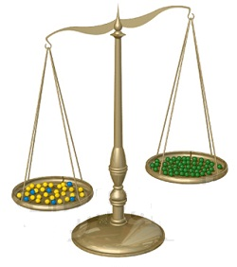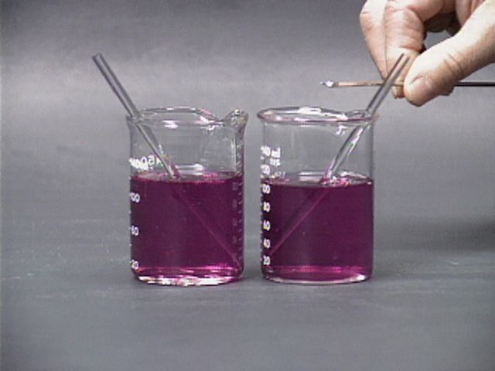

Weighing, Measuring

and

Preparing solutions

#### Weighing and measuring

There are two quantities you will need to measure regularly, mass and volume

**Mass**

You will certainly have access to electronic balances for weighing out chemicals but you may have a choice of which to use.

For normal usage, a balance that reads to 2dp (0.01g) is ideal. For many lab solutions, 1 dp (0.1g) would be acceptable but there is not a great amount of saving in either money or time to be gained from using this rather than 2 dp so that is what we would recommend

For accurate work, preparing accurate solutions for some Advanced Higher work for instance, you may need to use a balance that will read to 3 dp (0.001g) or even more.

Be aware of the maximum load a balance can take. Putting too heavy a load on a balance can cause permanent damage to it.

**Weigh boats**

In order to avoid dirtying or damaging your balance, you should place the reagent to be weighed in some sort of container. In some cases, you can place the beaker or flask directly on the pan but that may be too heavy for the balance.

The easiest this is to use a weigh boat. This (below) is a small container made of light plastic. You weigh out your chemical in this and then transfer it to the beaker/flask. Alternatively a piece of paper or aluminium foil will often do adequately.

**Taring/zeroing your balance**

It is important that you know what the start reading was on your balance.

In most cases, you can simply zero the balance once you have the weigh boat on the pan and just weigh up to the required amount.

For very accurate work, however, it is sometimes better to note the reading of the weigh boat and determine the mass of chemical added by subtraction (or addition).

This is also the best technique if you are using a change in mass to follow the process of a chemical reaction.

Eg.

To accurately weigh out 4.285 g of potassium iodate, you will use a 3 dp balance

If you put the weigh boat on the balance, it weighs 1.237 g

So the final mass you want to aim for is 1.237 + 4.285 = 5.522 g

**Care of your balance**

Balances can be expensive and relatively fragile pieces of equipment. With care, however, they can last a long time and produce accurate results.

**Some Do’s and Don’t’s**

* Be very careful if weighing out liquids as a spillage can damage the electronics.
* Be careful not to overload the balance – make sure you know what its maximum load is and have a rough idea of the mass you are weighing.
* Particularly with precision balances, try not to move them around too often. Many, if not most, balances have a locking mechanism for use when being transported to make sure the balance is not damaged. Remember to switch this off before using it.
* Make sure your balance is on a stable, level surface. Not doing so will not damage it but may affect the accuracy of your results.
* If you are doing several readings one after the other, make sure your balance is zeroed each time – they sometimes ‘drift’.
* Make sure you brush off any solid you spill on the pan of your balance while weighing it.

**Volume**

Most pieces of laboratory glassware have volume measurements on the side but these vary in accuracy

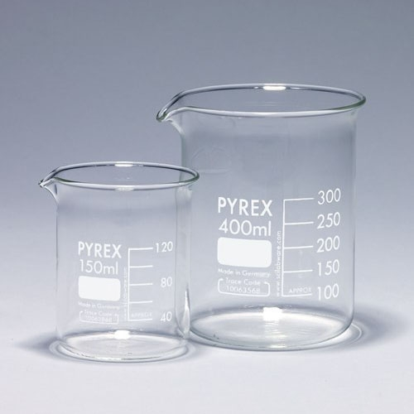**Beakers / flasks**

The markings on beakers or flasks are only approximate and should only be used if you do not need to know the volume accurately

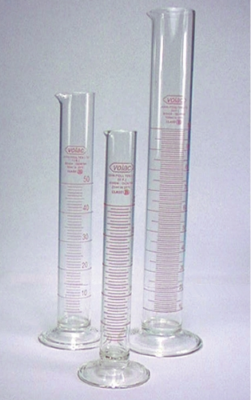**Measuring cylinders**

Measuring cylinders are more accurate and are the devices most commonly used for measuring liquid volume.

Make sure you choose the correct size measuring cylinder. To measure 10 cm3, it is much more accurate to use a 10 cm3 measuring cylinder than a 100 cm3 one.

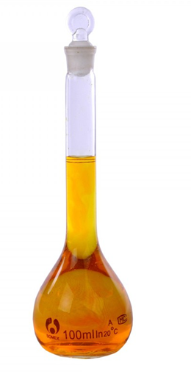

**Volumetric flasks**

These are flasks with a very accurate line drawn round the neck at a certain volume. If you are making up accurate solutions, you should use these.

**Pipettes**

For accurate measurement of smaller amounts of liquid, you should use a pipette. There are several types of these

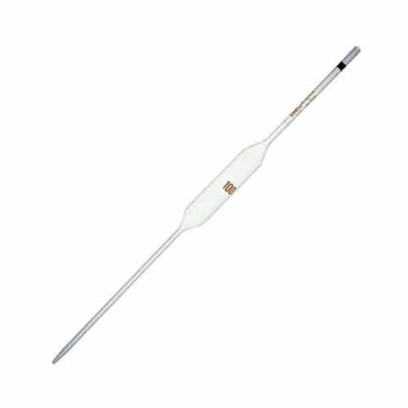**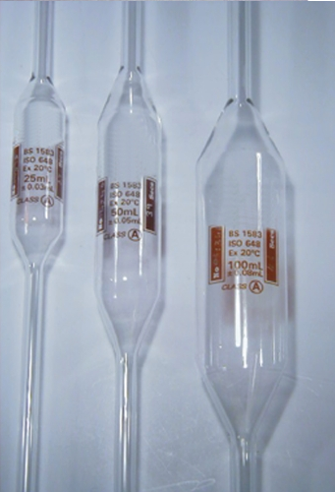Fixed volume pipettes**

These usually come in a range of volumes, usually from 25 cm3 down to about 5 cm3. The volume is indicated by a line on the barrel and the liquid is sucked up (by a pipette filler) to the line and then transferred to the container.

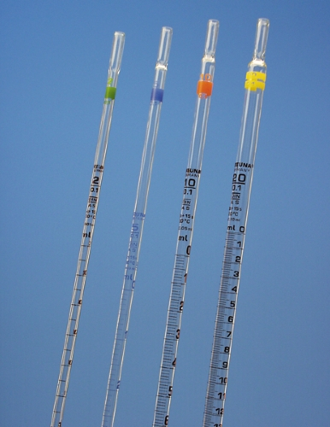**Graduated pipettes**

These usually come in 1, 2, 5 and 10 cm3 volumes and have a scale printed on the barrel. Unlike the volumetric pipettes, they have a barrel of an even diameter all the way down. You fill them by suction (using a pipette filler as above) but can select the exact volume you need.

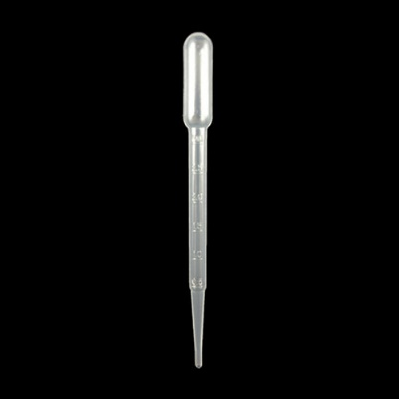**Pasteur pipettes**

These come in 1cm3 and 3 cm3 volumes and are pre-formed from plastic. You fill them by squeezing the bulb at the end, putting the tip under the surface and releasing to draw up the liquid. They have a scale printed on the barrel and while not as accurate as the glass pipettes are good enough for most purposes, though they can be a bit fiddly to use.

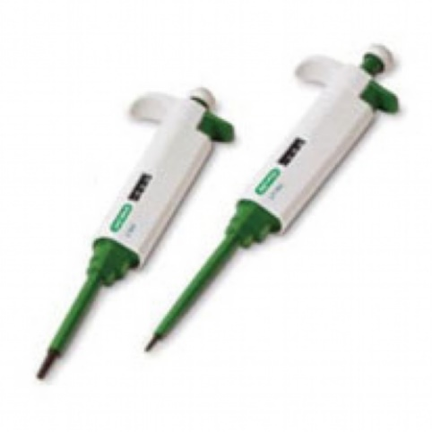

**Micropipettes**

For small volumes (though also for volumes up to about 5 cm3) you can buy micropipettes. These devices can be set to suck up small, set amounts of liquids into a disposable ‘tip’ by simply pressing and releasing a button on top. They are much faster and more convenient, though more expensive to buy.

**How to prepare a solution.**

Weigh or measure out your solute.

Dissolve the solute in about ⅔ - ¾ of the final volume of liquid in a beaker (to make it easier to stir)

*When you add your solid, the total volume will increase*. *If you measure out 100 cm3 of water and then add 10g of salt, the final volume will be over 100 so you will not have a 10% solution.*

Transfer it to a measuring cylinder or a volumetric flask

Wash out the original container several times and add the washings to the volumetric flask

Fill the cylinder / volumetric flask to the line that represents your final volume

**The meniscus**

If you look carefully at water (or many other liquids), particularly in a narrow tube like a measuring cylinder or a pipette, you will see that the surface is not a straight line, it dips in the middle.

This is called the meniscus and (it is caused by intermolecular forces but that needn’t bother us now)

It is standard practice to take all readings from the **bottom** of the meniscus*.

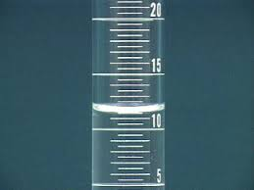

If you look at the diagram on the right. The top of the meniscus is at 12.5 cm3.

The bottom, the lowest point it dips down to in the middle, is at 11.5 cm3.

So the volume is 11.5 cm3.

*\* The exception to this is if the solution is a very dark colour – like potassium managanate(VII). In this case, you can’t see the bottom of the meniscus so the reading is taken from the top.*