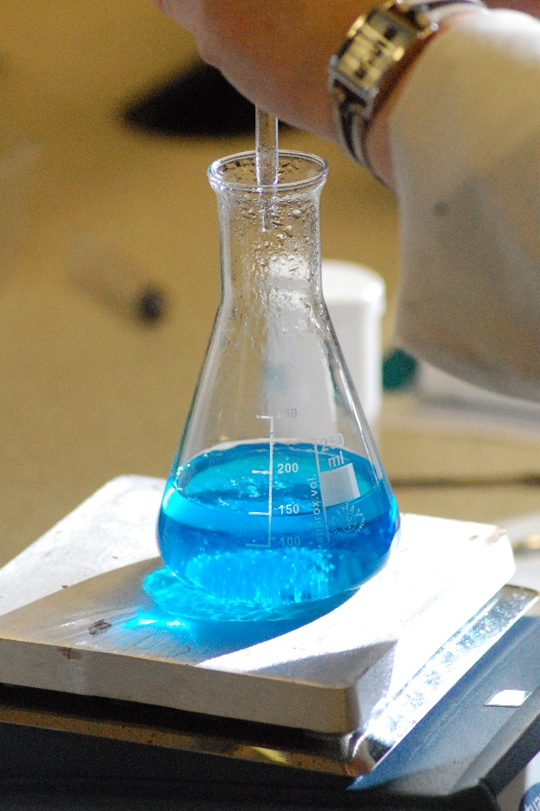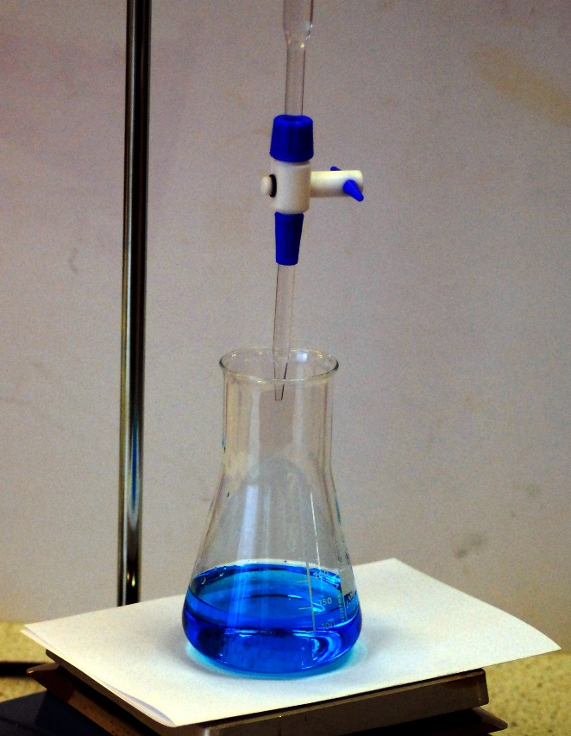

Titration

**What is a titration?**

A titration is used when one solution of a known concentration is used to determine the concentration of an unknown solution.

The most common type, and that required for this course, is an acid/base titration.

When an acid is added to a base, a salt and water are produced.

During a titration, a measured volume of a solution, for example an base, is placed in a flask and acid is added gradually from a burette (which has a scale marked on the side) until all the base has been neutralised, leaving just the salt and water. When the reaction is complete, the volume of acid added can be read off the scale on the burette.

*It is usually the acid that is placed in the burette as many bases can react (albeit slowly) with the glass of the burette and clog it up.*

An indicator, which will change colour, is used to determine when the reaction is complete or, what is called the endpoint, is reached.

Sometimes a pH meter can be used to determine the endpoint instead of an indicator.

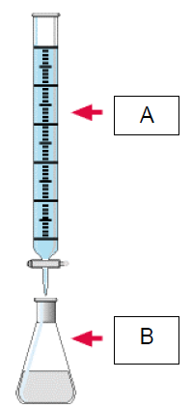**How to set up the equipment for a titration**

A titration is an analytical technique and so, to get meaningful results, there is a standard procedure which is followed.

The following pieces of apparatus/solutions are used:

a burette (A)

a pipette

a filter funnel

a conical flask (B)

distilled water

indicator or pH meter

### Preparing for a Titration

#### You will need

|  |  |
| --- | --- |
| 0.5 mol l-1 sulphuric acid | Your 0.4 mol l-1 NaOH solution |
| Bottle of suitable indicator | Burette |
| White tile or piece of white paper | Pipette |
| Pipette filler | Conical flask(s) |
| Filter funnel | Beaker(s) |
| Wash bottle of distilled water | Clamp and stand |
| Reagent bottle | Labels & Marker pen |

### Preparing the Burette

***This preparation is needed for high accuracy analytical work but is not essential for most titrations carried out in schools.***

1. Set up the burette in the stand.



1. Place a filter funnel in the burette as shown:
2. Pour some of the acid into a beaker and place it on the paper marked ‘Acid’.
3. Place the burette stand on a stool. (This ensures the burette is not above head level and you do not pour above your eyes in the next steps).
4. Make sure the burette tap is closed and carefully pour about 10 cm3 of the acid into the burette.
5. Remove the funnel.
6. Remove the burette from the stand and holding it almost horizontally in both hands, turn it to coat the inside with the acid (this cleans the burette).
7. Hold the burette above a ‘discard’ beaker or sink and open the tap to run some of the acid through the tip. Close the tap and then invert the burette to pour the rest of the acid out through the open top of the burette. (You will have to re-open the tap as you pour it).

### Preparing the Pipette

***This preparation is needed for high accuracy analytical work but is not essential for most titrations carried out in schools.***

1. Rinse out the pipette.
2. You will need a pipette filler.
3. Place some alkali in a clean beaker and place it on the paper marked ‘Alkali’.
4. Holding the pipette close to its top, carefully push the pipette into the filler.
5. Use the filler to draw a small amount of the alkali into the pipette.
6. 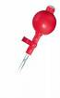Remove the filler and quickly place your finger over the end of the pipette to prevent the alkali escaping.
7. Holding it almost horizontally in both hands as you did for the burette, turn the pipette to coat and clean the inside with the alkali.
8. Discard this rinsing into the ‘discard’ beaker or a sink.
9. You are now ready to carry out the titration.

#### Common Indicators

By knowing the strength of the acid and alkali you can choose which indicator to use in your titration.

|  |  |  |
| --- | --- | --- |
| Type of Acid and alkali | Possible Indicator | Colour Changes |
| Strong Acid + Strong Alkali | Bromothymol blue | blue (in alkali)  straw yellow (in acid) |
| Strong acid + Weak Alkali | Screened Methyl Red | green (in alkali)  mauve (in acid) |
| Weak Acid + Strong alkali | Phenolphthalein | pink (in alkali)  colourless (in acid) |

### Setting up the titration

1. Transfer some of your acid into a small beaker to pour into the burette. Do not pour it back into the bottle at the end – you might contaminate the stock bottle.
2. With the burette in the clamp stand, fill it with the acid.
3. Ensure the outside of the burette is dry and the level is just above the scale.
4. With a ‘discard’ beaker under the tip of the burette, open the tap so the acid fills the tip and the level is on or below the start of the scale. The level of the acid will curve down in the burette. This is called the meniscus.

***meniscus***

1. Make sure the bottom of the meniscus is on the scale.
2. Place the white tile or paper on the stand
3. Now use the bulb to suck alkali into the pipette. Make sure the level is above the mark on the pipette but do not suck alkali into the bulb as it reacts with the rubber and ruins the bulb.
4. Still using the bulb and with your eyes level with the mark on the pipette, slowly allow the alkali to run out of the pipette into the discard beaker. The alkali in the pipette will also have a meniscus. Run the alkali out until the bottom of the meniscus of the liquid just touches the mark on the pipette as shown above.
5. Transfer this to a clean, dry, conical flask. When you think all the alkali has drained into the flask you will see that a small amount is still in the tip of the pipette. Touch the tip on the side of the flask or the surface of the alkali. Some alkali will run out, but a small amount will remain in the pipette.

Do not blow this last amount into the flask of alkali. This has been allowed for in the manufacture of the pipette.

1. Now add a few drops of the indicator to the alkali in the flask.

Note the reading on the scale of the burette. You should be able to estimate this to half the last figure in the scale - i.e. on a burette scale reading to 0.1cm³, you should be able to estimate to 0.05cm³.

**At N5, SQA are looking for an accuracy of within 0.2 cm3.**

1. Place the conical flask of alkali under the burette. Make sure the tip of the burette is inside the conical flask.
2. Tear two holes in a piece of white paper (filter paper will do) and slide it on to the burette. This makes it easier when the tip of the burette is inside the neck of the conical flask to see the scale.

### W:\CHEMISTRY\Photos, Videos etc\Photos\Activities\benedicts\Q-Benedicts-6.JPGCarrying out the titration:

1. Place the conical flask of alkali under the burette. Make sure the tip of the burette is over the neck of the conical flask – ideally low enough to be just inside it.
2. Open the tap (remembering the technique for holding the tap in) and allow a small quantity of acid to run into the flask. Gently swirl the flask as you do this to mix the acid and alkali.

Close the tap now and again and ensure the contents in the flask are really mixed well before adding more.

1. Continue to do this until the indicator changes colour again.
2. Make a note of the volume of acid added (try to estimate to 0.05 cm3).

The difference between the first reading on the scale and this second reading is the volume of acid added (called the titre).

Calculate this now. This first titration is done to give a rough estimate of the actual titre needed.

1. Refill the pipette with alkali as before. Place this in a clean conical flask. Alternatively, you can wash out your original flask and re use that) Add a few drops of the indicator again.
2. Make a note of the reading on the scale of the burette.
3. To save time, quickly add a volume of acid to the flask which is approximately 2 cm3 less than the rough titre you have just calculated.
4. Swirl the flask to mix the contents. The indicator should not have changed colour.
5. Now carefully open the tap and add a few drops of the acid to the flask, closing the tap after each addition and swirling the flask to thoroughly mix the contents before adding more acid.
6. Stop when the indicator just changes colour.
7. Make a note of the reading on the scale of the burette and calculate the accurate titre used.
8. Carry out least two more titration, ensuring you have concordant titres. (Titres agreeing to within +/- 0.2 cm3 of each other).
9. Calculate the average titre (ignoring the rough titre and any rogue results).
10. Rinse your burette and pipette with distilled water and allow them to dry.