Risk Assessment Activity.

The task
Preparation of potassium methoxide
4.5g potassium hydroxide is dissolved in 100 cm³ methanol.
Using a magnetic stirrer, stir till dissolved. This takes approximately 2 hours.
Bottle and label appropriately.

Information

The Location
Is this OK?
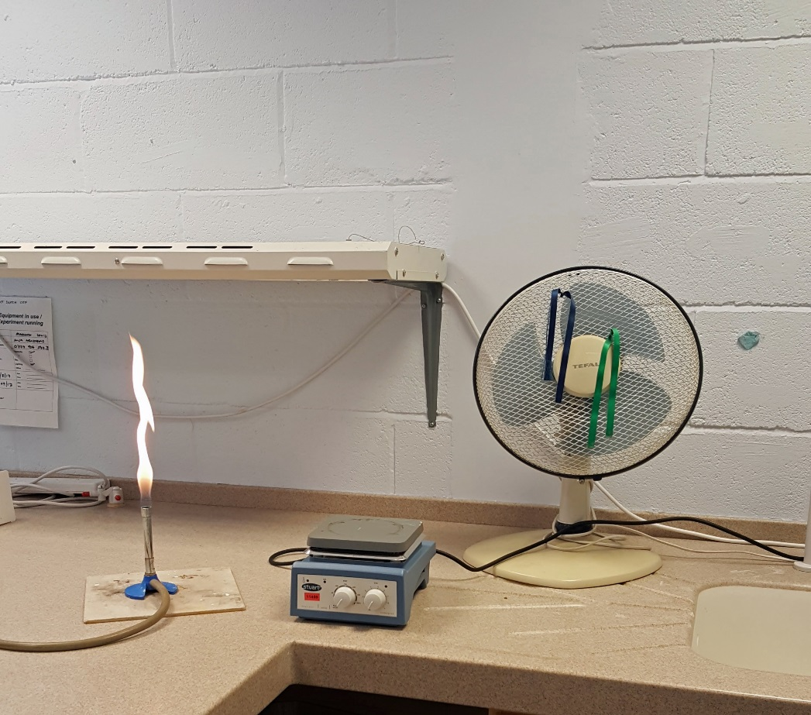

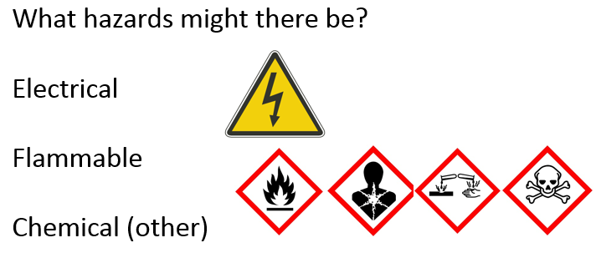

See separate sheets for chemical information

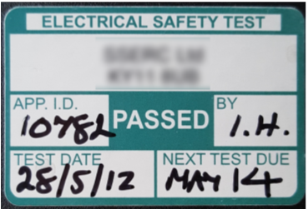
The stirrer / hotplate
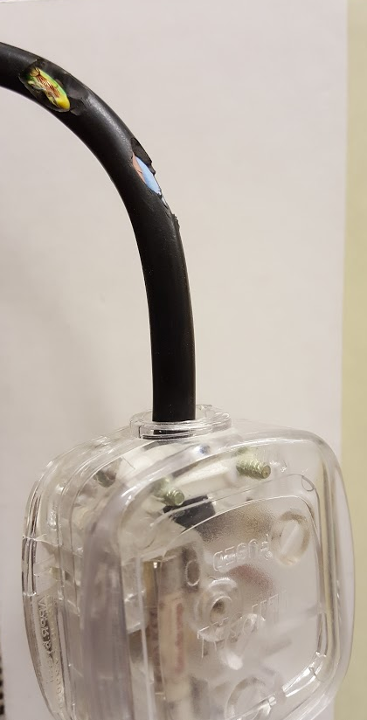

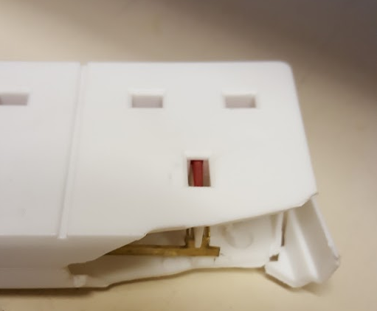

Methanol

Substance | Hazard | Comment
Methanol | 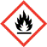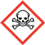  highly flammable, Toxic | Risk of the liquid catching fire.  Toxic if swallowed, in contact with skin or if inhaled. There is a risk of very serious irreversible effects (especially to the optic nerve).  Methanol is often added deliberately to ethanol (‘methylated spirit’) to make it undrinkable.

Control Measures
• Wear eye protection.
• Make sure the room is well ventilated or, in a laboratory, use a fume cupboard if possible.
• Check ways of putting out any fires.
• Do not use near naked flames; if heating is necessary, use an electrically-heated water bath or hot water from a kettle.

Think about the risks |  |  | Ask yourself
What are the details of the activity to be undertaken?  What are the hazards?  What is the chance of something going wrong?  Eg, Does methanol need to be heated? Could there be high levels of vapour?  How serious would it be if something did go wrong?  How can the risk(s) be controlled for this activity?  Eg, Can it be done safely? Does the procedure need to be altered? Should goggles or safety spectacles be worn? |  |  | Can I do a safer experiment instead?  Can I use a safer chemical for this experiment?  Can I use a lower concentration?  Can I use a smaller volume?  Do I need to use a fume cupboard?  What sort of eye or skin protection do I need?
Spills |  | What to do if you have an accident
- Make sure you don’t spill much.  Decant as small an amount as you can and use that for your experiment – do not try to use a large reagent bottle.  -if you do spill any, unless it is either dilute or a very small amount, call your teacher.  - Wipe up small amounts with a damp cloth and rinse it well |  | • In the eye  • Vapour breathed in  • Swallowed  • Spilt on skin or clothing  • Spilt on floor, bench, etc | Flood the eye with gently-running tap water for at least 20 minutes (for alkalis). See a doctor. If it is necessary to go to hospital, continue washing the eye during the journey in an ambulance.  Remove the casualty to fresh air. Call a doctor if breathing is difficult.  Do no more than wash out the mouth with water. Do not induce vomiting. Sips of water may help cool the throat and help keep the airway open. See a doctor.  Remove contaminated clothing. Drench the skin with plenty of water. If a large area is affected or blistering occurs, see a doctor.  Consider the need to evacuate the laboratory and open windows if large amounts are spilt and especially for (moderately) concentrated solutions. Cover with mineral absorbent (eg, cat litter) and scoop into a bucket. Neutralise with citric acid. Rinse with plenty of water. Wipe up small amounts with a damp cloth and rinse it well.
Personal Protective Equipment (PPE)
Only think about this once you have reduced all the other risks as low as possible – PPE is your last line of defence.
Eye protection – If you are using anything corrosive or toxic or that is a health hazard (carcinogenic, mutagenic etc) then wear chemical resistant goggles, NOT safety specs.
For anything of lower hazard, safety spectacles are fine.
Gloves – if you are using anything corrosive, toxic in contact with skin or that is a skin sensitiser, you should wear gloves. Be careful not to spill anything – you might not be able to handle things as easily as without them.
Lab coat – These are a good idea – though their main use is to protect your clothing rather than you.
Respirators and masks – not a good idea. These are much harder to fit and use properly than you might think. Dust masks for some activities might be acceptable but it is preferable to remove your exposure to dust and fumes by using, for instance, a fume cupboard.

Sodium hydroxide (& Potassium hydroxide)
also Soda lime which contains sodium hydroxide
Substance | Hazard | Comment
Sodium hydroxide Solid  Also potassium hydroxide (solid) | 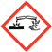  corrosive | (Caustic soda and potash) Also soda lime.  It causes severe burns; it is particularly dangerous to the eyes. Wear goggles.  It gives out heat when added to water.
Sodium or potassium hydroxide solution  (If 0.5 M or more) | corrosive | It causes severe burns; it is particularly dangerous to the eyes. Wear goggles.  Fehling’s solution contains sodium hydroxide of this concentration.
Dilute sodium or potassium hydroxide solution  (If less than 0.5 M but 0.05 M or more) | irritant | It is irritating to the eyes and skin. Wear eye protection
Very dilute sodium or potassium hydroxide solution  (If less than 0.05 M) | low hazard | It will not cause harm but may be extremely uncomfortable in the eyes or in a cut.

Control Measures
• Use the lowest concentration possible; avoid the solid if possible.
• Use the smallest amount possible.
• Wear eye protection, including when making or disposing of solutions. Goggles (or a face shield) rather than safety spectacles will be necessary if the chemical is classed as corrosive at the concentration used.
• Wear protective gloves if the concentrated solution is handled in more than tiny amounts.
• If possible, use a safer alternative, eg, sodium carbonate when making salts or Benedict’s solution rather than Fehling’s solution for food tests.

Storage
• In plastic containers, on shelves with general chemicals

Disposal
• Dilute with water then neutralise with dilute acid. Once neutral the solution can go down the drain with plenty of cold, running water.

Think about the risks |  |  | Ask yourself
What are the details of the activity to be undertaken?  What are the hazards?  What is the chance of something going wrong?  Eg, The solution spurting out of a test tube when being heated.  How serious would it be if something did go wrong?  NB Alkali in the eye causes more damage than acid of equivalent concentration.  How can the risk(s) be controlled for this activity?  Eg, Can it be done safely? Does the procedure need to be altered? Should goggles or safety spectacles be worn? |  |  | Can I do a safer experiment instead?  Can I use a safer chemical for this experiment?  Can I use a lower concentration?  Can I use a smaller volume?  Do I need to use a fume cupboard?  What sort of eye or skin protection do I need?
Spills |  | What to do if you have an accident
- Make sure you don’t spill much.  Decant as small an amount as you can and use that for your experiment – do not try to use a large reagent bottle.  -if you do spill any, unless it is either dilute or a very small amount, call your teacher.  - Wipe up small amounts with a damp cloth and rinse it well |  | • In the eye  • Vapour breathed in  • Swallowed  • Spilt on skin or clothing  • Spilt on floor, bench, etc | Flood the eye with gently-running tap water for at least 20 minutes (for alkalis). See a doctor. If it is necessary to go to hospital, continue washing the eye during the journey in an ambulance.  Remove the casualty to fresh air. Call a doctor if breathing is difficult.  Do no more than wash out the mouth with water. Do not induce vomiting. Sips of water may help cool the throat and help keep the airway open. See a doctor.  Remove contaminated clothing. Drench the skin with plenty of water. If a large area is affected or blistering occurs, see a doctor.  Consider the need to evacuate the laboratory and open windows if large amounts are spilt and especially for (moderately) concentrated solutions. Cover with mineral absorbent (eg, cat litter) and scoop into a bucket. Neutralise with citric acid. Rinse with plenty of water. Wipe up small amounts with a damp cloth and rinse it well.
Personal Protective Equipment (PPE)
Only think about this once you have reduced all the other risks as low as possible – PPE is your last line of defence.
Eye protection – If you are using anything corrosive or toxic or that is a health hazard (carcinogenic, mutagenic etc) then wear chemical resistant goggles, NOT safety specs.
For anything of lower hazard, safety spectacles are fine.
Gloves – if you are using anything corrosive, toxic in contact with skin or that is a skin sensitiser, you should wear gloves. Be careful not to spill anything – you might not be able to handle things as easily as without them.
Lab coat – These are a good idea – though their main use is to protect your clothing rather than you.
Respirators and masks – not a good idea. These are much harder to fit and use properly than you might think. Dust masks for some activities might be acceptable but it is preferable to remove your exposure to dust and fumes by using, for instance, a fume cupboard.

