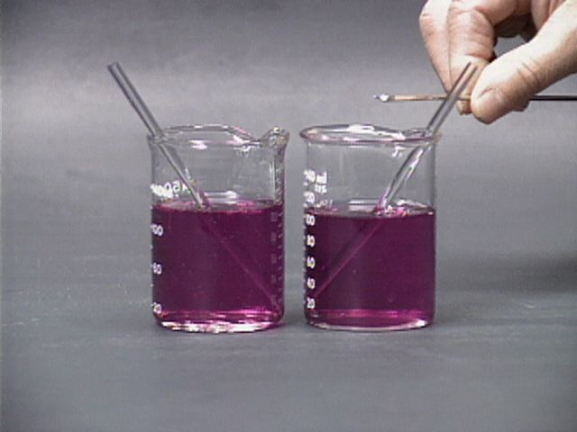
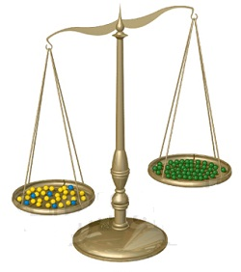
Measure for measure – a practical activity

Making up solutions
Equipment needed (per group)
Access to 2dp balance | Measuring cylinder(s)
Plastic cups (4 small, 2 large) | 2 x plastic stirrers
Bottles of Solutions X and Y | Jars of Solids A and B
2 Limes | 3 cm³ Pasteur pipettes
Weigh boats | Knife and tile

Making up solutions by mass – % m/v (or % w/v)
Simply what it says – the composition is simply a percentage. So a 10% m/v solution of salt is 10g of salt made up to 100 cm³ with water (or whatever solvent you are using)
To do
A – preparing 100 cm³ of a 50% solution of solid A (50% w/v) (14, 19, 20)
- How much of A will you need?

- Weigh out your mass of A
For most fairly dilute solutions you don’t need to worry about the volume of the solid. For a solution this concentrated, however, it will have a big effect.
- Place your sucrose into a plastic cup. Label this solution A There is a line on the side that marks 100cm³.
- Add water until it is close to that line – it will probably take about 80 cm³ or so – stirring once or twice in the process to make sure it is properly mixed.
- Stir until dissolved. Dissolving this substance takes time. Give it a good stir for a minute or two at the beginning and then put it to one side, giving the occasional stir while you get on with the next task.
- Once it has dissolved, Pour into a measuring cylinder, wash out with a few cm³ of water (use a Pasteur pipette) and make up to the final volume.
- Pour back into the plastic cup and set to one side.
This is Solution A

B1 Using Ratios to mix solutions (17)
Solutions are often diluted (and sometimes mixed) using ratios.
It can be slightly confusing in that a 10x dilution involves a 1:9 ratio of mixing. That is because you take 1 cm³ of your concentrated solution and add 9 cm³ of the solvent. The end result is 1 cm³ made up to 10 which is a 10x dilution.
Many solvents for chromatography are described in terms of ratios eg for TLC of soy sauce you can use butan-1-ol, glacial ethanoic acid & water in a 4:1:2 ratio.

Use an appropriate measuring cylinder to measure out 70 cm³ of Solution X
Pour into cup labelled B

You are now going to mix lime juice with solution B in the ratio of 3:2 (A : Lime)
How much lime juice will you need?

Use the juicer to extract sufficient juice from your lime(s) and measure it using the appropriate measuring cylinder
B2 Diluting Acidic solutions (18)
We are going to use this as an example of how to dilute an acid. (Limes do contain citric acid but that is not dangerous. When diluting a concentrated acid such as sulphuric acid, however, there are certain procedures that must be followed to carry it out safely.
1) Wearing appropriate PPE – in this particular case we will dispense with that.
2) Always add the acid (in this case the lime juice) to the water (or other liquid) The reason for this is that many acids produce a lot of heat when they dissolve and if you add water to the acid, it can boil, turn to steam and eject boiling hot concentrated acid from the container – not a good idea.

Measure out the volume of lime juice and mix with solution B.
What is the final volume of this solution?

This is Solution B
C – preparing 50 cm³ of a 1 mol l⁻¹ solution of C (23, 24)
Making up molar concentrations
It is much more common in chemistry that solutions are mare up in terms of moles per litre rather than mass or volume per litre. It is useful to chemists because the mole is a proxy for the number of atoms or molecules and so it allows reactants to be combined in the correct proportions most easily.
A 1 molar (mol l⁻¹ ) solution contains 1 mole of a substance in a litre of solution. One mole of a substance is the mass in grammes of its Gram Formula Mass (GFM) also known as Relative Molecular Mass (RMM). Eg 1 mole of sodium chloride is 58.5g.
- The RMM (GFM) of C is 180
- A 1 mol l⁻¹ solution contains 180g of C per litre of solution. How much C will you need?

- Weigh out your mass of C
For most fairly dilute solutions you don’t need to worry about the volume of the solid. For a solution this concentrated, however, it will have a big effect.
- Place your C into another plastic cup, Labelled C. There is a line on the side that marks 50cm³.
- Add water until it is close to that line – it will probably take about 30 cm³ or so – stirring once or twice in the process to make sure it is properly mixed.
- Stir until dissolved. Dissolving C takes time. Give it a good stir for a minute or two at the beginning and then put it to one side, giving the occasional stir while you get on with the next task.
- Once it has dissolved, Pour into a measuring cylinder, wash out with a few cm³ of water (use a Pasteur pipette) and make up to the final volume.
- Pour back into the plastic cup and set to one side as well.
This is Solution C

At this point, weigh the two larger plastic cups labelled D (while they are still empty)
Record the mass
More ratios (17)
Combine your solutions A, B and C in the ratio 2:2:1 up to a total of 100 cm^{3.}
Put the final solution into one of the larger cups labelled D.
What volumes of A, B and C will you need?

Measure and pour your solutions into the cup
Repeat the process with the other cup labelled D so you have 2 cups. If the measurements are correct, you should have enough solution.
These are solution D

Repeated measurements and Density (25, 26)
As you will see in tomorrow’s titration activity, repeated measurements are often taken to improve the accuracy of the results.
The individual measurements are taken and an average calculated.
A possible class activity (for some occasions only) is instead of getting each group to take many measurements, take the measurements from the whole class and calculate the average.
Density
Pupils need to know how to calculate density. (Density = mass ÷ volume)
You already have values for the mass of your empty cup D and the volume of liquid you have added.
Measure the mass of your cup (D) with its solution in and calculate the density.

Density =

Making up solutions by volume (15, 21, 22)
Making up solutions by volume – % v/v
Very similar to the first activity of making solutions by mass – the composition is simply a percentage. So a 10% v/v solution of ethanol is 10 cm³ of ethanol made up to 100 cm³ with water (or whatever solvent you are using)
Make up a 25 % v/v solution of Solution D in solvent Y
You will use the whole of your solution D
What is the volume of Solution D?
What volume of solvent Y will you require?

Measure out this volume of Solvent Y and add it to the cup containing solution D

Notes
This activity ends up making a version of a ‘Moscow Mule’ cocktail.
A version of it, without the alcohol, could easily be done in school.
1) You need to make sure that the ‘chemicals’ are all food grade. They are all cheap and widely available.
2) you will also need to make sure you are not using laboratory equipment. A set of plastic measuring cylinders is inexpensive and the quantities could be adjusted so that you only need one size (say 100cm³) if cost is at a premium. Weigh boats can be improvised from foil, or paper cupcake moulds, plasic cups can replace beakers and spoons can be used as stirring rods.
3) The activity should not be done in the lab if students are going to drink it. Use a Home Ec room or just an ordinary classroom.
And remember you can change the recipe in any way you like.

A is sucrose – caster sugar dissolved quicker than granulated. This will need 50g made up to 100 cm³.
Normally you would add the solid to the liquid but this is such a concentrated solution that the increase in volume would be too great.

X is vodka – probably not suitable for use with pupils!
The amount of lime juice needed in a 3:2 ratio is 46.67 cm³.

C is glucose. Glucose has a RMM (GFM) of 180. This means that 1 litre of a 1 molar solution contains 180g. So 50 cm³ will contain 180 x (1000 ÷ 50) g = 180 ÷ 20 = 9 g

To make up your solutions in a 2:2:1 ratio up to a maximum of 100 means mixing them at 40, 40 and 20.

Y is ginger ale
If your 100cm³ is 25% of the solution, then the total volume must be 400cm³ and so you need to add 300cm³ of ginger ale to give your final cocktail.

