Chemical Hazard – card grouping activity
On the following pages is a series of cards.
Print them off and then the students can attempt to group them together. Name of hazard, correct CLP symbol, meaning and one or more example.
To assist them, there is a summary table showing at a glance the chemical hazards of various substances, including all the ones used in this exercise. (The table can be downloaded separately as an excel spreadsheet if you prefer)

 | Explosive | Flammable | Oxidiser | Acute toxin | Harmful | health hazard | corrosive | Irritant | pressurised gas | harmful to environment
Ammonia (0.880, concentrated) |  |  |  |  |  |  | ✓ |  |  | ✓
barium chloride |  |  |  | ✓ |  |  |  |  |  | ✓
butane (cylinder) |  | ✓ |  |  |  |  |  |  | ✓
citric acid |  |  |  |  |  |  |  | ✓
cobalt chloride |  |  |  |  |  | ✓ |  |  |  | ✓
concentrated hydrochloric acid |  |  |  |  |  |  | ✓
concentrated nitric acid |  |  | ✓ |  |  |  | ✓
concentrated Sulphuric acid |  |  | ✓ |  |  |  | ✓
copper carbonate |  |  |  |  | ✓ |  |  |  |  | ✓
2,4-dinitrophenylhydrazine (2,4-DNPH) | ✓ |  |  |  | ✓
ethanol |  | ✓
ethoxyethane |  | ✓
hydrogen peroxide |  |  | ✓ |  |  |  | ✓
iron II sulphate
lead ethanoate |  |  |  |  |  | ✓ |  |  |  | ✓
mercury II chloride |  |  |  | ✓ |  | ✓ | ✓ |  |  | ✓
methanol |  | ✓ |  | ✓ |  | ✓
nickel sulphate |  |  |  |  | ✓ | ✓ |  | ✓ |  | ✓
nitrogen (cylinder) |  |  |  |  |  |  |  |  | ✓
oxygen (cylinder) |  |  | ✓ |  |  |  |  |  | ✓
PET ethers |  | ✓ |  |  |  | ✓ |  |  |  | ✓
phenylthiocarbamide (PCT) |  |  |  | ✓
potassium cyanide |  |  |  | ✓
potassium hydroxide |  |  |  |  |  |  | ✓
potassium manganate VII |  |  | ✓ |  | ✓
propanone |  | ✓
silver fulminates | ✓
silver nitrate |  |  | ✓ |  |  |  | ✓ |  |  | ✓
sodium chlorate V |  |  | ✓ |  | ✓ |  |  |  |  | ✓
sodium hydroxide |  |  |  |  |  |  | ✓
sodium tetraborate
sulphur dioxide |  |  |  | ✓ |  |  | ✓
zinc nitrate |  |  | ✓ |  | ✓ |  |  | ✓ |  | ✓

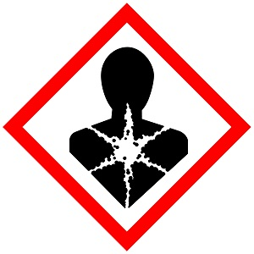 | Health Hazard | 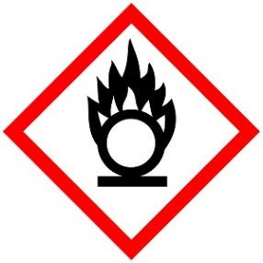 | Oxidiser
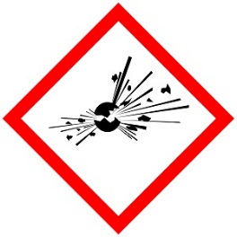 | Explosive | 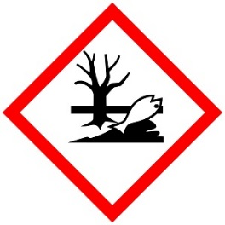 | Hazardous to the aquatic environment
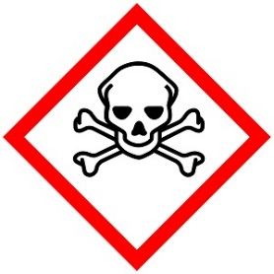 | Acute toxin | 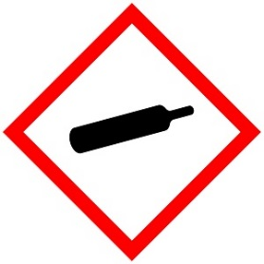 | Gas under pressure
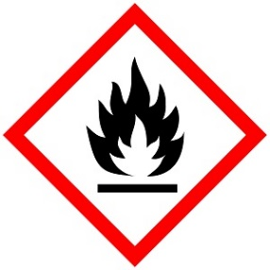 | Flammable | 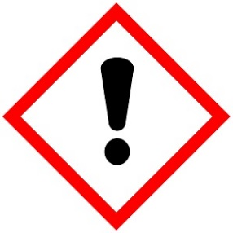 | Irritant  or  Harmful
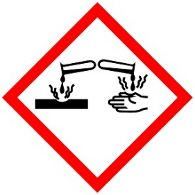 | Corrosive

Eg Nickel sulphate | Can cause long-term health effects  (carcinogenic, mutagenic, reproductive toxin, sensitiser etc) | Eg hydrogen peroxide | Can cause other substances to catch fire or even explode
Eg 2,4-dinitrophenylhydrazine | Possibility of reacting rapidly and exploding if dropped, heated, exposed to flame etc. | Eg zinc nitrate | Can harm aquatic animals or plants
Eg potassium cyanide (Cat 1) | Causes short-term toxic effects if swallowed, inhaled or in contact with skin (or any combination) | Eg butane cylinders | Gas under pressure (can explode) and can also be a cryogenic hazard
Eg Ethanol | Could catch fire and burn if heated or near an ignition source (eg a spark) | Copper carbonate | Irritating to eyes and skin or a mild acute toxin
Eg sodium hydroxide | Can cause corrosive burns to the skin and eyes.  Likely if in contact with body tissue.
Eg Cobalt chloride | Eg sodium tetraborate | Eg potassium manganate VII | Eg sodium chlorate V
Eg Silver fulminates | Eg sulphur dioxide | Eg Lead ethanoate | Eg mercury II chloride
Eg Barium chloride (Cat 3) | Phenylthiocarbamide (PTC) (Cat 2) | Eg oxygen cylinders | Eg nitrogen cylinders
Eg Propanone | Eg ethoxyethane | Eg citric acid | Eg Iron II sulphate
Eg concentrated sulphuric acid | Eg concentrated ammonia

