Hazard Cards – turnover activity.
One the next pages are images of various hazard warning signs with the definitions next to them.
There are a couple of ways of using them (at least)
- If you print them off, fold them over and then glue or, better, laminate them, you will have a set of cards of a hazard symbol with the definition on the reverse,
These can then be used as a learning activity. Students look at either the image or the definition and describe what is on the other side. If they are correct, they get a point.
- If you print them and cut them out then they can be put safe down and then used as a pairing/memory game. Pupils turn up 2 cards and if they match (sign and definition) they get to keep them and get a point, If not, they turn them back over. (It might be best to do this in a couple of groups, eg GHS signs and other safety signs, so there are not too many in one batch for them to remember.

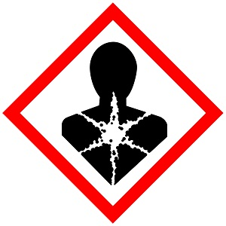 | Health Hazard | 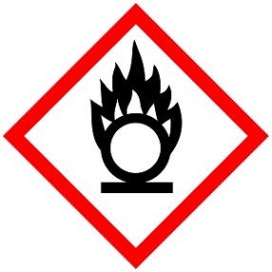 | Oxidiser
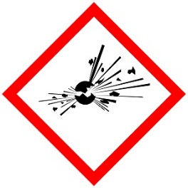 | Explosive | 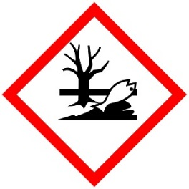 | Hazardous to the aquatic environment
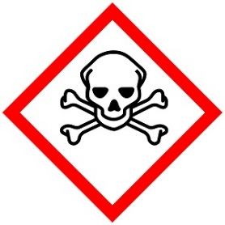 | Acute toxin | 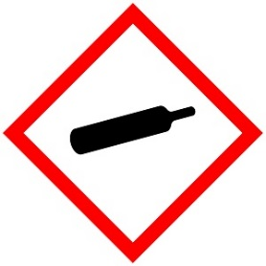 | Gas under pressure
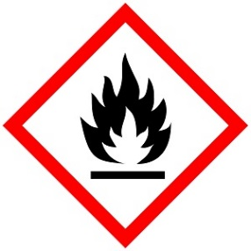 | Flammable | 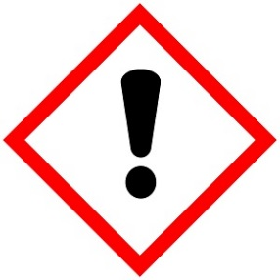 | Irritant  or  Harmful
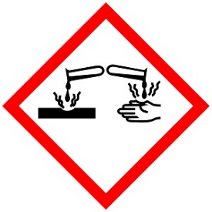 | Corrosive |  | Electrical Hazard

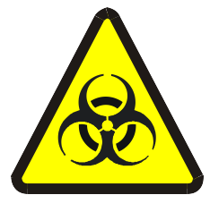 | Biohazard |  | Eye protection must be worn
 | Eye defenders must be worn | 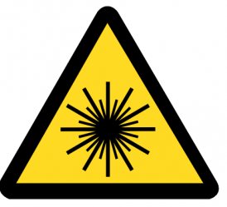 | Laser hazard
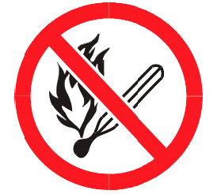 | No naked flames | 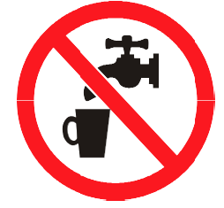 | Do not drink water from this tap
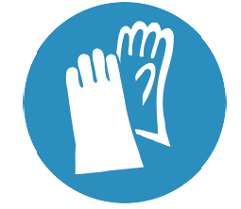 | Gloves must be worn | 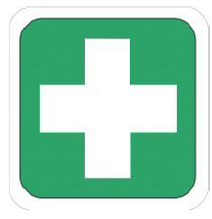 | First aid station
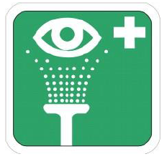 | Eyewash station | 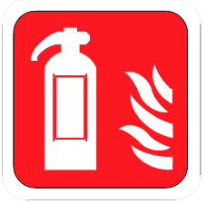 | Fire extinguisher
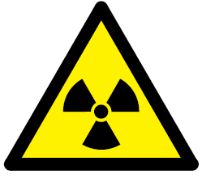 | radioactivity | 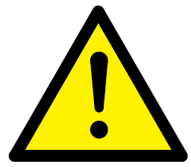 | Warning of general danger
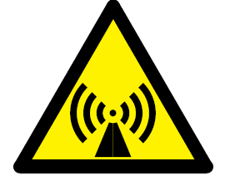 | Non-ionising radiation | 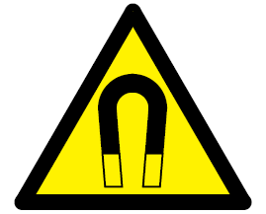 | Strong magnetic field
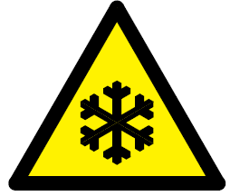 | Low temperature |  | Warning sign
 | Firefighting sign |  | 1st aid / emergency exit sign
 | Prohibition sign |  | Mandatory sign

