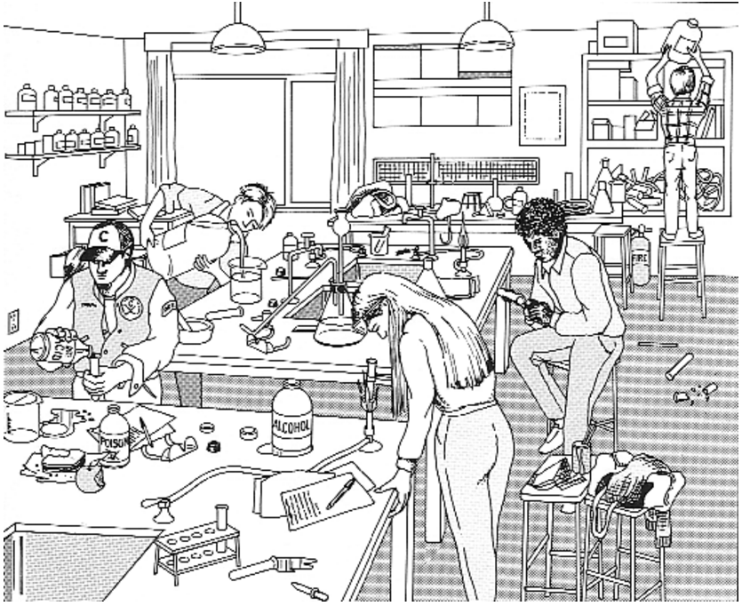
Hazards (in no particular order)
Some of these occur in more than one place

1) lifting down large container of liquid from a high shelf.
2) Standing on an insecure stool
3) Equipment just piled up.
4) Broken glass on the floor / test tube and spatula on floor
5) Stools with bags in middle of floor
6) no eye protection being worn
7) hair not tied back
8) test tube being held vertically to heat
9) Looking straight down into test tube
10) Bottle of flammable ethanol (with some spilled) close to flame
11) spilled liquid not cleared up
12) Eating in the lab
13) Open bottle of poison on bench (close to food)
14) No lab coats being worn
15) No gloves being worn
16) Acid being poured in such a way as to spill on hand
17) Pouring liquid from far too large a bottle
18) Head far too close to pouring liquid (with no protection)
19) Looks like carpet on the floor – can absorb chemicals and release fumes
20) Curtains at windows – possible fire risk

