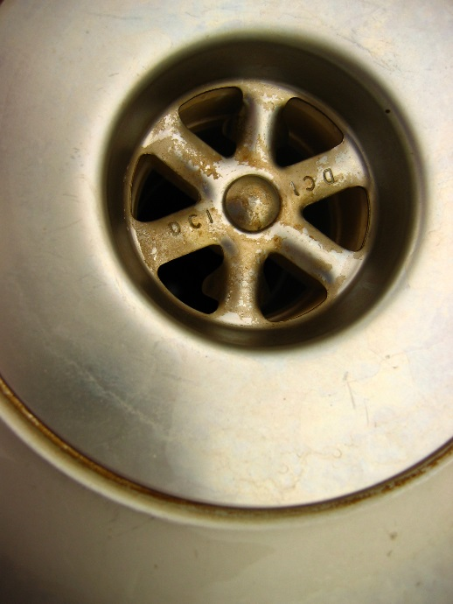
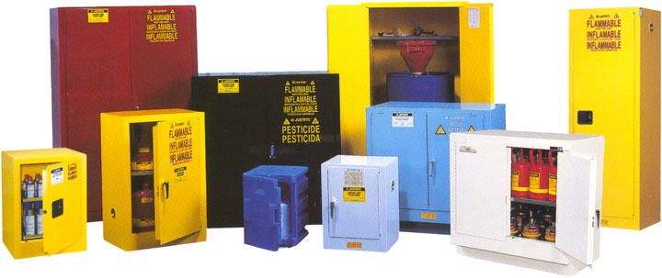
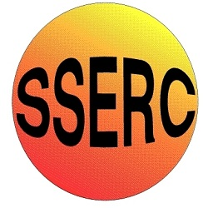

Chemical storage, spillage and disposal

Chemical storage
Questions about storing chemicals can generally be grouped under the following headings: where? How? And How long for?

WHERE?
The simple answer is ‘in a chemical store’. This should be fire resistant, lockable (with not too many keys in circulation) and convenient – ideally opening off the prep room but certainly not far away from it.
It is often a little more complex than that. It is best practice to keep as much of your chemical stock in the chemical store as you can but that may not always be possible.
As a general rule of thumb
In the lab - Small amounts of Low hazard chemicals, Harmful (Ac Tox 4), or Irritant (Cat 2)
In the prep room - Low hazard chemicals in larger amounts, Gas cylinders, radioactives*
In the chemical store - Everything else
* There are various other restrictions about storing radioactives so this may not be the best place.

HOW?
Most chemicals can simply be kept on open shelves but there are a few groups that need special treatment
Flammables – Everything that is highly flammable (Category 1 or 2) should be kept in a flammable cabinet, which should be as far from the door as possible. Some Category 3 flammables can go there too if there is room.
Corrosives – solids such as sodium hydroxide can just go on the shelves but liquids like concentrated acids should be stored at floor level in trays to control any spillage if the bottles break.
Oxidising agents – these should be kept away from the organics and particularly from anything flammable.
Alkali metals – these should be kept in a separate container, in their original containers.
Other than that, the arrangement of the organic and inorganic substances is a matter of preference. They can be mixed in or separated.

LABELLING CHEMICALS
We have already said that pictograms are required by law to be present on containers of chemicals bought into schools. However, if the chemical is then diluted into other bottles, or weighed into smaller amounts, there is no legal requirement to label the new container with the pictogram. However, it is good practice to do so to remind ourselves and others using the chemical of any danger associated with it. It also makes sense to include this information as well:
- name of the chemical (or its formula),
- the date it was prepared (some chemicals do go off),
- its concentration (if appropriate)
- the initials of who has prepared it.
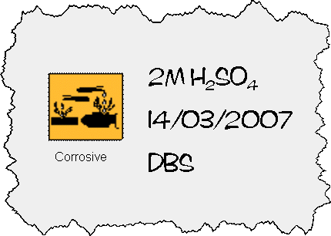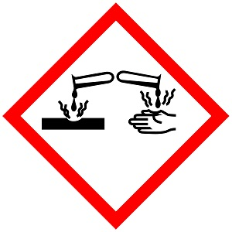e.g. The label on a bottle of 2 mol l⁻¹ sulphuric acid might look like this:

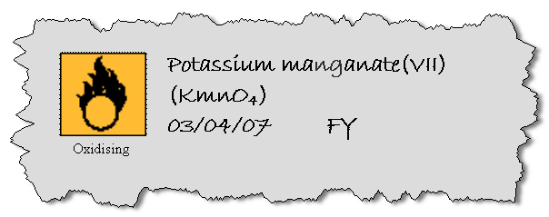
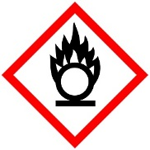
The label on a jar of potassium permanganate could look like this:

HOW LONG?
For most chemicals the only answer to that is ‘as long as they still work’. There is one exception though:
There are a few substances that become more hazardous on storage, These fall into two main categories:
- Those that form dangerous compounds – such as explosive peroxides. Eg potassium metal, ethoxyethane.
- Oxidising agents that might become contaminated by organic material such as dust, creating a dangerous mixture. Eg ammonium dichromate, sodium chlorate.
A list of these and the recommended time they should be kept for can be found on the SSERC website.
Do not worry too much about the dates manufacturers put on the containers – these are dates beyond which they will not guarantee the purity/quality, not dates by which they must be disposed.

STORING WASTE
Waste chemicals should be stored in the chemical store in clearly labelled bottles.
Solutions can be evaporated or precipitated to turn them into solids which take up much less space.
Organic solvents can be combined into two bottles: halogenated solvents and non-halogenated solvents. (A record should be kept of what is put into each bottle. It is not a good idea for waste bottles to be out in classrooms as this allows greater opportunity for contamination and potential accident.
Waste (as well as excess or unwanted) chemicals should be disposed of by using a licensed disposal contractor. SSERC does produce a list of some of the companies that offer this service. There are certainly others so look around and if they are not on our list let us know so we can check them out.
There is no specific limit on how long you can store waste for, just that it should be removed as soon as is reasonably practicable. In a school context, and annual uplift would be ideal but biennial is more likely. Longer than this is not a suitable option.

DISPOSAL
There are many chemicals in use in schools that can be simply put in the bin or washed down the sink but equally there are many others that can cause significant environmental damage.
The best way to address waste is to avoid creating waste that is a problem in the first place. You will not be able to eliminate it but you should be able to reduce it without too much trouble by two simple approaches:
- Use chemicals that are less environmentally damaging where possible
- Where environmentally damaging chemicals do have to be used, reduce the quantities.
Effectively, there are four ways you can dispose of chemical waste:
- In the bin – some solid wastes can simply be put into the domestic waste to go to landfill. Anything flammable or oxidising should not be disposed of this way.
- Down the drain – it is important in this case to use an outlet that drains directly into the foul-water system. Foul-water drains carry waste water from toilets, sinks, baths and household appliances to sewage treatment works – most facilities will fit this description.
- Evaporation – small amounts of volatile chemicals can be evaporated in a ducted fume cupboard (or in a secure place outside).
- By Registered Waste Carrier – collected and professionally disposed of.

The key questions you need to consider are:
Is it hazardous?
More particularly, is it classified as hazardous according to the CLP regulations (see table on the next page). This will depend on the concentration as well as the basic properties of the substance.
How much of it have I got?
It is obviously impractical to remove every last millilitre of reagents from glassware before cleaning it but equally you shouldn’t pour large quantities of anything down the drain. The quantity will be determined by how hazardous the reagents are.
Can I treat it to recycle or make it easier to dispose of?
There are various methods that can be used in different cases. Some examples might be . . .
- Acids and alkalis can be neutralised by sodium carbonate or ethanoic acid respectively.
- Silver residues are likely to be recycled as the silver salts are expensive.
- Chromium VI salts can be reduced to the less hazardous chromium III

‘Harmless chemicals’
Chemicals that are classed as harmless can be washed to waste or put in the bin for disposal to landfill.
Substances that do not mix with water (eg, liquid paraffin, vegetable oil) should not be washed down the drain as they can emulsify and cause blockages. Instead, absorb them onto a mineral absorbent (eg, cat litter) then place in the normal refuse.
Harmless chemicals obviously include any that do not have a hazard symbol – sodium chloride and alum for instance. But many hazardous substances too can be classed as ‘harmless’ if they are dilute enough.
(This dilution, while normally with water or another solvent can also refer to a solid. So solid lead oxide mixed with sand is also ‘diluted’ and will have a certain % composition

Hazard | Number | Concentration | Symbol
Acute Toxic Category 1&2 | H300, H310, H330 | 0.1% | 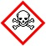
Acute Toxic Category 3 | H301, H311, H331 | 3%
Acute Toxic Category 4 | H302, H312, H332 | 25% | 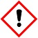
Carcinogenic/ Mutagenic Category 1 | H350, H340 | 0.1% | 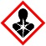
Reproductive toxin Category 1 | H360 | 0.5%
Skin / Respiratory sensitiser category 1 | H317 , H334 | 1%
Aspiration toxin Category 1 | H304 | 25%
Carcinogenic/ Mutagenic Category 2 | H351, H341 | 1%
Reproductive toxin Category 2 | H361 | 5%
Skin Corrosive Category 1 | H314 | 1% | 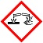
Eye Damage Category 1 | H318 | 10%
Skin / Eye / Respiratory irritant Category 2 | H315, H319, H335 | 20%
Hazardous to the aquatic environment Category 1 (acute or chronic) | H400, H410 | 0.1/M* % | 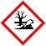
Hazardous to the aquatic environment Category 2,3,4 | H411, H412, H413 | 1%
NB – it is against the law to dilute reagents specifically for disposal. Though ones that are diluted for their normal use, or during a clear-up process are fine.
For example, a filter paper (1 g) containing less than 0.25 g of copper(II) oxide [H302 so ≤ 25%], can be placed in the waste. Deliberate dilution (eg, with sand) is not permitted but dilution will often occur naturally when preparing the waste for disposal (eg, wrapping in newspaper).

The main groups to be careful of are: organic solvents and the compounds of heavy metals: copper, zinc, lead, mercury, chromium, manganese etc.
The above is just a simple overview – for accurate information on disposal consult the relevant entries on the SSERC website.

Spillage
There are two aspects to dealing with spillages: ensuring that as little as possible is spilled in the first place and then dealing with it if some is spilled despite your best efforts.

Reducing spills
- Make sure the likelihood of spillage is minimised.
- Ensure there are no trip/slip hazards where anyone might be carrying chemicals
- Make sure chemicals are placed securely on shelves/benches, not too close to the edge, and in stable containers.
- Ensure minimum quantities of hazardous chemicals can be spilled
  - Decant say 100cm³ of concentrated acids rather than bring out a winchester full.
  - Similarly a few g of magnesium powder rather than the whole jar.

When to deal with a spill
There are some spillages that you should simply leave to the experts. In particular any spill that generates large amounts of hazardous fumes. Especially large quantities of:
- Bromine
- .880 Ammonia
- Glacial ethanoic acid (and propanoic or butanoic acids)
- Concentrated hydrochloric acid
- Concentrated nitric acid
And any other source of hazardous fumes – if for instance the spillage is a dilute acid and a sulphite – which will generate sulphur dioxide.
In situations like this, evacuate the chemical store/prep room/classroom as soon as possible – There MAY be time in the larger space of a classroom to open a window or switch on a ducted fume cupboard in passing.
In most cases, the ventilation will run its course and clear the air – though it could take many hours. If the ventilation is not clearing it – call the fire brigade.

How to deal with a spill
Each prep room should have a spillage kit. Details of what it should contain are on the SSERC website. In brief though, it should contain:
- Sodium carbonate - for spillage of concentrated mineral acid.
- Citric acid, for spillage of alkali solution
- Mineral absorbent (cat litter),
- Sand - For mixing with water reactive fuming corrosives.
- Calcium hydroxide/sulphur mix For dealing with mercury spills
- Detergent – to emulsify water-immiscible liquids
- PPE: goggles, gloves, face shield, apron (etc in several sizes if need be),
- Cleaning equipment eg plastic bucket and mop, plastic dustpan and brush.

