Chemical spill activity
The SQA support material suggests the following:

Simulated chemical spill:
use of sodium chloride or sucrose in place of sodium hydroxide, etc.
use of vinegar in place of ethanol or propanone

I think better options would be:
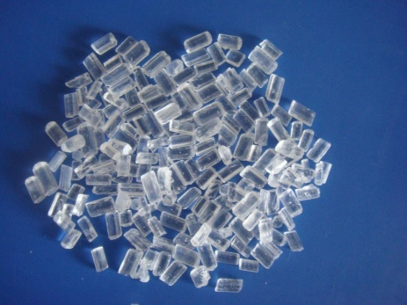
Sodium thiosulphate for sodium hydroxide – it has larger crystals which look more like NaOH pearls.

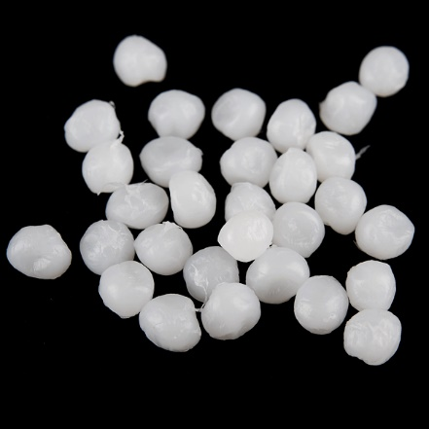
Even more similar are the ‘polymorph’ beads that are used as an example of a thermosetting plastic in work on Novel materials.
It can be found from various sources such as Amazon. It is also available from Mindsetsonline. The advantage of this is that at low temperatures (below 62C) it remains solid and is tough and long lasting so you would only need to but some once.

For the liquid spill, glycerol (propane-1,2,3-triol) is good to simulate concentrated sulphuric acid. It might perhaps need to be slightly watered down – but it needs still to be fairly viscous).
For ethanol/propanone – the suggestion of vinegar is OK but the smell is so familiar. I would be tempted to use water with a small amount of some odorant/perfume (vanilla extract perhaps?). Or possible even use ethanol itself – as long as you think the situation would not be too risky.

