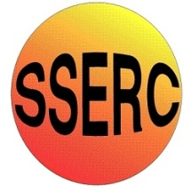
Chemical Demonstrations
Alkali Metals in Water
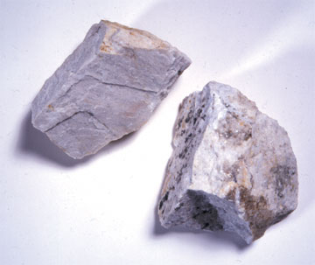
CfE Level 3
Through experimentation, I can identify indicators of chemical reactions having occurred. ...
SCN 3-19
N4 Chemistry in Society
The Properties of Metals and Alloys

This experiment can be carried out safely with sodium, potassium or lithium (or calcium)
You will need
Tile | Scalpel
Bottles of alkali metals | Tweezers or tongs
Container of cold water | Safety screens
Paper towel | Phenolphthalein or other indicator (optional)

Preparation
- Wear goggles (BS EN 166 3) and gloves and ensure all apparatus, i.e. tongs, spatula, tile etc are dry.
- Use two safety screens. (to protect students and teacher/technician) Place the safety screen as close to the trough as possible to avoid pieces flying out over the class. The behaviour of the sodium is very unpredictable and it may explode and eject particles. In place of safety screens, an acrylic sheet can be placed on top of the trough.
- Students should be 3 m away from the front screen.
The demonstration
- Using tongs or spatula(e) lift out a lump of sodium and place on a white tile. Replace the lid on the sodium jar immediately. Cut the required number of pieces. Return the lump from which the small pieces were cut to the sodium jar immediately and replace the lid again. (Do not return small scraps). Remove the oil with tissues.
- To cut the pieces, the teacher or technician, wearing eye protection and rubber or plastic gloves, should cut off small bits, about 0.1 g (approximately 2/3 mm), just before use. Use a scalpel or knife to cut the metal holding in place with tongs.
- Chill the water first with few ice cubes place a small piece of sodium (2 or 3 mm on each side) on the surface.
- Do not restrain its movement - allow it to roam freely on a large surface of water.
- The resulting solution of sodium hydroxide is CORROSIVE; dispose of it carefully, greatly diluting with water.
- Clear the mortar and spatula(e) from all small bits by placing under a large volume of water in a bucket.
If you put some indicator solution in the water, as the demonstration proceeds, you will see it change colour due to the alkaline hydroxides being produced.

Comments
Potassium will catch fire immediately and burn out rapidly with a lilac flame
Lithium will float and fizz on the surface but no flame will appear.
Sodium will fizz on the surface. Orange sparks will appear and it may catch fire. It is also possible that the sodium will explode.
An alternative method for sodium is to float a piece of filter paper on the surface of the water and place the sodium on top of this. The sodium is more likely to actually burn this way and stays away from the edge of the glass.
Calcium will sink to the bottom and then start to bubble – if you have some washing up liquid in the water, bubbles of hydrogen will appear on the surface which you can ignite with a pop to show it is hydrogen.

Health and Safety
Do NOT use larger pieces of the metals than suggested.
Carry out in a well-ventilated room as the fumes can be irritating if breathed in.

