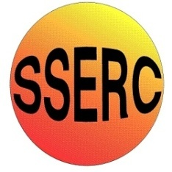

Chemical Demonstrations
Sea-Water Buffering

CfE Advanced Higher –
Inorganic and Physical Chemistry
Oxidation states of transition metals
Introduction
Ocean acidification is a growing problem as a result of man-made CO₂ emissions. The name is slightly misleading though. Sea water is actually alkaline, averaging around pH 8.2. The introduction of all the CO₂ is making the oceans less alkaline rather than more acid but the end result is the same.
The reason the situation is not as bad as it might be, and also why it was freshwater lakes that were being worse affected by acid rain than the seas, is that the salts dissolved in sea-water produce a significant buffering action.
You will need
2 x 250 cm³ flask / beaker | 1 x T-piece and tubing
Tap water* | Sea water
Universal indicator

* don’t use distilled water to compare as the small amount of CO₂ dissolved in it will turn universal indicator yellow from the start.
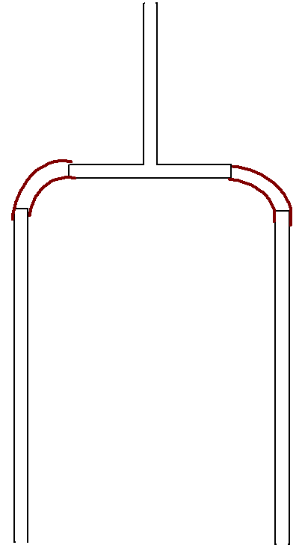
To Do
T - piece
Preparation
- Preparing the blowing tubes
Rubber/plastic tubing

Glass tube

b. Make up the seawater
You can use fresh seawater if you live near the sea but in this case make sure it is clean and free from contamination.
For artificial seawater, you will need to either buy marine salts from an aquatics centre or use the recipe on the SSERC website (leaving out the optional chemicals).
Dissolve the following salts in 250 cm³ of pure water and then dilute to 1000 cm³.
23.99g of sodium chloride
0.74g of potassium chloride
2.24g of calcium chloride-6-water
10.89g of magnesium chloride-6-water
4.01g of anhydrous sodium sulphate (or 9.1g of sodium sulphate-10-water)
0.20g of sodium hydrogen carbonate
0.09g of sodium bromide
0.03g boric acid (optional)
1.01g strontium chloride (optional)

Take a small sample of the two waters and add a drop or two of universal indicator solution to each. If they are the same colour then all is fine. If they are different then you will need to adjust the pH of the tap water (the buffers in sea water make it much harder to adjust). You can do this with a drop or two of very dilute sodium hydroxide or sodium carbonate (0.001M or less)
The demonstration
Pour roughly equal quantities of tap water and seawater into two beakers or flasks and add a few drops of universal indicator to each.
Put the tubes into each beaker/flask and blow through the T-piece. Air will bubble through both tubes and their liquids simultaneously.
Within a few seconds, you should see the tap water go paler green and eventually yellow while the seawater remains just about the same colour.
What is happening?
The carbonate/bicarbonate, buffer system is one of the most important buffering systems in nature. Like any buffering system, a bicarbonate buffer resists any change in pH, so it helps stabilize the pH of (in this case) ocean water. Ocean acidification is an example of how bicarbonate buffering works in practice.
When carbon dioxide gas is dissolved in water, it can react with water to form carbonic acid
H₂O + CO₂ ⇋ H₂CO₃.
Carbonic acid can in turn give up a hydrogen ion to become bicarbonate,
H₂CO₃ ⇋ H⁺ + HCO₃⁻
which can give up another hydrogen ion to become carbonate.
HCO₃⁻ ⇋ H⁺ + CO₃²⁻
All these reactions are reversible.
This sequence of reactions (from dissolved carbon dioxide to carbonate) rapidly reaches a dynamic equilibrium, a state in which the forward and reverse processes of this reaction happen at equal rates.
Adding acid will increase the rate of the reverse reaction and of carbon dioxide formation, causing more carbon dioxide to diffuse out of the solution.
Adding base, on the other hand, will increase the rate of the forward reaction, causing more bicarbonate and carbonate to form.
Any pressure on this system, in other words, causes a compensating shift in a direction that restores equilibrium.
The buffering system continues to work as long as its concentration is large in comparison to the amount of acid or base added to the solution.

