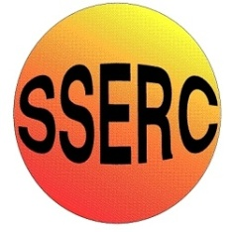
Chemical
Demonstrations
Magic Dye
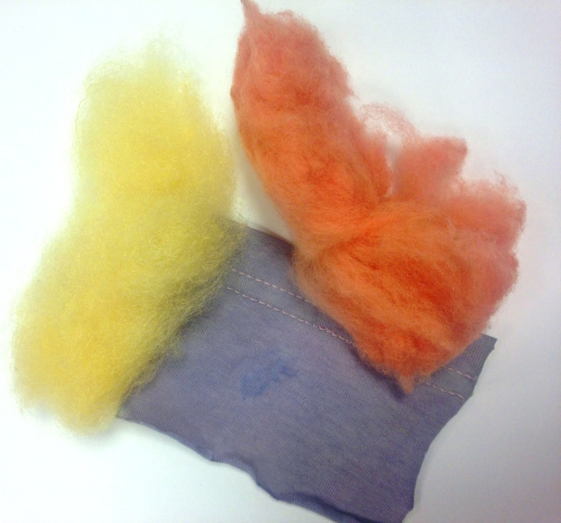
Introduction
This reaction can be applied to curriculum for excellence.

Through experimentation, I can identify indicators of chemical reactions having occurred ...
SCN 3-19a
CfE Higher
Chemical Change and Structure
Structure and Bonding
A good demonstration at almost any age. In particular at Higher as it provides an excellent visual demonstration of different types of bonding.

You will need
1 x 600 cm³ beaker (or larger) | hotplate
~ 100 cm³ of a 0.05% solution of acid blue 40 | ~ 100 cm³ of a 0.05% solution of disperse yellow 7
~ 100 cm³ of a 0.05% solution of direct red 23 | Samples of cloth and string.

What you do
- Pour all three dyes into the 600 cm³ beaker.
- Heat the mixture to close to boiling and keep it there.
- Place samples of different types of fabric in the dye bath. The easiest way to do this is to tie string to them which can hand over the side, making it a lot easier to get out
A good mix is cotton, wool and polyester or another synthetic.
- Leave for about 5-10 minutes – it may need longer if the dye bath is not hot enough.
- Remove the fabrics and rinse with clean water

Tips
The hotter the dye bath, the brighter the colours you will eventually get.
If you are in a hurry, it is quicker to use a Bunsen burner to heat the dye bath and use the hotplate just to maintain the temperature.
The mixed dye bath, once cooled, can be kept in a stoppered bottle and used again at a later date.

What is going on?
Different dyes bond to fabrics in different ways.
Acid dyes contain acidic –CO₂H and –SO₃H groups which bond to the basic –NH groups in the amide linkages of wool, silk and nylon.
Direct dyes bond by hydrogen bonding and take well to cellulose-based fibres such as cotton, viscose and rayon which have many –OH groups.
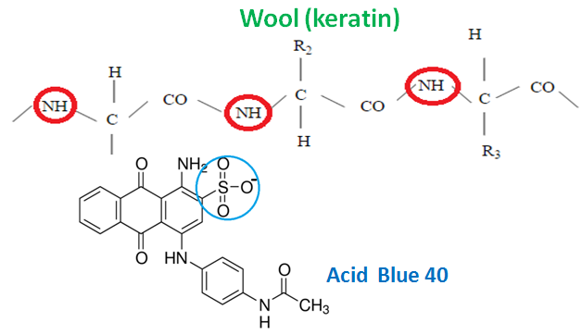
Disperse dyes are not water-soluble. They exist in the dye-bath as a fine suspension (hence the name), and are absorbed as a solid solution by hydrophobic fabrics such as polyesters.

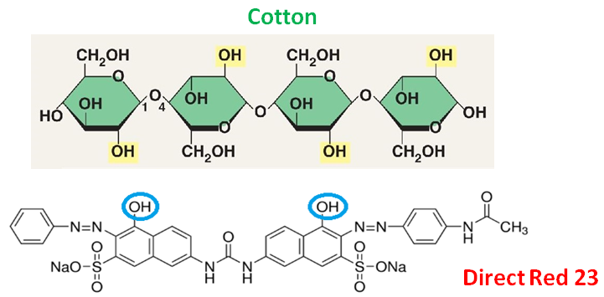

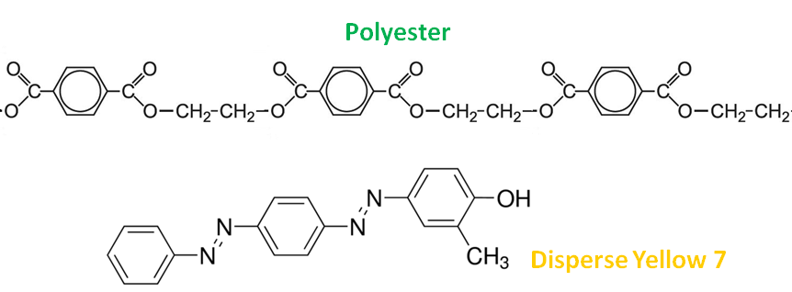

Extensions
You can compare the mixed dye bath to the individual baths.
Try different materials and get pupils to try to predict what will happen to materials like silk, linen and nylon.
Safety
The made-up dyes are of low hazard but care should be taken by the technicians making up the solutions.
It is the responsibility of teachers doing this demonstration to carry out an appropriate risk assessment.

